Topics to be covered
String Handling in Java: Introduction, Interface Char Sequence, Class String, Methods for Extracting Characters from Strings, Methods for Comparison of Strings, Methods for Modifying Strings, Methods for Searching Strings, Data Conversion and Miscellaneous Methods, Class String Buffer, Class String Builder.
Multithreaded Programming: Introduction, Need for Multiple Threads Multithreaded Programming for Multi-core Processor, Thread Class, Main Thread- Creation of New Threads, Thread States, Thread Priority-Synchronization, Deadlock and Race Situations, Inter-thread Communication - Suspending, Resuming, and Stopping of Threads.
Java Database Connectivity: Introduction, JDBC Architecture, Installing MySQL and MySQL Connector/J, JDBC Environment Setup, Establishing JDBC Database Connections, ResultSet Interface, Creating JDBC Application, JDBC Batch Processing, JDBC Transaction Management
String Handling in Java
String is an object that represents sequence of characters. In Java, String is represented by String class which is located into java.lang package. In java, every string that we create is actually an object of type String. One important thing to notice about string object is that string objects are immutable that means once a string object is created it cannot be changed.
The Java String class implements Serializable, Comparable and CharSequence interface that we have represented using the below image.
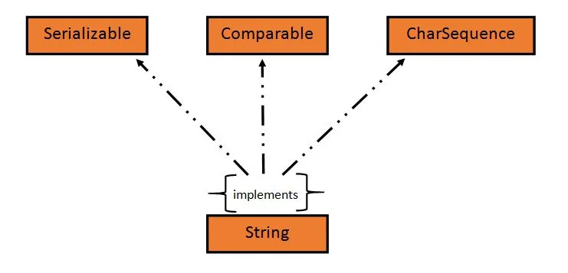
In Java, CharSequence Interface is used for representing a sequence of characters. CharSequence interface is implemented by String, StringBuffer and StringBuilder classes. This three classes can be used for creating strings in java.
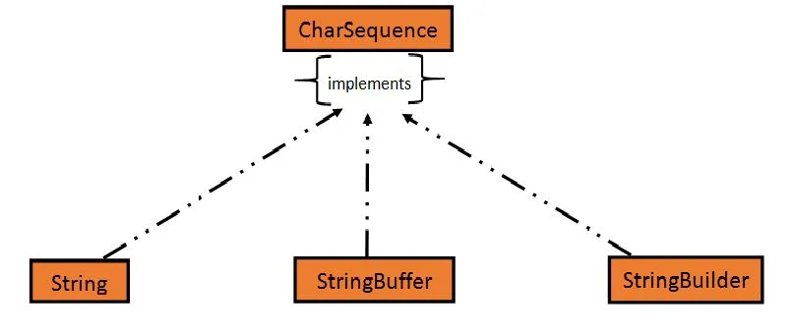
An object whose state cannot be changed after it is created is known as an Immutable object. String, Integer, Byte, Short, Float, Double and all other wrapper classes objects are immutable.
Creating a String object
String can be created in number of ways, here are a few ways of creating string object.
1) Using a String literal
String literal is a simple string enclosed in double quotes " ". A string literal is treated as a String object.
public class Demo{
public static void main(String[] args) {
String s1 = "Hello Java";
System.out.println(s1);
}
}
Output:
Hello Java
2) Using new Keyword
We can create a new string object by using new operator that allocates memory for the object.
public class Demo{
public static void main(String[] args) {
String s1 = new String("Hello Java");
System.out.println(s1);
}
}
Output:
Hello Java
Each time we create a String literal, the JVM checks the string pool first. If the string literal already exists in the pool, a reference to the pool instance is returned. If string does not exist in the pool, a new string object is created, and is placed in the pool. String objects are stored in a special memory area known as string constant pool inside the heap memory.
String object and How they are stored
When we create a new string object using string literal, that string literal is added to the string pool, if it is not present there already.
String str= "Hello";
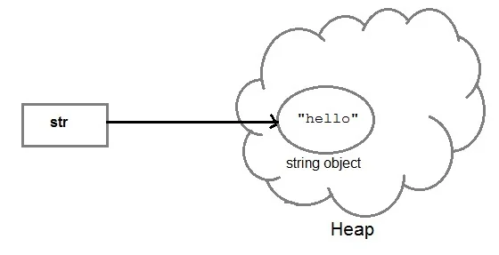

And, when we create another object with same string, then a reference of the string literal already present in string pool is returned.
String str2 = str;
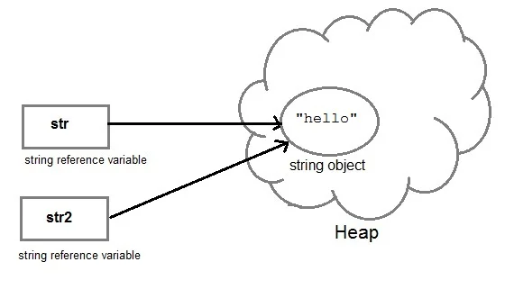
But if we change the new string, its reference gets modified.
str2=str2.concat("world");
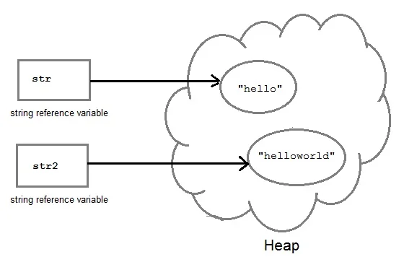
Concatenating String
There are 2 methods to concatenate two or more string.
- Using concat() method
- Using + operator
1) Using concat() method
Concat() method is used to add two or more string into a single string object. It is string class method and returns a string object.
public class Demo{

public static void main(String[] args) {
String s = "Hello";
String str = "Java";
String str1 = s.concat(str);
System.out.println(str1);
}
}
Output:
HelloJava
2) Using + operator
Java uses "+" operator to concatenate two string objects into single one. It can also concatenate numeric value with string object. See the below example.
public class Demo{
public static void main(String[] args) {
String s = "Hello";
String str = "Java";
String str1 = s+str;
String str2 = "Java"+11;
System.out.println(str1);
System.out.println(str2);
}
}
Output:
HelloJava
Java11
String Comparison
To compare string objects, Java provides methods and operators both. So we can compare string in following three ways.
- Using equals() method
- Using == operator
- By CompareTo() method
Using equals() method
equals() method compares two strings for equality. Its general syntax is,
boolean equals (Object str)
public class Demo{
public static void main(String[] args) {
String s = "Hell";
String s1 = "Hello";
String s2 = "Hello";
boolean b = s1.equals(s2); //true
System.out.println(b);
b = s.equals(s1) ; //false
System.out.println(b);
}
}
Using == operator
The double equal (==) operator compares two object references to check whether they refer to same instance. This also, will return true on successful match else returns false.
public class Demo{
public static void main(String[] args) {
String s1 = "Java";
String s2 = "Java";
String s3 = new String ("Java");
boolean b = (s1 == s2); //true
System.out.println(b);
b = (s1 == s3); //false
System.out.println(b);
}
}
By compareTo() method
String compareTo() method compares values and returns an integer value which tells if the string compared is less than, equal to or greater than the other string. It compares the String based on natural ordering i.e alphabetically. Its general syntax is.
int compareTo(String str)
public class HelloWorld{
public static void main(String[] args) {
String s1 = "Abhi";
String s2 = "Viraaj";
String s3 = "Abhi";
int a = s1.compareTo(s2); //return -21 because s1 < s2
System.out.println(a);
a = s1.compareTo(s3); //return 0 because s1 == s3
System.out.println(a);
a = s2.compareTo(s1); //return 21 because s2 > s1
System.out.println(a);
}
}
Java String class functions

String Methods List
Method | Description
char charAt(int index) | It returns char value for the particular index
int length() | It returns string length
static String format(String format, Object... args) | It returns a formatted string.
static String format(Locale l, String format, Object... args) | It returns formatted string with given locale.
String substring(int beginIndex) | It returns substring for given begin index.
String substring(int beginIndex, int endIndex) | It returns substring for given begin index and end index.
boolean contains(CharSequence s) | It returns true or false after matching the sequence of char value.
static String join(CharSequence delimiter, CharSequence... elements) | It returns a joined string.
static String join(CharSequence delimiter, Iterable<? extends CharSequence> elements) | It returns a joined string.
boolean equals(Object another) | It checks the equality of string with the given object.
boolean isEmpty() | It checks if string is empty.
String concat(String str) | It concatenates the specified string.
String replace(char old, char new) | It replaces all occurrences of the specified char value.
String replace(CharSequence old, CharSequence new) | It replaces all occurrences of the specified CharSequence.
static String equalsIgnoreCase(String another) | It compares another string. It doesn't check case.
String[] split(String regex) | It returns a split string matching regex.
String[] split(String regex, int limit) | It returns a split string matching regex and limit.
String intern() | It returns an interned string.
int indexOf(int ch) | It returns the specified char value index.
int indexOf(int ch, int fromIndex) | It returns the specified char value index starting with given index.
int indexOf(String substring) | It returns the specified substring index.
int indexOf(String substring, int fromIndex) | It returns the specified substring index starting with given index.
String toLowerCase() | It returns a string in lowercase.
String toLowerCase(Locale l) | It returns a string in lowercase using specified locale.
String toUpperCase() | It returns a string in uppercase.
String toUpperCase(Locale l) | It returns a string in uppercase using specified locale.
String trim() | It removes beginning and ending spaces of this string.
static String valueOf(int value) | It converts given type into string. It is an overloaded method.

public class Demo {
public static void main(String[] args) {
String str = "java programming";
String str1 = "java";
System.out.println(str1.equalsIgnoreCase("JAVA"));
System.out.println(str.charAt(2));
System.out.println(str.length());
}
}

StringBuffer class in Java
StringBuffer class is used to create a mutable string object. It means, it can be changed after it is created. It represents growable and writable character sequence.
It is similar to String class in Java both are used to create string, but stringbuffer object can be changed.
So StringBuffer class is used when we have to make lot of modifications to our string. It is also thread safe i.e multiple threads cannot access it simultaneously. StringBuffer defines 4 constructors.
- StringBuffer(): It creates an empty string buffer and reserves space for 16 characters.
- StringBuffer(int size): It creates an empty string and takes an integer argument to set capacity of the buffer.
- StringBuffer(String str): It creates a stringbuffer object from the specified string.
- StringBuffer(charSequence []ch): It creates a stringbuffer object from the charsequence array.
Example: Creating a StringBuffer Object
In this example, we are creating string buffer object using StrigBuffer class and also testing its mutability.
public class Demo {

public static void main(String[] args) {

StringBuffer sb = new StringBuffer("java");
System.out.println(sb);
// modifying object
sb.append("programming");
System.out.println(sb);

}
}
Example: difference between String and StringBuffer
In this example, we are creating objects of String and StringBuffer class and modifying them, but only stringbuffer object get modified. See the below example.
class Test {
public static void main(String args[])
{
String str = "java";
str.concat("programming");
System.out.println(str);

StringBuffer strB = new StringBuffer("java");
strB.append("programming");
System.out.println(strB);
}
}
The following methods are some most commonly used methods of StringBuffer class.
append()
This method will concatenate the string representation of any type of data to the end of the StringBuffer object. append() method has several overloaded forms.
StringBuffer append(String str)
StringBuffer append(int n)
StringBuffer append(Object obj)
insert()
This method inserts one string into another. Here are few forms of insert() method.
StringBuffer insert(int index, String str)
StringBuffer insert(int index, int num)
StringBuffer insert(int index, Object obj)
reverse()
This method reverses the characters within a StringBuffer object.
replace()
This method replaces the string from specified start index to the end index.
capacity()
This method returns the current capacity of StringBuffer object.
Java StringBuilder class
StringBuilder is identical to StringBuffer except for one important difference that it is not synchronized, which means it is not thread safe.
StringBuilder also used for creating string object that is mutable and non synchronized. The StringBuilder class provides no guarantee of synchronization. StringBuffer and StringBuilder both are mutable but if synchronization is not required then it is recommend to use StringBuilder class.
This class is located into java.lang package and signature of the class is as:
public final class StringBuilder
extends Object
implements Serializable, CharSequence
StringBuilder Constructors
- StringBuilder (): creates an empty StringBuilder and reserves room for 16 characters.
- StringBuilder (int size): create an empty string and takes an integer argument to set capacity of the buffer.
- StringBuilder (String str): create a StringBuilder object and initialize it with string str.
- StringBuilder (CharSequence seq): It creates stringbuilder object by using CharSequence object.
Creating a StringBuilder Class
Lets use StringBuilder class to create string object and check its mutability also.
public class Demo {
public static void main(String[] args) {
StringBuilder sb = new StringBuilder("study");
System.out.println(sb);
// modifying object
sb.append("tonight.com");
System.out.println(sb);
}
}

Difference between StringBuffer and StringBuilder class
StringBuffer class | StringBuilder class
StringBuffer is synchronized. | StringBuilder is not synchronized.
Because of synchronisation, StringBuffer operation is slower than StringBuilder. | StringBuilder operates faster.
StringBuffer is thread-safe | StringBuilder is not thread-safe
StringBuffer is less efficient as compare to StringBuilder | StringBuilder is more efficient as compared to StringBuffer.
Its storage area is in the heap | Its storage area is the stack
It is mutable | It is mutable
Methods are synchronized | Methods are not synchronized
It is alternative of string class | It is more flexible as compared to the string class
Introduced in Java 1.0 | Introduced in Java 1.5
Its performance is moderate | Its performance is very high
It consumes more memory | It consumes less memory

StringBuilder Methods
StringBuilder class has various methods to handle string object, such as append, insert, replace, reverse etc
Multithreaded Programming

Introduction
Unlike many other programming languages, java supports multithreaded programming. The multithreaded program contains two or more parts that can run concurrently. These parts are called “Threads”. Each Thread defines separate path of execution. Thus, Multithreading is specialized form of Multitasking.

However, there are two distinct types of multitasking: process based and thread-based. It is important to understand the difference between the two. For most readers, process-based multitasking is the more familiar form. A process is, in essence, a program that is executing. Thus, process-based multitasking is the feature that allows your computer to run two or more programs concurrently. For example, process-based multitasking enables you to run the Java compiler at the same time that you are using a text editor. In process based multitasking, a program is the smallest unit of code that can be dispatched by the scheduler.

In a thread-based multitasking environment, the thread is the smallest unit of dispatchable code. This means that a single program can perform two or more tasks simultaneously. For instance, a text editor can format text at the same time that it is printing, as long as these two actions are being performed by two separate threads. Thus, process-based multitasking deals with the “big picture,” and thread-based multitasking handles the details. Multitasking threads require less overhead than multitasking processes. Processes are heavy weight tasks that require their own separate address space.

Difference between Multiprocessing and Multithreading

Process-Based Multitasking | Thread-Based Multitasking
This deals with "Big Picture" | This deals with Details
These are Heavyweight tasks | These are Lightweight tasks
Inter-process communication is expensive and  limited | Inter-Thread communication is inexpensive.
Context switching from one process to another is costly in terms of memory | Context switching is low cost in terms of memory, because they run on the same address  space
This is not under the control of Java.  Controlled by Operating System. | This is controlled by Java
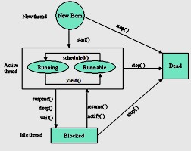
Life Cycle of a Thread
During the life time of the thread, there are many states it can enter. They include the following:
- Newborn state
- Runnable State
- Running State
- Blocked state
- Dead state

Fig 1: Life Cycle of Thread
A thread can always in any one of the five states. It can move from one state to other via variety of ways as shown in the fig.
Newborn State: When we create a thread it is said to be in the new born state. At this state we can do the following:
  - Schedule it for running using the start() method.
  - Kill it using stop() method.

Runnable State: A runnable state means that a thread is ready for execution and waiting for the availability of the processor. That is the thread has joined the queue of the threads for execution. If all the threads have equal priority, then they are given time slots for execution in the round rabin fashion, first-come-first-serve manner. The thread that relinquishes the control will join the queue at the end and again waits for its turn. This is known as time slicing.

Running state: Running state means that the processor has given its time to the thread for it execution. The thread runs until it relinquishes the control or it is preempted by the other higher priority thread. As shown in the Fig 1. a running thread can be preempted using the suspen(), or wait(), or sleep() methods.

Blocked state: A thread is said to be in the blocked state when it is prevented from entering into runnable state and subsequently the running state.

Dead state: Every thread has a life cycle. A running thread ends its life when it has completed execution. It is a natural death. However we also can kill the thread by sending the stop() message to it at any time.

The methods of the Thread class are as follow:

public void run(): is used to perform action for a thread.

public void start(): starts the execution of the thread.JVM calls the run() method on the thread.
public void sleep(long miliseconds): Causes the currently executing thread to sleep (temporarily cease execution) for the specified number of milliseconds.
public void join(): waits for a thread to die.

public void join(long miliseconds): waits for a thread to die for the specified miliseconds.
public int getPriority(): returns the priority of the thread.
public int setPriority(int priority): changes the priority of the thread.
public String getName(): returns the name of the thread.
public void setName(String name): changes the name of the thread.
public Thread currentThread(): returns the reference of currently executing thread.
public int getId(): returns the id of the thread.
public Thread.State getState(): returns the state of the thread.
public boolean isAlive(): tests if the thread is alive.
public void yield(): causes the currently executing thread object to temporarily pause and allow other threads to execute.
public void suspend(): is used to suspend the thread(depricated).
public void resume(): is used to resume the suspended thread(depricated).
public void stop(): is used to stop the thread(depricated).
public boolean isDaemon(): tests if the thread is a daemon thread.
public void setDaemon(boolean b): marks the thread as daemon or user thread.
public void interrupt(): interrupts the thread.
public boolean isInterrupted(): tests if the thread has been interrupted.
public static boolean interrupted(): tests if the current thread has been interrupted.

Multithreading in Java

Every program that we have been writing has at least one thread, that is, the "main" thread. Whenever a program starts executing, the JVM is responsible for creating the main thread and calling "main()" method. Along with this main thread, some other threads are also running to carryout the tasks such as "finalization" and "garbage collection". The thread can either die naturally or be forced to die.

- Thread dies naturally when it exits from the "run()" method.
- Thread can be forced to die by calling "interrupt()" method.

java.lang.Thread package

Creation of Thread in java is very simple task. There is a class called "Thread", which belongs to the "java.lang.Thread" package. This package contains one interface also called "Runnable". Both these contain a common method called "run()" which is the heart of the thread. The run() method would have the following syntax:

Syntax:
public void run()
{
//statement for implementing the thread.
}

Thread Constructors:
- Thread ()-without arguments, default constructor
- Thread(String str)- Thread contains name given as argument

The Main Thread

Every java program has a thread called "main" thread. When the program execution starts, the JVM creates "main" Thread and calls the "main()" method from within that thread. Along with this JVM also creates other threads for the purpose of the Housekeeping task such as "garbage" collection. The "main" thread Spawns the other Threads. These spawned threads are called "Child Threads". The main thread is always is the last thread to finish execution. We, as Programmer can also take control of the main thread, using the method "currentThread()". The main thread can be controlled by this method. We can also change the name of the Thread using the method "setName(String name)".

MainThread.java

Example Program:

class MainThread
{
public static void main(String args[])
{
Thread t=Thread.currentThread(); System.out.println("Name of the Thread is:"+t); t.setName("KSR");
System.out.println("Name of the Thread is:"+t);
}
}
Note: If we want name of the Thread alone, we can write t.getName().

Output:

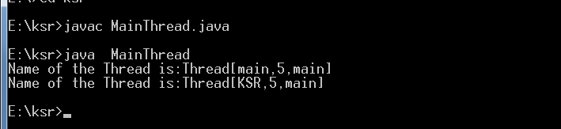

Creation of Threads

Creating the threads in the Java is simple. The threads can be implemented in the form of object that contains a method "run()". The "run()" method is the heart and soul of any thread. It makes up the entire body of the thread and is the only method in which the thread behavior can be implemented. There are two ways to create thread.
- Declare a class that extends the Thread class and override the run() method.
- Declare a class that implements the Runnable interface which contains the run() method

- Creating Thread using The Thread Class

We can make our thread by extending the Thread class of java.lang.Thread class. This gives us access to all the methods of the Thread. It includes the following steps:
- Declare the class as extending the Thread class.
- Override the "run()" method that is responsible for running the thread.
- Create a thread and call the "start()" method to instantiate the Thread Execution.

Declaring the class
TheThread class can be declared as follows: class MyThread extends Thread
{

}

Overriding the method run()
The run() is the method of the Thread. We can override this as follows: public void run()
{

}

Starting the new Thread
To actually to create and run an instance of the thread class, we must write the following:

MyThread a=new MyThread(); // creating the Thread a.start(); // Starting the Thread

Example program:

import java.io.*; import java.lang.*;

ThreadTest.java

class A extends Thread
{
public void run()
{
for(int i=1;i<=5;i++)
{
System.out.println("From Thread A :i="+i);
}
System.out.println("Exit from Thread A");
}
}
class B extends Thread
{
public void run()
{
for(int j=1;j<=5;j++)
{
System.out.println("From Thread B :j="+j);
}
System.out.println("Exit from Thread B");
}
}
class C extends Thread
{
public void run()
{
for(int k=1;k<=5;k++)
{
System.out.println("From Thread C :k="+k);
}
System.out.println("Exit from Thread C");
}
}
class ThreadTest
{
public static void main(String args[])
{
System.out.println("main thread started");
A a=new A();
a.start();
B b=new B(); b.start();
C c=new C(); c.start();
System.out.println("main thread ended");
}
}

output: First Run

First Run | Second Run
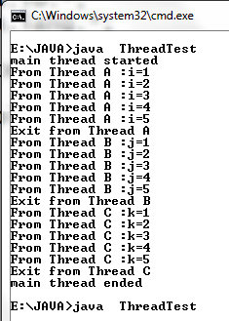 | 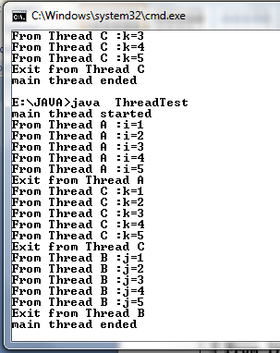

Note: If you observe here, first and second Runs produce different Results. This depends on the Processor availability, speed of the processor, Scheduling algorithms and priority of the threads. If you run this in two different systems they produce different outputs.
- Creating the Thread using Runnable Interface
The Runnable interface contains the run() method that is required for implementing the threads in our program. To do this we must perform the following steps:
Declare a class as implementing the Runnable interface
Implement the run() method
Create a Thread by defining an object that is instantiated from this "runnable" class as the target of the thread
Call the thread's start() method to run the thread.

Example program:
class A implements Runnable
{
public void run()
{
for(int i=1;i<=5;i++)
{
System.out.println("A's i="+i);
}
}
}
class B implements Runnable
{
public void run()
{
for(int i=1;i<=5;i++)
{
System.out.println("B's i="+i);
}
}
}
class RunnableTest
{ public static void main(String args[])
{
A a=new A(); B b=new B();
Thread t1=new Thread(a); //providing runnable object as argument Thread t2=new Thread(b);
t1.start();
t2.start();
}
}
First Run | Second Run
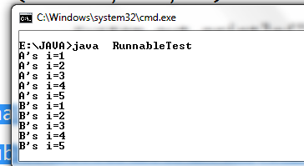 | 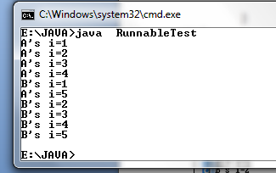
Output: Threads A and B execution by running the above program two times. (You may see a different sequence of Output, every time you run this program)
Which way of creating Thread is better?
Answer: We may get one question, that is which way of creating thread is better. The Answer is, if you want use others methods of the thread, then use Thread super class. If you are interested in only run() method use Runnable interface.

Advantage of the Multithreading
  - It enables you to write very efficient programs that maximizes the CPU utilization and reduces the idle time.
  - Most I/O devices such as network ports, disk drives or the keyboard are much slower than CPU
  - A program will spend much of it time just send and receive the information to or from the devices, which in turn wastes the CPU valuable time.
  - By using the multithreading, your program can perform another task during this idle time.
  - For example, while one part of the program is sending a file over the internet, another part can read the input from the keyboard, while other part can buffer the next block to send.
  - It is possible to run two or more threads in multiprocessor or multi core systems simultaneously.

When a Thread is ended: isAlive() and join() methods
It is often very important to know which thread is ended. This helps to prevent the main from terminating before the child Thread is terminating. To address this problem "Thread" class provides two methods: 1) Thread.isAlive() 2) Thread.join().

The general form of the "isAlive()" method is as follows:

final boolean isAlive();

This method returns the either "TRUE" or "FALSE" . It returns "TRUE" if the thread is alive, returns "FALSE" otherwise.

General form of run() method

public void join();

While isAlive( ) is occasionally useful, the method that you will more commonly use to wait for a thread to finish is called join( ). This method forces the currently running thread to finish it task first.
This method also has another version as follow:

Public void run(milliseconds);
Here, time milliseconds are used to specify the deadline within which the thread has to finish its task, context-switching is done to transfer control otherwise.

Example program: displaying two tables ( 2 and 3 table)
Without join() method | With join() method
class A implements Runnable  {  public void run()  {  for(int i=1;i<=10;i++)  {  System.out.println("2*"+i+"="+(2*i));  }  }  }  class B implements Runnable  {  public void run()  {  for(int j=1;j<=10;j++)  {  System.out.println("3*"+j+"="+(3*j));  }  }  }  class JoinTest  {  public static void main(String args[])  {  A a=new A(); B b=new B();  Thread t1=new Thread(a);  //providing runnable object as argument  Thread t2=new Thread(b); t1.start();  t2.start();  }  } | class A implements Runnable  {  public void run()  {  for(int i=1;i<=10;i++)  {  System.out.println("2*"+i+"="+(2*i));  }  }  }  class B implements Runnable  {  public void run()  {  for(int j=1;j<=10;j++)  {  System.out.println("3*"+j+"="+(3*j));  }  }  }  class JoinTest  {  public static void main(String args[])  {  A a=new A(); B b=new B();  Thread t1=new Thread(a); //providing runnable object as argument  Thread t2=new Thread(b);  Thread t3=new Thread(); //new thread t3 is created, but note starte  //calling isAlive() method System.out.println("Thread t3 is live :"+t3.isAlive()); t1.start();  //calling join() method try  {  t1.join();  }  catch(InterruptedException ie)  {  }  t2.start();  System.out.println("Thread t2 is live :"+t2.isAlive());  }  }
Without join() output | With join() output

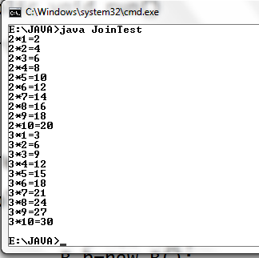 | 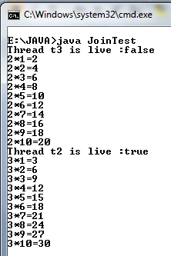
Daemon Thread
Daemon thread is a low priority thread that runs in background to perform tasks such as garbage collection.

Properties:

- They cannot prevent the JVM from exiting when all the user threads finish their execution.
- JVM terminates itself when all user threads finish their execution
- If JVM finds running daemon thread, it terminates the thread and after that shutdown itself. JVM does not care whether Daemon thread is running or not.
- It is an utmost low priority thread.
- When is a user thread is finished, the JVM automatically terminates the Daemon threads.

Methods:

- void setDaemon(boolean status): This method is used to mark the current thread as daemon thread or user thread. For example if I have a user thread tU then tU.setDaemon(true) would make it Daemon thread. On the other hand if I have a Daemon thread tD then by calling tD.setDaemon(false) would make it user thread.

Syntax:

public final void setDaemon(boolean on)

- boolean isDaemon():
This method is used to check that current is daemon. It returns true if the thread is Daemon else it returns false.

Syntax:

public final boolean isDaemon() returns: true or false
class DT extends Thread
{
public void run()
{
for(int i=1;i<=1000;i++)
System.out.println("Daemon i="+i);
}
}
class UD extends Thread
{
public void run()
{
for (int j=1;j<=5;j++) System.out.println("User j="+j);
}
}
class DTest
{
public static void main(String args[])
{
DT d=new DT(); d.setDaemon(true); UD u=new UD(); d.start();
u.start();
} | }

The Thread Priorities

Thread priorities are used by the thread scheduler to decide when and which thread should be allowed to run. In theory, higher-priority threads get more CPU time than lower- priority threads. In practice, the amount of CPU time that a thread gets often depends on several factors besides its priority. (For example, how an operating system implements multitasking can affect the relative availability of CPU time.) A higher-priority thread can also preempts (stops) a lower-priority one. For instance, when a lower-priority thread is running and a higher-priority thread resumes (from sleeping or waiting on I/O, for example), it will preempt the lower priority thread.

To set a thread’s priority, use the setPriority( ) method, which is a member of Thread.

This is its general form:

final void setPriority(int level)

Here, level specifies the new priority setting for the calling thread. The value of level must bewithin the range MIN_PRIORITY and MAX_PRIORITY. Currently, these values are 1 and10, respectively. To return a thread to default priority, specify NORM_PRIORITY, which iscurrently 5. These priorities are defined as static final variables within Thread.

You can obtain the current priority setting by calling the getPriority( ) method of Thread,shown here:

final int getPriority( )

Example Program:

class PThread1 extends Thread
{
public void run()
{
System.out.println(" Child 1 is started");
}
}
class PThread2 extends Thread
{
public void run()
{
System.out.println(" Child 2 is started");
}
}
class PThread3 extends Thread
{
public void run()
{
System.out.println(" Child 3 is started");
}
}

class PTest
{
public static void main(String args[])
{

//setting the priorities to the thread using the setPriority() method
PThread1 pt1=new PThread1(); pt1.setPriority(1);
PThread2 pt2=new PThread2(); pt2.setPriority(9);
PThread3 pt3=new PThread3(); pt3.setPriority(6);
pt1.start();
pt2.start();
pt3.start();
//getting the priority
System.out.println("The pt1 thread priority is :"+pt1.getPriority());
}
}
Note: Of course, the exact output produced by this program depends on the speed of your CPU and the number of other tasks running in the system. When this same program is run under a non preemptive system, different results will be obtained.

Synchronization
When two or more threads need access to a shared resource, they need some way to ensure that the resource will be used by only one thread at a time. The process by which this is achieved is called synchronization.
Key to synchronization is the concept of the monitor (also called a semaphore). A monitor is an object that is used as a mutually exclusive lock, or mutex. Only one thread can own a monitor at a given time. When a thread acquires a lock, it is said to have entered the monitor. All other threads attempting to enter the locked monitor will be suspended until the first thread exits the monitor. These other threads are said to be waiting for the monitor. A thread that owns a monitor can reenter the same monitor if it so desires.

Let us try to understand the problem without synchronization. Here, in the following example two threads are accessing the same resource (object) to print the Table. The Table class contains one method, printTable(int ), which actually prints the table. We are creating two Threads, Thread1 and Thread2, which are using the same instance of the Table Resource (object), to print the table. When one thread is using the resource, no other thread is allowed to access the same resource Table to print the table.

Example without the synchronization

class Table
{
void printTable(int n)
{
//method not synchronized for(int i=1;i<=5;i++)
{

try
{

}

System.out.println(n+"*"+i+"="+(n*i));

Thread.sleep(400);

catch(InterruptedException ie)
{
System.out.println("The Exception is :"+ie);
}
}
//end of the printTable() method
}
}

class MyThread1 extends Thread
{
Table t; MyThread1(Table mt)
{
t=mt;
}
public void run()
{
t.printTable(5);
}
} //end of the Thread1

class MyThread2 extends Thread
{
Table t; MyThread2(Table mt)
{
t=mt;
}
public void run()
{
t.printTable(100);
}
} //end of Thread2

class TestSyn
{
public static void main(String args[])
{
Table tab = new Table();//only one object MyThread1 t1=new MyThread1(tab); MyThread2 t2=new MyThread2(tab); t1.start();
t2.start();
}
}

The output for the above program will be as follow:

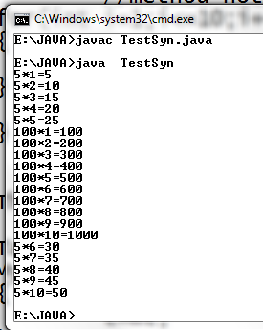
In the above output, it can be observed that both the threads are simultaneously accessing the Table object to print the table.

Using the Java synchronized method

If you declare any method as synchronized, it is known as synchronized method. Synchronized method is used to lock an object for any shared resource. When a thread invokes a synchronized method, it automatically acquires the lock for that object and releases it when the thread completes its task.
The general form of the synchronized method is: synchronized type method_name(para_list)
{
//body of the method
}
where synchronized is the keyword, method contains the type, and method_name represents the name of the method, and para_list indicate the list of the parameters.
Example using the synchronized method

class Table
{
synchronized void printTable(int n)
{
//method not synchronized for(int i=1;i<=10;i++)
{
System.out.println(n+"*"+i+"="+(n*i));
}
//end of the printTable() method
}
}
class MyThread1 extends Thread
{ Table t; MyThread1(Table mt)
{
t=mt;
}
public void run()
{
t.printTable(5);
}
} //end of the Thread1
class MyThread2 extends Thread
{ Table t; MyThread2(Table mt)
{
t=mt;
}
public void run()
{
t.printTable(100);
}
} //end of Thread2 class TestSyn
{
public static void main(String args[])
{
Table tab = new Table();//only one object
MyThread1 t1=new MyThread1(tab); MyThread2 t2=new MyThread2(tab); t1.start();
t2.start();
}
}
Output:
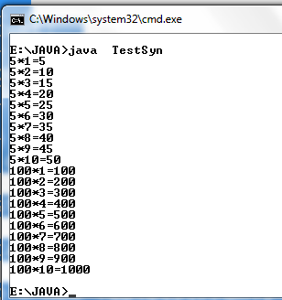

In the above output it can be observed that when Thread1 is accessing the Table object, Thread2 is not allowed to access it. Thread1 preempts the Thread2 from accessing the
printTable() method.

In the above output it can be observed that when Thread1 is accessing the Table object, Thread2 is not allowed to access it. Thread1 preempts the Thread2 from accessing the
printTable() method.
NOTE:
1. This way of communications between the threads competing for same resource is called implicit communication.
2. This has one disadvantage due to polling. The polling wastes the CPU time. To save the CPU time, it is preferred to go to the inter-thread communication.
Inter-Thread Communication
If two or more Threads are communicating with each other, it is called "inter thread" communication. Using the synchronized method, two or more threads can communicate indirectly. Through, synchronized method, each thread always competes for the resource. This way of competing is called polling. The polling wastes the much of the CPU valuable time. The better solution to this problem is, just notify other threads for the resource, when the current thread has finished its task, meanwhile other threads will be doing some useful work. This is explicit communication between the threads.

Java addresses this polling problem, using via wait(), notify(), and notifyAll() methods. These methods are implemented as final methods in Object, so all classes have them. All three methods can be called only from within a synchronized context.

- wait( ) tells the calling thread to give up the monitor and go to sleep until some other thread enters the same monitor and calls notify( ).
- notify( ) wakes up a thread that called wait( ) on the same object.
- notifyAll( ) wakes up all the threads that called wait( ) on the same object. One of the threads will be granted access.

These methods are declared within Object, as shown here:

final void wait( ) throws InterruptedException final void notify( )
final void notifyAll( )
Additional forms of wait( ) exist that allow you to specify a period of time to wait.

Although wait( ) normally waits until notify( ) or notifyAll( ) is called, there is a possibility that in very rare cases the waiting thread could be awakened due to a spurious wakeup. In this case, a waiting thread resumes without notify( ) or notifyAll( ) having been called. (In essence, the thread resumes for no apparent reason.) Because of this remote possibility, Sun recommends that calls to wait( ) should take place within a loop that checks the condition on which the thread is waiting. The following example shows this technique.

Example program for producer and consumer problem: class Q
{
int n;
boolean valueSet = false;//flag

synchronized int get()
{
while(!valueSet) try {
wait();
}
catch(InterruptedException e)
{
System.out.println("InterruptedException caught");
}
System.out.println("Got: " + n);
valueSet = false;
notify();
return n;

} //end of the get() method synchronized void put(int n)
{
while(valueSet) try {
wait();
}
catch(InterruptedException e)
{
System.out.println("InterruptedException caught");
}
this.n = n;
valueSet = true;
System.out.println("Put: " + n);
notify();

}//end of the put method
} //end of the class Q

class Producer implements Runnable
{
Q q; Producer(Q q)
{
this.q = q;
new Thread(this, "Producer").start();
}
public void run()
{
int i = 0;
while(true)
{
q.put(i++);
}
}
}//end of Producer
class Consumer implements Runnable
{
Q q;
Consumer(Q q)
{
this.q = q;
new Thread(this, "Consumer").start();
}
public void run()
{
while(true)
{
q.get();
}
}
}//end of Consumer

class PCFixed
{
public static void main(String args[])
{
Q q = new Q(); new Producer(q); new Consumer(q);
System.out.println("Press Control-C to stop.");
}
}

Suspending, Blocking and StoppingThreads

Whenever we want stop a thread we can stop from running using "stop()" method of thread class. It's general form will be as follows:

Thread.stop();
This method causes a thread to move from running to dead state. A thread will also move to dead state automatically when it reaches the end of its method.
Blocking Thread
A thread can be temporarily suspended or blocked from entering into the runnable and running state by using the following methods:
sleep() —blocked for specified time
suspend() ----blocked until further orders
wait() --blocked until certain condition occurs
These methods cause the thread to go into the blocked state. The thread will return to the runnable state when the specified time is elapsed in the case of sleep(), the resume() method is invoked in the case of suspend(), and the notify() method is called in the case of wait().

Example program:
The following program demonstrates these methods:

// Using suspend() and resume().
TestThread.java
//(1) declare a class
class AThread extends Thread
{
//(2) override run() method public void run()
{
try{
for(int i=1;i<=10;i++)
{
System.out.println("A Thread i ="+i); Thread.sleep(1000);
}
}
catch(Exception e)
{
}
}
}
//(1) declare a class
class BThread extends Thread
{
//(2) override run() method public void run()
{
try{
for(int j=1;j<=10;j++)
{
System.out.println("B Thread j ="+j); Thread.sleep(1000);
}
}
catch(Exception e)
{
}
}
}
class TestThread
{
public static void main(String args[])
{
//(3) create object from above class and call start() method AThread a=new AThread();
BThread b=new BThread();
//call start() method a.start();
b.start();
try
{
Thread.sleep(1000); System.out.println("Thread a is suspending"); a.suspend(); //suspending Thread.sleep(1000); System.out.println("Thread a is Resuming"); a.resume(); // resuming
b.stop(); //stoping
}
catch(Exception e)
{
}
}
}
Thread Exceptions
Note that a call to the sleep() method is always enclosed in try/ catch block. This is necessary because the sleep() method throws an exception, which should be caught. If we fail to catch the exception the program will not compile. The join() method also generates an exception called “InterruptedException”.
It’s general form will be as follows try
{
Thread.sleep(1000);
}
cathc(Exception e)
{ --------

}

Deadlock
Deadlock in java is a part of multithreading. Deadlock can occur in a situation when a thread is waiting for an object lock, that is acquired by another thread and second thread is waiting for an object lock that is acquired by first thread. Since, both threads are waiting for each other to release the lock, the condition is called deadlock.
X
Thread1
Thread2
Y

Here, in the above figure, the resource X is held by Thread1, and at the same time the Thread1 is trying to access the resource which is held by the Thread2. This is causing the circular dependency between two Threads. This is called, Deadlock.
Example program:

public class TestDead
{

TestDead.java

public static void main(String[] args)
{
final String resource1 = "John Gardner"; final String resource2 = "James Gosling";
// t1 tries to lock resource1 then resource2

Thread t1 = new Thread()
{
public void run()
{ //locking the resource synchronized (resource1)
{
System.out.println("Thread 1: locked resource 1");

try {

}

Thread.sleep(100);

catch (Exception e)
{
System.out.println(e);
}

synchronized (resource2)
{
System.out.println("Thread 1: locked resource 2");
}
}
} //end of run()
}; //end of t1

// t2 tries to lock resource2 then resource1 Thread t2 = new Thread()
{
public void run()
{
synchronized (resource2)
{
System.out.println("Thread 2: locked resource 2"); try { Thread.sleep(100);} catch (Exception e) {} synchronized (resource1)
{
System.out.println("Thread 2: locked resource 1");
}
}
}//end of run()
}; //end of t2

t1.start();
t2.start();
}
}

Output:
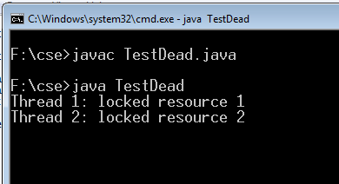
e

