Validations in the Tcode ZDOCSEARCH

Validation 1

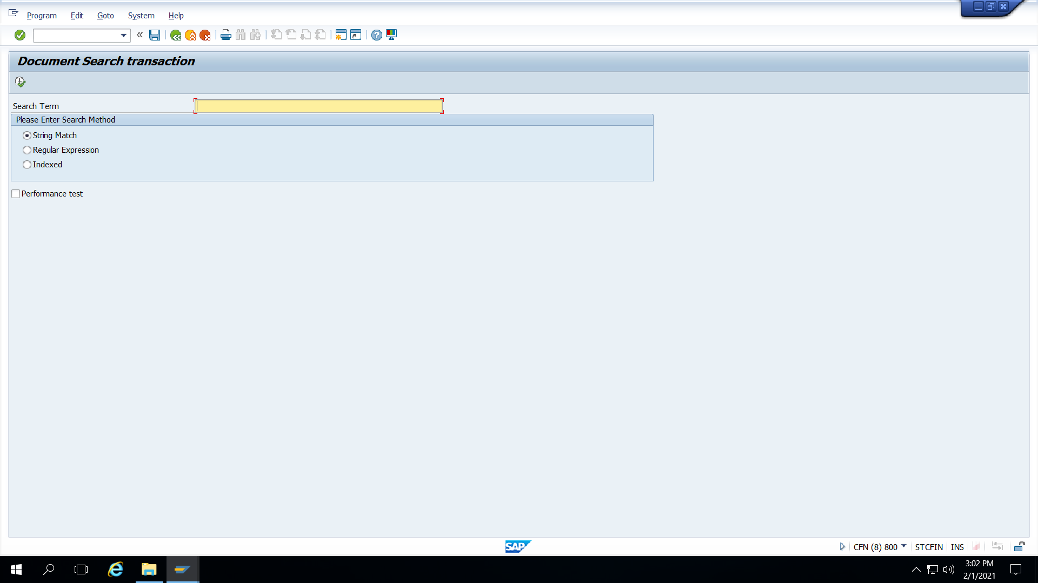

Step 1 : Do not enter Search Term and click on execute

Step 2 : Error message is obtained above

Validation 2

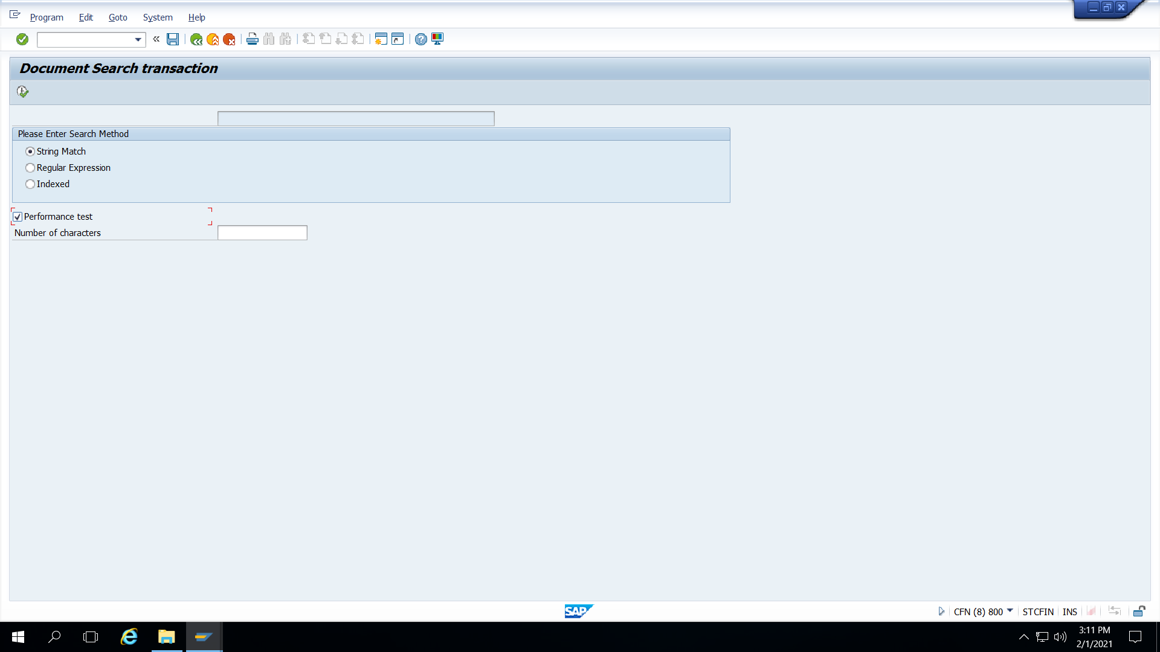

Step 1 : Execute the program with the Performance test checked and the number of characters not entered.



Step 2 : Error message is obtained above.