

HEAVELL.COM

E-Commerce Website



Team: Kickers.

Prashid Pradhan, Adarsh Rauniyar, sagar kafle, jhalak budhathoki

Team Project: Work In Progress

Contents

Belbin Analysis 2

PROJECT PURPOSE 3

HOW TO ACOMPLISH(OBJECTIVE) 3

Project Scope 3

Moscow approach (Requirements) 4

Requirements (Non- Functional) 4

Skill Audit 5

Gantt Chart 6

Communication Tool (Github) 7

Entity Relationship Diagram 8

Use Case Diagram 9

Screen shots 10

Team: Kicker’s

# Belbin Analysis

|  |  |  |  |  |
| --- | --- | --- | --- | --- |
| Members | Primary Role | Secondary Role | Least Likely Role | Role To Improve |
| Prashid Pradhan | Plant,  Co-ordinator | Team Worker,  Monitor Evaluator | Resource Investigator | Resource Investigator |
| Adarsh Rauniyar | Specialist | Shaper | Team worker | Complete finisher |
| Jhalak Budhathoki | Team Worker | Monitor Evaluator | Co-ordinator | Shaper |
| Sagar Kafle | Plant,  Shaper, Implementer | Complete Finisher | Monitor Evaluator | Team Worker |

# PROJECT PURPOSE

To provide the traders and customers of Cleckhuddersfax completely new taste of shopping. the Traders of Cleckhuddersfax will have a unique e-commerce web-portal where the traders can show case their product online for selling purpose and the customers can buy from the traders online.

# HOW TO ACOMPLISH(OBJECTIVE)

* Developing a complete package of e-commerce web-portals integrated with an online payment.
* Accomplishment of Web-Portal by 2016- -

# Project Scope

* Customer can navigate through the product by shop and product type.
* Search facility.
* Online Payment
* Cart facility

# Moscow approach (Requirements)

Customer Interface

* Registration/Log In details
* Cart facility
* Online payment
* Edit account details

Trader Interface

* Add/Update/Remove Products
* Update/Remove Shops

Super Admin Interface

* View/ Add/ Update/ Delete Customers, Traders, Products

# Requirements (Non- Functional)

* Separate user sessions
* Password protection
* Convincing User Interface

# Skill Audit

|  |  |  |  |  |  |  |
| --- | --- | --- | --- | --- | --- | --- |
| Skill | Training For | Level | Training Objective | Training Medium | Time(hrs) | Completion Date |
| HTML | Adarsh, Jhalak | 4 |  |  |  |  |
| PHP | Prashid, Sagar, Adarsh | 4 | Server-side Validation, Mailing Features | Youtube, Tutorials, w3schools.com | 10 | 2016/03/26 |
| CSS | Adarsh, Jhalak | 4 |  |  |  |  |
| JAVASCRIPT | Adarsh, Jhalak | 2 |  |  |  |  |
| PAYMENT GATEWAY INTEGRATION | Sagar | 5 | Addition of E-sewa and Pay pal | Youtube, Tuturial | 5 | 2016/03/27 |
| APEX ORACLE | Sagar, Prashid, Jhalak | 4 | Connection and implementation of trigers | Youtube, Tuturial, docs.oracle.com | 5 | 2016/03/22 |
| TESTING AND EVALUATING | Sagar, Adarsh, Jhalak, Prashid | 5 |  |  |  |  |
| DOCUMENTATION | Sagar, Adarsh, Jhalak, Prashid | 4 |  |  |  |  |

# Gantt Chart

# Communication Tool (Github)

# Entity Relationship Diagram

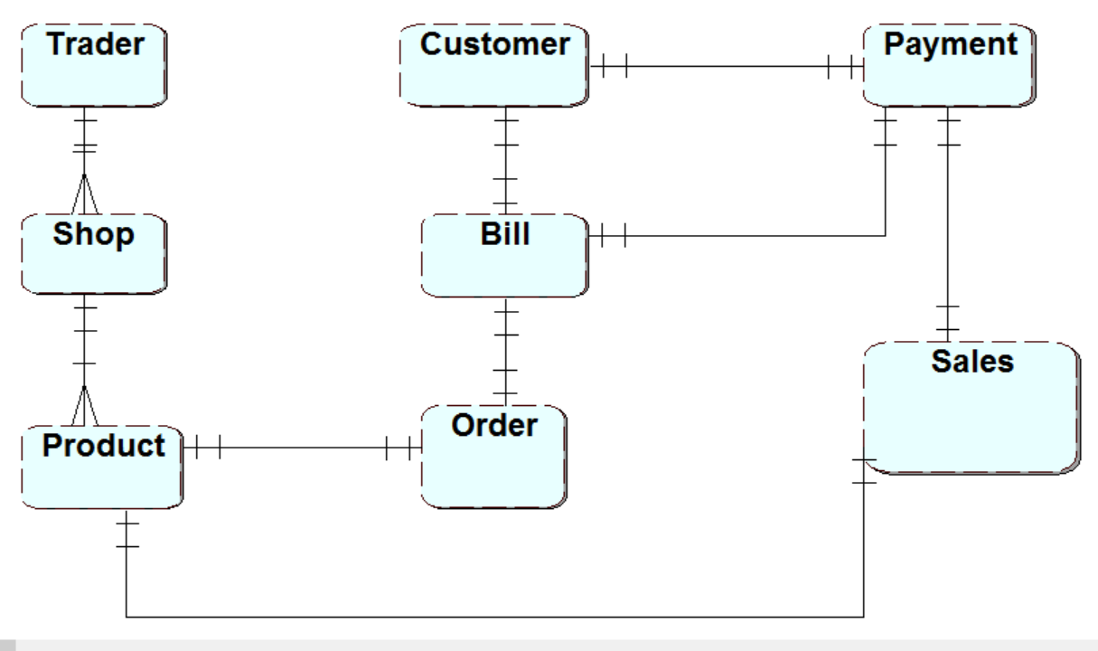

# Use Case Diagram

# Screen shots

Homepage



Browsing Interface



Traders Interface

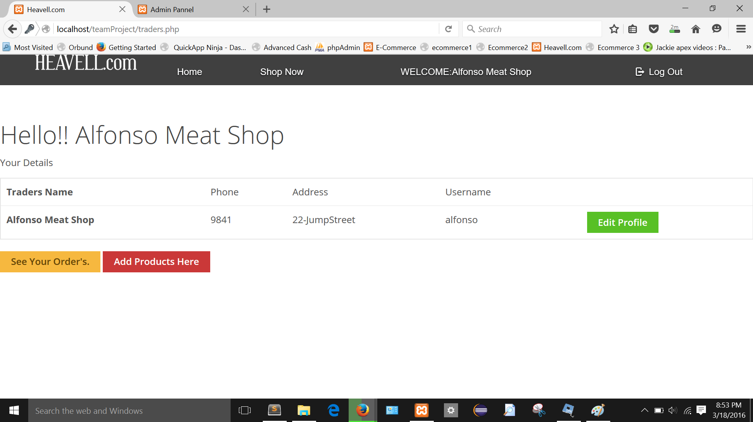

Customer’s Interface

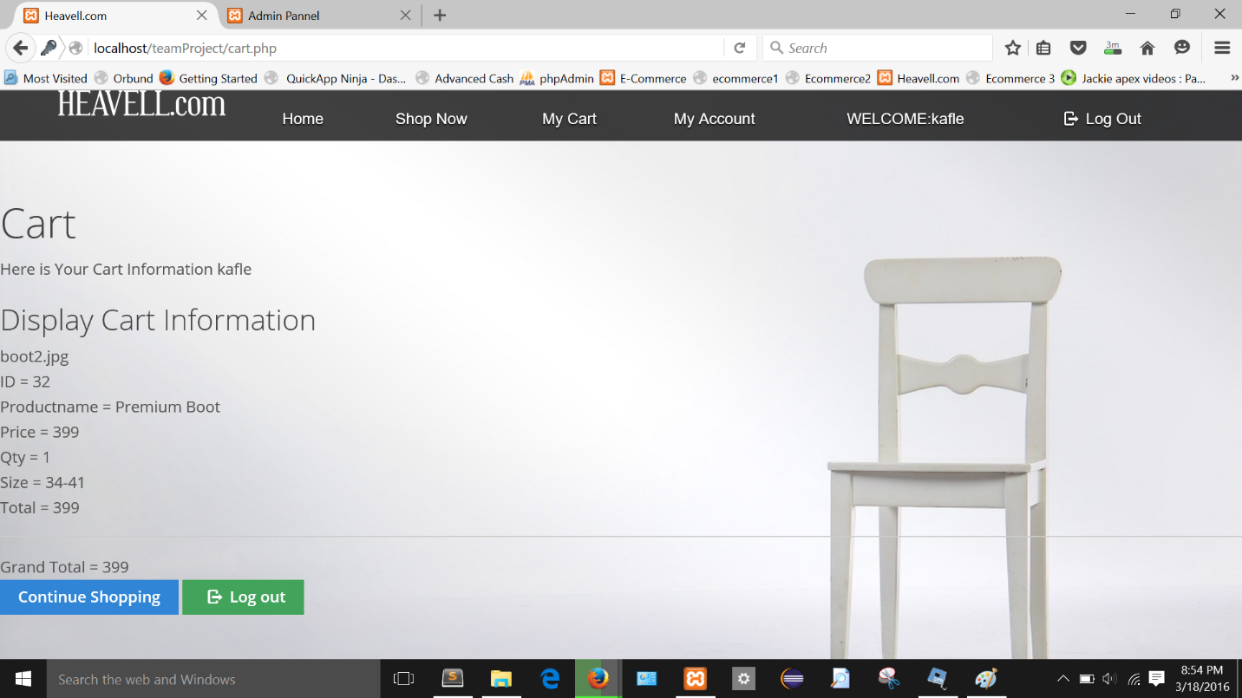

Super Admin Interface

