

Dissertation
Smart Indoor Air Quality Monitor with Mould Risk Prediction

Module Title: Dissertation
Module Code: CSYM023
Supervisor Name: Suraj Ajit
Student Name: Parastoo Shojaei Sarcheshmeh
Student ID: 25828319

Contents
1 Introduction 5
1.1 Problem Definition 5
1.2 Rationale 5
1.3 Research Aim 6
1.4 Research Objectives 6
1.5 Scope and Limitations 6
2 Critical Literature Review 7
2.1 Indoor Air Quality and Health Impacts 7
2.2 Mould Risk in UK Housing: A Policy and Public Health Concern 7
2.3 Mould Growth Prediction Models 7
2.4 Existing Commercial Solutions 8
2.5 Low-cost IoT Sensor Technologies 8
2.6 Gap in the Literature and Research Justification 8
3 Methodology 10
3.1 Research Design 10
3.2 Development Approach 10
3.3 Hardware and Software Design Decisions 10
3.4 Deviations from the Interim Report 10
3.5 Ethical Considerations 11
4 Artefact Development and Implementation 12
4.1 System Architecture 12
4.2 Hardware Design 13
4.2.1 Sensors 14
4.2.2 OLED Display 17
4.2.3 Power Distribution and the RGB LED 19
4.3 Firmware Implementation 19
4.3.1 The Sensor Reading Cycle 20
4.3.2 Translating the ASHRAE/Viitanen Equations into C++ 20
4.3.3 Data Logging 22
4.3.4 Verifying Correct Operation 23
4.4 Web Dashboard Implementation 23
4.4.1 How the Dashboard Is Served 24
4.4.2 The Main Dashboard Page 24
4.4.3 Trend Pages and the Interactive Chart 26
4.4.4 Loading Log Data Efficiently 27
4.4.5 Downloading and Clearing the Log 27
4.4.6 Limitations of the Dashboard 28
4.5 PCB Design 28
4.5.1 Design Overview 28
4.5.2 Power Input and Charging 29
4.5.3 Battery and Voltage Regulation 29
4.5.4 5 V Boost Converter 30
4.5.5 Microcontroller 30
4.5.6 Programming Header and Buttons 32
4.5.7 Sensor Blocks 33
4.5.8 Display and Status LED 34
4.5.9 Passive Components 35
4.5.10 Board Layout 35
4.5.11 Design Review and Checks 36
4.5.12 Power Budget and Battery 37
4.5.13 Cost and Manufacturability 37
4.5.14 Comparison with the Breadboard Prototype and Next Steps 38
4.6 Development Challenges and Solutions 39
4.6.1 Project-Level Challenges 39
4.6.2 Hardware Challenges 39
4.6.3 Firmware Challenges 40
4.6.4 Network and WiFi Challenges 40
4.6.5 Lessons Learned 41
5 Testing and Evaluation 42
5.1 Test Plan 42
5.1.1 Approach 42
5.1.2 Tests and Success Criteria 42
5.1.3 Scope and Limits of the Tests 43
5.2 Algorithm Validation 43
5.2.1 Purpose 43
5.2.2 The Test Dataset 43
5.2.3 Implementations and Procedure 45
5.2.4 Results 45
5.2.5 Comparison with the Published Behaviour 47
5.2.6 Why the Published Model Was Used 47
5.2.7 Discussion and Limits of the Validation 48
5.3 Real-World Testing 48
5.3.1 Test Setup 48
5.3.2 Functional Tests (T5) 48
5.3.3 Extended Run 50
5.3.4 Results 50
5.4 Comparison with the Airthings Wave Mini 52
5.4.1 Setup 52
5.4.2 Temperature and Humidity 52
5.4.3 Mould Risk and VOC at the Same Moment 54
5.4.4 Discussion and Limits 56
5.5 Industry-Expert Evaluation 56
5.5.1 Method 56
5.5.2 Questionnaire Results 57
5.5.3 Comments from the Meeting 57
5.5.4 Use of the Findings 58
5.5.5 Discussion and Limits 58
5.6 Evaluation Against the Objectives 58
5.6.1 Results of the Tests 59
5.6.2 The Six Objectives 59
5.6.3 Overall Evaluation 61
6 Conclusions and Recommendations 62
6.1 Critical Reflection 62
6.1.1 What Worked 62
6.1.2 What Was Difficult 62
6.1.3 What I Would Do Differently 62
6.2 Achievement of the Objectives 63
6.3 Contribution and Limits 63
6.4 Recommendations for Future Work 63
References 65
Appendices 67
Appendix A: Industry Evaluation Questionnaire 67
Appendix B: Periodic Progress Reports 68

1 Introduction

1.1 Problem Definition
People spend about 90% of their time indoors, yet the air inside a building can be two to five times more polluted than the air outside (Cincinelli and Martellini, 2017). One of the most serious indoor risks, and one of the least monitored, is mould. In 2020, two-year-old Awaab Ishak died after long exposure to mould in his home. His death led to the Social Housing (Regulation) Act 2023 and made mould in homes a national issue (Iacobucci, 2022). Since then, the law has become stricter. Awaab's Law came into force for social landlords in England in October 2025, and it says that landlords must investigate and fix damp and mould hazards within fixed timeframes (Shelter England, 2025). The Renters' Rights Act 2025 also allows the government to give private landlords the same duties, but no start date has been set (Russell-Cooke LLP, n.d.).
Even with this growing legal pressure, the tools that landlords and tenants can use are limited. Of the four leading commercial air quality monitors I reviewed for this project (Section 2.4), none combines full air quality monitoring with mould risk prediction. The Airthings Wave Mini is the only one with a mould-risk feature. It works without a mould sensor, but it has no CO2 or PM2.5 sensing at all. The other three measure several air quality values but do not predict mould. This means that landlords and tenants have no affordable way to see a mould risk early enough to act before the mould becomes visible. By then, the harm to health and the cost of repairs have already begun.

1.2 Rationale
The science behind predicting mould risk without a mould sensor is well established. Hukka and Viitanen (1999) present a mathematical model that calculates a mould growth index from surface temperature and relative humidity. The model is based on regression equations from controlled experiments on pine and spruce sapwood. It was later developed further by Viitanen and Ojanen (2007) and is referenced in ASHRAE Standard 160 Addendum e (ASHRAE, 2016). This means that mould risk can, in principle, be estimated from ordinary temperature and humidity readings, without sensing the mould itself.
This is the theoretical foundation of the project. A device placed in a normal room can log temperature and humidity all the time, and the published mould growth equations can turn these readings into a mould risk before any mould is visible. Only cheap, commercially available sensors are needed. My device also measures CO2, VOCs and PM2.5, which fills the market gap described above. It also meets a practical need created by recent UK housing law, because it is a low-cost tool that can help landlords and tenants spot a rising mould risk early, instead of reacting only after damage is visible.
I carried out this project with Mavis Technologies, an industry partner. The company gave me early access to hardware and later evaluated my finished prototype from an industrial and commercial point of view.

1.3 Research Aim
To design, develop and validate a low-cost, autonomous indoor air quality monitor that predicts mould risk from a published scientific model, without needing a dedicated mould sensor.

1.4 Research Objectives
- To review the academic literature on indoor air quality, mould and health, housing policy and mould prediction models, and to find the gaps in current commercial air quality devices.
- To design and build a self-contained hardware and firmware platform around an ESP32 microcontroller, with CO2, temperature, humidity, VOC and PM2.5 sensing, a local web dashboard and on-device status indicators.
- To implement a mould-risk algorithm based on the published ASHRAE/Viitanen mould growth model, which updates continuously from live sensor data.
- To validate the algorithm's implementation independently, and to test the device in real use by comparing it side by side with the Airthings Wave Mini, the closest commercial product.
- To design a custom printed circuit board that turns the breadboard prototype into a compact, low-cost and manufacturable form, and to assess its commercial value with an industry practitioner.
- To reflect critically on the results, document all findings and produce a structured dissertation.

1.5 Scope and Limitations
This project focuses on the design, building and validation of the monitoring device itself. It does not include a large field deployment or a user study with many participants. The mould-risk algorithm uses the air in the room as a stand-in for the surface conditions that the original model needs, and it assumes one generic building material (pine, resawn), because the device cannot know what the walls in a user's home are made of. I discuss these simplifications again in the Methodology and Conclusions chapters.

2 Critical Literature Review

2.1 Indoor Air Quality and Health Impacts
Pollutants such as CO2, particulate matter and VOCs have been linked to breathing problems, heart disease and cancer (Peixe and Marques, 2024), yet most indoor spaces are not monitored at all, so people have no way of knowing when the air around them has become unhealthy.

2.2 Mould Risk in UK Housing: A Policy and Public Health Concern
Mould is a clear example of this problem. Iacobucci (2022) reports that close to 941,000 homes in England had serious damp in 2020, and links exposure to mould with health problems ranging from asthma to allergic respiratory disease.
The law has moved faster than the tools that landlords can use to follow it. Benton (2024) reports that social landlords at a think tank agreed that preventing damp and mould is better than reacting to it, and that monitoring temperature and humidity can support proactive maintenance if landlords act on the data. This gap between what the law requires and what affordable tools can do is the second motivation for this project.

2.3 Mould Growth Prediction Models
The idea that mould risk can be predicted without a mould sensor comes from research at the VTT Technical Research Centre of Finland. Hukka and Viitanen (1999) developed a mathematical model that calculates a mould growth index, on a scale of 0 to 6, from surface temperature and relative humidity. It is based on regression models fitted to controlled experiments on pine and spruce sapwood. Viitanen and Ojanen (2007) later tested other common building materials, such as gypsum board, concrete and fibreboard. They found that the model for wood did not suit all of them, because each material reacts differently, so the growth equation needs its own coefficients for each material.
This model, often called the Finnish or VTT model, is influential enough to sit behind the mould-index criteria in ASHRAE Standard 160, but it has weaknesses. Kopecký and Staněk (2023) note that different mould growth models can disagree even under simple, constant conditions, and that the Finnish model's parameters were fitted to pine and spruce sapwood, so using it on a different surface adds uncertainty.
Even with this limit, the Finnish/ASHRAE model is still seen as the state of the art in dynamic mould growth modelling (Kopecký and Staněk, 2023).

2.4 Existing Commercial Solutions
I reviewed four commercial indoor air quality monitors for this project, namely the Airthings Wave Mini, the Qingping Air Monitor Pro Gen 2, the Aranet4 HOME and the AirGradient ONE.
The Qingping, Aranet4 HOME and AirGradient ONE measure several air quality values well, but treat mould risk as outside their scope, and none advertises a mould-risk feature (Air Purifier First, n.d.; Aranet, n.d.; Open Source Hardware Association, 2024).
The Airthings Wave Mini is the exception, and it is also the closest match to this project. Instead of a mould sensor, it works out a mould-risk reading as a "virtual" fourth measurement from its temperature and humidity readings (Airthings, 2022). Its equations are not published, so nobody can check them, repeat them or judge them critically. This is a clear difference from this project, where the exact published equations (Hukka and Viitanen, 1999; Viitanen and Ojanen, 2007) are used and fully open. The manufacturer's manual also lists practical limits: the device must be placed within about 40cm of the area of concern, since it "does not estimate mould risk in areas more than approximately 15in (or 40cm) from the device" (Airthings, 2022), so it covers one small area rather than a whole room. Continuous logging and CSV export need a separate Hub accessory, priced at about £57.50 excluding VAT (TJR Ventilation Solutions, n.d.); without it, the monitor only uploads readings when the phone app is within Bluetooth range. CO2 and PM2.5 sensing are not included at all.
Even the closest commercial product offers its mould-risk feature only by giving up broader sensing and whole-room coverage, and by not publishing its equations. None of the four devices reviewed combines full air quality sensing, a transparent mould-risk model and autonomous whole-room logging in one device.

2.5 Low-cost IoT Sensor Technologies
Besides what to measure, there is the question of whether it can be measured cheaply and reliably. Peixe and Marques (2024) carried out a systematic review of low-cost IoT air quality monitoring systems. They conclude that these systems can give useful, at least qualitative, information at a fraction of the cost of reference-grade instruments. They also flag sensor calibration and energy use as the main remaining challenges, since a wrongly calibrated sensor cannot give trustworthy measurements. In the 17 systems they reviewed, CO2, particulate matter, temperature and humidity were the most monitored parameters, and mould was not monitored at all.

2.6 Gap in the Literature and Research Justification
The literature and the commercial market point to the same gap from two directions. The science of mould growth is well established but rarely built into products in an open way. None of the products reviewed here combines full air quality sensing with a disclosed, whole-room mould-risk model, and the 17 low-cost IoT systems reviewed by Peixe and Marques (2024) did not monitor mould at all.
This project does not propose a new mould growth formula, because that science already exists (Hukka and Viitanen, 1999; Viitanen and Ojanen, 2007). My contribution is better described as a software engineering one. I translated the published model, including its logarithmic and exponential growth-rate equations, directly into embedded C++ firmware. This firmware runs the calculation continuously, in real time, from live sensor data on a low-cost microcontroller, alongside independent CO2, VOC and PM2.5 sensing. Within the literature and products reviewed in this chapter, I found no other openly documented and repeatable implementation of the model in a consumer device. This is different from the Wave Mini, whose equations are not published.

3 Methodology

3.1 Research Design
This project follows a Design Science Research (DSR) approach, as defined by Hevner et al. (2004). They describe design science as creating and testing new artefacts, such as constructs, models, methods or instantiations, to solve real-world problems. Unlike behavioural science, which tries to explain or predict human or organisational behaviour, design science aims to build something that works and to show that it does. This suits the project, because its main result is a working device and not only a theoretical contribution.

3.2 Development Approach
I developed the system step by step, in an incremental, agile-style process. I built and tested one capability at a time instead of trying to build the whole system at once, and I checked each stage before I added the next. I set up and tested the ESP32 platform and its individual sensors first, then built a working web dashboard with placeholder values, then added live sensor integration, then persistent data logging, and only then the mould-risk algorithm itself. This order was deliberate. When a fault appeared, the number of parts that could be responsible was always small, so I could find and fix faults much more easily.

3.3 Hardware and Software Design Decisions
The finished system is built around a single ESP32 microcontroller. It handles sensor reading, the mould-risk calculation, data logging and a self-hosted web dashboard, all from one low-cost, low-power device. I decided to host the dashboard on the device itself, with no cloud service or app, because of the literature I reviewed in Chapter 2. Peixe and Marques (2024) found that most low-cost IoT air quality systems store data in the cloud, so they depend on outside services. A fully self-hosted, autonomous device avoids this dependency completely.

3.4 Deviations from the Interim Report
Dual-board architecture to an independent ESP32 system. My interim plan was to build on an existing Mavis Technologies hardware platform, with a separate ESP32 board added for the features it lacked. During development, debug access to the Mavis board proved to be locked at firmware level, most likely through read-out protection, so after discussing this with the industry partner I decided to build a fully independent ESP32-based system instead.
MQTT and a separate web application to a self-hosted local dashboard. My interim report proposed sending data by MQTT to a companion web application. Once I moved to an independent microcontroller, hosting the dashboard on the device itself was simpler and more robust, removing the need for external hosting or a message broker and keeping the system self-contained.
Hourly algorithm updates to continuous, time-scaled updates. My interim report proposed recalculating mould risk once per hour. The system I built instead runs continuously, calculating growth or decline from the real time between readings, because the original equations are defined in terms of continuous exposure time, and this avoids the approximation error a fixed time step would add.

3.5 Ethical Considerations
As in my interim report, this project does not involve vulnerable groups or the collection of personal data. The only human input was a evaluation of my finished prototype by an industry expert. Ethical issues are therefore limited to intellectual property, academic integrity, responsible handling of equipment and fair use of the expert's feedback.
Intellectual Property. The existing Mavis Technologies hardware and firmware remain the property of the company. I did not copy, change or share any confidential company material. I built my independent ESP32-based system entirely separately, using only openly available components and libraries. I agreed this arrangement with the industry partner before the project began.
Data Privacy. All data collected is environmental, namely temperature, humidity, CO2, VOC and PM2.5 readings. No personally identifiable information is collected or stored at any point, and the web dashboard needs no user accounts.
Equipment and Safety. After I moved to an independent ESP32-based platform, I did all the hardware assembly, firmware development and testing myself, and not at the Mavis Technologies facility as first planned. I handled and disposed of electronic components responsibly, in line with WEEE regulations.
Use of AI Tools. I used AI tools to help debug firmware problems.

4 Artefact Development and Implementation

4.1 System Architecture
The finished system is a single, self-contained device built around an ESP32 microcontroller (a Freenove ESP32 Dev Board with a dual-core 240MHz Xtensa LX6 processor and 4MB of flash). The ESP32 handles all of these tasks. It reads all the sensors, runs the mould-risk calculation, stores the data and serves a live web dashboard, without any external server, cloud service or companion app.
The three sensors connect to the ESP32 in two different ways, depending on what each sensor supports. The SCD40 (CO2) and the BME688 (temperature, humidity and VOC) share one I2C bus. This bus uses the ESP32's default I2C pins (GPIO21 for SDA and GPIO22 for SCL), and the two sensors have the addresses 0x62 and 0x76. The 128×64 pixel SSD1306 OLED display sits on the same bus at address 0x3C. All three I2C devices are therefore wired in parallel on the same two lines, and each has its own fixed address so that they do not clash. The PMS5003 (PM2.5) sensor only supports UART, so it uses a dedicated hardware serial port on the ESP32 (GPIO16 as RX and GPIO17 as TX) at the sensor's fixed baud rate of 9600.
Inside the firmware, everything is organised around one sensor-reading cycle. Every five seconds, the device reads all three sensor interfaces, updates the mould-risk calculation with the new temperature and humidity, and refreshes the OLED display and the RGB LED. Every 30 seconds, it also adds a new line to a CSV log file stored in the ESP32's internal flash memory, using the LittleFS filesystem. The five-second interval matches the SCD40's own measurement period. It is also short enough to follow fast changes, such as a shower raising the humidity within minutes, without over-sampling sensors whose readings change slowly.
The dashboard is served by the ESP32 itself, so no data is sent to any third party. Readings are only shown to devices on the same network that open the dashboard or download the CSV file, and the only outgoing internet requests are for time synchronisation. Figure 4.1 summarises this architecture.
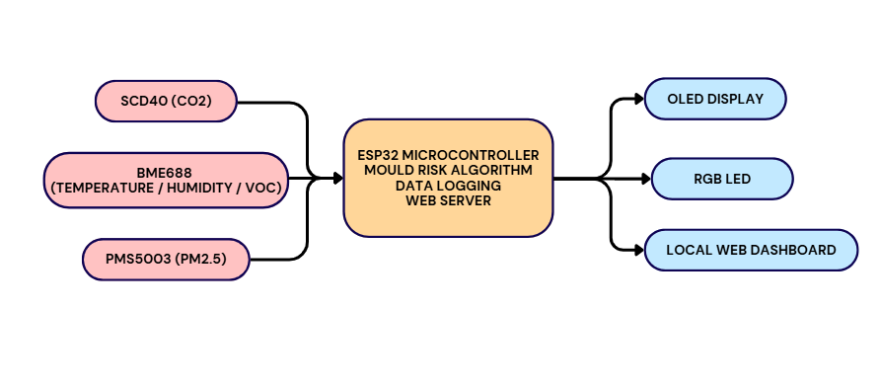
Figure 4.1: System architecture: three sensors feed the ESP32, which drives the OLED display, the RGB LED and the web dashboard.

4.2 Hardware Design
The breadboard prototype puts the ESP32 and all three sensors on one shared power rail. The OLED display and the RGB LED are wired next to them for output on the device. Figure 4.2 shows the complete assembly.
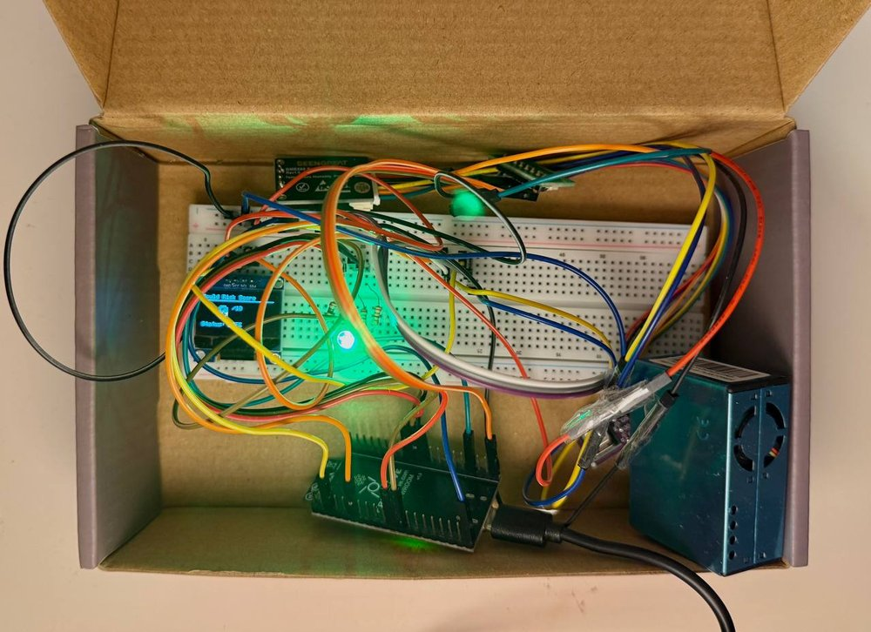
Figure 4.2: The complete breadboard assembly
The ESP32 board is a Freenove ESP32-WROOM board, built around the ESP32-WROOM-32E module. It was chosen over other microcontrollers because one low-cost board gives a dual-core 240MHz processor, built-in WiFi and enough GPIO pins for I2C, UART and digital outputs at the same time. This removes the need for a separate WiFi module or external radio.
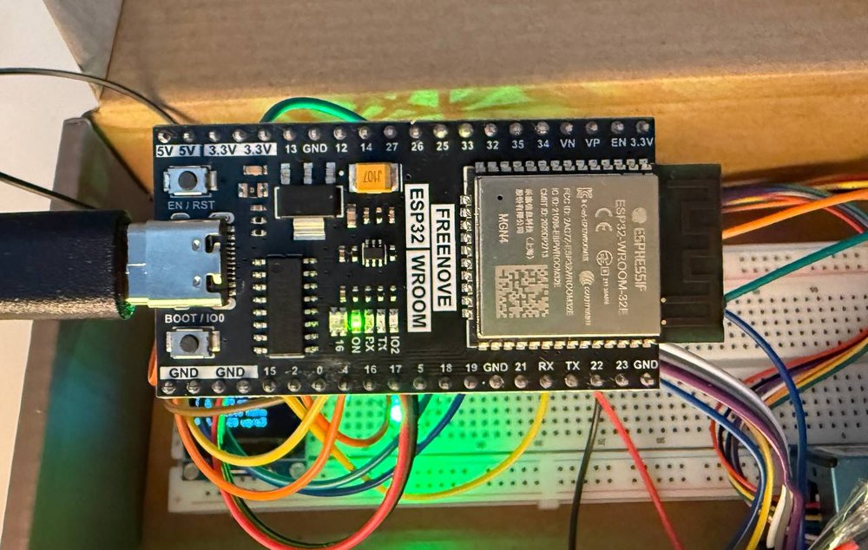
Figure 4.3: ESP32-WROOM development board used as the central microcontroller.

4.2.1 Sensors

SCD40 (CO2)
The SCD40 (Figure 4.4) is a photoacoustic NDIR (non-dispersive infrared) CO2 sensor from Sensirion. NDIR sensing was chosen over cheaper electrochemical sensors because it usually drifts less and ages more slowly, although it still needs calibration (see Section 4.6). CO2 was included as a general sign of ventilation. A consistently high CO2 level suggests that a room is poorly ventilated, and that is also when humidity, and therefore mould risk, is most likely to build up.
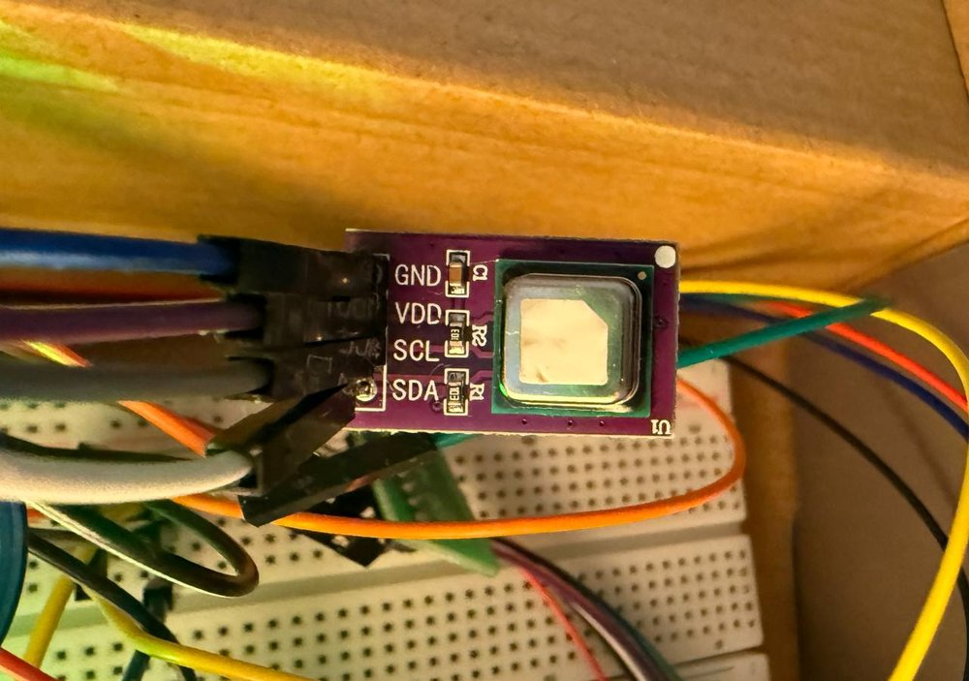
Figure 4.4: The SCD40 CO2 sensor breakout board, connected via its four-pin I2C interface (VDD, GND, SCL, SDA).

BME688 (Temperature, Humidity, VOC)
The BME688 (Figure 4.5) is a Bosch environmental sensor that measures four things in one package, namely temperature, humidity, barometric pressure and gas resistance, which is used as a stand-in for VOC concentration. It was chosen mainly because temperature and relative humidity are the two direct inputs to the mould-risk algorithm (Section 4.3.2). Their accuracy and update rate therefore decide how accurate the algorithm's output is. The BME688 also gives VOC sensing from the same package, so no separate sensor was needed. In the firmware, it is read through the Adafruit BME680 library.
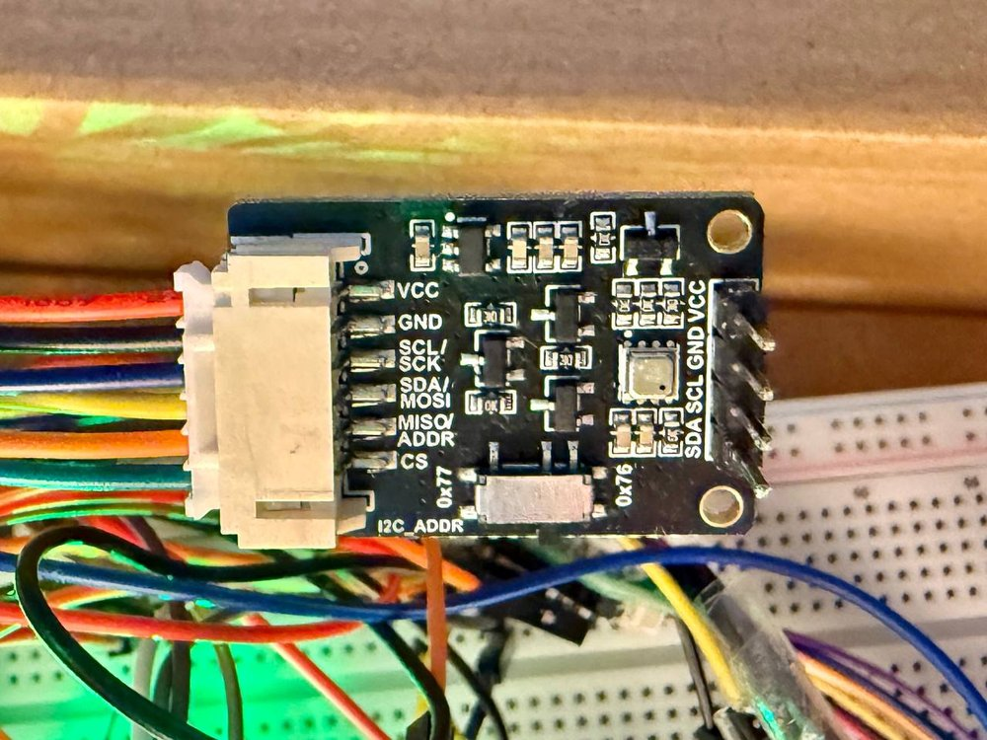
Figure 4.5: The BME688 breakout board

PMS5003 (PM2.5)
The PMS5003 (Figures 4.6 and 4.7) is a laser-scattering particulate matter sensor from Plantower. A small fan draws air through its chamber and a laser shines across the airstream. Particles that pass through the beam scatter light in proportion to their size and number, and the sensor's processor turns this into PM1.0, PM2.5 and PM10 values. It was included because particulate matter matters for health and is not covered by the Airthings Wave Mini or by the CO2, VOC and humidity sensors already in the system.
Unlike the other three I2C devices, the PMS5003 uses UART (serial). It connects to the ESP32 through a small adapter board (Figure 4.8) that breaks its own connector out into separate pins (VCC, GND, SET, TXD, RXD and RST).
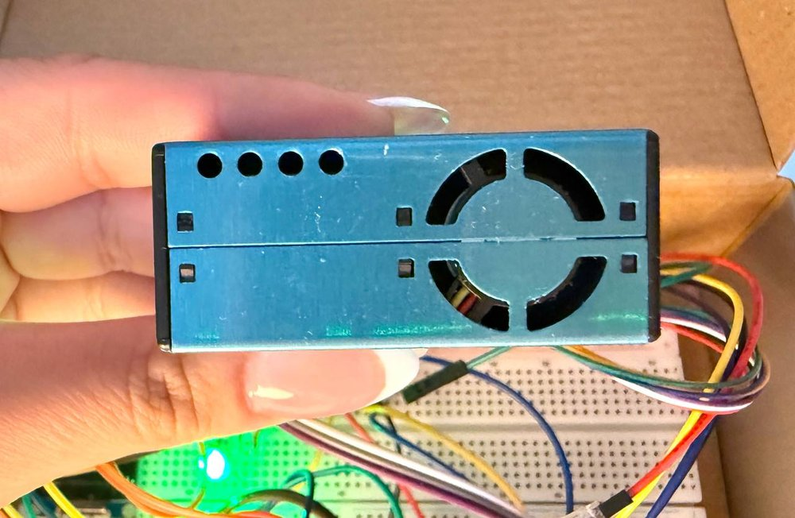
Figure 4.6: The PMS5003 PM2.5 sensor
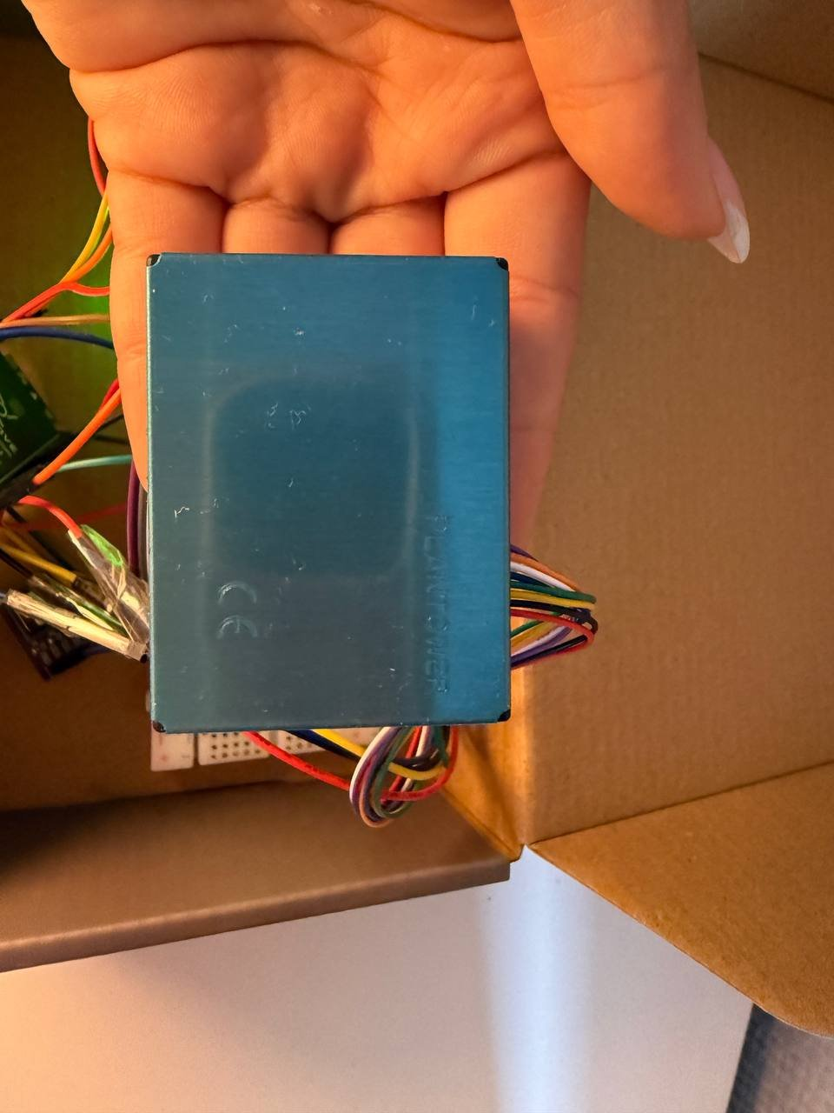
Figure 4.7: The PMS5003 sensor's panel
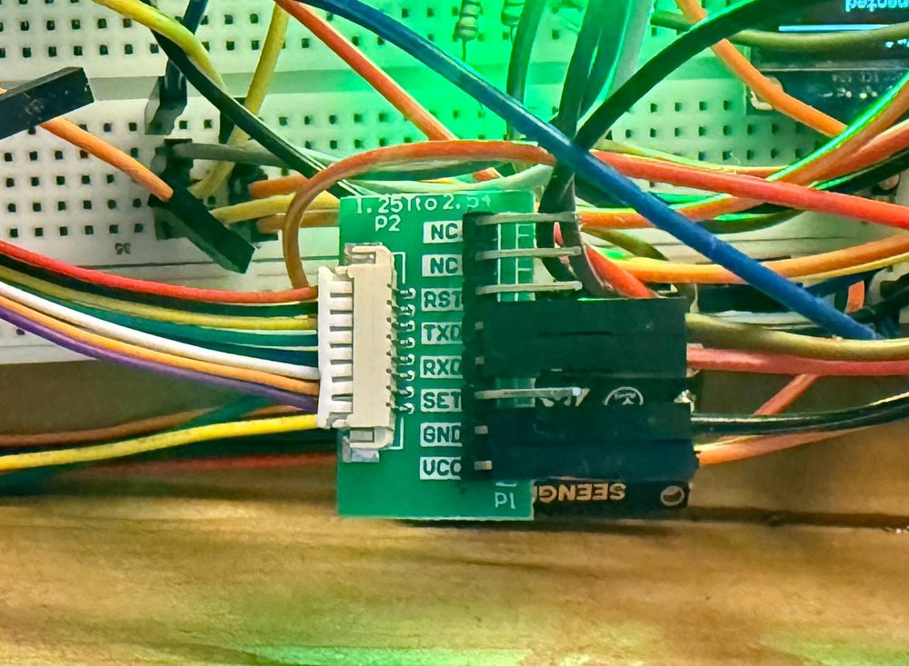
Figure 4.8: The PMS5003 UART adapter board, exposing the VCC, GND, SET, TXD, RXD and RST pins.

4.2.2 OLED Display
The 128×64 pixel SSD1306 OLED display lets the device show its status without a phone, a laptop or even a WiFi connection. This matters for a device that is meant to be checked at a glance. The screen is small, so instead of showing everything at once, the firmware switches between three pages every few seconds.
The first page (Figure 4.9) shows the five live sensor readings that fit comfortably on the display, namely temperature, humidity, CO2, the BME688's raw gas resistance and PM2.5. The second page (Figure 4.11) shows the current mould-risk score out of 10 and a plain-text status (SAFE, CAUTION or HIGH RISK). This is the most important number the device produces. The third page (Figure 4.10) shows the network status. It says whether WiFi is connected, gives the device's current IP address (needed to open the dashboard from another device on the same network), and shows a one-word OK or ERR status for each of the three sensors.
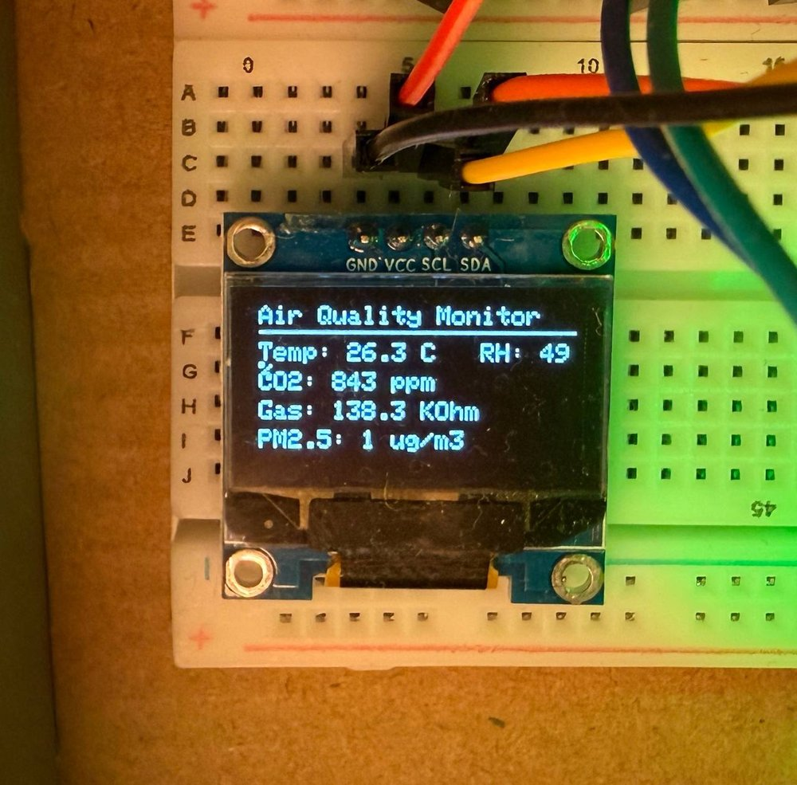
Figure 4.9: OLED page 1: live sensor readings (temperature, humidity, CO2, gas resistance, PM2.5).
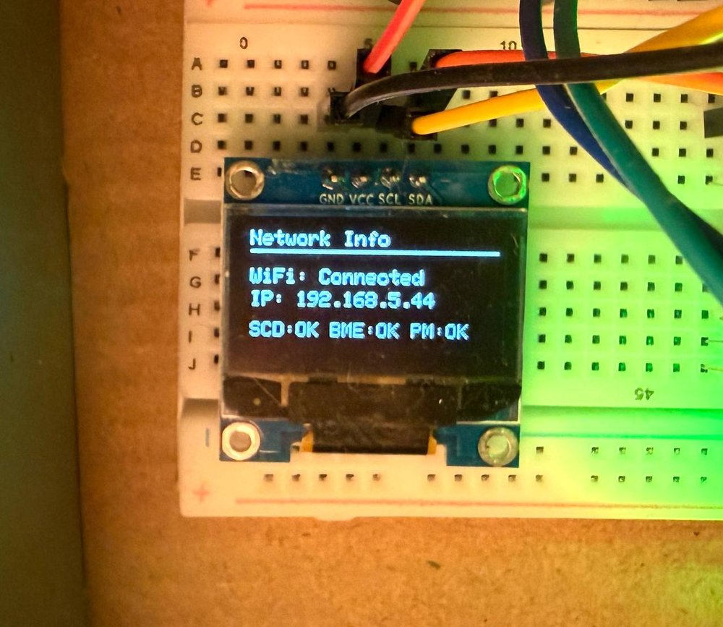
Figure 4.10: OLED page 3: network status, showing the device's WiFi connection, IP address, and per-sensor OK/ERR status.
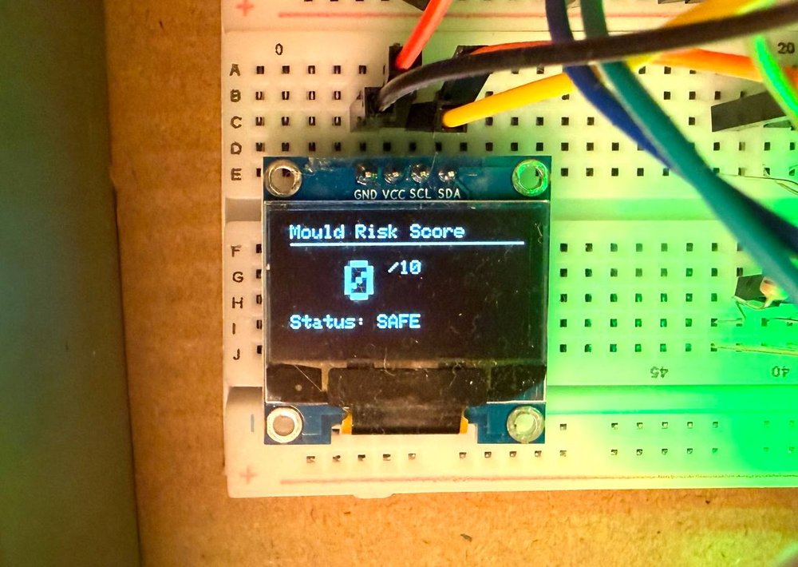
Figure 4.11: OLED page 2: the current mould-risk score (0-10) and status.

4.2.3 Power Distribution and the RGB LED
Everything is powered from the ESP32 board's 3.3V regulator and shares a common ground rail, with one exception. The PMS5003 needs 4.5–5.5V to work reliably, so it is powered from the board's separate 5V pin and not from the shared 3.3V rail. This is why the PCB design (Section 4.5) needs a dedicated boost converter to make a stable 5V supply from a single-cell LiPo battery.
The RGB LED is wired directly to three ESP32 GPIO pins (GPIO25, GPIO26 and GPIO27), one for each colour. Each channel goes through a current-limiting resistor to protect the LED. The firmware sets the pins high or low in different combinations to show the three status colours used across the device, namely green for a safe mould-risk score, yellow for caution and red for high risk.

4.3 Firmware Implementation
The firmware runs on the ESP32 using the Arduino framework (C/C++).

4.3.1 The Sensor Reading Cycle
The main loop() function is deliberately short. On every pass it calls the web server's request handler, so the dashboard always responds quickly, and it checks two separate timers. One timer triggers a full sensor read every 5 seconds, and the other triggers an OLED page change every 3 seconds. The two timers run independently, so the display can change pages at its own pace whatever the sensor reading schedule is.
Using millis() comparisons instead of delay() calls is important here, because a delay() would block the whole program, including the web server, for as long as it lasts.
The readSensors() function reads each sensor in turn, using each library's own interface. It only updates the matching global variable if the read worked, and otherwise it keeps the previous value.
This approach of trying each sensor separately and keeping the previous value matters for reliability. For example, if the PMS5003 sometimes returns no data, the other readings and the mould-risk calculation continue to use the sensors that did respond.

4.3.2 Translating the ASHRAE/Viitanen Equations into C++
The mould-risk algorithm is the most important part of the firmware. The equations (reviewed in Chapter 2) are reproduced exactly as published by Hukka and Viitanen (1999) and Viitanen and Ojanen (2007), with no simplification. Most equations were written as their own function, for clarity and so that they could be tested separately.
Equation 1 calculates the critical relative humidity, RHcrit, below which no mould growth can occur at all at a given temperature:
float calculateRHcrit(float tempC) {
if (tempC <= 20.0) {
return -0.00267 * tempC * tempC * tempC
+ 0.160 * tempC * tempC
- 3.13 * tempC + 100.0;
} else {
return 80.0;
}
}
This is written as a direct cubic polynomial in temperature, which matches the published curve exactly (Figure 1 in Hukka and Viitanen, 1999). Above 20°C, the paper gives a constant value of 80%, so the function switches to that value instead of extending the polynomial beyond the range it was fitted to.
Equation 2 calculates Mmax, the highest mould index that current conditions could ever produce, however long they persist:
float calculateMmax(float RH, float rhCrit) {
if (rhCrit >= 100.0) return 6.0;
float ratio = (rhCrit - RH) / (rhCrit - 100.0);
float mmax = 1.0 + 7.0 * ratio - 2.0 * ratio * ratio;
if (mmax < 0) mmax = 0;
if (mmax > 6.0) mmax = 6.0;
return mmax;
}
Equations 3, 5 and 6 (the response-time functions tm and tv, and the correction factor k1) are combined inside the main calculateMouldRisk() function, together with the growth equation (Equation 8) and the decline equation (Equation 9). They are only ever used together, and never on their own elsewhere in the firmware:
void calculateMouldRisk() {
unsigned long nowMillis = millis();
double elapsedHours;
if (lastMouldUpdateMillis == 0) {
elapsedHours = 5.0 / 3600.0;
} else {
elapsedHours = (nowMillis - lastMouldUpdateMillis) / 3600000.0;
}
lastMouldUpdateMillis = nowMillis;

float rhCrit = calculateRHcrit(currentTemp);

if (currentHumidity > rhCrit && currentTemp > 0) {
dryStreakHours = 0.0;

float mmax = calculateMmax(currentHumidity, rhCrit);
float k1 = calculateK1(mouldIndex, currentTemp, currentHumidity);
float k2 = 1.0 - exp(2.3 * (mouldIndex - mmax));
if (k2 < 0) k2 = 0;

float lnT = log(currentTemp);
float lnRH = log(currentHumidity);
float exponent = -0.68*lnT - 13.9*lnRH
+ 0.14*MATERIAL_W - 0.33*MATERIAL_SQ + 66.02;
float denom = 7.0 * exp(exponent);

float dM_perDay = (denom > 0) ? (k1 * k2 / denom) : 0.0;
float dM_perHour = dM_perDay / 24.0;

mouldIndex += dM_perHour * elapsedHours;
} else {
dryStreakHours += elapsedHours;
float dM_perHour;
if (dryStreakHours <= 6.0) dM_perHour = -0.032 / 24.0;
else if (dryStreakHours <= 24.0) dM_perHour = 0.0;
else dM_perHour = -0.016 / 24.0;
mouldIndex += dM_perHour * elapsedHours;
}

if (mouldIndex < 0) mouldIndex = 0;
if (mouldIndex > 6.0) mouldIndex = 6.0;
mouldScore = (int)round(mouldIndex * 10.0 / 6.0);
}
Several specific engineering decisions in this function are worth explaining in detail:
Real elapsed time, not a fixed step. elapsedHours is worked out from the real number of milliseconds since the last update (nowMillis - lastMouldUpdateMillis), converted to hours. It does not assume a fixed interval, such as one reading being one hour. The published equations are defined in terms of continuous exposure time, so this follows the model more faithfully than a fixed-step approximation would.
Division-by-zero guards. The line float denom = (tv/tm) - 1.0; inside calculateK1() (Listing 4.4) could reach zero or a negative value for some temperature and humidity combinations. Then 2.0/denom would be infinite or negative, which makes no physical sense. The guard if (denom <= 0) return 1.0; avoids this. It falls back to a neutral correction factor (k1 = 1, meaning no correction) whenever the equation's own assumptions are not met, so an invalid number never reaches the mould index.
float calculateK1(float M, float T, float RH) {
if (M < 1.0) return 1.0;
float tm = calculateTm(T, RH);
float tv = calculateTv(T, RH);
float denom = (tv / tm) - 1.0;
if (denom <= 0) return 1.0;
return 2.0 / denom;
}
Unit conversion (days to hours). The published growth equation gives a rate in mould-index units per day (the factor of 7 in the equation turns the time to reach M = 1, given in weeks, into days). The firmware updates far more often than once a day, so this rate is divided by 24 to get a rate per hour, and only then multiplied by the real elapsed hours calculated above.
Clamping the final result. mouldIndex is kept inside the valid 0–6 range after every update. It is also converted to the 0–10 score used by the dashboard and the RGB LED (mouldIndex * 10.0 / 6.0). Keeping two scales, the model's own 0–6 index and a simpler 0–10 score for the user, means the internal calculation always matches the published model exactly, while the score shown to the user stays easy to understand.

4.3.3 Data Logging
Sensor readings are logged to a CSV file in the ESP32's internal flash storage, using the LittleFS filesystem. This means the device keeps its history after a power loss or restart, and no SD card or other external storage is needed.
Two design decisions deal with the limits of an embedded platform. First, a file size check (sz > LOG_MAX_BYTES) stops the log filling the ESP32's flash: once larger than 1MB it is deleted and restarted with a fresh header, trading long-term history for a guarantee that the device keeps working. Second, sensor reads and log writes run on separate timers (Section 4.3.1): sensors are read every 5 seconds so the algorithm always has fresh data, but a log line is written only every 30 seconds, since logging every read would fill the size limit six times faster without helping the calculation, which uses live values in memory rather than reading them back from the log.
Timestamps come from getTimestamp(). It uses the ESP32's network-synchronised (NTP) clock once it is available. Until the time sync is done, it uses a label based on how long the device has been running (for example uptime_123s). This way, every row has some usable time reference, even before WiFi has connected.

4.3.4 Verifying Correct Operation
The firmware prints detailed diagnostic messages to the serial console during start-up. These were used all through development to check that each subsystem worked before moving on to the next. Figure 4.12 shows the SCD40 starting up successfully, followed by the WiFi hotspot scan beginning. Figure 4.13 shows the scan finishing, a successful connection, time synchronisation and the web server starting. This confirms that every subsystem described in this section starts correctly on a real device,.
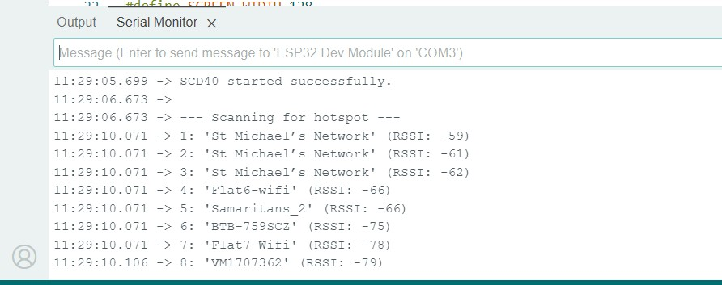
Figure 4.12: Serial console output: SCD40 initialising successfully, followed by the start of the WiFi hotspot scan.
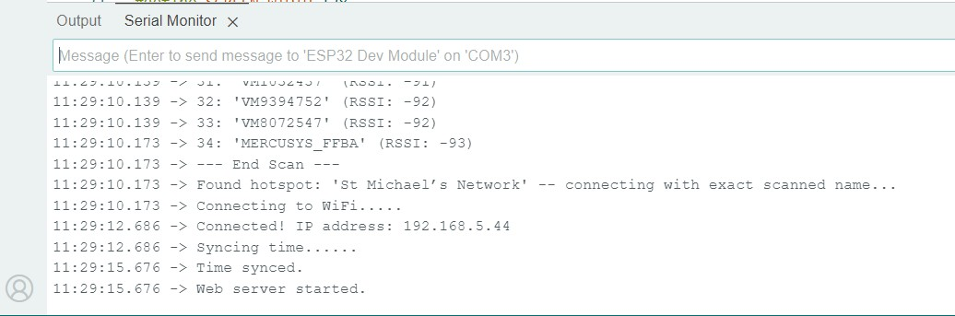
Figure 4.13: Serial console output continued: the hotspot scan completing, a successful WiFi connection, time synchronisation, and the web server starting.

4.4 Web Dashboard Implementation
The web dashboard is how a user actually sees what the device measures. It runs on the ESP32 itself, so there is nothing to install and no account to create. A phone, tablet or laptop on the same WiFi network only needs a browser and the device’s IP address, which is shown on the third OLED page (Section 4.2).

4.4.1 How the Dashboard Is Served
The firmware starts a WebServer on port 80 with four routes, namely / for the main dashboard, /trend for the history charts, /download for the CSV log and /clearlog to empty it. The server is handled in the main loop next to the sensor timers (Section 4.3.1). Each page is built as a text string in the firmware, with its CSS, SVG graphics and small JavaScript parts written inside the same page. No external libraries, fonts or images are loaded, so the dashboard still works if the WiFi network has no internet connection. The layout is a single column on a phone and switches to up to four tiles per row on a wider screen (Figures 4.14 and 4.16). The main page reloads itself every five seconds.

4.4.2 The Main Dashboard Page
The top of the page is a circular gauge showing the mould-risk score out of 10 (Figure 4.14). The ring fills as the score rises and uses the same three colour bands as the RGB LED, namely green for 0–3, amber for 4–6 and red for 7–10. Under it, a status label (SAFE, CAUTION or HIGH RISK) tells the user what to do, such as ventilating the room when the score is high.
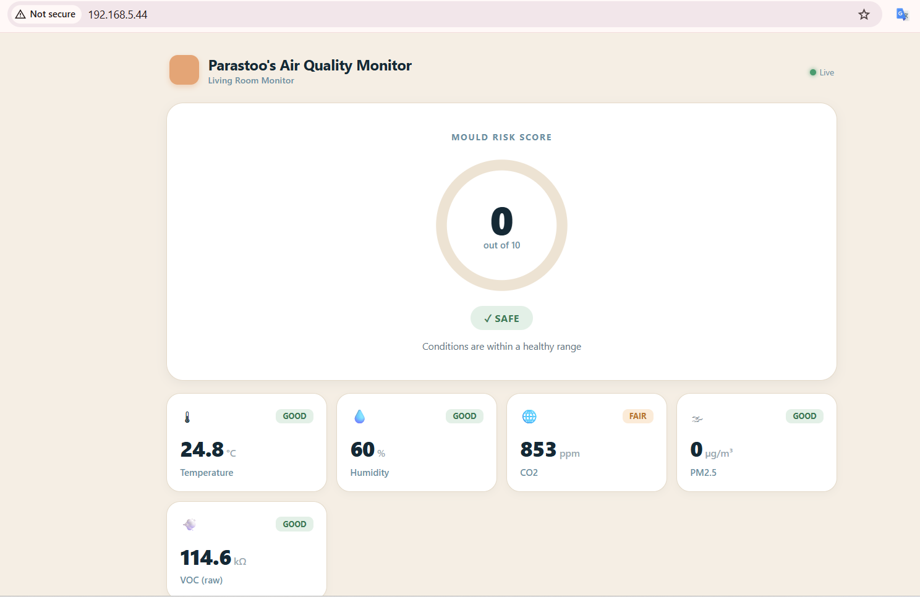
Figure 4.14: The main dashboard on a laptop: the mould-risk gauge, then the temperature, humidity and CO2 tiles.
Below the gauge, five tiles show temperature, humidity, CO2, PM2.5 and VOC, each with its current value and a GOOD, FAIR or POOR tag (thresholds in Table 4.1) so a user can judge the room at a glance; these are fixed values meant as a simple guide, not a formal health classification.

Parameter | GOOD | FAIR | POOR
Temperature (°C) | 26 or below | above 26 to 30 | above 30
Humidity (%) | RHcrit − 10 or below | up to RHcrit | above RHcrit
CO2 (ppm) | 800 or below | above 800 to 1200 | above 1200
PM2.5 (µg/m³) | 12 or below | above 12 to 35 | above 35
VOC (kΩ, raw) | above 50 | above 20 to 50 | 20 or below
Table 4.1: Thresholds used for the GOOD, FAIR and POOR tags on the dashboard tiles.

Two of the tags work differently from the others. The humidity thresholds are not fixed numbers. They follow the critical humidity RHcrit from the mould model (Equation 1, Section 4.3.2). Humidity is GOOD when it is at least 10 percentage points below RHcrit, FAIR in the last 10 points before it, and POOR once it goes above it, which is exactly when the algorithm starts adding mould growth. The VOC tag is reversed, because a higher gas resistance means cleaner air. The VOC value itself is shown as raw resistance in kΩ, since turning it into a calibrated concentration needs Bosch’s BSEC library, which is left as future work (Chapter 6).
Under the tiles, a small line chart shows the last 20 humidity readings (Figure 4.15). They are kept in a circular buffer in memory and drawn as an inline SVG, so no charting library is needed, covering only the last 100 seconds or so. The longer history is on the trend pages. The last card shows how many readings are in the log, with the Download CSV and Clear buttons.
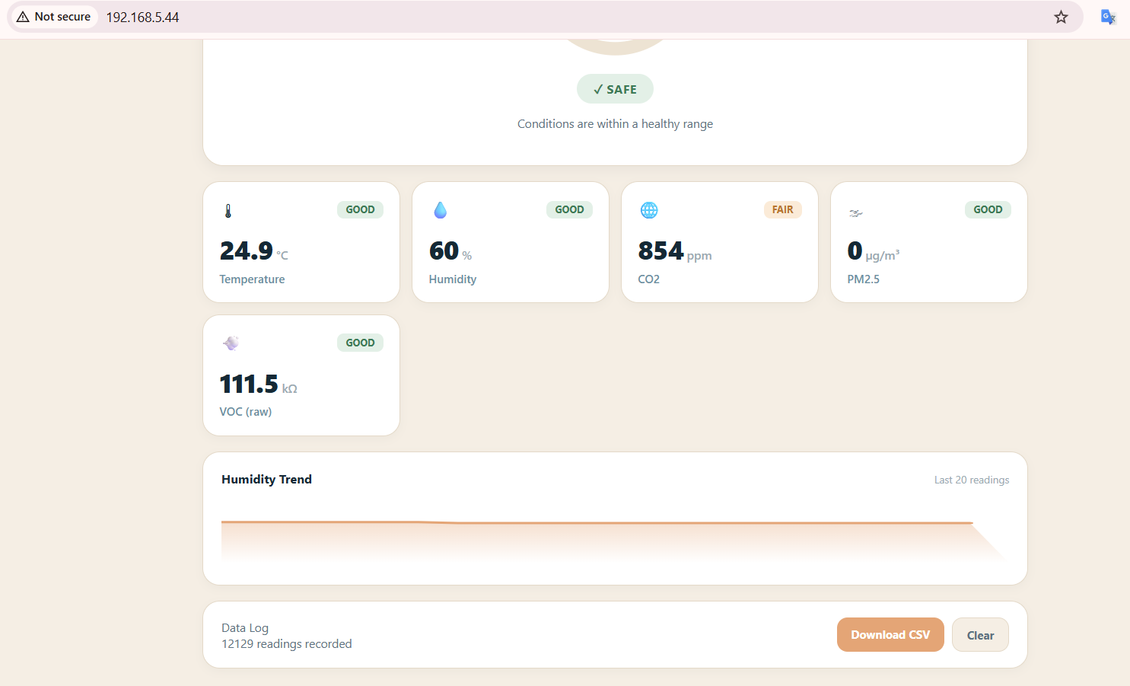
Figure 4.15: The lower part of the dashboard: the PM2.5 and VOC tiles, the humidity sparkline and the data log card.
The same page works on a phone (Figure 4.16a). The tiles stack into two columns and everything stays readable without zooming.

4.4.3 Trend Pages and the Interactive Chart
Touching a tile opens a trend page for that parameter, with tabs for the last 24 hours, 7 days and all logged data (Figures 4.16b and 4.17); the tabs are ordinary links with the range in the address, so the ESP32 rebuilds the chart for each request as an SVG with three dashed grid lines (minimum, middle, maximum), five date/time labels, and a filled line.
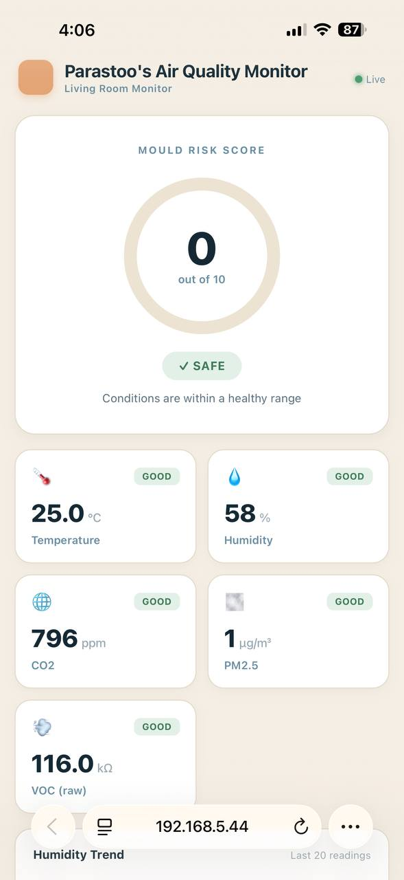 | 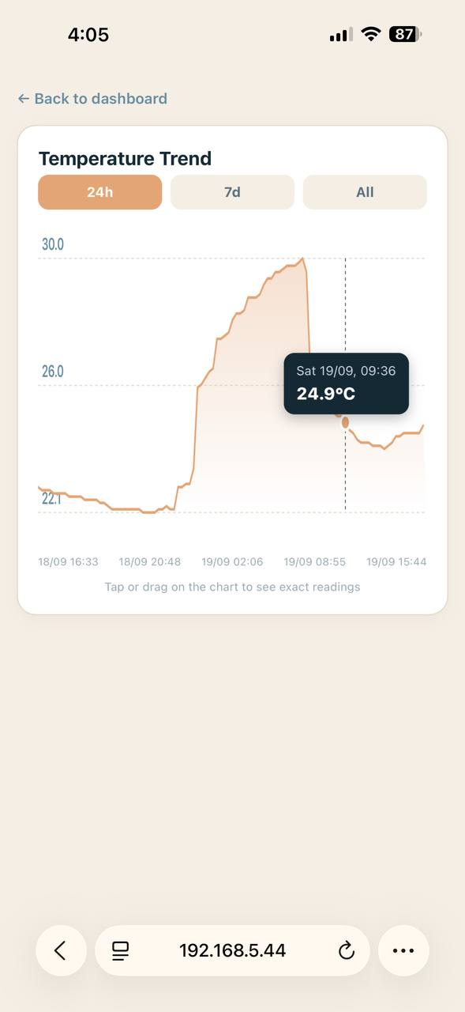
Figure 4.16: The dashboard on a phone: (a) the main page and (b) a trend page with the tooltip open.
To read exact values, the user touches or drags along the chart; a small script finds the nearest logged point, moves a highlighted dot and dashed line to it, and shows a tooltip with the date, time and value, all from a JavaScript array written into the page, so it works fully in the browser.
Figures 4.16b and 4.17 show real logged data. Over 24 hours the room temperature rises from about 22 °C to 30 °C during the night and falls again after early morning, which matches the room heater being used overnight.
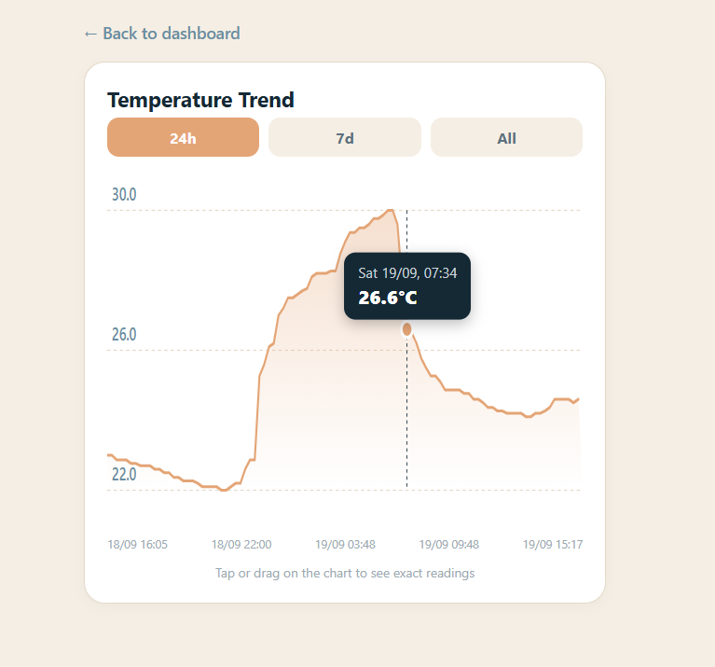 | 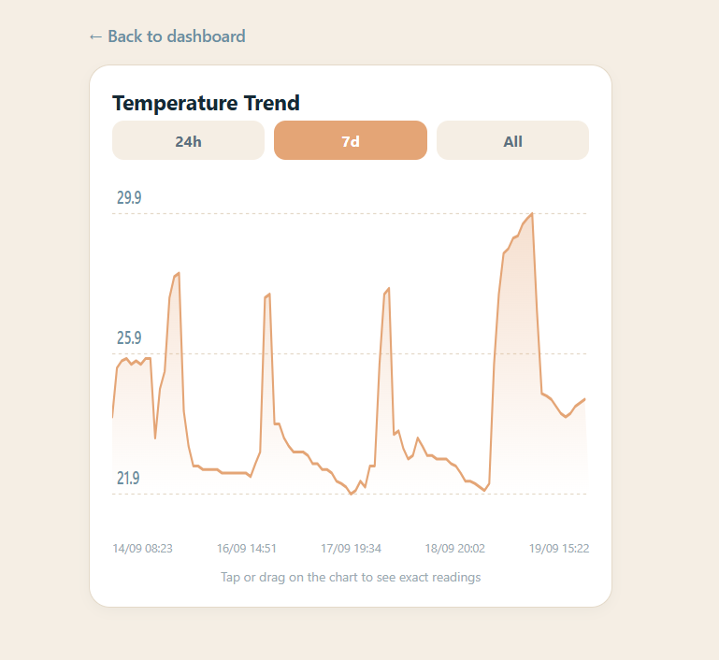
Figure 4.17: The temperature trend page on a laptop: (a) the 24-hour view and (b) the 7-day view.

4.4.4 Loading Log Data Efficiently
The first version of the trend page was slow. It read the whole log file twice, once to count the matching rows and once to pull them out, and it turned every line into a String object. On the ESP32, many small String objects fragment the memory and slow down as the log grows.
The function loadTrendData() was rewritten to work in a single pass with a fixed amount of memory. Each line is read into a 96-byte character buffer, the timestamp is converted with sscanf, and the wanted column is found by scanning for commas in place, so no String objects are created at all. Only rows inside the chosen time window are kept.
A chart with 100 points is enough for a phone screen, but a week of logging holds far more readings than that. To pick 100 points that still represent the whole period, the code uses reservoir sampling. The first 100 matching rows fill the buffer, and every later row replaces a random slot with a probability of 100 divided by the number of rows seen so far. This gives an even random sample while only ever storing 100 values, and the points are sorted by time before drawing.
Sampling has a cost. In the 7-day and All views, thousands of readings are shown as 100 points, so a short event, such as a few minutes of shower steam, can fall between two sampled points and not appear, and reloading the page can give a slightly different set of points. For spotting daily patterns this is acceptable, and the complete data is always available through the CSV download.

4.4.5 Downloading and Clearing the Log
The Download CSV button calls /download, which streams the log file straight from flash storage as air_quality_log.csv. The file opens directly in Excel (Figure 4.18). It has one row every 30 seconds and ten columns, covering the timestamp, the five sensor readings, PM1.0 and PM10, and the mould score and index. The files downloaded this way are the source of the real data analysed in Chapter 5. The Clear button asks for confirmation, then deletes the log and starts a new one with a fresh header. The size limit and the automatic reset of the log are described in Section 4.3.3.
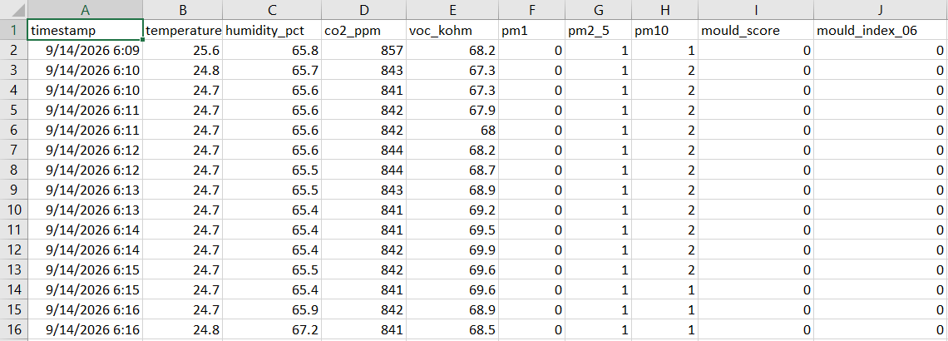
Figure 4.18: The first rows of a downloaded log file opened in Excel, showing the ten logged columns.

4.4.6 Limitations of the Dashboard
The dashboard is served over plain HTTP with no login, which is why the browser shows “Not secure” in Figures 4.14 and 4.16. The data is only environmental readings, and the device is meant for a home network, but anyone on that network can view the dashboard or clear the log, and the only protection on the Clear button is a confirmation prompt. Adding a simple password and HTTPS would be a sensible next step. The dashboard also needs the phone or laptop to be on the same network as the device, so there is no remote access. This links to the industry partner’s suggestion of adding LTE connectivity, discussed in Chapter 5.

4.5 PCB Design
The breadboard prototype shows that the design works, but it is bulky and its loose wires can cause faults (Section 4.6). To meet objective 5, I therefore redesigned the circuit as a printed circuit board (PCB) in Altium Designer. The PCB is a design deliverable. I completed and checked it, but I did not manufacture it within the project time, so I did all the tests in Chapter 5 on the breadboard prototype.

4.5.1 Design Overview
The schematic has ten blocks. Power flows between them as follows. The USB-C connector supplies 5 V to a battery charger, which charges a LiPo battery and feeds the battery node (VBAT). VBAT supplies two converters, a 3.3 V regulator for the microcontroller, sensors, display and LED, and a boost converter that makes the 5 V needed by the PMS5003. The ESP32 module reads the SCD40 and BME688 sensors and controls the OLED display over the I2C bus, reads the PMS5003 over UART, and drives the status LED.

4.5.2 Power Input and Charging
This block (Figure 4.19) brings in external power and charges the battery. The USB-C connector J3 provides 5 V. Resistors R3 and R4 (5.1 kΩ) connect the CC1 and CC2 pins to ground. This tells the USB source that a power-only device is attached,. No data pins are used.
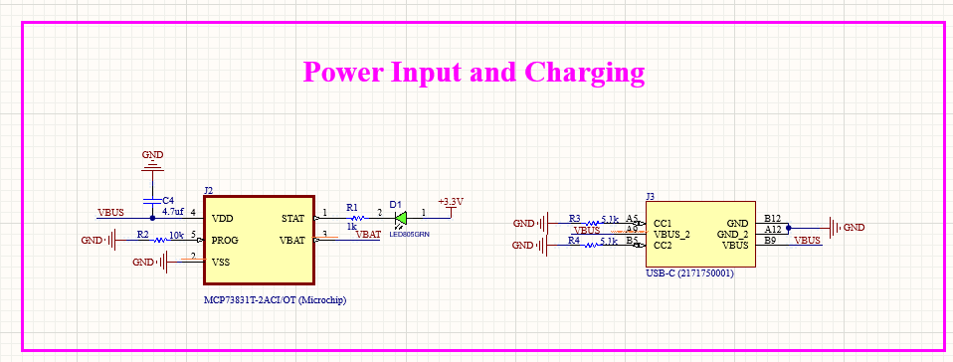
Figure 4.19: The Power Input and Charging block of the schematic.
VBUS feeds the VDD pin of the MCP73831T-2ACI/OT charger (input capacitor C4, 4.7 µF), which regulates the battery at its 4.20 V full-charge voltage; the charge current is set by R2 (10 kΩ) on the PROG pin, giving 100 mA (1000 V divided by R2, Microchip Technology, 2014). VBAT connects to the battery node and VSS to ground.

4.5.3 Battery and Voltage Regulation
The battery connects through J1, a two-pin JST-PH connector (B2B-PH-K-S: pin 1 VBAT, pin 2 ground, Figure 4.20), to voltage regulator VR1, a Microchip MCP1700T-3302E giving a fixed 3.3 V output (input from VBAT via C2, 10 µF; output +3.3V rail via C3, 10 µF). It delivers up to 250 mA, uses only 1.6 µA of its own current, and accepts 2.3–6.0 V, covering the whole LiPo range (Microchip Technology, 2016); fed from the battery node, it keeps the device running if USB is removed.
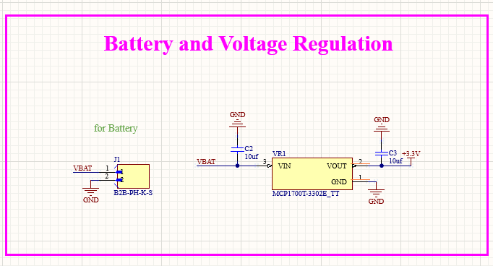
Figure 4.20: The Battery and Voltage Regulation block of the schematic.

4.5.4 5 V Boost Converter
The PMS5003 needs 4.5–5.5 V (Plantower, 2019), which a single LiPo cell cannot give directly (Figure 4.21). The MT3608 step-up converter U5 makes this voltage from VBAT. The EN pin (pin 4) is tied to VBAT, so the converter is always enabled. Diode D3 (SS14, a Schottky type) and output capacitor C9 (22 µF) produce the 5V_BOOST output, and C10 (10 µF) smooths the input. Resistors R11 (75 kΩ) and R12 (10 kΩ) form a divider from the output to the feedback pin (FB, pin 3). The converter keeps this pin at its 0.6 V reference, so the output is 0.6 × (1 + 75/10) = 5.1 V (Aerosemi Technology, n.d.). The 5V_BOOST net is connected only to the PM2.5 sensor connector.
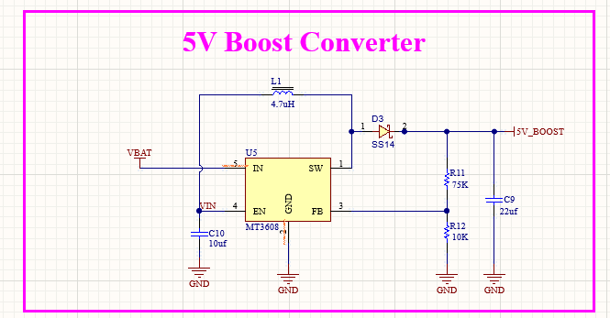
Figure 4.21: The 5 V Boost Converter block of the schematic.

4.5.5 Microcontroller
The microcontroller block holds the ESP32-MINI-1-N4 module U3 (Figure 4.22): its 3V3 pin is supplied from +3.3V via C5 (4.7 µF), with all ground pins tied to ground. Table 4.2 lists the module’s signals: the I2C lines (GPIO21 SDA, GPIO22 SCL) each have a 2 kΩ pull-up to 3.3 V (R5, R6); the PMS5003 UART uses GPIO18/19; the status LED uses GPIO25/26/27; the first UART (RXD0/TXD0) goes to the programming header; and GPIO0 is the BOOT pin.
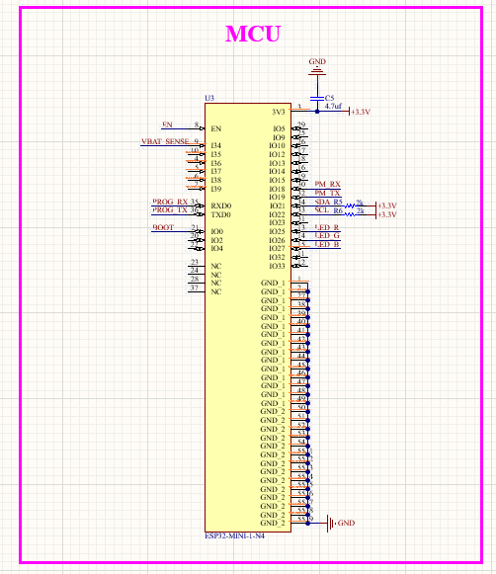
Figure 4.22: The MCU block of the schematic.

Signal | ESP32 pin | Connected to
SDA | GPIO21 | SCD40, BME688 and OLED, with pull-up R5
SCL | GPIO22 | SCD40, BME688 and OLED, with pull-up R6
PM_RX | GPIO18 | PM2.5 connector J4, pin 3 (PMS5003 TXD)
PM_TX | GPIO19 | PM2.5 connector J4, pin 4 (PMS5003 RXD)
LED_R | GPIO25 | R9, then the red LED
LED_G | GPIO26 | R8, then the green LED
LED_B | GPIO27 | Not connected in this version
PROG_RX, PROG_TX | RXD0, TXD0 (UART0) | Programming header J5, pins 3 and 4
EN | EN (pin 8) | Reset button S1, R7 and C7, header J5 pin 5
BOOT | GPIO0 | Boot button S2, R10 and C8, header J5 pin 6
VBAT_SENSE | GPIO34 | Input-only pin, not used by the current firmware
Table 4.2: The signals connected to the ESP32-MINI-1 module.

4.5.6 Programming Header and Buttons
The six-pin header J5 (Figure 4.23) loads the firmware with an external USB-to-serial adapter: pins 3/4 go to the module’s first UART, and pins 5/6 are the reset/boot lines for automatic programming, or the two buttons do the same job by hand. Reset button S1 connects EN to ground (pull-up R7, 10 kΩ; capacitor C7, 100 nF, giving a short power-up delay and reducing bounce); boot button S2 connects GPIO0 to ground (R10, 2 kΩ; C8, 100 nF).
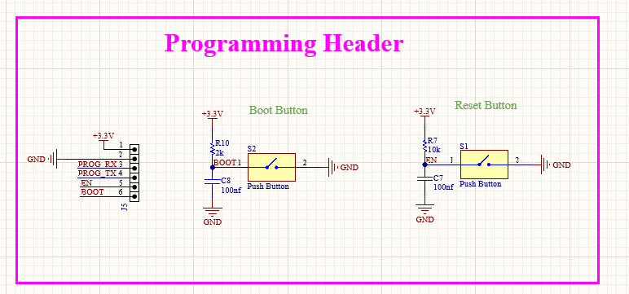
Figure 4.23: The Programming Header block of the schematic, with the boot and reset buttons.

4.5.7 Sensor Blocks
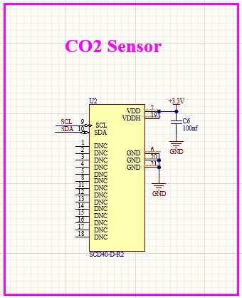
Figure 4.24: The CO2 Sensor block of the schematic.
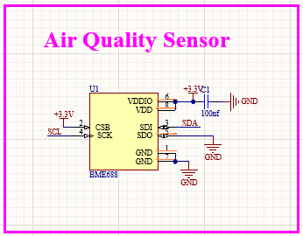
Figure 4.25: The Air Quality Sensor block of the schematic.
PM2.5 sensor connector. Too large to mount on the board, the PMS5003 plugs into the four-pin header J4 (Figure 4.26): pin 1 is 5 V (5V_BOOST), pin 2 ground, pin 3 (PM_RX) GPIO18, pin 4 (PM_TX) GPIO19; its UART uses 3.3 V logic (Plantower, 2019), so it connects directly to the ESP32.
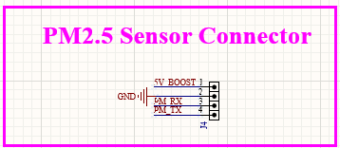
Figure 4.26: The PM2.5 Sensor Connector block of the schematic.

4.5.8 Display and Status LED
The OLED module U4 (DM-OLED096-636, 0.96″ 128×64) connects with four wires (Figure 4.27): ground (pin 1), +3.3V (pin 2), SCL (pin 3), SDA (pin 4), sharing the I2C bus with the two sensors at address 0x3C and the same pull-up resistors R5/R6.
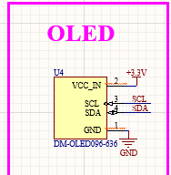
Figure 4.27: The OLED block of the schematic.
The last block (Figure 4.28), still called “RGB LED” after the breadboard version, holds a two-colour LED (D2) on the PCB: green via GPIO26/R8 (220 Ω) and red via GPIO25/R9 (220 Ω), with yellow made by lighting both together, so the blue channel is not needed.
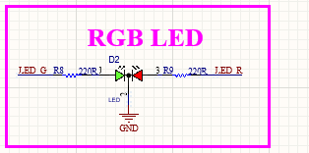
Figure 4.28: The RGB LED block of the schematic, which holds the two-colour status LED.

4.5.9 Passive Components
The passive components are the resistors and capacitors shown in the schematic blocks above (Figures 4.19 to 4.28).

4.5.10 Board Layout
The board measures 46.43 × 35.59 mm (1,645 mm²) with two copper layers (Figure 4.29) — enough since the circuit has no high-speed signals beyond the I2C and UART lines, as USB is used only for power.
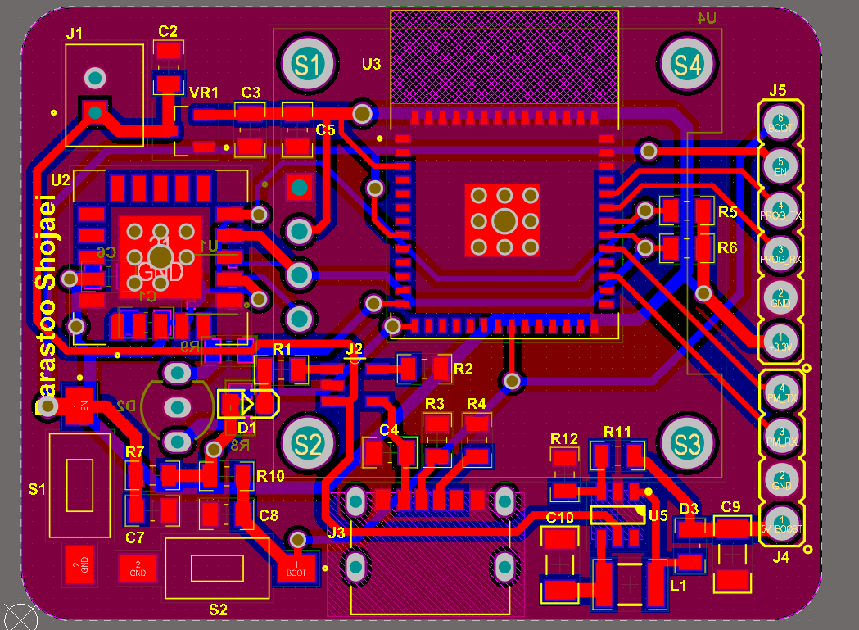 | 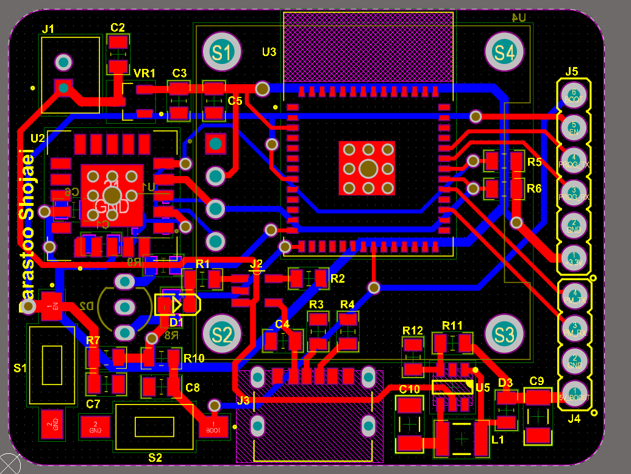
Figure 4.29: The PCB layout in 2D: (a) with copper fills and (b) with traces only (red: top layer, blue: bottom layer).
Components sit on both sides (Figure 4.30): the top holds the ESP32 module, SCD40, USB-C connector, power components, buttons and headers; the bottom holds the OLED, status LED and BME688, kept on the opposite side from the ESP32 module and boost converter (the main heat sources) so self-heating disturbs its readings as little as possible. The ESP32 module’s antenna sits at the board edge with a copper-free keep-out area (the hatched area in Figure 4.29), as recommended in its datasheet (Espressif Systems, n.d.).
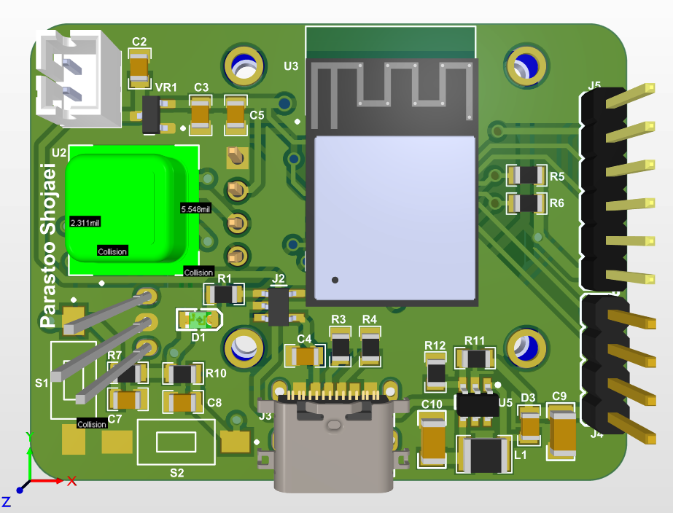 | 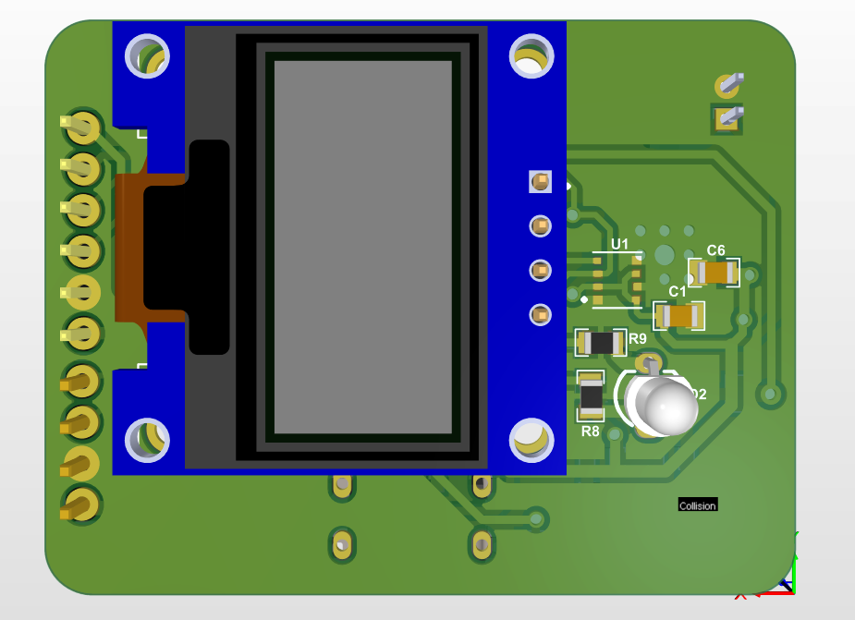
Figure 4.30: The PCB in 3D: (a) the top side and (b) the bottom side, with the OLED display and the status LED.

4.5.11 Design Review and Checks
The schematic and layout were reviewed before the design was finished, and four points were corrected: decoupling capacitors drawn in series along the power trace were moved to parallel (shunt) positions; the EN pull-up resistor R7 was changed from 2 kΩ to 10 kΩ; the PMS5003 UART pins, GPIO16/17 on the breadboard, were moved to GPIO18/19 since the smaller ESP32-MINI-1 module does not expose the originals (PMS_RX_PIN and PMS_TX_PIN must be updated in the firmware to match); and the copper-free antenna keep-out area was added.
The final layout was then checked with Altium’s Design Rule Check on 19 September 2026, reporting 0 warnings and 0 rule violations (Figure 4.31).
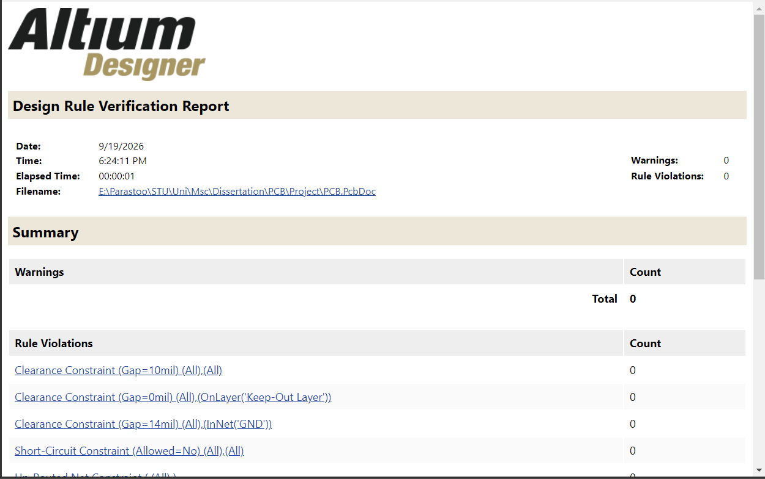
Figure 4.31: The Altium Design Rule Check report for the final layout: 0 warnings and 0 rule violations.

4.5.12 Power Budget and Battery
The device is designed to run from USB power, with a single-cell 3.7 V, 500 mAh LiPo battery as a back-up. Table 4.3 estimates the current that the circuit would draw. These are design estimates from datasheets, not measurements.

Load | Supply | Current | Basis
ESP32-MINI-1, WiFi on | 3.3 V | ≈ 100 mA | About 95–100 mA when receiving and up to 240 mA in transmit bursts (Espressif Systems, n.d.)
SCD40, measuring every 5 s | 3.3 V | 15 mA | Typical average current (Sensirion, n.d.)
BME688, OLED and LED | 3.3 V | ≈ 25 mA | Assumed
PMS5003 | 5 V | ≈ 160 mA from the battery | Up to 100 mA at 5 V (Plantower, 2019); 3.7 V battery and 85% converter efficiency assumed
Total from the battery |  | ≈ 300 mA
Table 4.3: Estimated current draw of the PCB design when everything is running.

At about 300 mA, the 500 mAh cell would run the device for roughly one and a half hours with all sensors on, so in normal use it runs from USB, with the battery covering short power cuts and moves. Running time could be increased by switching the PMS5003 on only for short periods (standby below 0.2 mA versus up to 100 mA running, Plantower, 2019) and using the SCD40's low-power mode (3.2 mA instead of 15 mA, Sensirion, n.d.).

4.5.13 Cost and Manufacturability
Table 4.4 shows the estimated bill of materials: about £62 (£61.82) for one unit, falling to about £30 (£29.76) at 100 units. The three sensors make up about 63% of the single-unit cost, the PMS5003 alone about 40%, which is why cost falls so much with volume as its price drops from £24.50 to £8.69. For comparison, the Airthings Wave Mini costs about £112 with the Hub it needs for continuous logging (Section 2.4). These figures are component and fabrication estimates only, excluding assembly labour, testing, certification, shipping or profit.
Component | Qty = 1 (£) | Qty = 100 (£)
ESP32-MINI-1-N4 module | 2.35 | 2.09
SCD40-D-R2 (CO2 sensor) | 10.15 | 7.51
BME688 (temperature, humidity, VOC) | 4.56 | 3.32
PMS5003 (PM2.5 sensor) | 24.50 | 8.69
0.96″ OLED display module | 3.16 | 1.42
MCP73831 (LiPo charger IC) | 0.29 | 0.14
MCP1700 (3.3 V regulator) | 0.13 | 0.07
MT3608 (5 V boost converter) | 0.29 | 0.04
USB-C connector | 0.34 | 0.17
JST battery connector | 0.05 | 0.03
LiPo battery, 500 mAh | 5.93 | 2.77
Bicolour status LED | 0.12 | 0.04
Resistors and capacitors (miscellaneous) | 1.58 | 0.40
Tactile buttons (×2) | 0.47 | 0.16
Programming header | 0.40 | 0.08
PCB fabrication (per unit) | 3.00 | 1.03
Enclosure (ABS project box) | 4.50 | 1.80
Total | 61.82 | 29.76
Table 4.4: Estimated bill of materials for one unit and for 100 units.

The design is simple to manufacture. It is a two-layer board with standard surface-mount parts and a common USB-C connector, and the ESP32 module already contains the radio circuit and antenna, so no radio design is needed.

4.5.14 Comparison with the Breadboard Prototype and Next Steps
I designed the PCB to reproduce the tested breadboard prototype as closely as possible. It uses the same sensors, the same I2C addresses (0x62, 0x76 and 0x3C), the same UART speed and the same pins for the I2C bus (GPIO21 and GPIO22) and for the green and red LEDs (GPIO26 and GPIO25). Only three things change. I replaced the ESP32 development board with the bare ESP32-MINI-1 module. The PMS5003 UART moves from GPIO16 and GPIO17 to GPIO18 and GPIO19. I replaced the RGB LED with a two-colour LED. For these reasons, I expect the same firmware to run on the PCB once the two UART pin numbers are changed.

The design still has to be produced. The boards must be ordered, assembled and tested, and I did not have time to do this within the project, so this is an expectation and has not yet been shown on real hardware. The breadboard prototype is therefore the artefact that I evaluate in Chapter 5.

4.6 Development Challenges and Solutions
Taking the project from a locked industry board to a working monitor meant solving problems at four levels, namely the project as a whole, the hardware, the firmware and the network connection. The method was similar every time, which was to make the problem visible with a diagnostic, form one hypothesis, change one thing and check the result. This is the build-and-evaluate cycle of design-science research (Hevner et al., 2004), where each test of the artefact gives feedback for the next design step.

4.6.1 Project-Level Challenges
The parts also did not all arrive at the same time, and the first PMS5003 bought had a connector that does not fit a breadboard, so development followed the order in which hardware became available: the OLED, LED and WiFi first, then a dashboard with simulated values, then the sensors one at a time, then data logging, and last the mould-risk algorithm (Section 3.2). Adding only one new part at each step meant a fault could almost always be traced to it.

4.6.2 Hardware Challenges
PMS5003 connector and power. The PMS5003 bought uses a 1.25 mm pitch connector that cannot plug into a breadboard, so a small adapter board breaks it out into separate pins (Section 4.2). It also needs 4.5–5.5 V (Plantower, 2019), so it is powered from the ESP32's 5 V pin, not the shared 3.3 V rail.
SCD40 “Error writing to I2C bus” (error 270). After working correctly for some time, the SCD40 stopped starting on every attempt. A bus scanner added to setup() showed the sensor still answering at address 0x62; two more diagnostics, errorToString() and a four-try retry loop, showed it answered the scan but refused the commands.
This pointed to the power supply. Answering an address probe takes very little current, but starting a measurement does not, as the SCD40 datasheet gives an average supply current of 15 mA and peaks of about 205 mA at 3.3 V (Sensirion, 2021). A worn jumper wire adds resistance, and by Ohm’s law the voltage drop grows with the current. The VCC and GND jumper wires were replaced and the sensor was moved to a fresh breadboard row, and it started at once. This is one reason for the PCB design in Section 4.5, where the sensor is soldered to the board and has its own decoupling capacitor (C6).
The start-up sequence was also made more robust, waking the sensor, clearing any measurement left running, reloading its settings and only then starting periodic measurement, with pauses between steps; the slower 50 kHz I2C clock and a one-second time-out also make the bus more tolerant of long jumper wires.
CO2 readings offset from the fresh-air level. After repeated power cycling during debugging, CO2 readings drifted from the level expected in fresh air; automatic self-calibration (Sensirion, 2021) needs fresh air at about 400 ppm weekly and continuous operation, so forced recalibration was used instead: placing the device in fresh air and recalibrating with a 400 ppm reference corrected the baseline within minutes.

4.6.3 Firmware Challenges
Keeping the dashboard responsive. The web server, sensor readings and display all run in one loop on one processor, and a delay() call would freeze the server, so every task uses a millis()-based timer instead (Section 4.3.1); the mould calculation uses the real elapsed time, so a short delay while a page is built does not change its result.
Reading the PMS5003 data stream. The PMS5003 sends continuous 32-byte frames starting with 0x42 and 0x4D and ending with a checksum (Plantower, 2019); since the ESP32 may start listening mid-frame, reading a fixed 32 bytes could give wrong values. The firmware instead discards any byte that is not 0x42, checks the header bytes once a full frame is read, and verifies the checksum before taking the PM1.0, PM2.5 and PM10 values; a bad frame is ignored and the previous values stay on the display.
Sensors that fail or are not ready. The first version read the SCD40 before its first measurement was finished and returned a “not enough data” error, which the data-ready check removed.
Limited memory and flash. Building large web pages from many small String objects fragments the ESP32's limited RAM and slows the trend pages, so the trend code was rewritten to read the log in a single pass with a fixed character buffer, keeping only 100 points via reservoir sampling (Section 4.4.4). Flash is limited too, so the log is capped at 1 MB and restarts when full (Section 4.3.3).
Correct timestamps. The trend pages and CSV need real dates and times, so the clock is set from internet time servers with a London time-zone rule (GMT0BST,M3.5.0/1,M10.5.0) that switches GMT/BST automatically; if the time cannot be set, the row is labelled with time since start-up instead, so every row keeps a time reference (Section 4.3.3).
Compile errors. Two versions of the sketch (1.ino and 2.ino) left in the same folder caused every variable to be reported as defined twice, since the Arduino IDE compiles every .ino file in a folder together; each sketch now has its own folder. The compiler also rejected raw non-ASCII characters, such as the degree sign, inside the web page strings, so these are now written as HTML numeric character references (for example &deg;).

4.6.4 Network and WiFi Challenges
Joining a network was harder than expected and caused several separate problems. I changed the firmware to handle each of them.
A name that could not be matched. At first the ESP32 was refused with the status WRONG_PASSWORD, although the password was correct. The network name had been copied through a messaging app and contained a curly apostrophe (’), while the code contained a plain one. The network name is part of the WPA2 key calculation (IEEE, 2004), so a name that differs by one character is refused like a wrong password. The firmware matches on the part of the name without the apostrophe, and then connects with the exact name returned by the scan, so no typed name is needed.
Power saving. WiFi.setSleep(false) switches off the WiFi power-saving mode, so the web server answers quickly when the page is opened.
Finding the device. The device receives a different IP address on each network, and there is no cloud service to look it up. The address is therefore shown on the OLED display, so anyone can open the dashboard without a computer or the Serial Monitor.

4.6.5 Lessons Learned
Four points came out of these challenges and shaped the rest of the design. First, physical connections and power quality should be checked before any code, which led to soldered connections and decoupling capacitors on the PCB. Second, a diagnostic should be added before a fix is tried. The I2C scan, the readable error text, the checksum test and the network list each turned a vague symptom into a clear one. Third, the firmware should tolerate small faults, using retries, time-outs, checksums and values that are kept when a read fails, so that one bad moment does not stop the device. Fourth, a device that runs in a home cannot assume a perfect network, so it should keep working without one and be easy to find when it is connected. Together, these choices make the final design more reliable than the first breadboard version.

5 Testing and Evaluation
In this chapter, I test and evaluate my artefact against the six objectives in Section 1.4. Because the project follows design science research, I use several methods that suit different parts of the artefact (Hevner et al., 2004), namely simulation with artificial data, functional testing, observation in real use, comparison with a commercial product, and assessment by an industry expert.

5.1 Test Plan

5.1.1 Approach
An evaluation has to show two things, namely that the artefact is built correctly, and that it is useful (Hevner et al., 2004). I chose the tests to fit what can really be tested.

5.1.2 Tests and Success Criteria
Table 5.1 lists the tests, the project objective that each one supports (from Section 1.4), the evaluation method, and the criterion used to decide whether the test was passed.

No. | Test | Objective supported | Method | Success criterion | Section
T1 | Firmware algorithm against an independent reference, on a 12-month dataset | Mould-risk algorithm; validation | Simulation with artificial data | Same score in every hour; index difference below 0.001 (0.02% of the 0–6 scale) | 5.2
T2 | Model behaviour against the published curves | Mould-risk algorithm; validation | Informed argument | Same plateau values and the same ordering of growth times as Figure 2 of Viitanen and Ojanen (2007) | 5.2
T3 | Response to short events and to long exposure | Mould-risk algorithm | Scenario testing | Short humidity peaks leave the score unchanged; a three-week leak raises it | 5.2
T4 | Computing time of the algorithm on the ESP32 | Hardware and firmware platform; mould-risk algorithm | Dynamic analysis | One update takes far less than the 5-second reading cycle | 5.2
T5 | Readings, display, LED, dashboard and logging with live sensors | Hardware and firmware platform | Functional testing | All parameters shown and logged, with plausible values | 5.3
T6 | Extended operation in a real room | Hardware and firmware platform; mould-risk algorithm | Field study | Continuous logging over several days without failure | 5.3
T7 | Side-by-side comparison with the Airthings Wave Mini | Validation and comparison with the Wave Mini | Field comparison | Temperature and humidity agree within the tolerance of low-cost sensors; the mould-risk conclusion is consistent | 5.4
T8 | Design rule check of the PCB layout | PCB and commercial viability | Static analysis | No design rule violations | 4.5.11
T9 | Assessment by an industry expert | PCB and commercial viability | Scenarios and questionnaire | Expert ratings of the design, cost and market need | 5.5
T10 | Evaluation against the objectives | All objectives | Informed argument | Every objective addressed with evidence | 5.6
Table 5.1: The test plan.

5.1.3 Scope and Limits of the Tests
The tests cover the device in a small number of rooms over several days, and compare it with one commercial product. In line with the scope set in Section 1.5, I had no reference-grade instrument and did no long-term deployment or user study. I did not compare the mould index itself with measured mould growth, because that would need laboratory work on real materials.

5.2 Algorithm Validation

5.2.1 Purpose
The mould-risk algorithm is the most important part of the firmware, and it cannot be tested by waiting for mould to grow. I therefore run the algorithm with artificial data, in which the conditions are known exactly (simulation in the terms of Hevner et al., 2004). I ask two questions. First, is the implementation correct, that is, does the firmware give the same answers as an independent calculation of the same equations? Second, does the model behave like the published model, that is, are its growth times and limits of the same size as those in Viitanen and Ojanen (2007)?

5.2.2 The Test Dataset
The test uses a synthetic dataset of one year of hourly temperature and humidity readings (8,760 rows), made by a script (generate_dataset.py) with a fixed random seed so it can be regenerated exactly. It contains normal life, meaning a seasonal cycle, a daily cycle and a short morning shower peak, plus one failure: a three-week leak followed by a dry spell in which the room recovers (Figure 5.1, Table 5.2).
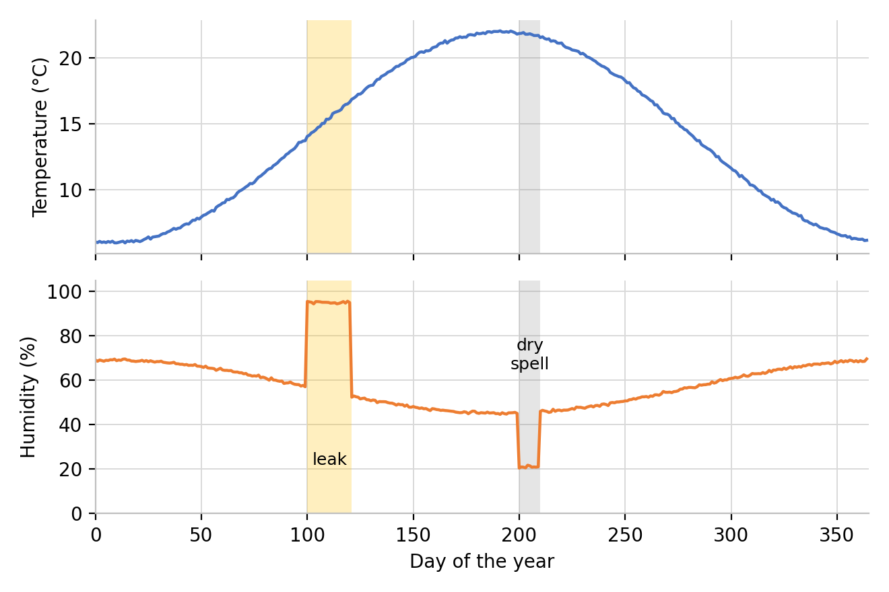
Figure 5.1: The synthetic dataset: (a) daily mean temperature and (b) humidity, with the leak and the dry spell shaded.

Part | Description
Seasonal pattern | Temperature averages 14 °C and varies by ±8 °C over the year. Humidity averages 55% and varies by ±12 percentage points, and is highest in winter.
Daily pattern | Temperature varies by ±1.5 °C and humidity by ±6 points during the day, with the warmest and driest time in the afternoon.
Shower peak | Humidity is raised by 25 points at 07:00 and 08:00 every day.
Leak | Days 100–120 (21 days): humidity held at 95% (±1.5), with temperatures between 12 and 18 °C.
Dry spell | Days 200–209 (10 days): humidity lowered by 25 points.
Noise and limits | Random noise on both series (0.3 °C and 1.5 points). Temperature is limited to 2–32 °C and humidity to 15–98%.
Table 5.2: The parts of the synthetic dataset.
Outside the leak, humidity was above the critical level RHcrit in 439 of the 8,256 hours (5.3%), such as during shower peaks and humid winter nights — short events that should not raise the risk, making them a useful test of whether the algorithm ignores them.

5.2.3 Implementations and Procedure
Two implementations were compared: the firmware algorithm in C++ on the ESP32, and a separate Python implementation (reference_model.py) written directly from the published equations, differing in language and number precision (Python's 64-bit numbers versus the ESP32's 32-bit mould index). Writing the Python version separately checks the firmware for slips such as a wrong sign, unit or missing guard; since I wrote both, this finds coding mistakes but not a shared misreading of the equations, which is checked separately in Section 5.2.5.
The procedure had five steps: (1) generate the dataset as a CSV file; (2) run the Python model on it for the reference result; (3) convert the temperature and humidity columns into a C++ header file (generate_header.py) for the ESP32's program memory; (4) run the test sketch test_mould_algorithm.ino on the ESP32 over the same 8,760 readings, writing every result to a file; (5) download the file over WiFi and compare it with the reference, hour by hour. The test sketch uses the same equations as the live firmware, feeding one reading per hour (rather than the real few-second interval the live firmware uses), so only the elapsed time differs. Figure 5.2 shows the output of both runs.
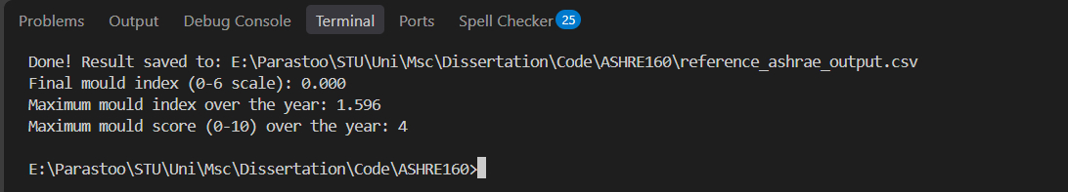
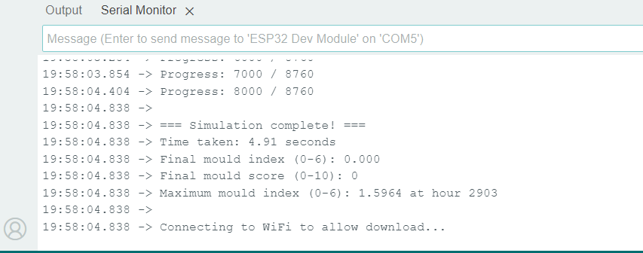
Figure 5.2: (a) The Python reference model and (b) the ESP32 test sketch on the Serial Monitor (maximum index 1.5964, run time 4.91 seconds).

5.2.4 Results
The two implementations agree in every respect (Table 5.3, Figure 5.3): the maximum mould index is 1.5964 in both, at the same hour (2903, the last hour of the leak); the score is identical in all 8,760 hours; and the largest index difference is 0.000077 (mean 0.000012), far below the 0.001 limit. Test T1 is therefore passed.

Measure | ESP32 firmware | Python reference | Difference
Maximum mould index | 1.5964 | 1.5964 | 0.0000
Hour of the maximum | 2903 | 2903 | 0
First hour with M ≥ 1 | 2795 (day 116) | 2795 (day 116) | 0
Hours with M ≥ 1 | 1,174 | 1,174 | 0
Final index (end of year) | 0.0000 | 0.0000 | 0.0000
Hours in SAFE / CAUTION / HIGH RISK | 7,586 / 1,174 / 0 | 7,586 / 1,174 / 0 | 0
Table 5.3: Comparison of the ESP32 firmware and the Python reference over 8,760 hours.
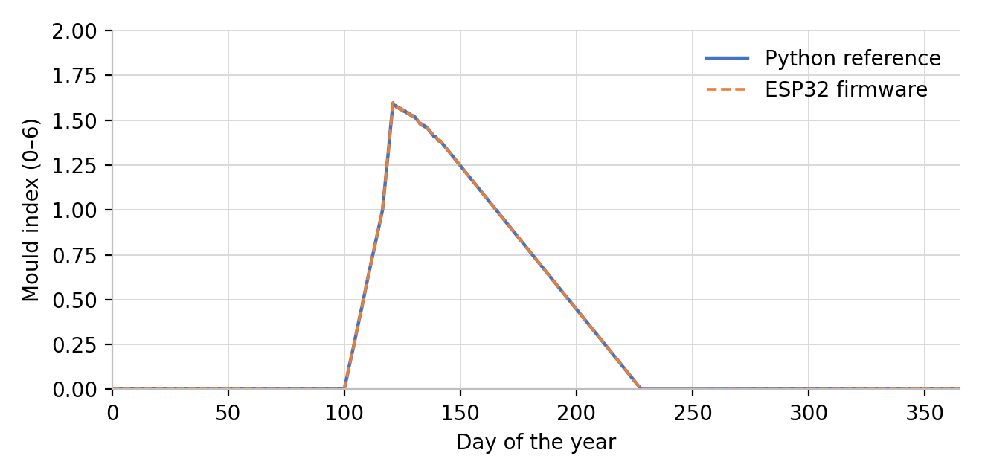
Figure 5.3: The mould index over the year from the ESP32 firmware and the Python reference; the two curves overlap.
The curves in Figure 5.3 also show how the model behaves (test T3): in normal months the index stays close to zero (highest value 0.0037 before the leak), then rises after the leak starts on day 100, first slowly and then faster past 1, reaching 1 on day 116 (16 days after the leak began), when the device changes from SAFE to CAUTION.
After the leak the index falls slowly, taking about 44 days to fall back below 1 and about 107 days to reach zero (day 228), which is intended, since mould does not disappear as soon as the air dries.
Test T4 is about computing time. The 8,760 updates took 4.91 seconds on the ESP32, including the time to write every result to flash memory. That is 0.56 ms per update. The live firmware makes one update every five seconds, so the algorithm uses less than one part in 8,000 of the available time.

5.2.5 Comparison with the Published Behaviour
The comparison above shows that the firmware and the Python code agree, but it does not show that both follow the published model. To check this, the model was run at constant temperature and humidity, the same type of conditions as the laboratory experiments in Figure 2 of Viitanen and Ojanen (2007). Table 5.4 gives the results for 90% and 97% relative humidity at 15 °C and 23 °C.

Conditions | Plateau of M | Weeks to M = 1 | Weeks to M = 3 | Weeks to 95% of the plateau
97% RH, 23 °C | 5.5 | 1.3 | 2.7 | 4.4
97% RH, 15 °C | 5.5 | 1.8 | 3.7 | 6.1
90% RH, 23 °C | 4.0 | 3.8 | 7.0 | 8.9
90% RH, 15 °C | 4.0 | 5.1 | 9.7 | 12.3
Table 5.4: The model at constant conditions.
Table 5.4 shows the pattern expected from the model, where at each humidity the index levels off at the same plateau at both temperatures, and every stage is reached sooner at higher humidity and at higher temperature. The plateau values, 5.5 at 97% humidity and 4.0 at 90%, are the same as those at which the pine sapwood model curves level off in Figure 2 of Viitanen and Ojanen (2007). The times are of the same order as in the figure. The figure was read by eye, so this is a comparison of shape and size and not an exact fit. Test T2 is therefore passed.

5.2.6 Why the Published Model Was Used
An early prototype of the device used a simple rule instead of the published equations. Table 5.5 compares this rule with the published model at 20 °C, by calculation, for four constant humidity levels.

Humidity | Early rule: time to a score of 10 | Model: index after 4 weeks | Model: index after 12 weeks | Model: weeks to M = 1
65% | 27 hours | 0.00 | 0.00 | never
75% | 8 hours | 0.00 | 0.00 | never
85% | 3 hours | 0.43 | 1.73 | 9.4
95% | 3 hours | 3.11 | 5.12 | 2.0
Table 5.5: The early rule compared with the published model at 20 °C.
The rule gives the maximum score in about a day at 65% humidity, and in eight hours at 75%. The published model gives no growth at all in these cases, because the critical humidity at 20 °C is 80%, and mould does not grow below it. At 85% the rule reaches the maximum in three hours, while the model needs more than nine weeks to reach an index of 1.

5.2.7 Discussion and Limits of the Validation
The validation has limits. The data is synthetic, so it shows what the algorithm does in known conditions and not how it performs in a real home. The result is only as good as the published model, which was fitted to laboratory tests on pine and spruce sapwood and, as its authors note, is weaker for long seasonal cycles and for other materials (Viitanen and Ojanen, 2007; Kopecký and Staněk, 2023). Finally, the score bands are a design choice.
One further result matters for the sensors. The model is far more sensitive to humidity than to temperature. At 20 °C, lowering the humidity from 95% to 92% increases the calculated time to reach an index of 1 from about 14 days to about 22 days, which is 56% longer, while a change of 1 °C changes it by about 3%.

5.3 Real-World Testing
In this section, I test the whole device with live sensors in a real room. It covers test T5 (readings, display, LED, dashboard and logging with live sensors) and test T6 (extended operation in a real room), as set out in Table 5.1.

5.3.1 Test Setup
The prototype (Figure 4.2) ran on USB power in the living room, inside its cardboard box, and was connected to the WiFi network. The log starts on 14 September 2026 at 06:09 and the last reading used here was taken on 19 September at 23:55, so it covers about 5.7 days.

5.3.2 Functional Tests (T5)
The functional checks are listed in Table 5.6. Figure 5.4 shows the dashboard at 23:58 on 19 September, a few minutes after the last reading in the log.

Check | Evidence | Result
Five live readings on the OLED display | Figure 4.9 | Temperature, humidity, CO2, gas resistance and PM2.5 shown
Mould-risk score, status text and LED colour | Figures 4.2 and 4.11 | Score and status shown; LED green for a safe status
Dashboard on a laptop and on a phone | Figures 4.14 to 4.17 and 5.4 | All tiles, tags and trend pages shown on both
GOOD, FAIR and POOR tags | Figure 5.4 and Table 4.1 | Tags follow the thresholds (CO2 of 845 ppm is FAIR)
Dashboard values against the log | Figure 5.4 and the last row of the log | Same values: 24.1 °C, 57%, 845 ppm, 6 µg/m³, 131.7 kΩ
Trend pages and tooltip | Figures 4.16, 4.17 and 5.5 | Charts drawn from the log; single readings shown with the tooltip
Logging interval | Log file | Median 30 s; 99% of the intervals between 29 and 31 s
Time stamps | Log file | 12,487 of 12,934 readings (97%) carry the date and time from the network clock
Downloading the log | Figure 4.18 | This log was downloaded as a CSV file from the dashboard
Table 5.6: The functional checks made on the running device (test T5).
The values on the tiles are the same as in the last row of the log (24.1 °C, 57%, 845 ppm, 6 µg/m³ and 131.7 kΩ), so the dashboard, the log and the sensors agree with each other. All the checks were passed, so test T5 is met.
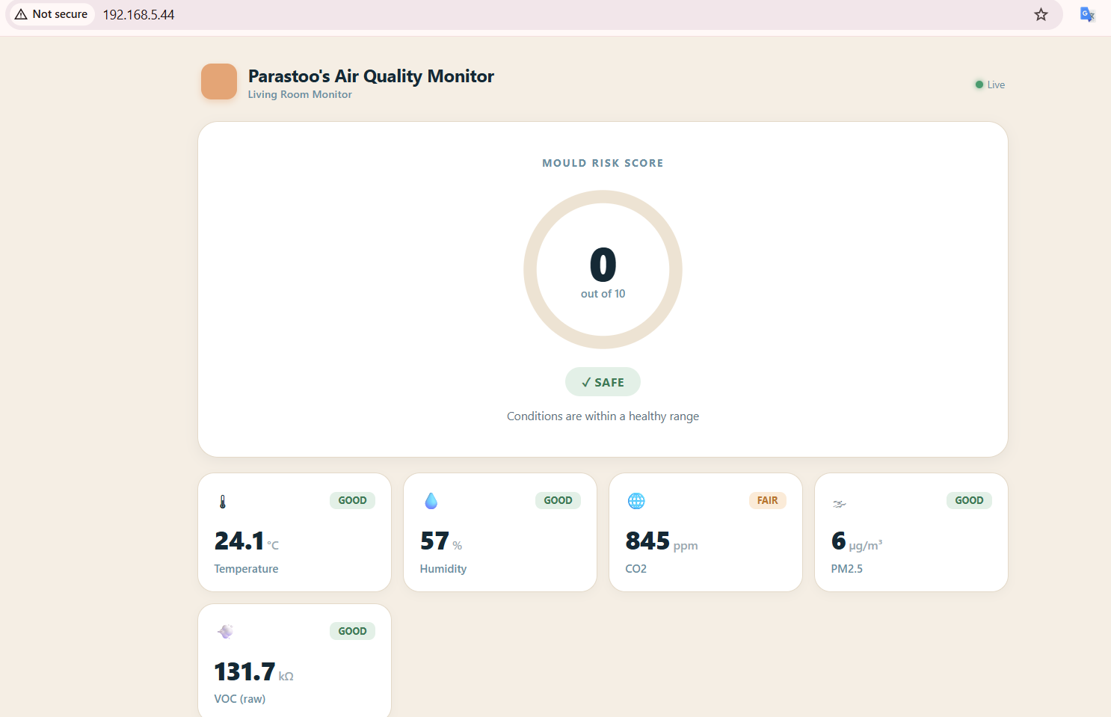
Figure 5.4: The main dashboard page at 23:58 on 19 September 2026: mould-risk score 0 (SAFE) and the five parameter tiles.

5.3.3 Extended Run
The log holds 12,934 readings, which is about 108 hours of logging within the 5.7 days. The first two days were not regular. On 14 and 15 September the log has several breaks, the longest of about 26 hours, and the device restarted three times. While its clock was not yet set after a restart, the device wrote the time since start-up in place of the date. This affects 447 readings (3.5% of the log). From 15 September at 23:11 the log is regular. For about 3.8 days, until 19 September at about 18:00, no gap between two readings was longer than 70 seconds.
All sensor values were present in every reading, and none of the temperature, humidity, CO2 or VOC values was zero or negative. The 3.8-day stretch meets the criterion for test T6, which asks for several days of continuous logging without failure. The breaks and restarts at the start show that the run was not free of interruptions at first, but logging started again each time.
The results in Section 5.3.4 use the regular part of the log, from 15 September at 23:11 to 19 September at 23:55 (11,427 readings over 4.0 days).

5.3.4 Results
Table 5.7 gives the range of each parameter. Figure 5.5 shows how they changed over the days.

Parameter | Minimum | Mean | Maximum | Middle 90% of readings
Temperature (°C) | 21.9 | 24.2 | 30.0 | 22.1 to 28.3
Relative humidity (%) | 40.6 | 54.5 | 65.0 | 44.1 to 62.9
CO2 (ppm) | 394 | 700 | 1,241 | 408 to 1,044
PM2.5 (µg/m³) | 0 | 19.7 | 947 | 0 to 111
VOC, raw gas resistance (kΩ) | 31.1 | 128.4 | 153.7 | 97.1 to 149.7
Table 5.7: Summary of the readings, 15 September 23:11 to 19 September 23:55 (11,427 readings); the last column holds the middle 90%.
Temperature. The mean was 24.2 °C and the range was 21.9 to 30.0 °C. On average the temperature was highest at about 03:00 (27.7 °C) and lowest at about 19:00 (22.3 °C).
Humidity. The mean was 54.5% and the range was 40.6 to 65.0%. The highest value in the whole log was 69.5%. The humidity changed slowly over the days (Figure 5.5(b)) and it was always in the GOOD band of the dashboard, which ends at 70% (Table 4.1).

(a)  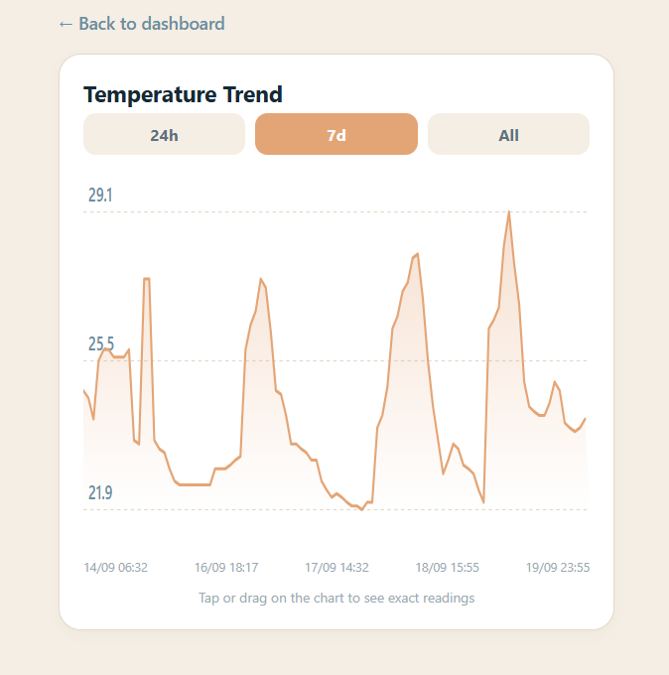 | (b)  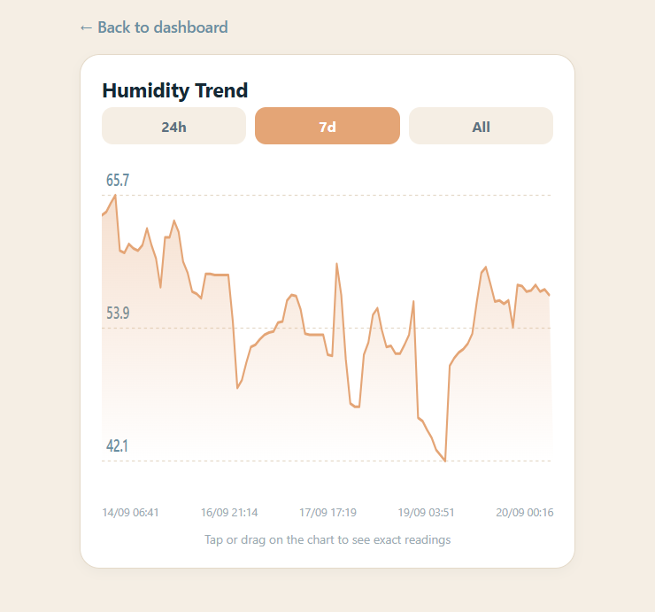
Figure 5.5: The 7-day trend pages of the dashboard: (a) temperature and (b) humidity. Each shows up to 100 sampled readings, so its extremes can differ from Table 5.7.
Mould-risk score. The score was 0 in all 12,934 readings, and the mould index stayed at 0.000. In the whole log the humidity never went above 69.5% and the temperature never went below 21.9 °C, so the humidity was always below the critical humidity of 80% that applies above 20 °C (Section 4.3.2). The model calculates no growth below this level, so the score cannot rise. It cannot show how the score reacts to a real damp problem, because none happened. That behaviour was tested with the 12-month simulation in Section 5.2.
CO2. The mean was 700 ppm. In 68% of the readings the CO2 was at or below 800 ppm (GOOD) and in 99% it was at or below 1,200 ppm. Only 109 readings (1%) were higher, with a maximum of 1,241 ppm.
PM2.5. The median was 1 µg/m³. In 85% of the readings the PM2.5 was at or below 12 µg/m³ (GOOD) and in 90% it was at or below 35 µg/m³. The mean of 19.7 µg/m³ is much higher than the median because of a few episodes with high values. There were eight episodes above 35 µg/m³, and five lasted between 39 and 155 minutes and three were shorter than 11 minutes. The highest value was 947 µg/m³.
VOC. The raw gas resistance of the BME688 was between 31 and 154 kΩ, with a mean of 128 kΩ, and it was above 50 kΩ (the GOOD range in Table 4.1) in 99.98% of the readings.

5.4 Comparison with the Airthings Wave Mini
The Airthings Wave Mini is the closest commercial product to this project (Section 2.4). It measures temperature, humidity and VOCs, and it estimates the risk of mould from temperature and humidity, without a mould sensor. The Wave Mini has no CO2 or PM2.5 sensor, so these two parameters cannot be compared.

5.4.1 Setup
The two devices stood next to each other in the same room, as Figure 5.6 shows. The Wave Mini readings were taken from the Airthings app on a phone, which shows the average and the range for the period that is chosen. The log of the prototype runs from 14 September at 06:09 to 19 September at 23:55, so the two periods cover almost the same days but they are not identical. The Wave Mini takes a reading about every 5 minutes (Airthings, 2022), while the log of the prototype has one every 30 seconds.
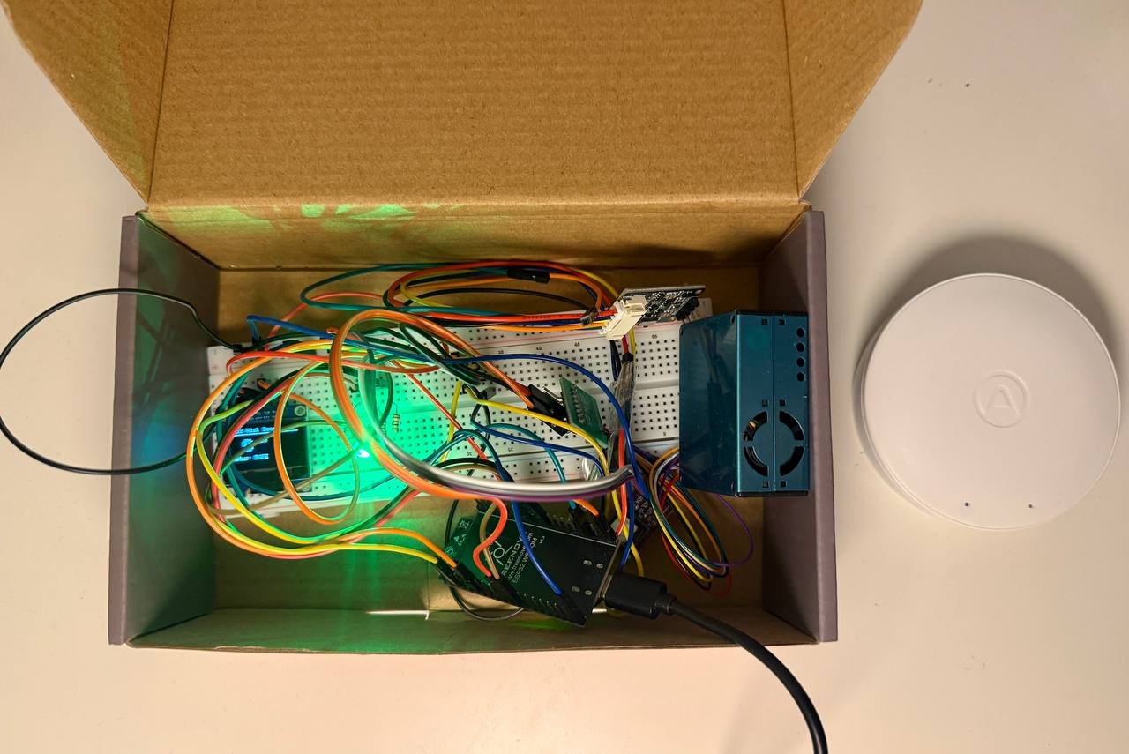
Figure 5.6: The prototype in its box (left) and the Airthings Wave Mini (right) during the comparison.

5.4.2 Temperature and Humidity
Table 5.8 compares the two summaries. The averages differ by 0.1 °C for temperature and by 2 percentage points for humidity. The lowest and highest values differ by 0.4 and 0.9 °C for temperature, and by 0.1 and 0.5 percentage points for humidity.

Value | Prototype | Wave Mini | Difference (prototype − Wave Mini)
Temperature, average (°C) | 24.3 | 24.4 | −0.1
Temperature, lowest (°C) | 21.9 | 21.5 | +0.4
Temperature, highest (°C) | 30.0 | 29.1 | +0.9
Humidity, average (%) | 55.0 | 57 | −2.0
Humidity, lowest (%) | 36.9 | 37 | −0.1
Humidity, highest (%) | 69.5 | 69 | +0.5
Table 5.8: Temperature and humidity of the prototype (whole log, 12,934 readings) and of the Wave Mini (app summary, 13–20 September).
These differences are small compared with sensor tolerances: the BME688 is ±0.5 °C and ±3% relative humidity (Bosch Sensortec, 2024), and the Wave Mini is ±0.5 °C at 25 °C (±1 °C from 0–60 °C) and ±3% relative humidity (Airthings, 2022), so two such devices could differ by up to 1.5 °C and 6 percentage points and still both be in specification — well outside the observed differences.
The largest difference, 0.9 °C, is at the highest temperature. The BME688 datasheet notes that its temperature depends on the board temperature and on self-heating, and that it is typically above the ambient temperature (Bosch Sensortec, 2024).
Figure 5.7 shows the 7-day graphs of the Wave Mini, showing the same pattern as the dashboard's trend pages (Figure 5.5): a daily temperature peak, marked above 25 °C in red, and humidity that changes slowly and stays below 70%.
(a) Temperature  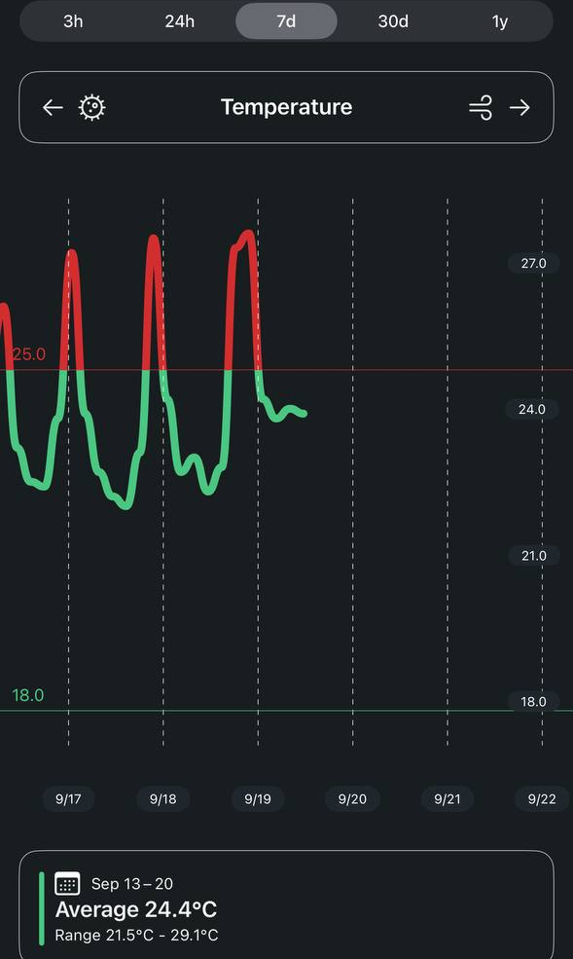 | (b) Humidity  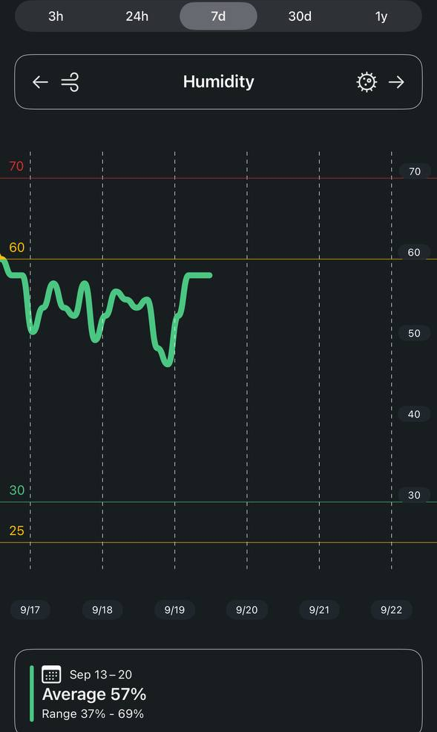
Figure 5.7: The 7-day graphs of the Wave Mini app: (a) temperature and (b) humidity, with the average and range for 13–20 September.

5.4.3 Mould Risk and VOC at the Same Moment
Table 5.9 lists what the two devices showed at the same moment, at about 23:57 on 19 September. Figure 5.8 shows the two screens, the dashboard of the prototype and the app of the Wave Mini.

Parameter | Prototype | Wave Mini
Temperature | 24.1 °C | 24.0 °C
Relative humidity | 57% | 58%
Mould risk | 0 out of 10 (SAFE) | 1 out of 10
VOC | 131.7 kΩ, raw gas resistance (GOOD) | 72 ppb (Good)
CO2 | 845 ppm (FAIR) | not measured
PM2.5 | 6 µg/m³ (GOOD) | not measured
Table 5.9: The readings of the two devices at about 23:57 on 19 September 2026.
For mould risk, the Wave Mini showed 1 out of 10 and the prototype 0 out of 10. On the scale of the Wave Mini, values below 3 are the lowest band (Airthings, 2022), and on the scale of the prototype the scores from 0 to 3 are SAFE (Section 4.3.2). Both devices are therefore in their lowest band and give the same message, that the risk of mould is minimal.
Both devices also rate the VOC level as good. The prototype shows the raw resistance of the sensor in kΩ, while the Wave Mini shows an estimate in ppb, which it calibrates to the room over about 7 days (Airthings, 2022). The colour light of the Wave Mini was green as well (Figure 5.9). Green means that the current readings of the sensors are in the healthy range (Airthings, 2022), and the LED of the prototype was also green (Figure 5.6).
(a) Prototype | (b) Wave Mini  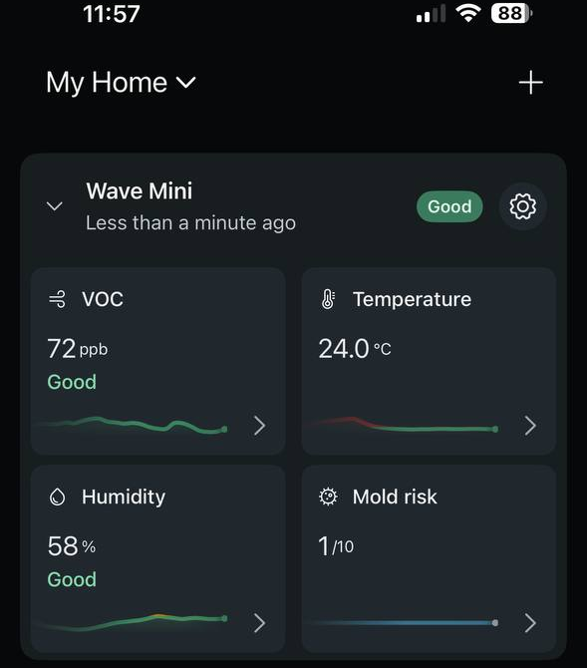
Figure 5.8: The two devices at the same moment: (a) the prototype dashboard at 23:58 and (b) the Wave Mini app at 23:57 on 19 September 2026.
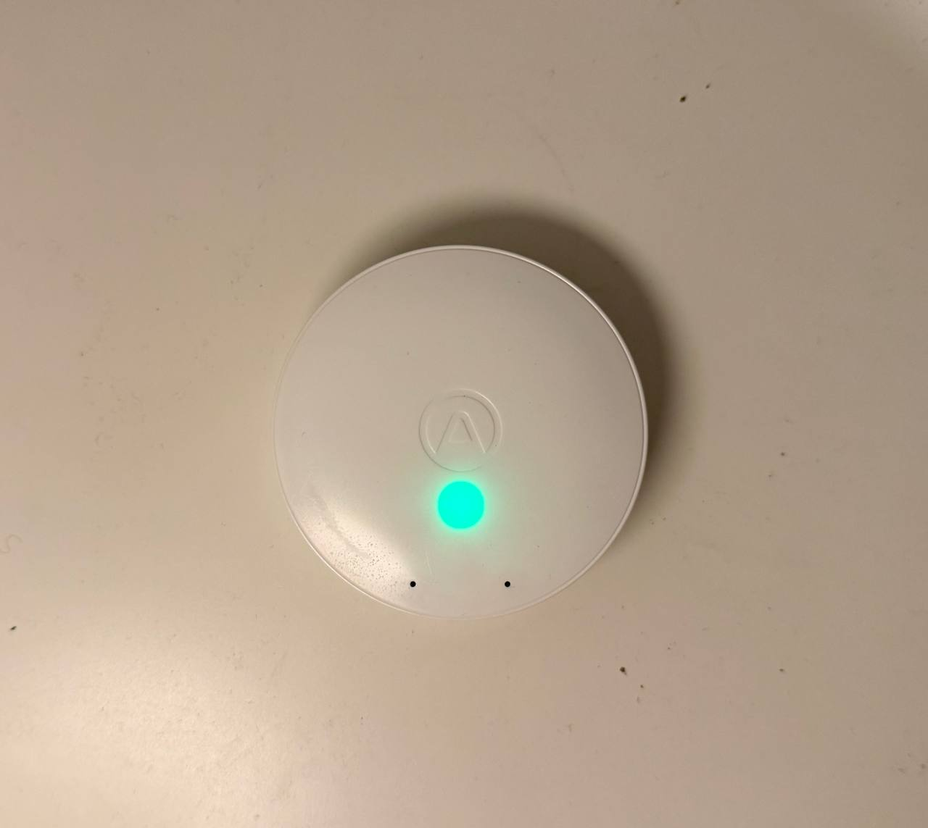
Figure 5.9: The colour light of the Airthings Wave Mini, which is green.

5.4.4 Discussion and Limits
The comparison meets the criterion of test T7. Temperature and humidity agree with the Wave Mini much more closely than the combined tolerances of the two sensors allow, and both devices give the same conclusion on mould risk. This supports the readings of the BME688 in the prototype, which are the input of the mould model.
The comparison also has limits. The Wave Mini is a low-cost sensor as well and not a reference instrument, so the agreement shows that the two devices are consistent with each other and not that either is exact. The manual of the Wave Mini says that its mould-risk value is meant for the area within about 40 cm of the device (Airthings, 2022). Here the two devices were only in the same room, so the comparison shows that the two indicators agree in this room and not more.

5.5 Industry-Expert Evaluation
Whether a device could work as a product cannot be measured on a bench. Test T9 therefore asks an expert from industry to judge the design, the cost and the need for the device (Table 5.1). As stated in Section 3.5, the expert is not named.

5.5.1 Method
The meeting took place on 14 September 2026. I presented the prototype, the PCB design (Section 4.5) and the cost analysis (Table 4.4) to the industry expert, who works for the industry partner (Section 1.2). I asked six open questions from an industry point of view, on the need, the risks, the PCB, the cost and possible improvements. The expert then completed a written questionnaire with 12 statements, each rated from 1 (strongly disagree) to 5 (strongly agree). The completed questionnaire is in Appendix A.

5.5.2 Questionnaire Results
Table 5.10 shows the ratings. Six statements were rated 5, four were rated 4 and one was rated 3. For one statement, the questionnaire has both the 4 and the 5 box marked. It is shown as 4–5 in the table and counted as 4.5 in the average. No statement was rated below 3, and the average rating is 4.5 (4.46).
No. | Statement | Rating
1 | This project addresses a genuine and practical need. | 5 – Strongly agree
2 | The overall concept has been well thought through. | 5 – Strongly agree
3 | The device is well-constructed and presented to a professional standard. | 4–5 (both boxes marked)
4 | The dashboard interface is clear and intuitive to use. | 4 – Agree
5 | Based on the demonstration, the device performs reliably. | 4 – Agree
6 | The project demonstrates a strong level of engineering competence. | 5 – Strongly agree
7 | The estimated production cost per unit is reasonable. | 3 – Neutral
8 | The design could realistically be scaled for volume manufacturing. | 4 – Agree
9 | The device could compete effectively with similar products currently on the market. | 4 – Agree
10 | There is a genuine market demand for a device of this type. | 5 – Strongly agree
11 | The project is at a stage where further commercial development would be worthwhile. | 5 – Strongly agree
12 | There is clear scope for this project to be developed further toward an industrial or commercial product. | 5 – Strongly agree
Table 5.10: The ratings of the industry expert on the 12 statements of the questionnaire.

The only neutral rating, 3, was for the cost per unit. This matches what the expert said about the cost in the meeting.

5.5.3 Comments from the Meeting
Need and market. The expert was confident there is a real market for a device like this, pointing to the new legal duties on landlords to investigate and fix damp and mould within fixed times (Section 1.1), and saw its main strength in combining general air-quality sensing and mould-risk prediction in one device, a combination not seen elsewhere. Since the law creates a duty to act on damp and mould but does not require a monitoring device, the project is best seen as a compliance-support tool, helping detect and record a rising risk before a complaint or deadline, not as a legally required product.
Battery life. The expert named battery life as the main risk, because the PM2.5 sensor draws current constantly; industrial devices usually solve this with duty cycling. This agrees with the power budget (Section 4.5.12), where the PMS5003 is the largest single load (about 160 mA, Table 4.3) with a standby current below 0.2 mA.
Manufacturing. The expert did not see any problem in producing the PCB. A two-layer board is straightforward to make and to assemble on standard automated equipment (Section 4.5.13).
Cost. The expert found £62 for one unit expensive but £30 at 100 units reasonable, matching the neutral cost rating; the figures cover parts and board production only (Section 4.5.13), so a finished product would cost more.
Connectivity. The main suggestion was to add LTE connectivity (NB-IoT or LTE Cat-1), so the device does not depend on the property's WiFi, which a landlord cannot rely on a tenant to keep available. This links to the dashboard limit in Section 4.4.6.

5.5.4 Use of the Findings
The two technical suggestions, duty cycling of the PM2.5 sensor and cellular connectivity, become recommendations for future work in Chapter 6. They do not change the prototype, which runs on USB power and WiFi, but they show what a next version needs.

5.5.5 Discussion and Limits
The evaluation meets the criterion of test T9. The expert rated the need for the device and the concept with the highest rating, rated the cost as neutral, and gave no negative rating.
The evaluation also has limits. The expert works for the industry partner that supported the project, so the ratings may be more favourable than those of an outsider. All 12 statements are worded positively, which can make agreement more likely. Finally, the ratings are opinions and not measurements. They support the commercial case for the device, but they do not prove that there is demand for it.

5.6 Evaluation Against the Objectives
In this section, I bring the results together (test T10). In Section 5.6.2, I judge each of the six objectives in Section 1.4 against the evidence, as an informed argument in the sense of Hevner et al. (2004). I rate each objective as achieved, achieved with limits, or partly achieved.

5.6.1 Results of the Tests
Table 5.11 gives the result of each test against the success criterion in Table 5.1. All the tests were passed.

Test | Result | Section
T1 | Passed. The score was the same in all 8,760 hours, and the largest difference in the index was 0.000077 (limit 0.001). | 5.2
T2 | Passed. The plateaus of 5.5 and 4.0 are the same as in the published curves, and the growth times are of the same order (compared by eye). | 5.2
T3 | Passed. Short humidity peaks left the score unchanged (index at most 0.0037 before the leak), and the three-week leak raised the device to CAUTION after 16 days. | 5.2
T4 | Passed. One update took 0.56 ms, against a reading cycle of 5 seconds. | 5.2
T5 | Passed. All parameters were shown and logged with plausible values, and the dashboard values were the same as the log. | 5.3
T6 | Passed. The device logged continuously for 3.8 days (12,934 readings in 5.7 days). | 5.3
T7 | Passed. The averages differed by 0.1 °C and 2 percentage points from the Wave Mini, and both gave the same mould-risk conclusion. | 5.4
T8 | Passed. The Design Rule Check reported 0 warnings and 0 rule violations. | 4.5.11
T9 | Passed. The need and the concept were rated 5, the cost 3 (neutral), and the average rating was 4.5. | 5.5
T10 | This section. | 5.6
Table 5.11: The results of the ten tests.

5.6.2 The Six Objectives
Table 5.12 shows the evidence for each objective and the result. The paragraphs after the table explain each result and its limits.
Objective | Evidence | Result
1. Literature review and gap | Review of health effects, UK law, mould models and four commercial monitors, leading to a clear gap (Sections 2.1 to 2.6). | Achieved
2. Hardware and firmware platform | ESP32 with three sensors, display, LED and dashboard (Sections 4.1 to 4.4); functional tests passed and 3.8 days of continuous logging (Section 5.3). | Achieved
3. Mould-risk algorithm | Published VTT/ASHRAE equations in C++, updated with real elapsed time (Section 4.3.2); tests T1 to T4 passed (Section 5.2). | Achieved
4. Validation and Wave Mini comparison | Identical scores against an independent Python model (Section 5.2); temperature and humidity agree with the Wave Mini, with the same mould-risk conclusion (Section 5.4). | Achieved, with limits
5. PCB and commercial viability | PCB designed, with 0 rule violations, and cost estimated (Section 4.5); industry expert rated the need and the concept 5 (Section 5.5); board not manufactured. | Partly achieved
6. Reflection and dissertation | This dissertation, the submitted artefact and the reflection in Chapter 6. | Achieved
Table 5.12: The six objectives, the evidence for each, and the result.

Objective 1: literature review. The review led to a clear gap, since within the literature and products reviewed, none combines full air-quality sensing with a published, transparent mould-risk model (Section 2.6). The objective is achieved. Its limit is scope. Four commercial products are a small sample, so the gap is stated for the products reviewed and not for the whole market.
Objective 2: hardware and firmware platform. The objective is achieved. The limits are that the platform is a breadboard prototype, that the VOC value is a raw resistance and not a calibrated concentration, that the dashboard has no password (Section 4.4.6), and that the device needs a WiFi network.
Objective 3: mould-risk algorithm. The objective is achieved. The limits come from the model and not from the implementation. The device measures the air of the room and not the surface of a wall, it assumes one generic material, and the score bands are a design choice (Sections 1.5 and 5.2.7).
Objective 4: validation and comparison. The objective is achieved with limits. The simulation uses artificial data, and I wrote both implementations. The comparison used one commercial device in one room, and neither device is a reference instrument. The mould index was not compared with real mould growth, which would need laboratory work (Section 5.1.3). The comparison with a reference instrument planned in the interim report (Section 3.4) was not made.
Objective 5: PCB and commercial viability. The objective is only partly achieved, because the board has not been manufactured or tested. It is therefore an expectation, and not yet a result, that the same firmware runs on it (Section 4.5.14). The commercial assessment rests on one expert who works for the industry partner, and the expert rated the cost as neutral.
Objective 6: reflection and dissertation. This dissertation, with the submitted artefact (source code, tests and test data), documents the work from the problem to the results. Chapter 6 reflects on the outcomes. The objective is achieved.

5.6.3 Overall Evaluation
Four of the six objectives were achieved, objective 4 was achieved with limits, and objective 5 was achieved in part. No objective was missed, and the changes from the interim plan (Section 3.4) did not stop any of them.
The evidence is weaker in four places. First, the mould index was not compared with real mould growth, so the tests show that the device follows the published model correctly, but not that the model predicts mould in every home. Second, the real-world tests cover one room and about six days, without a humid period. Third, the comparison used one commercial device and the assessment one expert. Fourth, the PCB is a design that still has to be built. In the terms of design science, the evaluation shows that the artefact is correctly built and useful for its purpose (Hevner et al., 2004). It does not yet show how well it works in the homes of tenants and landlords.

6 Conclusions and Recommendations
The aim of the project was to design, develop and validate a low-cost, autonomous indoor air quality monitor that predicts mould risk from a published scientific model, without a dedicated mould sensor (Section 1.3).

6.1 Critical Reflection

6.1.1 What Worked
Four decisions worked well: the incremental build, which meant a fault could almost always be traced to the one new part just added (Section 4.6.1); adding a diagnostic before trying a fix, so the I2C scan, error text, checksum test and WiFi list each turned a vague symptom into a clear one (Section 4.6.5); moving the dashboard onto the device, which removed the need for a cloud service and a message broker (Section 3.4); and testing the algorithm independently, since a mould-risk score can look reasonable and still be wrong, so I compared the firmware with a second implementation on a dataset with known events (Section 5.2).

6.1.2 What Was Difficult
The largest difficulty came early: the industry partner’s board could not be used because its debug access was locked (Section 3.4), so I changed to an independent ESP32 system, which gave me full control but meant designing and testing every part from the beginning.
A second difficulty was the mould model itself, described across more than one paper, so I had to put the equations together and check them with care (Hukka and Viitanen, 1999; Viitanen and Ojanen, 2007). My early rule-based score was simple but not based on the science, and I replaced it once tests showed it gave the maximum score after about a day at 65% humidity (Section 5.2.6); the lesson is to go to the primary sources early.
The change to my validation plan (Section 3.4) was a trade-off: a simulated year checked against an independent implementation is a strong test of the code, but not of sensor accuracy against a reference-grade instrument, so I only compared the sensors with another low-cost device (Section 5.4).

6.1.3 What I Would Do Differently
I would do three things differently. First, I would order the PCB earlier, so that I could build and test it before the end of the project and not only design it. Second, I would start the real-world logging sooner and cover more than one room, so that a humid period would be more likely to be included. Third, I would keep the dataset, the reference model and the test results under version control from the beginning, so that I could repeat every result exactly from a labelled version.

6.2 Achievement of the Objectives
Section 5.6 judges each objective against the evidence: four were achieved, one with limits and one in part. The aim of the project has therefore been met for the device as a working prototype, though I have not shown that it gives an early warning in real homes, which is the main question that remains open.

6.3 Contribution and Limits
My contribution is a software-engineering one and not a new mould formula (Section 2.6): I turned the published VTT/ASHRAE model into embedded C++ that runs continuously on a low-cost microcontroller, alongside independent CO2, VOC and PM2.5 sensing, and showed it gives the same results as an independent implementation. I documented the equations, the code and the tests, so the work can be checked and repeated — not possible for a product whose algorithm is unpublished.
There are two practical results: the device itself, with five parameters and a mould-risk score in one unit, a dashboard and a CSV download needing no cloud service; and my PCB design with a cost estimate of about £62 for one unit and £30 for 100 units, which the industry expert found reasonable at volume (Section 5.5).
My contribution has the same limits as those in Sections 1.5 and 5.6: it measures room air, not a wall surface, and assumes one generic material (pine, resawn), while the model was fitted to pine and spruce sapwood and is weaker for other materials (Viitanen and Ojanen, 2007; Kopecký and Staněk, 2023). I therefore see it as a tool that supports compliance, helping to detect and record a rising risk, as the industry expert described it (Section 5.5.3), and not as a proven prediction of mould.

6.4 Recommendations for Future Work
The recommendations follow from the limits of the project and from the comments of the industry expert. Table 6.1 lists them, with the reason for each.
Area | Recommendation | Reason
1. PCB | Order, assemble and test the boards: the power rails first, then an I2C scan, the UART link and the firmware with the two new pin numbers. Measure the current and the 3.3 V rail during WiFi activity. | Shows that the design works and that the same firmware runs on it (Section 4.5.14).
2. Power | Switch the PMS5003 on only for short periods, use the low-power mode of the SCD40, and review the WiFi power-saving setting. | Battery life was the main risk named by the expert (Sections 4.5.12 and 5.5.3).
3. Connectivity | Add LTE Cat-1 or NB-IoT, with an alert when the risk stays above SAFE. | The device would not depend on the WiFi of the property, and the dashboard has no remote access (Sections 4.4.6 and 5.5.3).
4. Set-up | Replace the fixed network name with a set-up page on the device, and let the device be found by a name instead of reading its IP address from the display. | Easier installation in homes (Section 4.6.4).
5. Security | Add a password and HTTPS to the dashboard. | Anyone on the network can view the dashboard and clear the log (Section 4.4.6).
6. VOC | Use the Bosch BSEC library to turn the raw gas resistance into an air-quality index. | The current value is uncalibrated (Section 5.3.4).
7. Model | Add material-specific parameters, and if possible measure the conditions near a cold wall and not only in the room air. | The model was fitted to wood and the air is only a proxy for the surface (Sections 1.5 and 5.2.7).
8. Field trials | Test in several rooms and homes over weeks and through a humid season, with a reference instrument, with checks for real mould, and with tenants and landlords as users. | The present tests cover one room and about six days (Section 5.1.3).
9. Compliance support | Produce a report of the periods above SAFE, with dates and times, that a landlord can keep as a record. | The law creates a duty to act on damp and mould, not to install a device (Section 5.5.3).
Table 6.1: Recommendations for future work.

The first three recommendations are the most urgent. I have to build the PCB before I can say anything more about the hardware. The battery and connectivity points come from the industry expert, and both matter for a device that landlords would use. The PMS5003 is both the largest load on the battery and the largest cost item (Section 4.5.13), so it is the part to review first.

References
Aerosemi Technology (n.d.) MT3608: high efficiency 1.2MHz 2A step up converter. Available at: https://www.radiolocman.com/datasheet/pdf.html?di=177837 (Accessed: 19 September 2026).
Air Purifier First (n.d.) Qingping Air Quality Monitor (Generation 2) – hands-on review. Available at: https://www.airpurifierfirst.com/review/qingping-air-quality-monitor-gen-2/ (Accessed: 19 September 2026).
Airthings (2022) Wave Mini: user manual. Version 5. Available at: https://www.airthings.com/manuals/wave-mini (Accessed: 20 September 2026).
Aranet (n.d.) Aranet4 HOME: CO2 monitor for indoor air quality at home and work. Available at: https://aranet.com/products/aranet4/ (Accessed: 19 September 2026).
ASHRAE (2016) Addendum e to ANSI/ASHRAE Standard 160-2009: Criteria for moisture-control design analysis in buildings. Atlanta, GA: ASHRAE.
Benton, E. (2024) ‘Damp and mould—the big picture. How do we tackle the damp and mould crisis in social housing: lessons from the UK’, Frontiers in Environmental Health, 3, article 1340092. Available at: https://doi.org/10.3389/fenvh.2024.1340092.
Bosch Sensortec (2024) BME688: digital low power gas, pressure, temperature & humidity sensor with AI. Datasheet, revision 1.3, document number BST-BME688-DS000-03. Available at: https://www.bosch-sensortec.com/media/boschsensortec/downloads/datasheets/bst-bme688-ds000.pdf (Accessed: 20 September 2026).
Cincinelli, A. and Martellini, T. (2017) ‘Indoor air quality and health’, International Journal of Environmental Research and Public Health, 14(11), p. 1286.
Espressif Systems (n.d.) ESP32-MINI-1 & ESP32-MINI-1U datasheet. Version 1.5. Available at: https://www.espressif.com/sites/default/files/documentation/esp32-mini-1_datasheet_en.pdf (Accessed: 19 September 2026).
Hevner, A.R., March, S.T., Park, J. and Ram, S. (2004) ‘Design science in information systems research’, MIS Quarterly, 28(1), pp. 75–105.
Hukka, A. and Viitanen, H. (1999) ‘A mathematical model of mould growth on wooden material’, Wood Science and Technology, 33(6), pp. 475–485.
Iacobucci, G. (2022) ‘Awaab Ishak and the politics of mould in the UK’, eClinicalMedicine, 54, article 101801. Available at: https://doi.org/10.1016/j.eclinm.2022.101801.
IEEE (2004) IEEE Std 802.11i-2004: amendment 6: medium access control (MAC) security enhancements. New York: IEEE.
Kopecký, P. and Staněk, K. (2023) ‘Modelling of mould growth on pine sapwood: the preliminary analysis of input parameters in a logistic mould growth model’, Journal of Physics: Conference Series, 2654, article 012018. Available at: https://doi.org/10.1088/1742-6596/2654/1/012018.
Microchip Technology (2014) MCP73831/2: miniature single-cell, fully integrated Li-Ion, Li-Polymer charge management controllers. DS20001984G. Available at: https://www.radiolocman.com/datasheet/pdf.html?di=128841 (Accessed: 19 September 2026).
Microchip Technology (2016) MCP1700: low quiescent current LDO. Available at: https://www.radiolocman.com/datasheet/pdf.html?di=128895 (Accessed: 19 September 2026).
Open Source Hardware Association (2024) AirGradient ONE. Available at: https://certification.oshwa.org/th000013.html (Accessed: 19 September 2026).
Peixe, J. and Marques, G. (2024) ‘Low-cost IoT-enabled indoor air quality monitoring systems: a systematic review’, Journal of Ambient Intelligence and Smart Environments, 16(2), pp. 167–180. Available at: https://doi.org/10.3233/AIS-220577.
Plantower (2019) PMS5003 series data manual. Available at: https://docs.smartcitizen.me/assets/datasheets/pms5003/PTQ3004-2015%20PMS5003%20series%20data%20manual%20English_SLT_V1.0K.pdf (Accessed: 19 September 2026).
Russell-Cooke LLP (n.d.) Awaab’s Law – extending safety standards to the private rented sector. Available at: https://www.russell-cooke.co.uk/news-and-insights/news/awaab-s-law-extending-safety-standards-to-the-private-rented-sector (Accessed: 19 September 2026).
Sensirion (2021) SCD4x datasheet. Version 1.1. Available at: https://www.alldatasheet.com/html-pdf/1425089/SENSIRION/SCD40-D-R2/2297/4/SCD40-D-R2.html (Accessed: 19 September 2026).
Sensirion (n.d.) Low power operation of SCD4x CO2 sensors. Application note. Available at: https://sensirion.com/en/media/documents/077BC86F/62BF01B9/CD_AN_SCD4x_Low_Power_Operation_D1.pdf (Accessed: 19 September 2026).
Shelter England (2025) Round up of housing law and news: October 2025. Available at: https://england.shelter.org.uk/professional_resources/news_and_updates/round_up_of_housing_law_and_news_october_2025 (Accessed: 19 September 2026).
Social Housing (Regulation) Act 2023, c. 36. Available at: https://www.legislation.gov.uk/ukpga/2023/36/contents (Accessed: 19 September 2026).
TJR Ventilation Solutions (n.d.) Airthings Hub. Available at: https://www.tjrvent.co.uk/product-page/airthings-hub (Accessed: 16 September 2026).
Viitanen, H. and Ojanen, T. (2007) ‘Improved model to predict mold growth in building materials’, in Thermal Performance of the Exterior Envelopes of Whole Buildings X: proceedings of the Buildings X Conference, Clearwater Beach, FL, 2–7 December 2007. Atlanta, GA: ASHRAE, pp. 1–8. Available at: https://web.ornl.gov/sci/buildings/conf-archive/2007%20B10%20papers/162_Viitanen.pdf (Accessed: 20 September 2026).

Appendices

Appendix A: Industry Evaluation Questionnaire
The questionnaire completed by the industry expert, as described in Section 5.5. 

Appendix B: Periodic Progress Reports
The periodic progress reports written during the project, in order.
Project Periodic Progress Report
Programme/Course Title: MSc Computing (Software Engineering)
Name: Parastoo Shojaei
Project Title: Smart Indoor Air Quality Monitor with Mould Risk Prediction Report Number: 1

Objectives for Period: (refer to previous report)
Share the project plan with the industry partner and begin MVP Phase 1: setting up the development environment, getting a development board running, and beginning PM2.5 sensor integration.

Summary of Progress for Period: (identify evidence of progress)
Shared the project plan with the industry partner (Mavis Technologies) and collected the Mavis Technologies development board. As the board's firmware is confidential, work will proceed from the schematic provided rather than from the firmware itself.

Problem Areas and Suggested Solutions:
None at this stage.

Objectives, Deliverables & Plan for Next Period:
Begin the MVP Phase 1 hardware investigation of the Mavis board and set up the development environment.

Date: 22 June 2026
Project Periodic Progress Report
Programme/Course Title: MSc Computing (Software Engineering)
Name: Parastoo Shojaei
Project Title: Smart Indoor Air Quality Monitor with Mould Risk Prediction Report Number: 2

Objectives for Period: (refer to previous report)
Review the Mavis board and schematic in detail; order and receive all components needed for prototyping; establish communication with the Mavis board.

Summary of Progress for Period: (identify evidence of progress)
Reviewed the Mavis board and schematic in detail. Ordered and received all prototyping components (ESP32, PMS5003 PM2.5 sensor, OLED display, and supporting components). Began firmware development, starting with the development environment setup and an attempt to establish UART communication between the Mavis board and the ESP32. As part of this, powered the Mavis board via an ST-Link V2 programmer (confirming a target voltage of 3.12V and successful STM32 boot) and attempted SWD debug access via STM32CubeProgrammer, and separately monitored the board's debug UART output via a USB-to-TTL converter across all commonly used baud rates (4800 to 230400).

Problem Areas and Suggested Solutions:
STM32CubeProgrammer reported “No STM32 target found” at every SWD frequency tested, and the UART output was garbled at every baud rate tested. This indicates debug access is locked on the board (likely via STM32 Read-Out Protection) and/or the data is encoded, and since the firmware is confidential, the correct communication protocol cannot be reverse-engineered within the scope of this project.

Objectives, Deliverables & Plan for Next Period:
Conclude the Mavis board investigation and, if debug access cannot be resolved, proceed with a fully independent ESP32-based system.

Date: 6 July 2026
Project Periodic Progress Report
Programme/Course Title: MSc Computing (Software Engineering)
Name: Parastoo Shojaei
Project Title: Smart Indoor Air Quality Monitor with Mould Risk Prediction Report Number: 3

Objectives for Period: (refer to previous report)
Conclude the Mavis board investigation and, if necessary, begin development of a fully independent ESP32-based system.

Summary of Progress for Period: (identify evidence of progress)
Concluded the Mavis board investigation: the board powers on and actively transmits serial data, but SWD debug access could not be established and the UART baud rate could not be identified, and the firmware is confidential (confirmed by the industry partner). Decision made to proceed with a fully independent ESP32-based system. Set up the ESP32 development environment (Arduino IDE 2.3.2, esp32 board package v3.3.11) and completed board bring-up (blink/serial test). Integrated the OLED display (SSD1306 library) with a rotating 3-page layout (readings / mould score / network info), established WiFi connectivity (using a phone hotspot with “Maximize Compatibility” enabled for 2.4GHz support), built an initial web dashboard (auto-refreshing, with a rolling humidity trend chart) using simulated sensor values as a placeholder, redesigned the dashboard visually with a colour-coded GOOD/FAIR/POOR status system and a circular mould-risk gauge modelled on commercial air-quality products, and implemented three-tier RGB LED status logic (green/yellow/red).

Problem Areas and Suggested Solutions:
Progress was slower than planned this period due to moving house. More time will be dedicated to the project over the coming weeks to make up for lost time and stay on schedule. A minor firmware issue — the Arduino compiler rejecting raw non-ASCII characters (e.g. °, checkmarks) embedded directly in string literals — was resolved by using HTML numeric character references instead.

Objectives, Deliverables & Plan for Next Period:
Integrate the SCD40 and BME688 sensors once they arrive, replacing the simulated sensor placeholder with real readings.

Date: 24 July 2026
Project Periodic Progress Report
Programme/Course Title: MSc Computing (Software Engineering)
Name: Parastoo Shojaei
Project Title: Smart Indoor Air Quality Monitor with Mould Risk Prediction Report Number: 4

Objectives for Period: (refer to previous report)
Integrate the SCD40 (CO2) and BME688 (temperature, humidity, VOC) sensors with the ESP32 and display live readings, replacing the simulated placeholder values.

Summary of Progress for Period: (identify evidence of progress)
Received the SCD40 and BME688 sensors and soldered pin headers onto both boards. Wired both sensors to the ESP32 over the shared I2C bus alongside the OLED display. Ran an I2C scanner to confirm both sensors were detected correctly (address 0x62 for the SCD40, 0x76 for the BME688). Integrated the live sensor readings into the existing WiFi-connected web dashboard and the on-device OLED display, replacing the earlier simulateSensorReadings() placeholder function (PM2.5 remained a hard-coded placeholder value at this stage, pending the PM2.5 sensor's adapter cable).

Problem Areas and Suggested Solutions:
Two minor firmware issues were resolved: duplicate .ino files left in the same project folder caused “redefinition” compiler errors and were removed; the SCD40 initially returned a “Not enough data received” error because it was read before its first measurement cycle completed, fixed by checking data-ready status before every read. This update was sent two days later than planned (Monday instead of Friday).

Objectives, Deliverables & Plan for Next Period:
Integrate the PMS5003 PM2.5 sensor; add persistent data logging; begin implementing the mould-risk prediction algorithm based on ASHRAE Standard 160 using the real temperature and humidity data now available.

Date: 10 August 2026
Project Periodic Progress Report
Programme/Course Title: MSc Computing (Software Engineering)
Name: Parastoo Shojaei
Project Title: Smart Indoor Air Quality Monitor with Mould Risk Prediction Report Number: 5

Objectives for Period: (refer to previous report)
Integrate the PMS5003 PM2.5 sensor so all four sensors operate together; add persistent data logging; begin the mould-risk prediction algorithm.

Summary of Progress for Period: (identify evidence of progress)
Connected the PMS5003 sensor (via UART, with checksum-validated frame parsing), so all four sensors (CO2, temperature, humidity, VOC, and PM2.5) are now working together on the ESP32. Updated the web dashboard and OLED display to show live PM2.5 readings. Added persistent CSV data logging to internal flash storage (LittleFS) with NTP time synchronisation (London timezone, automatic BST/GMT switching) and web endpoints to download or clear the log. Made a start on the mould-risk prediction algorithm using real sensor data, based on ASHRAE Standard 160.

Problem Areas and Suggested Solutions:
The SCD40, having worked correctly earlier, later failed to initialise, returning “Error writing to I2C bus” (error 270) on every attempt, even though an I2C scan still showed its address on the bus — indicating a power-supply issue rather than a wiring/address problem. Diagnosed using a bus scanner, human-readable error messages, and a retry loop; resolved by replacing the SCD40's power jumper wires, after which it initialised successfully.

Objectives, Deliverables & Plan for Next Period:
Continue development and validation of the mould-risk algorithm using the newly available logged data.

Date: 21 August 2026
Project Periodic Progress Report
Programme/Course Title: MSc Computing (Software Engineering)
Name: Parastoo Shojaei
Project Title: Smart Indoor Air Quality Monitor with Mould Risk Prediction Report Number: 6

Objectives for Period: (refer to previous report)
Validate the mould-risk algorithm's behaviour against real logged data and correct any issues found.

Summary of Progress for Period: (identify evidence of progress)
Analysed downloaded CSV log data to validate the mould-risk algorithm. Discovered that the original algorithm added a fixed increment on every sensor reading (every 5 seconds) rather than scaling with real elapsed time, causing the risk score to climb from 0 to 7 (out of 10) in under 10 minutes at only ~62% humidity — unrepresentative of real mould growth, which depends on sustained exposure over hours to days. Rewrote the algorithm to calculate real elapsed time between readings and apply humidity- and temperature-dependent rates per real hour instead of per reading.

Problem Areas and Suggested Solutions:
Post-fix validation confirmed the correction: a brief steam-induced humidity spike to 78.1% (lasting 15-20 seconds) caused no change in the score, correctly ignoring momentary fluctuations; over a 2.7-hour session with humidity mostly at 56-60% (around 40 minutes near 60-61%), the logged score remained 0, exactly matching the theoretical calculation (rate 0.3/hr x temperature factor 1.25 x elapsed 0.67hr = 0.25, which rounds down to 0). No unresolved problems.

Objectives, Deliverables & Plan for Next Period:
Validate the corrected algorithm against a wider range of synthetic test scenarios beyond what real-world testing can practically cover.

Date: 24 August 2026
Project Periodic Progress Report
Programme/Course Title: MSc Computing (Software Engineering)
Name: Parastoo Shojaei
Project Title: Smart Indoor Air Quality Monitor with Mould Risk Prediction Report Number: 7

Objectives for Period: (refer to previous report)
Validate the mould-risk algorithm against a wide range of synthetic humidity and temperature scenarios beyond what could be tested in real conditions.

Summary of Progress for Period: (identify evidence of progress)
Implemented a Python port of the algorithm and tested it against seven designed 30-day scenarios (constant high/moderate/low humidity, daily humidity cycles, gradual increase, daily shower spikes, high humidity at low temperature), comparing results against an early ASHRAE-inspired reference model.

Problem Areas and Suggested Solutions:
The algorithm was found to saturate to maximum risk within days even at moderate (around 65%) sustained humidity, and did not correctly account for reduced mould growth at low temperature — behaviour inconsistent with established mould growth science, despite passing all real-world validation in the previous period. Identified as a significant limitation requiring the underlying model to be replaced with the actual published ASHRAE/Viitanen equations rather than a hand-designed heuristic.

Objectives, Deliverables & Plan for Next Period:
Undertake a focused literature investigation to obtain the exact published ASHRAE/Viitanen mould-growth equations.

Date: 27 August 2026
Project Periodic Progress Report
Programme/Course Title: MSc Computing (Software Engineering)
Name: Parastoo Shojaei
Project Title: Smart Indoor Air Quality Monitor with Mould Risk Prediction Report Number: 8

Objectives for Period: (refer to previous report)
Identify and obtain the primary published sources underlying the ASHRAE Standard 160 mould-risk model.

Summary of Progress for Period: (identify evidence of progress)
Obtained and read in full: ASHRAE Standard 160-2009 Addendum e; Viitanen & Ojanen (2007), “Improved Model to Predict Mold Growth in Building Materials”; and Hukka & Viitanen (1999), “A mathematical model of mould growth on wooden material” (Wood Science and Technology), accessed via the university library. The 1999 paper was found to contain equations (response-time functions, a correction factor, and the true maximum-index formula) not present in the more commonly cited 2007 paper alone.

Problem Areas and Suggested Solutions:
The two source papers use the surface-quality parameter with opposite sign conventions; this inconsistency was noted for reconciliation before the final write-up.

Objectives, Deliverables & Plan for Next Period:
Implement the complete, exact equation set in both the device firmware and an independent Python reference model.

Date: 30 August 2026
Project Periodic Progress Report
Programme/Course Title: MSc Computing (Software Engineering)
Name: Parastoo Shojaei
Project Title: Smart Indoor Air Quality Monitor with Mould Risk Prediction Report Number: 9

Objectives for Period: (refer to previous report)
Replace the heuristic algorithm with the exact ASHRAE/Viitanen equations in the device firmware and independently verify correctness.

Summary of Progress for Period: (identify evidence of progress)
Implemented the full equation set (critical relative humidity, maximum reachable index, response-time functions, correction factors, and growth/decline kinetics) in the ESP32 firmware. Independently re-implemented the same equations in Python. Generated a 12-month synthetic dataset (8,760 hourly readings, including a simulated 3-week leak and a 10-day dry spell) and ran both implementations against it, finding a maximum mould index of approximately 0.16-0.19 out of 6 across the full year.

Problem Areas and Suggested Solutions:
No implementation problems encountered. Cross-validation confirmed the maximum discrepancy between the C++ (device) and Python implementations was on the order of 5x10^-5 on the 0-6 mould index scale, attributable to floating-point precision differences between the two platforms rather than any implementation error.

Objectives, Deliverables & Plan for Next Period:
Build a dedicated test harness to run the same validation directly on the physical ESP32 hardware.

Date: 2 September 2026
Project Periodic Progress Report
Programme/Course Title: MSc Computing (Software Engineering)
Name: Parastoo Shojaei
Project Title: Smart Indoor Air Quality Monitor with Mould Risk Prediction Report Number: 10

Objectives for Period: (refer to previous report)
Confirm the algorithm's correctness directly on the ESP32 hardware, not only in simulation.

Summary of Progress for Period: (identify evidence of progress)
Built a standalone test sketch that loads the 12-month synthetic dataset (converted to a compact on-device data table) and runs the same algorithm as the main firmware, producing a downloadable results file. Ran the test on the physical device and compared the output against the Python reference model.

Problem Areas and Suggested Solutions:
Results matched to within floating-point precision, confirming the embedded implementation is correct. A WiFi connection issue affecting the test sketch's ability to upload results was resolved.

Objectives, Deliverables & Plan for Next Period:
Improve the dashboard's historical trend visualisation and progress the PCB design.

Date: 4 September 2026
Project Periodic Progress Report
Programme/Course Title: MSc Computing (Software Engineering)
Name: Parastoo Shojaei
Project Title: Smart Indoor Air Quality Monitor with Mould Risk Prediction Report Number: 11

Objectives for Period: (refer to previous report)
Add per-parameter historical trend visualisation to the web dashboard and resolve outstanding connectivity issues.

Summary of Progress for Period: (identify evidence of progress)
Implemented dedicated trend chart pages for each sensor parameter with selectable 24-hour, 7-day and all-time ranges, including an interactive tooltip showing the exact date, time and value at any point on the chart. Separately, a persistent WiFi connection failure (WRONG_PASSWORD despite correct credentials) when connecting to a network was traced to a character-encoding mismatch: an apostrophe in the network name had been silently converted to a typographic apostrophe by messaging software, differing from the plain ASCII apostrophe hardcoded in the firmware. Resolved by scanning for a stable substring of the network name and connecting using the exact SSID string returned by the device's own WiFi scan.

Problem Areas and Suggested Solutions:
The initial trend chart implementation read the log file twice using memory-heavy string objects, making the chart slow to load with several days of data. Rewritten as a single-pass implementation using a fixed-size sampling technique, significantly improving load time.

Objectives, Deliverables & Plan for Next Period:
Complete comparative testing against a commercial competitor device.

Date: 6 September 2026
Project Periodic Progress Report
Programme/Course Title: MSc Computing (Software Engineering)
Name: Parastoo Shojaei
Project Title: Smart Indoor Air Quality Monitor with Mould Risk Prediction Report Number: 12

Objectives for Period: (refer to previous report)
Benchmark the device against an existing commercial product with comparable functionality.

Summary of Progress for Period: (identify evidence of progress)
Purchased and ran an Airthings Wave Mini alongside the custom device in a real bathroom environment. Recorded overlapping temperature and humidity readings from both devices, finding close agreement (within approximately 0.6-1C and 2% respectively). Documented feature-level differences: the Wave Mini lacks CO2 and PM2.5 sensing, requires a separate paid Hub for continuous logging, and uses an undisclosed proprietary mould-risk algorithm.

Problem Areas and Suggested Solutions:
A temperature anomaly (a rise then fall over ~35 minutes), initially suspected to be a self-heating or placement artefact from laptop proximity, was corroborated as a genuine environmental event by the Wave Mini independently recording a similar dip-and-rise pattern at the same time, despite being a separate, independently placed device.

Objectives, Deliverables & Plan for Next Period:
Progress the PCB design in Altium and prepare a full itemised cost comparison.

Date: 8 September 2026
Project Periodic Progress Report
Programme/Course Title: MSc Computing (Software Engineering)
Name: Parastoo Shojaei
Project Title: Smart Indoor Air Quality Monitor with Mould Risk Prediction Report Number: 13

Objectives for Period: (refer to previous report)
Design a custom PCB to replace the breadboard prototype, integrating all sensors, power management and connectivity.

Summary of Progress for Period: (identify evidence of progress)
Completed a ten-block schematic in Altium Designer covering power input and charging, battery and voltage regulation, the MCU, the CO2 and environmental sensors, the PM2.5 sensor and OLED connectors, an LED status indicator, a programming and reset interface, and a boost-converter block to power the PM2.5 sensor from battery. Selected a compact ESP32-MINI-1-N4 module in place of the development board, with two GPIO pins used for the PM2.5 sensor remapped since they are not broken out on the smaller module, and the antenna area positioned to overhang the board edge with a clearance zone kept free of copper, per the module's RF layout guidelines.

Problem Areas and Suggested Solutions:
Several design issues were identified and corrected during review: capacitors were initially wired in series along the power trace, a critical error that would have blocked current flow entirely, and were corrected to proper parallel placement; the PM2.5 sensor connector was moved to a dedicated boosted voltage rail rather than the main logic rail, since the sensor requires a higher voltage than the module supplies directly to operate reliably on battery power.

Objectives, Deliverables & Plan for Next Period:
Complete a full itemised bill of materials and cost comparison; finalise remaining PCB layout details.

Date: 10 September 2026
Project Periodic Progress Report
Programme/Course Title: MSc Computing (Software Engineering)
Name: Parastoo Shojaei
Project Title: Smart Indoor Air Quality Monitor with Mould Risk Prediction Report Number: 14

Objectives for Period: (refer to previous report)
Produce a complete cost breakdown and formal comparison document against commercial alternatives.

Summary of Progress for Period: (identify evidence of progress)
Compiled a full itemised bill of materials with per-unit costs at quantities of one and one hundred, giving an estimated single-unit cost of approximately £62 and a bulk cost of approximately £30 per unit, compared with a commercial alternative's combined device-and-accessory cost of over £100. Produced a formal document comparing features, real-world data and cost against two commercial alternatives.

Problem Areas and Suggested Solutions:
None significant.

Objectives, Deliverables & Plan for Next Period:
Arrange an evaluation meeting with the industry contact ahead of dissertation write-up.

Date: 12 September 2026
Project Periodic Progress Report
Programme/Course Title: MSc Computing (Software Engineering)
Name: Parastoo Shojaei
Project Title: Smart Indoor Air Quality Monitor with Mould Risk Prediction Report Number: 15

Objectives for Period: (refer to previous report)
Arrange and conduct an industry evaluation meeting to gather independent feedback on the project's practical and commercial viability.

Summary of Progress for Period: (identify evidence of progress)
Arranged a meeting with the industry expert (Mavis Technologies) to present the completed prototype, PCB design, and cost analysis, and to ask for an independent perspective on the device. The meeting was held and a structured evaluation questionnaire was completed, covering technical quality and commercial potential.

Problem Areas and Suggested Solutions:
None significant.

Objectives, Deliverables & Plan for Next Period:
Begin drafting the dissertation report, incorporating all validation results, troubleshooting case studies, and industry feedback gathered to date.

Date: 15 September 2026

