Home page: Displays 100 art work images with title and accession number.

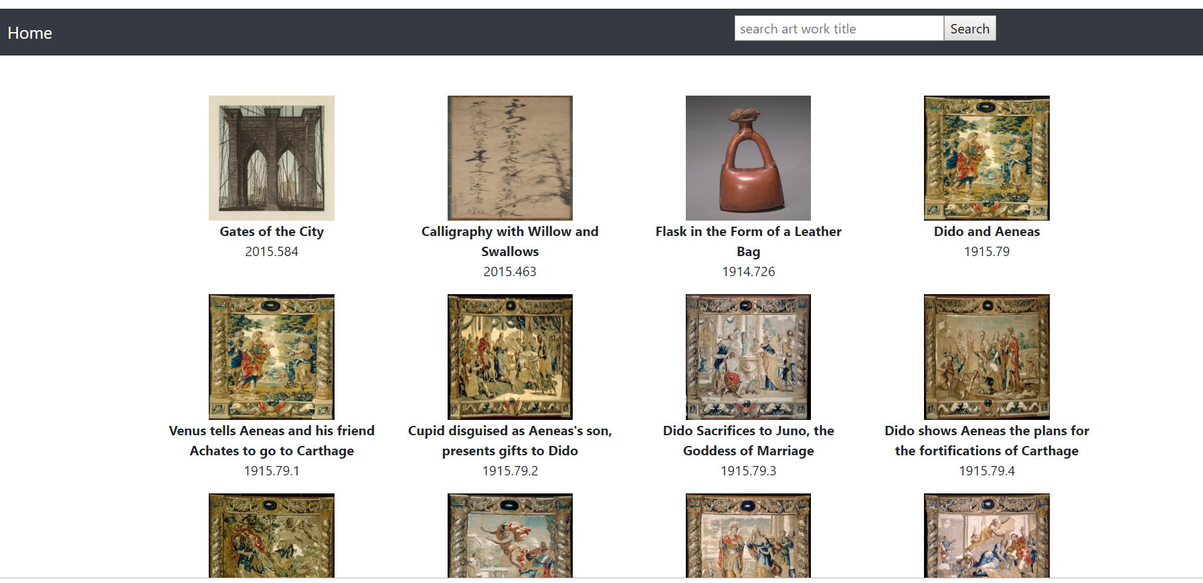

On click of Image

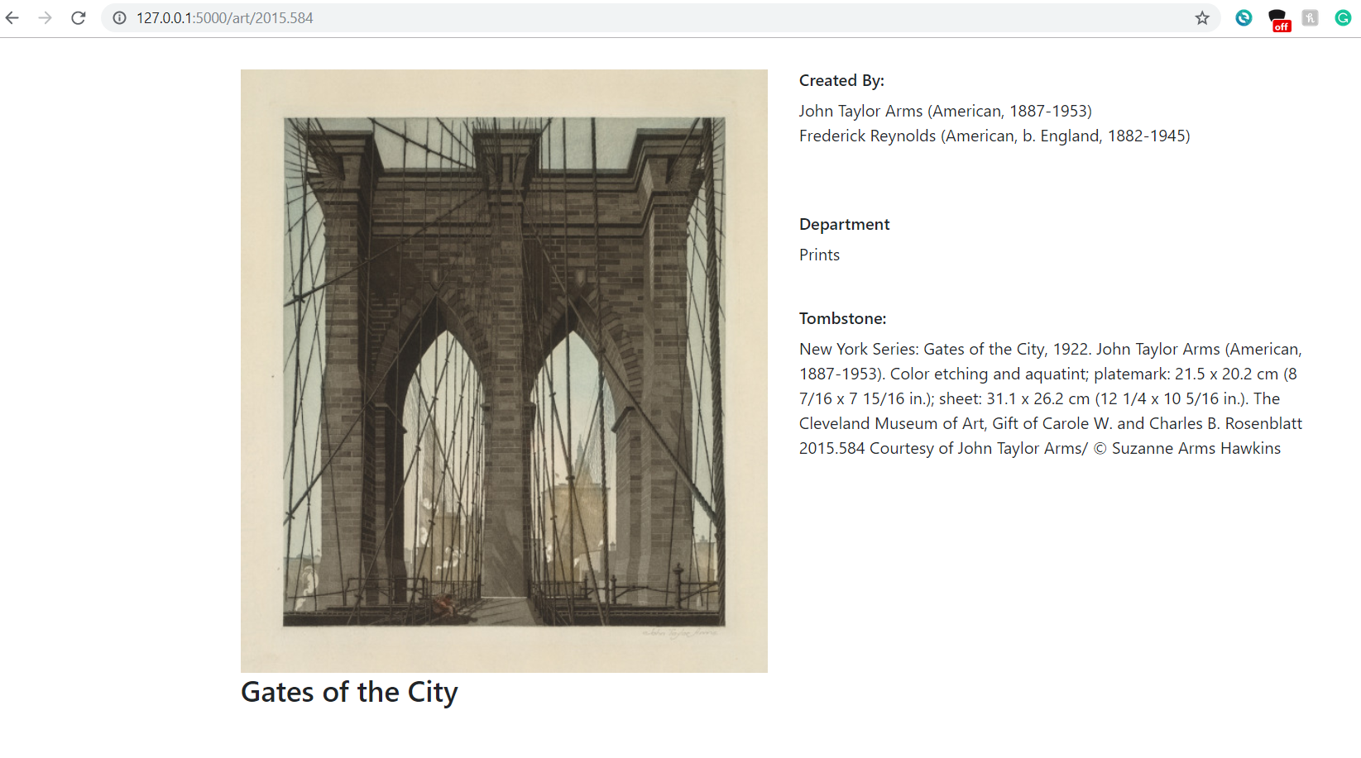

Search with art title

