Supplementary Material
Transcription Workflow, Model Settings, and Tesseract-vs-Vision-Model Readings
Digitised Johor rainfall register (Federated Malay States series, 1926–1958)

1. Transcription workflow
Each scanned register page is processed by a three-stage pipeline — DETECT → READ → STITCH — in which optical character recognition and a vision-language model play complementary roles and printed annual totals act as the final arbiter of which readings to trust. No value is ever altered to force a row to add up; every row is either verified against its printed annual, corrected by a single unambiguous fix, or kept exactly as read and flagged.

1.1 Stage 1 — Detection (structural gate)
The vision model proposes station-block boundaries on the full page (header position, column side, vertical extent). Each proposed block is then validated structurally by Tesseract OCR — not by the model that proposed it — using the token positions Tesseract returns. A block passes the gate only if five checks hold: (i) ~14 columns are recoverable; (ii) row pitch is regular (low coefficient of variation of inter-row spacing); (iii) the year column is monotonic; (iv) a header is present; and (v) a MEAN/MAX sentinel row is found at the foot. Detection uses Tesseract’s geometry (where tokens sit), which is reliable, not its character values (what the tokens say), which are not.

1.2 Stage 2 — Reading (Tesseract-first, reconciliation-gated escalation)
Within a validated block each row is read cheaply by Tesseract first. The twelve monthly values are summed and compared with the printed annual. The difference decides what happens next, on the following escalation ladder:
- ≤ 0.10 accept the Tesseract row — tag ok_reconciled.
- ≤ 0.50 accept, tag ok_rounding (records the computed sum; a rounding artifact).
- single-cell fix if exactly one cell change makes the row reconcile, apply it — tag ocr_corrected:MONTH_old→new.
- escalate otherwise re-read the whole row with the vision model (temperature 0).
- still fails keep the reading as-is and tag annual_discrepancy:computed=X_printed=Y — never invent a value.
Because the printed annual is an independent check carried in the source itself, escalation is triggered by arithmetic evidence of a misread rather than by a confidence score. The vision model is therefore invoked only where it is needed, which is where Tesseract’s cheap reading demonstrably fails to reconcile.

1.3 Stage 3 — Stitching
Stations whose rows span a column break or a page break are rejoined. A block flagged continues_from_prev is a headerless continuation; it is attached to the most recent block carrying the same (or an inferable) station number, and its already-reconciled rows are concatenated in year order. Stitching concatenates rows that were each reconciled during Stage 2; it performs no further arithmetic reconciliation of its own.

1.4 Image pre-processing (shared by both readers)
Pre-processing happens once, at block-crop time, and the same prepared crop is handed to both Tesseract and the vision model so neither has an unfair advantage. For each block the page is cropped to the station’s column and vertical extent, up-scaled ×3 by Lanczos resampling, converted to grayscale, and contrast-stretched with autocontrast (cutoff 0.35) to burn off scan haze and lift faint ink. In code (code/johor_detect_and_read.py):
def preprocess(img, x1f, y1f, x2f, y2f, scale=3, cutoff=0.35):
w, h = img.size
c = img.crop((int(w*x1f), int(h*y1f), int(w*x2f), int(h*y2f)))
c = c.resize((c.width*scale, c.height*scale), Image.LANCZOS)
return ImageOps.autocontrast(c.convert("L"), cutoff=cutoff), c.convert("RGB")

2. Model and OCR settings
All settings are recorded verbatim in the header line of every output CSV (the run_metadata() line), so each delivered file carries its own provenance.

2.1 Vision-language model
Parameter | Value | Role / rationale
model | claude-sonnet-4-6 | block proposal (Stage 1) and escalated row re-reading (Stage 2)
temperature | 0 | deterministic transcription — same image yields the same reading
top_p | 1 | no nucleus truncation (inert at temperature 0)
max_tokens (read) | 3000 | station-block transcription response budget
max_tokens (find) | 1500 | header-location / block-proposal response budget
input | 1 PNG + text prompt | single pre-processed crop per call, base64-encoded
output | strict JSON | parsed between the first { and last } ; no prose accepted
Table S1. Vision-language model settings. Determinism (temperature 0) is deliberate: the model is used as a careful reader, not a generator.

2.2 Tesseract OCR
Parameter | Value | Role / rationale
engine | Tesseract 5.3.4 | structural validation + cheap first-pass reading
--psm | 6 | assume a single uniform block of text (tabular rows)
preserve_interword_spaces | 1 | keep column gaps so token x-positions map to columns
token filter | regex [0-9]{1,4}\.?[0-9]{0,2}, conf>30 | keep only plausible numeric cells
pre-processing | ×3 Lanczos, grayscale, autocontrast 0.35 | identical crop to the vision model
Table S2. Tesseract OCR settings. Tesseract is trusted for token geometry (column/row positions) and used only as a first-pass reader whose output must survive the reconciliation check.

3. Prompts (verbatim)
The two prompts below are reproduced exactly as issued. Both demand strict JSON and forbid prose. The reading prompt explicitly instructs the model to read digits as printed and never to adjust a cell to make a row sum — the reconciliation step, not the model, resolves arithmetic.

3.1 Block-proposal prompt (Stage 1, FIND_PROMPT)
This is one full page of a colonial-era Malaysian rainfall register (two
columns). List every station block in reading order. For each: station_no
(int or null for a headerless continuation), station_name (or null), column
("left"/"right"), y_start and y_end as fractions of page height,
continues_from_prev (bool), continues_next_page (bool). Return ONLY JSON:
{"blocks":[...]}. No prose.

3.2 Row-reading prompt (Stage 2, READ_PROMPT)
This image is one station block from a rainfall register (station:
{station}). Each data row: 4-digit YEAR, twelve monthly values (Jan..Dec,
inches, 2 dp), then printed ANNUAL. Blank cells (dashes) -> null. Summary
rows labelled MEAN/MAX get year null and row_type MEAN/MAX24HR/MAX48HR/
MAX72HR; ordinary years row_type DATA. Read digits EXACTLY as printed;
never adjust to make a row sum. Illegible cell -> null. Return ONLY JSON:
{"rows":[{"row_type":"DATA","year":1931,"months":[...12...],
"annual":118.93}]}

4. Table structure
The figures below trace a single station block (Station 53, Mount Austin Estate; image Image00029, right column) from the raw two-column page down to one isolated data row, showing the tabular structure the pipeline must recover: a 4-digit year, twelve monthly columns (Jan–Dec), and a printed annual total.
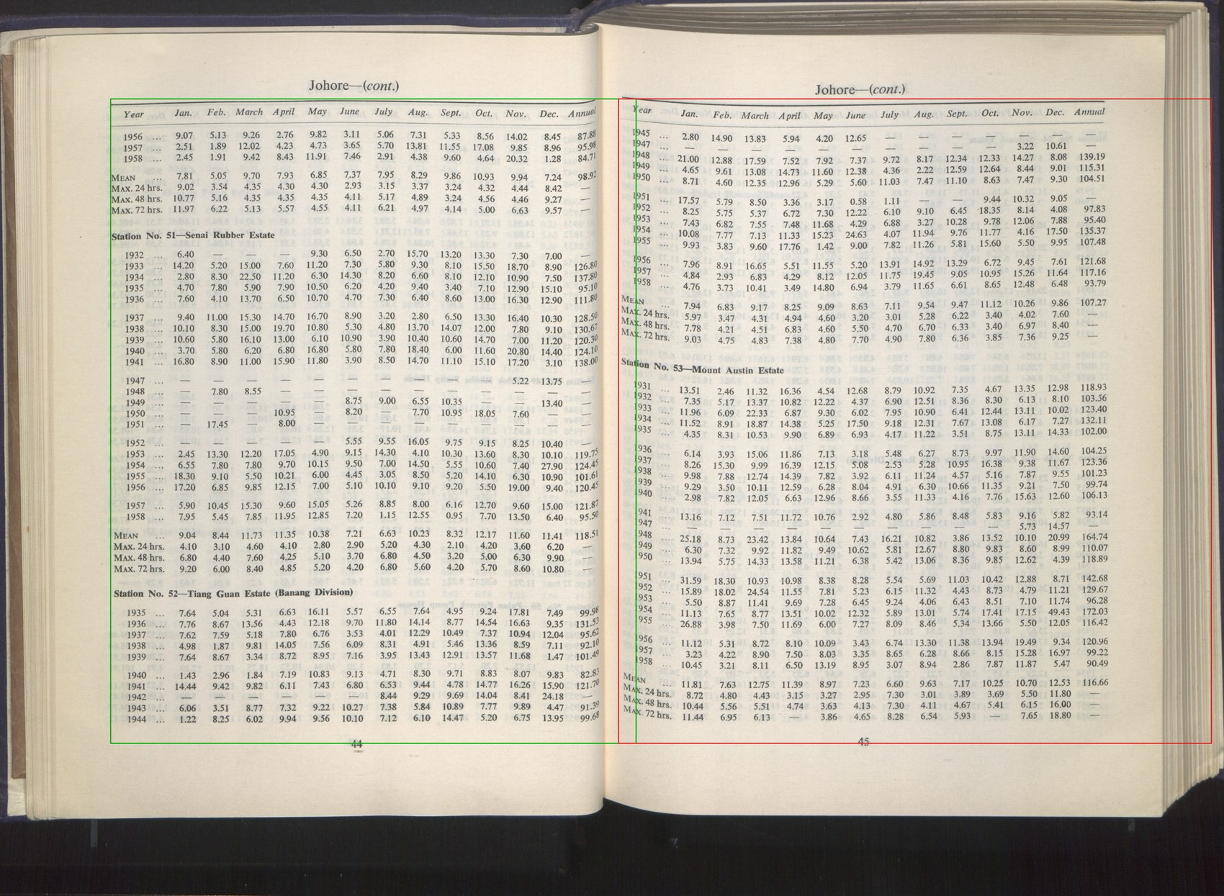
Figure S1. Column isolation. The full register page (left) is cropped to a single station column (right); COLUMN_X bounds are {left:(0.07,0.53), right:(0.50,0.995)} as fractions of page width.
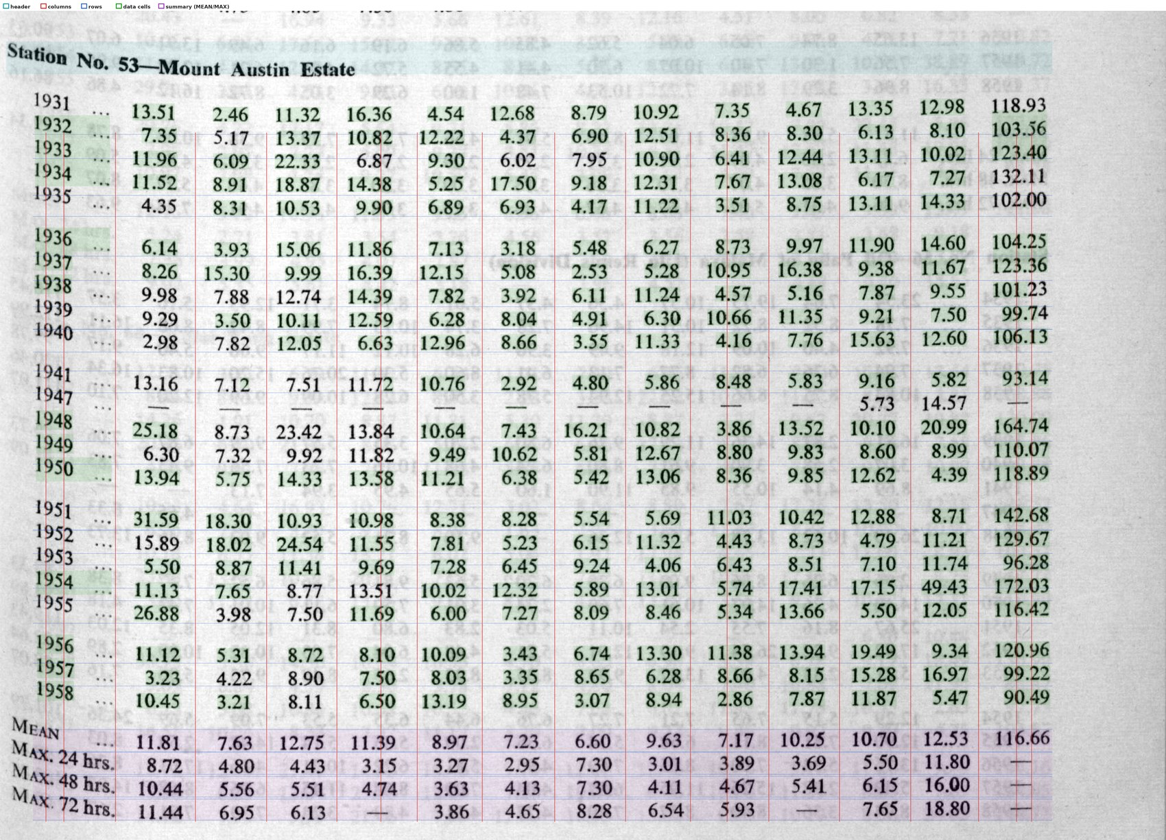
Figure S2. Detected data block on the pre-processed crop. The 14-column grid (year + Jan–Dec + annual) is overlaid on the ×3-upscaled, autocontrast-stretched block that both readers receive. Summary rows (MEAN, Max.24/48/72hr) sit at the foot.
Figure S3. A single isolated data row from Figure S2: one year, twelve monthly values, one printed annual — the unit on which reconciliation operates.

5. Tesseract readings vs vision-model readings
To make the division of labour concrete, the pre-processed Station 53 block (Figure S2) was read with Tesseract under the exact settings of Table S2, and its output is set beside the delivered vision-model values. Two characteristic failure modes appear, both of which the reconciliation check detects.

5.1 Row collapse
Because the register’s row pitch is tight and the ink is faint, Tesseract’s line grouping merged adjacent years: on this block it returned only 8 line-clusters for ~23 data rows, with several years mashed into one cluster and others fragmented. Leading-token year matching therefore collapses — which is why rows are aligned by reading order, and why a structural reader alone cannot safely segment this source. The vision model, prompted with the explicit row schema, recovers all rows cleanly.

5.2 Cell-level comparison (worked example: 1933 row)
The 1933 data row is one Tesseract cluster that aligns almost one-to-one with the delivered row, so it isolates the per-cell error cleanly. Values that differ are shaded.
Column | Tesseract (raw) | Vision model (delivered) | Issue
Jan | 11.96 | 11.96 | ✓
Feb | 6.09 | 6.09 | ✓
Mar | 22.33 | 22.33 | ✓
Apr | 687 | 6.87 | decimal dropped
May | 9.30 | 9.3 | ✓
Jun | 602 | 6.02 | decimal dropped
Jul | 7.95 | 7.95 | ✓
Aug | 1090 | 10.9 | decimal dropped
Sep | 641 | 6.41 | decimal dropped
Oct | 12.44 | 12.44 | ✓
Nov | —(dropped) | 13.11 | cell missed
Dec | 10.02 | 10.02 | ✓
Annual |  | 123.40 | (annual not in cluster)
Table S3. Station 53, 1933 row. Tesseract reads the digits but repeatedly drops the decimal point on two-decimal values (6.87→“687”, 6.02→“602”, 10.9→“1090”, 6.41→“641”) and misses one cell entirely (Nov 13.11). The raw months then sum to far more than any plausible annual, so the row fails reconciliation and is escalated; the vision model re-reads it and the twelve months reconcile to the printed annual 123.40 (ok_reconciled).
The pattern generalises across the block: Tesseract recovers clean integers and many whole cells correctly (11.96, 22.33, 12.44, and the printed annual 103.56 on the row above all match exactly), but drops decimals and collapses rows often enough that its unescalated output would not reconcile. This is the empirical basis for the Tesseract-first, reconciliation-gated, vision-model-on-failure design: the cheap reader handles the easy cells, arithmetic flags the misreads, and the expensive reader is spent only where it earns its cost.

6. A note on accuracy metrics
Character/word error rate and Levenshtein distance require an independent, hand-keyed gold standard for the same cells, which does not exist for this source; computing them against the pipeline’s own output would measure nothing. The defensible intrinsic accuracy measure is instead the reconciliation rate — the fraction of full-year rows whose twelve transcribed months sum to the independently printed annual within tolerance. Across the delivered dataset this stands at 96.4%, with the remainder explicitly flagged (annual_discrepancy, partial_year, or column-cascade) rather than silently accepted.

