Transcribing Colonial-Era Johor Rainfall Records
The Recognition, Reconciliation, and Automation Pipeline
40 stations · 917 rows · monthly rainfall 1926–1958 · Federated Malay States rainfall series

1. Overview and Source Material
This document walks through how monthly rainfall figures were digitised from scanned pages of a colonial-era Johor rainfall register into a clean, validated CSV. The emphasis throughout is on honest reconstruction: every number is either verified against the printed annual total or explicitly flagged as uncertain — nothing is silently invented to make a row "add up". Sections 1–8 describe the recognition-and-reconciliation method; Section 9 documents how that method was turned into an automated, reproducible pipeline.
Each scanned page (roughly 1288 × 952 pixels) is a two-column spread. Each column holds one or more station tables: a header naming the station, a block of yearly rows (twelve monthly values plus a printed annual), and usually summary rows (a long-term MEAN and 24/48/72-hour maxima).
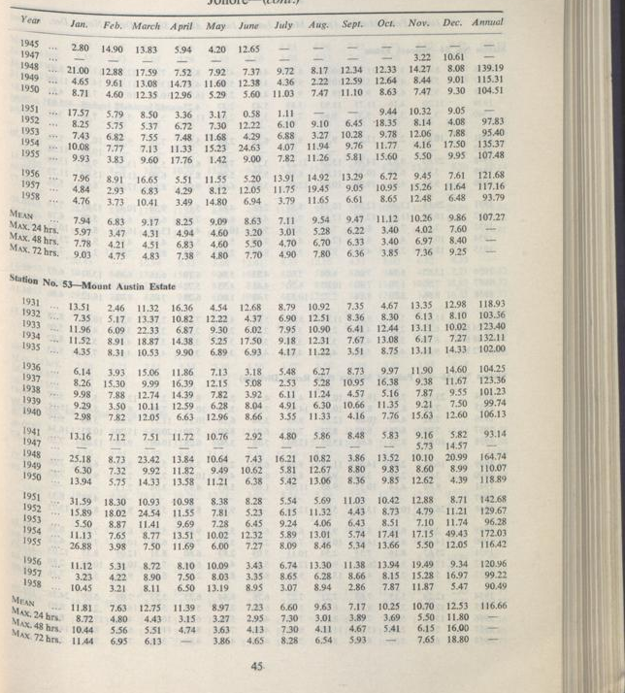
Figure 1. A representative source page. Ink is faded, columns are tightly spaced, and page curvature distorts the outer margin — all of which challenge automated recognition.
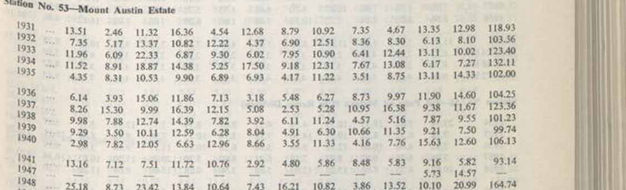
Figure 2. One station block. Leftmost column is the year; the next twelve are months; the rightmost is the printed annual that anchors all validation.

2. The Pipeline at a Glance
Step | Action | Purpose
1 | Locate station headers | Find where each station begins and which image/column holds it
2 | Isolate the column | Crop to the single data column, discarding maps and margins
3 | Preprocess the crop | Upscale, grayscale, and stretch contrast for legibility
4 | Recognise text | Read digits (OCR and/or a vision model), trying several settings
5 | Reconcile each row | Sum the twelve months, compare to the printed annual
6 | Correct single misreads | Where one value uniquely fixes the sum, apply and log it
7 | Flag the unresolved | Where no clean fix exists, keep the reading and mark it uncertain
8 | Assemble and re-verify | Write the CSV and re-check every full-year row

3. Steps 1–2: Locating and Isolating a Station
Station headers ("Station No. 53—Mount Austin Estate") are found by scanning each column top-to-bottom. Because tables flow across column and page boundaries, part of the work is establishing which physical image holds which years. Once located, the relevant column is cropped away from everything else, using fractional coordinates so the same logic works across pages of slightly different size.
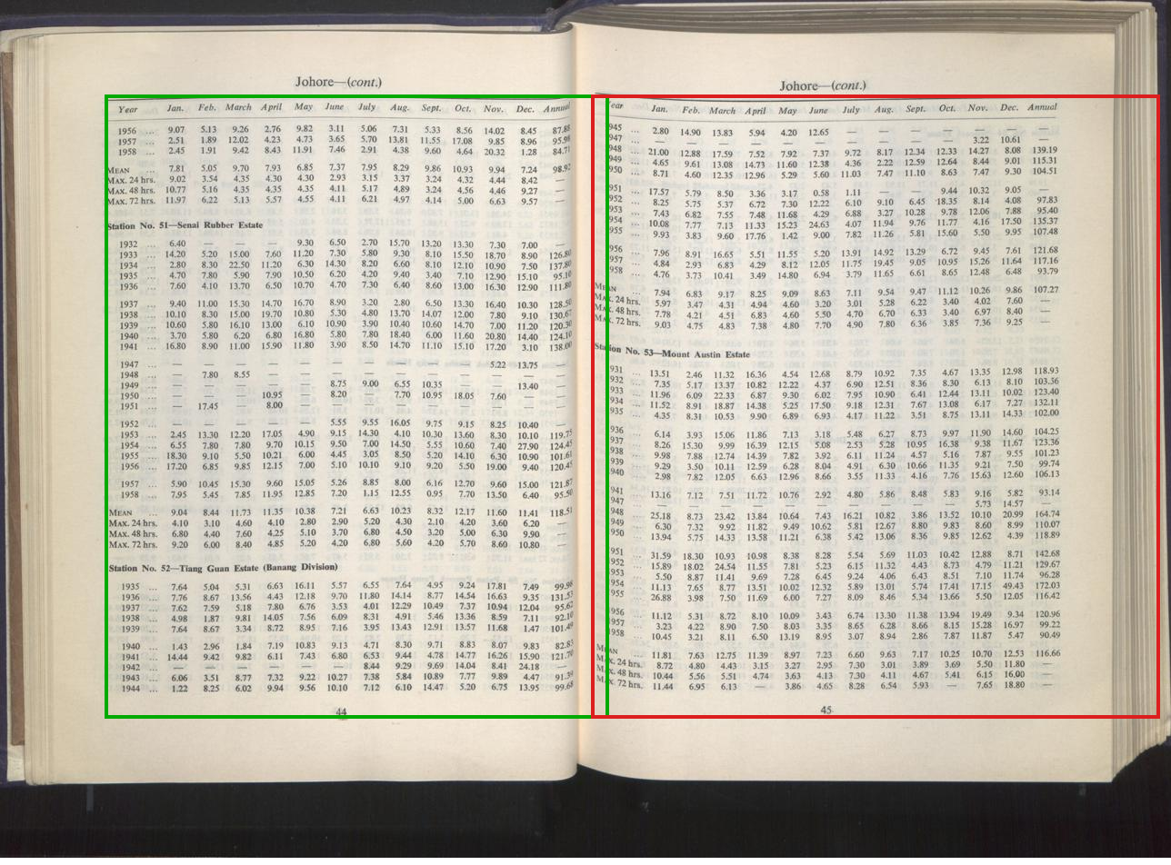
Figure 3. Column isolation. Green marks the left-column crop, red the right. Everything outside — the facing page, gutter shadow, curved margin — is excluded before recognition.
crop = img.crop((int(w*0.505), int(h*0.11), int(w*0.99), int(h*0.83)))

4. Step 3: Preprocessing the Crop
Raw crops are too small and low-contrast for reliable recognition. Three transformations are applied in sequence, shown here on a single data row: a, the raw crop; b, after 6× Lanczos upscaling; and c, after grayscale conversion and contrast stretching.
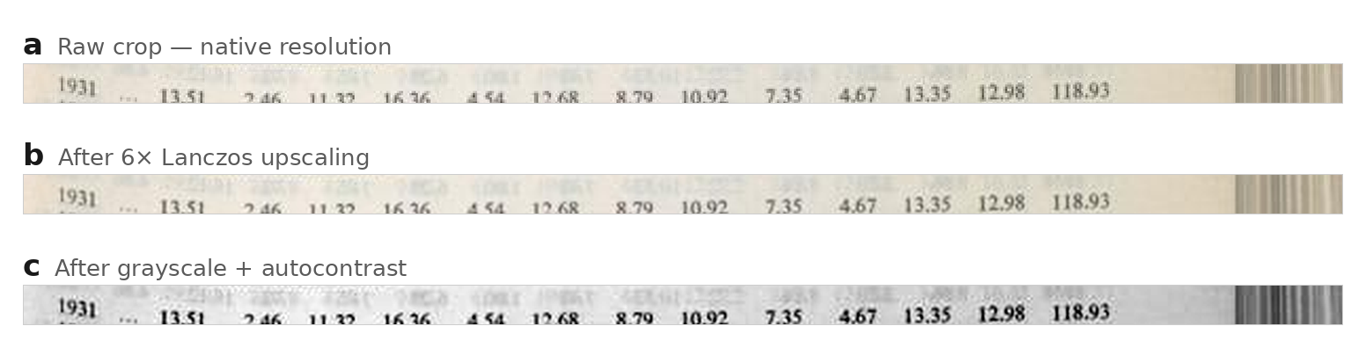
Figure 4. Preprocessing stages on one data row. a, raw native-resolution crop — marginal for OCR; b, after 6× Lanczos upscaling — strokes smooth and separable; c, after grayscale + autocontrast — the image actually passed to the recognizer. Compare the crispness of "118.93" between a and c.
crop = crop.resize((crop.width*6, crop.height*6), Image.LANCZOS)
gray = ImageOps.autocontrast(crop.convert('L'), cutoff=0.4)

5. Step 4: Recognising the Numbers
Recognition is where the trial-and-error lives. Two complementary methods are used: optical character recognition (OCR) and direct reading by a vision model. Difficult material is tried under several settings and judged against the one fact that cannot lie — the printed annual.

5.1 OCR settings tried
PSM | Tesseract interpretation | Best for
6 | A single uniform block | Multi-row data blocks (default)
4 | A single column of variable text | Table blocks where PSM 6 mis-groups rows
7 | A single text line | Individual row crops
8 | A single word | Isolated, stubborn cells

5.2 Characteristic OCR confusions
Printed | Misread as | Printed | Misread as
8 | $, S, B, 3 | 7 | T, Y
5 | $, S | 0 | O, Q
1 | I, l, ! | decimal point | comma / dropped
9 | O, 0, 2 | 11 (two ones) | 8, B
The single most common real-world OCR failure was dropped decimal points: "7.35" read as "735". Because a rainfall month is almost never ≥ 100 inches, this can be repaired heuristically — but the safety net is reconciliation, which flags the row if the repair is wrong.

5.3 Direct reading by a vision model
OCR is fast but brittle on faded ink and tight kerning. The decisive quality gain came from having a vision-capable model read the enlarged crops directly, the way a person would, rather than relying on Tesseract's character output. This helps in four concrete ways:
- Whole-row context: the model reads all twelve months together as rainfall figures bounded by an annual total, and rejects a reading that is physically implausible.
- Layout reasoning: it recognises structural defects — a year label offset one row above its data, or columns cascading down the page — and compensates.
- Disambiguation by expectation: faced with an ambiguous glyph, it weighs which reading lets the row reconcile to its printed total.
- Graceful uncertainty: when a cell genuinely cannot be read, it flags it rather than emitting a confident wrong character.
An important note on provenance. In the interactive work that produced this dataset, the "direct visual reading" was performed by the model reading each enlarged crop turn by turn and writing the values into the build scripts — it was not, at that stage, an automated function inside a script. In practice this reading reconciled almost perfectly (zero or one correction per station) against several per station for pure OCR. Section 9 describes how this manual reading was subsequently turned into automated model API calls, so the recognition step is reproducible from code alone.

6. Steps 5–6: Reconciliation and Correction
Every yearly row carries a printed annual total. Summing the twelve months and comparing to that total is the master check; the size of the gap dictates the response.
Sum vs printed annual | Interpretation | Action
≤ 0.10 | Rounding of two-decimal values | Accept; tag ok_reconciled
0.10 – 0.50 | Accumulated rounding | Accept; tag ok_rounding
0.51 – ~1.0 | Probable single-digit misread | Re-crop; attempt a unique fix
> 1.0 | Clear misread or column defect | Re-read; correct if unique, else flag

6.1 The single-digit correction rule
A value is changed only when exactly one substitution makes the row reconcile. If two or more different changes could each fix the sum, none is applied and the row is flagged instead. This uniqueness requirement is what keeps corrections honest.

6.2 A row that could not be reconciled
In the row below (Senai Rubber Estate, 1934) the twelve legible months sum to 119.20 but the printed annual is 137.80 — a gap no single cell accounts for. Both the months and the annual are preserved, and the row is tagged annual_discrepancy.
Figure 5. A flagged row. The January cell (red) and the annual (blue) do not agree with the month sum, so the row is kept as-read and marked uncertain — never silently "fixed".

7. Structural Defects the Pipeline Handles

7.1 Year-label vertical offset
On many pages the printed year labels sit one row above the data they belong to. This is caught during reconciliation — the mis-paired rows fail to balance systematically — and corrected by shifting the year-to-row mapping by one.
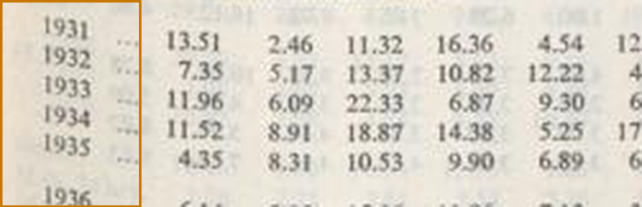
Figure 6. The year column (orange) is offset from its data. The first data row belongs to the year printed above it.

7.2 Diagonal column cascade
In a few stations the later years suffer a printing defect where the September–December columns drift diagonally down the page. Where this makes month assignment unsafe, Jan–Aug are recorded, the drifted cells left blank, and the printed annual preserved with a flag.
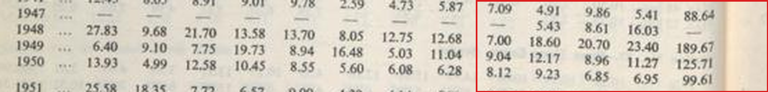
Figure 7. Column cascade (red). The right-hand month columns step downward across rows, so one horizontal position no longer maps to a single month.

7.3 Verifying genuine extremes
Reconciliation also protects real but surprising values. A March 1943 reading of 44.22 inches at Wessyngton Estate looks like an error, but the row sums exactly to its printed annual of 97.60 — so it is kept as a genuine wet-month record.
Figure 8. A verified extreme. The March value (green) is far above its neighbours, yet the row reconciles exactly — confirming it real, not a misread.

8. Step 8: Assembly, Schema, and Verification
Validated values are written to a growing combined CSV, each station appended after its rows reconcile. A final pass re-sums every full-year row to confirm nothing regressed. Every row carries a data_confidence tag recording exactly how it was validated.
Tag | Meaning
ok_reconciled | Months sum to the printed annual within ±0.10
ok_rounding | Difference ≤ 0.50, rounding artifact
ocr_corrected:F_old→new | One value corrected by the unique-fix rule
partial_year | One or more months missing
annual_discrepancy:… | Months and annual disagree, no clean fix — kept as-read
source_printed_mean | A MEAN row, verified to sum to its printed annual

9. From Manual Reading to an Automated Pipeline
The method above was first carried out interactively, with the model reading crops and a human directing the flow. To make it a standalone, reproducible tool, the recognition step was re-implemented as automated model API calls, and the station-finding and page-spanning problems were solved in code. This section documents that evolution across three successive versions.

9.1 Version 1 — single-call API recognition
The first automated version replaces "a person reads the crop" with one function that sends the preprocessed crop to the Anthropic Messages API and parses the structured rows it returns. The prompt instructs the model to read digits exactly as printed, use null for illegible cells, and never adjust a value to force a sum — reconciliation stays downstream. The model is called at exactly one place, once per station block; everything after it is the same deterministic arithmetic.
block = preprocess(page, x1, y1, x2, y2) # crop + upscale + clean
rows = vision_read_block(block) # <-- the model call
for r in rows: reconcile_and_tag(r) # unchanged logic
Cost is modest: a 70-year station is roughly 10,000 tokens across about five calls — on the order of a few cents, so the whole 40-station set runs for a dollar or two. The bottleneck was never tokens; it was recognition accuracy, which the reconciliation net protects.

9.2 Version 2 — two-stage "find headers, then crop"
Version 1 still needed hand-tuned crop coordinates — someone had to decide that Station 53 occupies "y = 0.41 to 0.72 of the right column". Version 2 removes that. Stage 1 sends the whole page to the model and asks it to return every station header with its column and vertical span as fractions. Stage 2 then crops each block from those returned fractions and transcribes it. The model's reliable header-reading replaces Tesseract's brittle header detection, and no coordinates are typed by hand.
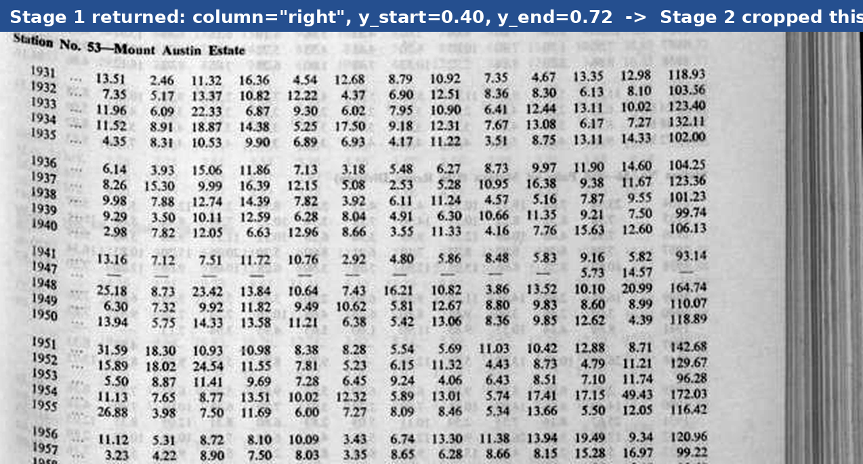
Figure 9. The crop produced entirely from Stage-1 output. The model reported column="right", y_start=0.40, y_end=0.72; Stage 2 cut exactly this block — header at top, every yearly row captured, no bleed from the neighbouring station.

9.3 Version 3 — cross-page stitching
A station's record often runs across a page break: its early years sit at the bottom of one column and the rest continue, without a repeated header, at the top of the next page. Version 3 handles this. Stage 1 additionally reports a "headerless continuation" block and two flags — continues_next_page and continues_from_prev. A small state machine holds any station flagged as running off the page and merges it with the matching continuation on the next page into a single record, recording both source pages for provenance.
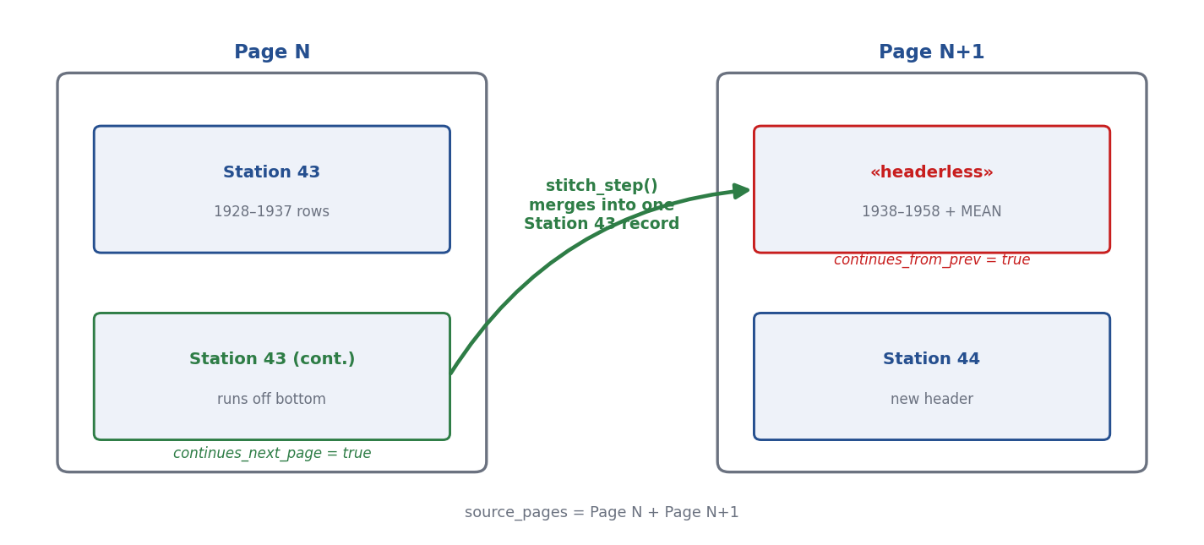
Figure 10. Cross-page stitching. A station running off the bottom of Page N (continues_next_page) is merged with the headerless continuation atop Page N+1 (continues_from_prev) into one record spanning both pages.
The stitching logic was validated on five cases: a normal two-page split, a record spanning three pages, an expected continuation that never arrives, an orphan continuation with no parent, and a station left open at the end of the input. Each resolves correctly, and the ambiguous cases (missing or orphaned continuations) are surfaced as flags rather than silently mis-joined — the same honesty principle that governs reconciliation.

9.4 Division of labour
Across all three versions the split is constant: the model READS (finds headers, transcribes digits) and arithmetic reconciliation DECIDES what to trust. A bad read cannot silently corrupt the dataset; it surfaces as a flagged row for review. That is why the same reconciliation layer that made the manual batches trustworthy now sits behind an automated, reproducible recognition call.

