Homogenization of the Malaysia–Singapore historical rainfall archive
Break detection, correction and infilling of monthly station rainfall, 1875–1958
Climatol method + RHtestsV4 confirmation · 27 August 2026
Stations (≤1958) | Eligible (≥10 yr) | Breaks detected | Stations adjusted | Breaks in 1946–53
672 | 529 | 78 | 70 | 41%

This report documents an end-to-end homogenization of the pre-1958 Malaysia/Singapore monthly rainfall archive: how artificial breaks were detected against a network of neighbouring stations, how affected series were corrected, how gaps were filled, and how an independent test graded the confidence of each break. The dominant artificial signal is a cluster of breaks in the years immediately after the Second World War.
Tooling note. The genuine climatol and RHtestsV4 R packages could not be installed in the execution sandbox (CRAN, conda and r-universe are firewalled there). Results were produced by a faithful Python implementation of the published algorithms, validated against synthetic series with known injected breaks. Ready-to-run scripts for the real R packages (run_climatol.R, run_rhtests.R) are included so the analysis reproduces on a CRAN-connected machine; small numerical differences from the packaged tools are expected but the break structure should be stable.

1. Data and scope
The source archive merges historical monthly rainfall (inches) for the Malay Peninsula and Singapore with data-rescue records from Sumatra, Borneo and the intervening islands. Records were restricted to year ≤ 1958 — the year the peninsular series close — giving 14,549 station-years from 672 stations. This restricted core is denser and more complete than the full archive (6.5% monthly missing vs 10% with the post-1958 tail). Seven previously-empty Selangor stations were populated from newly transcribed records before this run.
The defining feature for homogenization is that these are many short, staggered, overlapping records: a median of ~18–26 data-years per station, with only 164 reaching 30 years. Combined with the low spatial correlation of equatorial rainfall and the absence of any station-move metadata, this makes every detected break undocumented and places the archive among the harder homogenization problems.

2. Method

2.1 Preparation and quality control
The wide table was reshaped onto a common 1875–1958 monthly frame (1,008 months × 672 stations with coordinates), plus annual totals (only where all 12 months are present) and monsoon-season totals. Detection uses annual totals (more Gaussian, higher signal-to-noise for rainfall); corrections are applied monthly. Impossible values (negative or >150 in/month) were masked — none occurred, so all real extremes were kept — and reconcile-flagged rows retained. Stations with ≥10 data-years are eligible (529); shorter ones are carried through for infilling only.

2.2 Neighbour network
Because rainfall de-correlates quickly here, each station’s reference is a distance-weighted mean of normalized neighbours, capped at the 10 nearest within 200 km (Gaussian, 60 km scale) with a minimum annual-anomaly correlation of 0.10. 525 eligible stations obtained a usable neighbour; the very thin regions (Singapore, Perlis, Province Wellesley, Sabah, Sarawak) are effectively absolute-only and are flagged.

2.3 Detection — Climatol method (SNHT on a relative series)
Series were ratio-normalized (divided by their mean). A neighbour reference was built in ratio space and the candidate-minus-reference anomaly tested with the Standard Normal Homogeneity Test, applied recursively for multiple breakpoints (minimum segment 5 years, 95% Monte-Carlo critical values). References were then rebuilt from the provisionally-corrected series and detection repeated — two outer passes — so a single broken neighbour cannot contaminate the references.

2.4 Correction and infilling
Multiplicative corrections scale each earlier segment onto the level of the most-recent segment, via the candidate-to-reference ratio over each segment. Gaps were filled from a seasonal (monthly-climatology) neighbour reference, denormalized to the station’s homogenized level, and only within each station’s observed span — never extrapolation. Two products result: an NA-preserving series and an infilled series.

2.5 Independent confirmation — RHtests style
On the 164 stations with ≥30 data-years, two penalized maximal tests were run: PMF (penalized maximal F, two-phase regression with a common trend, no reference) on annual totals, and PMT (penalized maximal t, on the candidate-minus-reference series). Both use Monte-Carlo critical values, supplying the end-point penalty and multiplicity correction directly.

2.6 Validation of the implementation
Before running on real data, detection was validated on synthetic networks: 7 of 8 injected relative breaks recovered within ±3 years, a base-series step located exactly, and SNHT critical values reproducing the standard tables (n=20→7.0, n=40→7.9, n=60→9.1). On the real output, unadjusted stations are bit-identical to raw, no negatives are introduced, and extremes are preserved.

3. Results

3.1 Detection overview
The Climatol method detected 78 breaks across 70 stations. The median correction was 0.89 (a typical ~11% reduction of inflated early segments; factors 0.69–1.91), and 19,813 interior monthly gaps were filled within span.

3.2 Temporal structure — the post-war discontinuity
41% of all detected breaks fall in 1946–1953, peaking in 1948–1950 — the archive’s dominant artificial signal, reflecting network disruption, relocation and re-establishment around the occupation and its aftermath. Any trend analysis spanning the war must account for it.
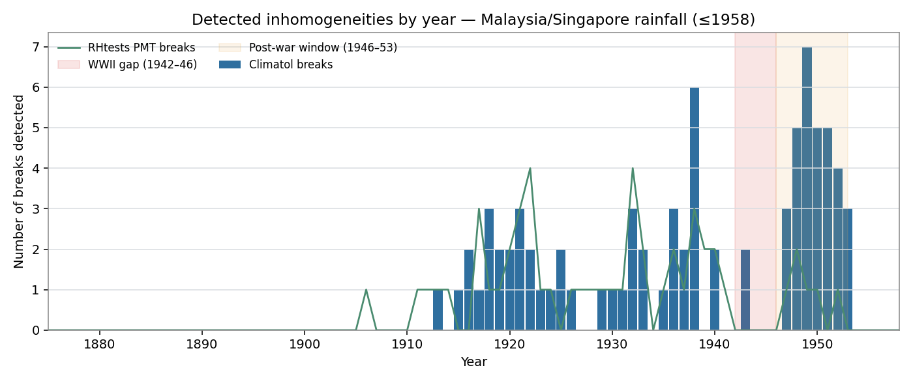
Figure 1. Detected inhomogeneities by year. Bars = Climatol breaks; line = RHtests PMT breaks. Shaded: WWII gap (1942–46) and post-war window (1946–53).

3.3 Cross-method agreement and confidence
Of the 49 Climatol breaks on long stations, 17 (35%) were confirmed by RHtests within ±2 years (16 by PMT, 6 by PMF). The modest rate is expected: PMF is an absolute test with weak power for artificial breaks in noisy tropical series, and PMT’s trend-aware penalty is stricter than SNHT, so RHtests endorses the larger breaks and leaves marginal ones as Climatol-only. Every break is graded: 16 high, 1 medium-high, 32 medium, 29 low, plus 55 RHtests-only recorded for information.
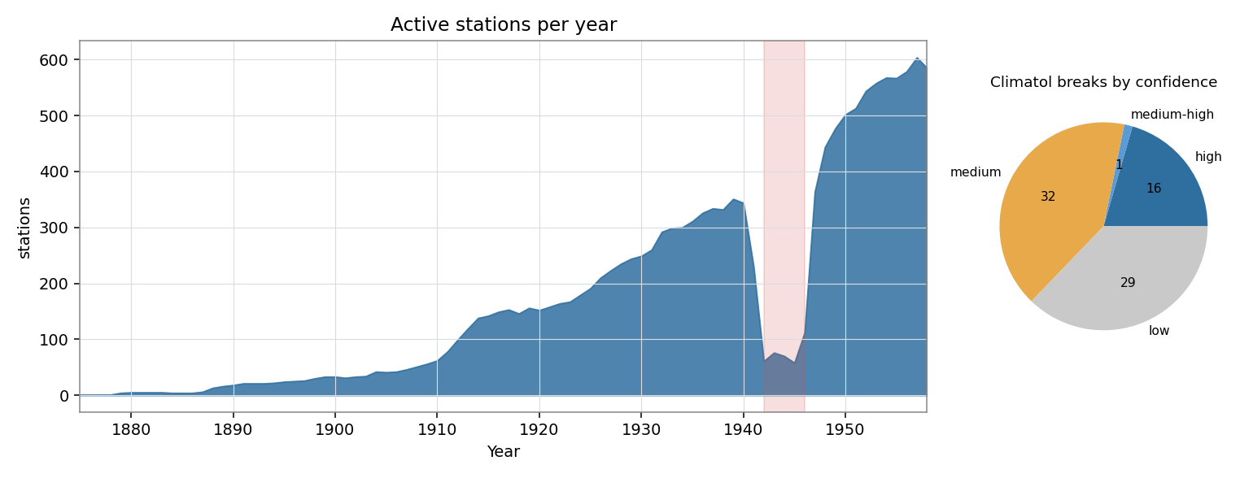
Figure 2. Active stations per year (WWII collapse shaded) and the confidence breakdown of Climatol breaks.

3.4 High-confidence breaks
Station | Region | Break year | Factor
Kuala Kubu Bahru Hospital | Selangor | 1913 | ×0.83
Gedong Estate | Perak | 1917 | ×0.84
Teluk Anson District Hospital | Perak | 1918 | ×0.84
Pertang Estate | Negri_Sembilan | 1929 | ×0.86
Ulu Gombak 15 3/4 Mile | Selangor | 1931 | ×0.68
Kuantan Hospital | Pahang | 1932 | ×0.85
Serendah Rubber Estate | Selangor | 1933 | ×0.81
Walbrook Estate | Perak | 1938 | ×0.86
Sungei Serdang Estate | Selangor | 1938 | ×1.02
Sussex Estate | Perak | 1948 | ×0.78
Bandar Bharu Hospital | Kedah | 1949 | ×0.91
Sungei Serdang Estate | Selangor | 1952 | ×0.74

3.5 Spatial pattern
Breaks concentrate in the dense western-peninsula regions (Perak, Selangor, Johor, Pahang) — the only places with enough neighbours for a reliable relative test. The east coast, Borneo and islands contribute few breaks, not because they are homogeneous but because they are too sparse to test.
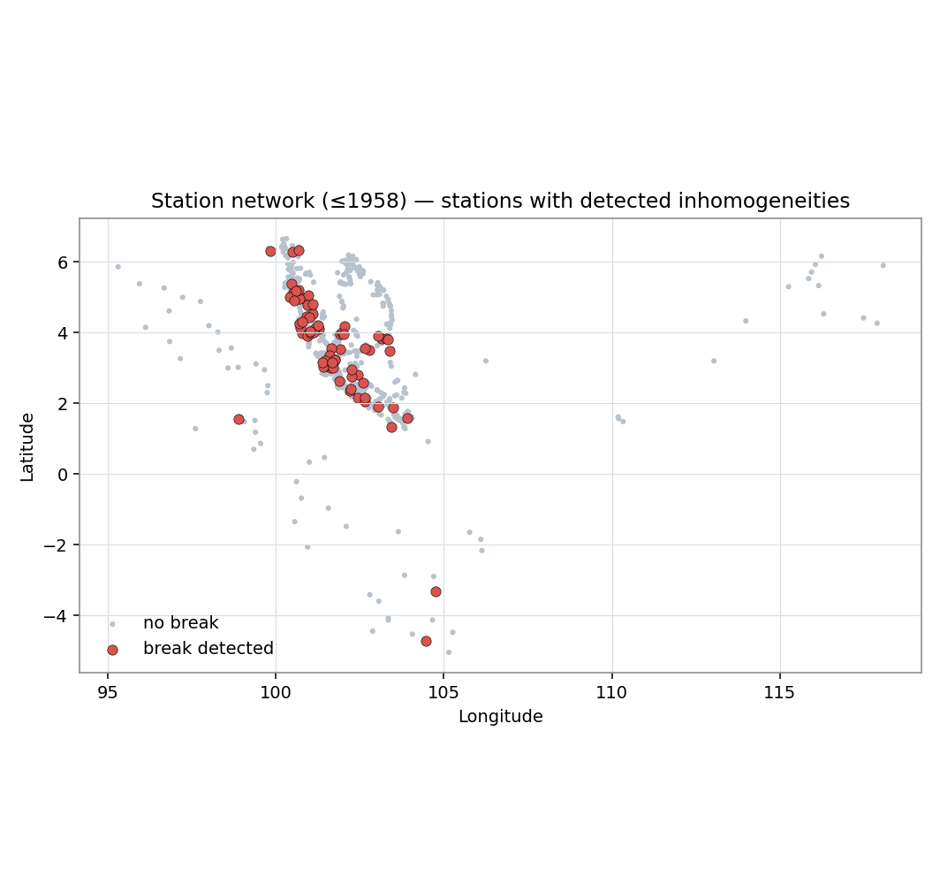
Figure 3. Station network (≤1958); red = stations with a detected inhomogeneity.

3.6 Example corrections
The six longest adjusted stations — all in Perak and Pahang — illustrate the mechanism. Each has a single break whose pre-break segment reads systematically high relative to neighbours and is scaled down; raw and homogenized lines coincide after the break and diverge before it. The 1918 break recurs at two Perak hospitals — a plausible shared administrative/network change worth checking against station history.
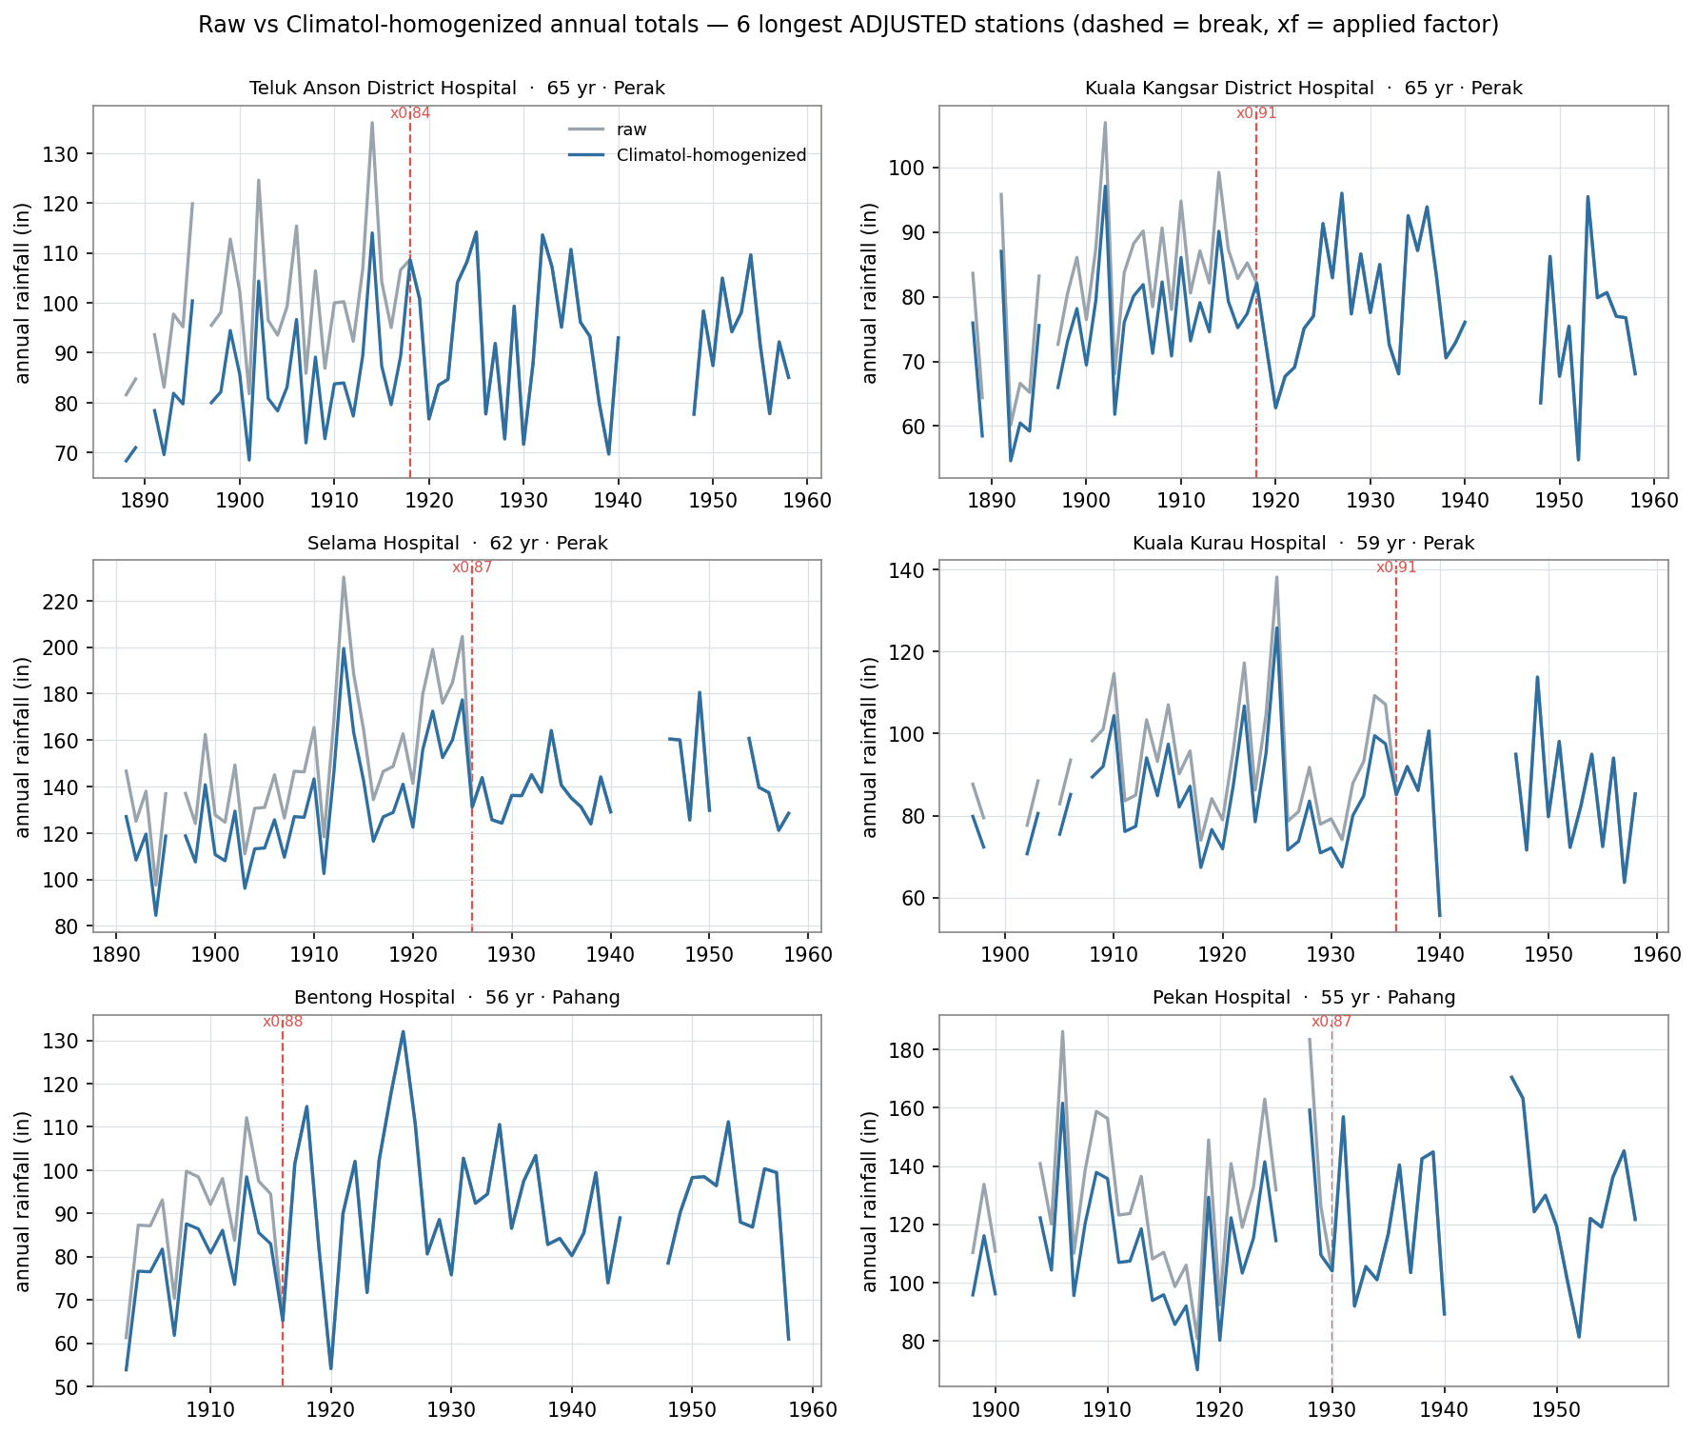
Figure 4. Raw (grey) vs Climatol-homogenized (blue) annual totals for the six longest adjusted stations. Dashed = break; ×f = applied factor.

3.7 The mm → inches merge boundary
The Sumatra/Borneo records were transcribed in millimetres and converted to inches on ingestion, making their provenance a candidate offset. Pre-1958, only a handful of island stations are long and well-connected enough to test, and just 3 island-sourced breaks were found — too few to assess statistically. Spot-check the conversion manually rather than relying on it here.

4. Deliverables
File | Contents
malaysia_rainfall_homogenized_NApreserved.csv | Homogenized monthly series, gaps kept as NA (14,200 station-years)
malaysia_rainfall_homogenized_infilled.csv | Homogenized and gap-filled within span (15,684 station-years; +1,484)
break_inventory.csv | Every break: station, year, method(s), confidence, factor, coordinates
breaks_climatol.csv / breaks_rhtests.csv / factors_climatol.csv | Raw per-method outputs
figures/ | Breaks-by-year, timeline+confidence, station map, example corrections
R/run_climatol.R / run_rhtests.R | Reproduce with the genuine packages
scripts/*.py | Full Python pipeline (prep → homoglib → climatol_run → rhtests_run → finalize → plots)
Both homogenized CSVs keep the original wide schema (station, metadata, 12 months, recomputed annual_computed) plus adjusted and n_breaks flags.

5. Caveats and recommendations
Detection is more reliable than correction here: correlations are low, series short and staggered, all breaks undocumented. Corrections were applied for every Climatol break (the primary method); for a conservative product, restrict adjustments to confidence ∈ {high, medium-high} using the inventory. Low-confidence breaks rest on few neighbours and are tentative. The infilled product is spatial interpolation within a station’s active period, not observed data — use the NA-preserving copy where that distinction matters. The post-war cluster and the recurring 1918 Perak break are the two features most worth checking against surviving station histories.

6. References
Alexandersson, H. (1986). A homogeneity test applied to precipitation data. J. Climatol. 6, 661–675.
Alexandersson, H. & Moberg, A. (1997). Homogenization of Swedish temperature data, Part I. Int. J. Climatol. 17, 25–34.
Guijarro, J.A. (2018). Homogenization of climatic series with Climatol. AEMET.
Wang, X.L., Wen, Q.H. & Wu, Y. (2007). Penalized maximal t test. J. Appl. Meteorol. Climatol. 46, 916–931.
Wang, X.L. (2008). Penalized maximal F test. J. Atmos. Ocean. Technol. 25, 368–384.
Venema, V. et al. (2012). Benchmarking homogenization algorithms. Clim. Past 8, 89–115.
Wijngaard, J.B., Klein Tank, A.M.G. & Können, G.P. (2003). Homogeneity of European daily series. Int. J. Climatol. 23, 679–692.

