dwdc esfsdrfgrgrrrrrrhjbjblOMoARcPSD|1714095

dwdc esfsdrfgrgrrrrrrhjbjblOMoARcPSD|1714095



PPD: Airline Management system

# Life Cycle Model - WATERFALL MODEL

## Waterfall Model - Design

Waterfall approach was first SDLC Model to be used widely in Software Engineering to ensure success of the project. In "The Waterfall" approach, the whole process of software development is divided into separate phases. In this Waterfall model, typically, the outcome of one phase acts as the input for the next phase sequentially.

The following illustration is a representation of the different phases of the Waterfall Model.

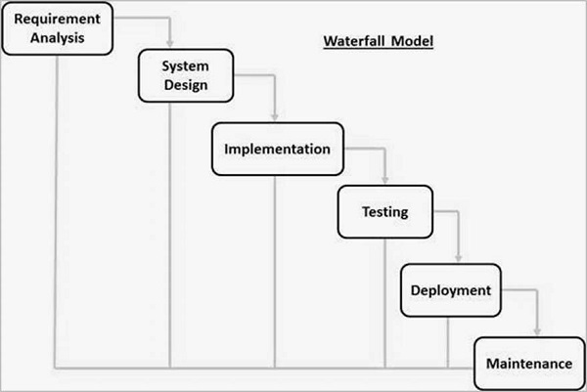

The sequential phases in Waterfall model are −

**Requirement Gathering and analysis** − All possible requirements of the system to be developed are captured in this phase and documented in a requirement specification document.

**System Design** − The requirement specifications from first phase are studied in this phase and the system design is prepared. This system design helps in specifying hardware and system requirements and helps in defining the overall system architecture.

**Implementation** − With inputs from the system design, the system is first developed in small programs called units, which are integrated in the next phase. Each unit is developed and tested for its functionality, which is referred to as Unit Testing.

**Integration and Testing** − All the units developed in the implementation phase are integrated into a system after testing of each unit. Post integration the entire system is tested for any faults and failures.

**Deployment of system** − Once the functional and non-functional testing is done; the product is deployed in the customer environment or released into the market.

**Maintenance** − There are some issues which come up in the client environment. To fix those issues, patches are released. Also to enhance the product some better versions are released. Maintenance is done to deliver these changes in the customer environment.

WHY WE USED WATERFALL MODEL?

Simple and easy to understand and use

Easy to manage due to the rigidity of the model. Each phase has specific deliverables and a review process.

Phases are processed and completed one at a time.

Works well for smaller projects where requirements are very well understood.

Clearly defined stages.

Well understood milestones.

Easy to arrange tasks.

Process and results are well documented.

# Tools used throughout the lifecycle

Planning tools- Gantt Pro Design tools-Canvas, Draw.io Version control-GitHub

Development tool-Jango, Python3.10, HTML, JSS,Gantt Pros

# Deliverables categorised as reuse or built

Built Components – Detailed Documentation

Front end of the project i.e creating the website with HTML, CSS and JS.

Backend where the database stores the contents, integrating this with PHP.

Reused Components –

Images, user interface components Payment gateway and ticket display page

# WBS

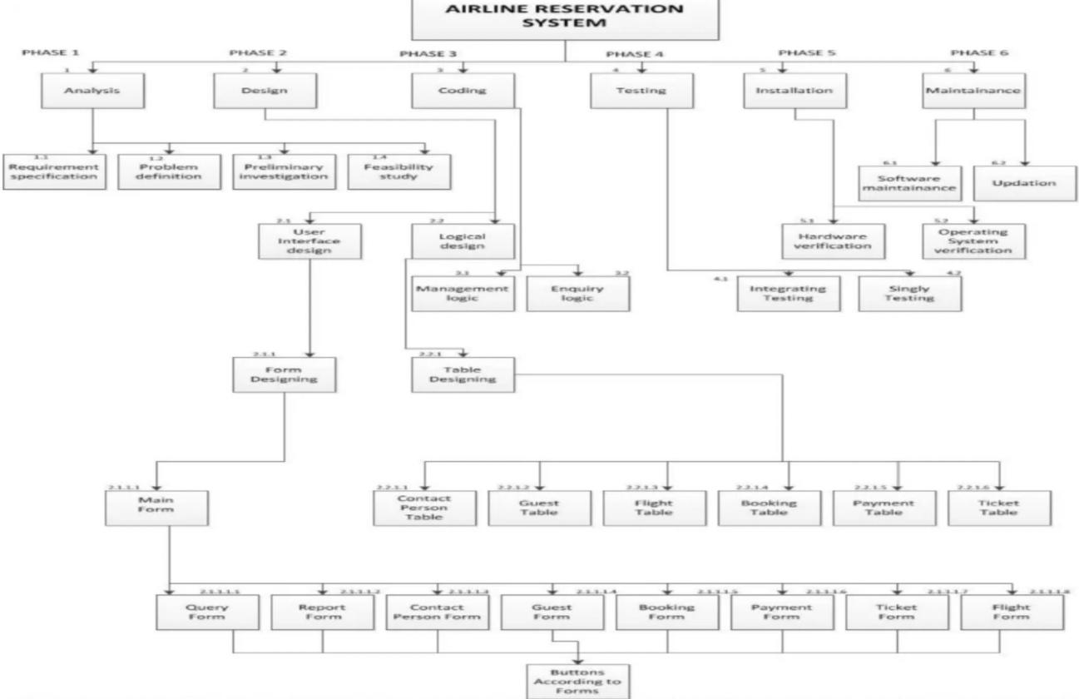

1. Rough estimate of effort required to accomplish each task in terms of person months

The team consists of 5 members.

Estimated time : 2-3 months for about 2000 lines of code.

# Gantt Chart -

