Recipe search app

Using Django and edamam API I have created an application which search for recipes and gives nutrition values of the related search

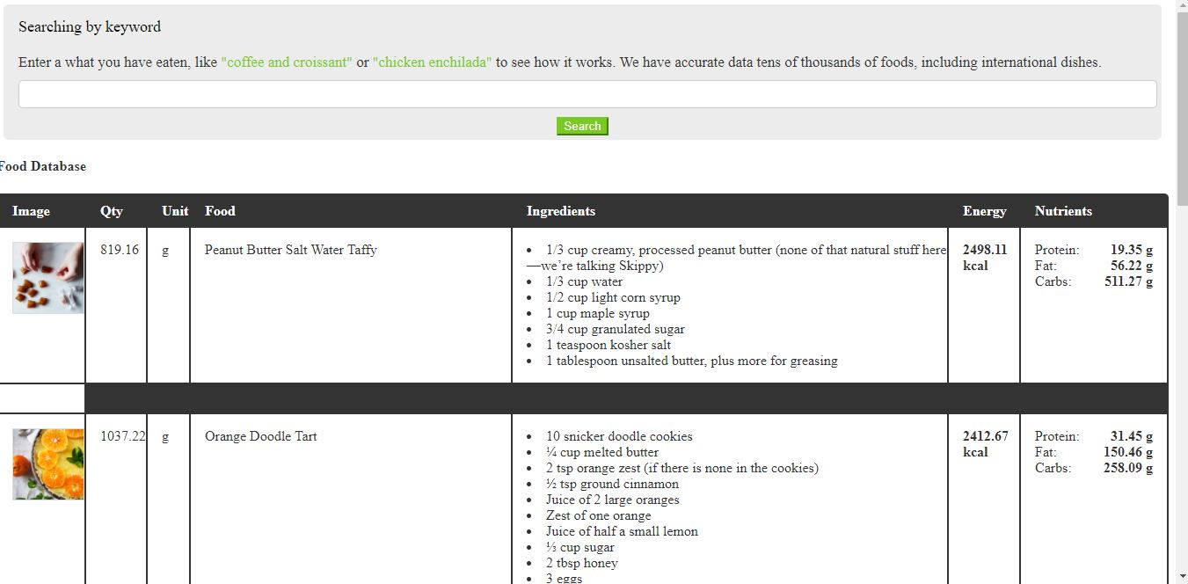

By giving input to the search bar it will gives results related to given keyword

