**Commands for docker :**

**1-docker build -t myjava77 .**

**2-docker run –name java_container myjava77**

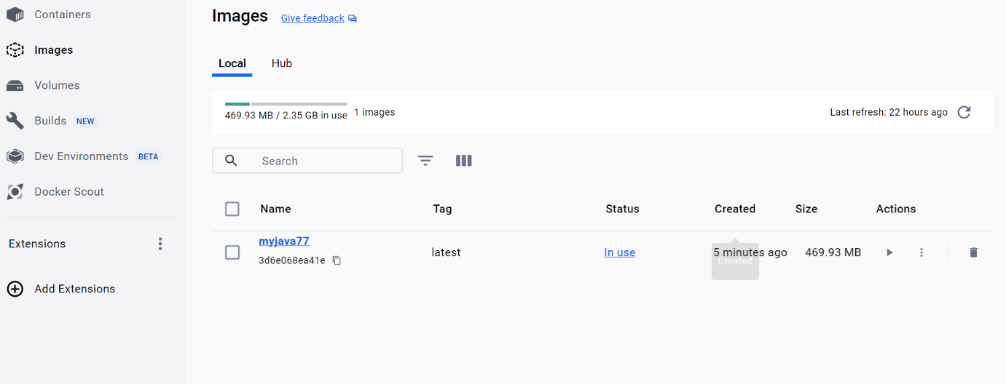

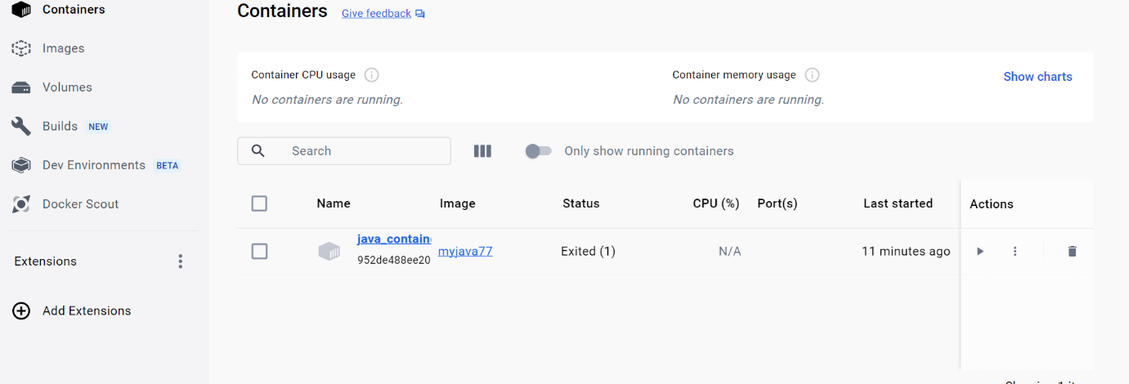

**2-Code Pushed to Github:**

**Git commands:**

echo "# esgfsg" >> README.md

git init

git add README.md

git commit -m "first commit"

git branch -M main

git remote add origin https://github.com/prthmeshh/assessment-week1.git

git push -u origin main

**url for repository:**  [**https://github.com/prthmeshh/assessment_week1.git**](https://github.com/prthmeshh/assessment_week1.git)

**3-UML diagram for java application :**

**Code for uml diagram:**

@startuml

class JavaApplication {

- numbers: int[6]

+ JavaApplication()

+ inputNumbers(numbers: int[6]): void

+ calculateSumOfEven(): int

+ printSum(sum: int): void

}

@enduml

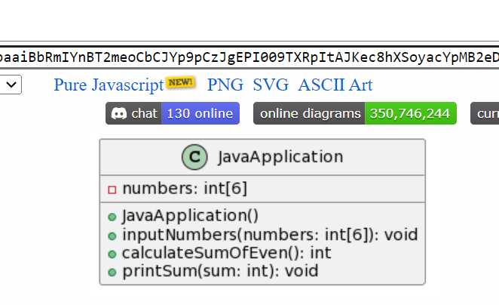

**4-CI/CD implementation**

**Pipeline script:**

pipeline {

agent any

stages {

stage('Build sum of numbers') {

steps {

checkout scmGit(branches: [[name: '*/master']], extensions: [], userRemoteConfigs: [[url: 'https://github.com/prthmeshh/assessment_week1.git']])

bat 'mvn clean install'

}

}

}

}

