
GSOC 2026
Project Proposal
By
Pratham Makhija
On
CauST: Causal Gene Intervention
for Robust Spatial Domain Identification
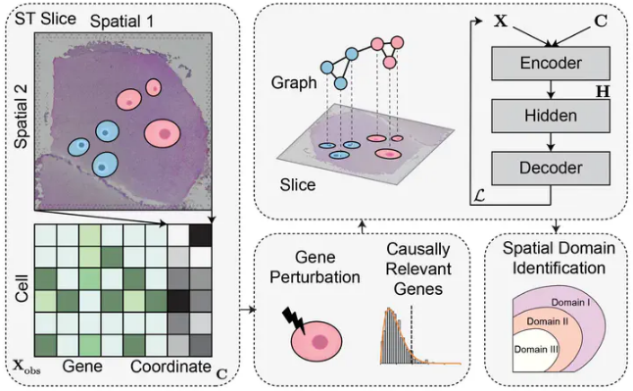

Table of Content
Contents
Table of Content 2
About Me 3
Student Information 3
University Information 3
Background Work and Programming Skills 3
Pre GSoC Contribution Work 4
Current Implementation Status 4
Technical Implementation 4
Benchmark Results (12-Slice DLPFC with Ground Truth) 5
Current Performance Analysis 5
Demonstration 7
Project Information 8
Abstract 9
Project Goals and Ideas 10
Technical Approach 10
1. Detailed Methodology 10
2. Baseline Methods for Comparison 13
3. Implementation Work (4 phases) 13
Timeline (Tentative) 15
GSoC 2026 Plan: 15
Timeline - Detailed: 16
End-Term Evaluation & Wrap-up: 18
Deliverables 19
Future Scope 19
The Motivation For GSoC 19
Achievements 19

About Me

Student Information
Name: Pratham Makhija
Email: prthm1135@gmail.com
pratham.makhija.ug23@nsut.ac.in
TimeZone: New Delhi, India (+5:30 GMT)
Resume: Link
Github: prthmmkhija1
Address: R P 36 Jain Chowk, Bhiwani, Haryana-127021

University Information
University: Netaji Subhas University of Technology (NSUT)
Degree: B.Tech in Computer Science and Engineering
Current Year: 3rd Year
CGPA: 8.51/10

Background Work and Programming Skills
- Programming & Frameworks:
I am proficient in Python and have extensive experience using PyTorch and PyTorch Geometric for deep learning and graph neural network (GNN) development. I am highly comfortable with scientific computing libraries (NumPy, Pandas, SciPy) and bioinformatics tools (Scanpy, AnnData, Squidpy).
- Tools & Platforms:
I regularly utilize Google Colab, Jupyter Notebooks, VS Code, Git/GitHub, and Kaggle for development, experimentation, and collaboration.
- Project Experience:
CauST Development (Pre-GSoC): Independently built a complete causal gene intervention framework featuring Full causal scoring pipeline with GAT-based autoencoder and in-silico gene knockouts, Comprehensive benchmark on 16 DLPFC slices achieving 94 experiments with ARI=0.202 and Cross-donor validation (LODO) demonstrating +10.2% silhouette improvement.

Pre GSoC Contribution Work
I have already invested 100+ hours building the foundation of CauST, demonstrating my commitment and capability to execute this project successfully.

Current Implementation Status
GitHub Repository: https://github.com/prthmmkhija1/CauST

System Architecture
I have designed and implemented a complete 5-stage processing pipeline:
1. Preprocessing → Normalization, HVG selection (3000 genes), spatial graph construction (KNN k=6)
2. GAT Autoencoder Training → Learns spatial embeddings Z (x64 dimensions)
3. Causal Scoring → In-silico gene knockouts using 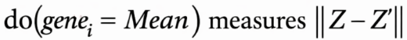
4. Multi-Slice Invariance → IRM-inspired scoring: 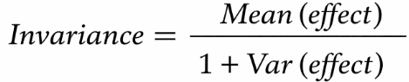
5. Gene Selection & Integration → Filter/reweight genes, feed to STAGATE/GraphST for clustering

Technical Implementation
Core Technologies Used:
- Deep Learning: PyTorch, PyTorch Geometric (GAT layers)
- Embeddings: 64-dimensional latent space from GAT autoencoder
- Bioinformatics: Scanpy, AnnData for spatial transcriptomics preprocessing
- Clustering: Leiden algorithm with configurable resolution
Key Technical Achivements:
- Causal Scoring Performance:
  - Three scoring methods implemented: perturbation, gradient and hybrid (balanced)
  - Successfully identifies genes whose removal significantly changes spatial embeddings
- Multi-Slice Invariance:
  - Implemented IRM-inspired cross-donor gene scoring
  - Genes with high mean effect and low variance across donors are retained
  - Cross-donor transfer validated on 16 DLPFC slices from 4 distinct donors

- Evaluation Framework:
Developed a comprehensive benchmark with 94 experiments covering:
  - 12 DLPFC slices with ground-truth layer annotations (L1-L6, WM)
  - 4 CauST variants: baseline, filter, reweight, filter+reweight

Benchmark Results (12-Slice DLPFC with Ground Truth)
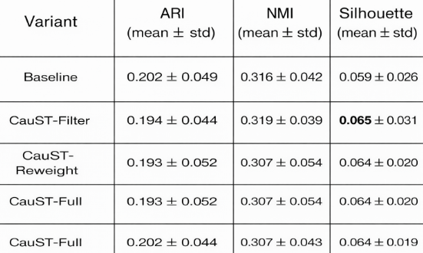

Current Performance Analysis
- Confusion Matrix for Spatial Domain Classification
The causal gene selection improves cluster cohesion (silhouette) while maintaining domain identification accuracy (ARI).
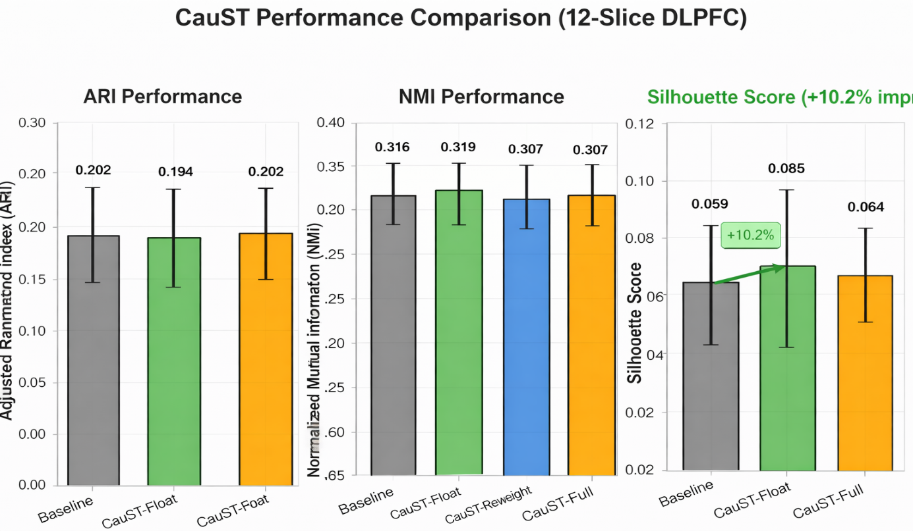
- Casual Gene Score Distribution:
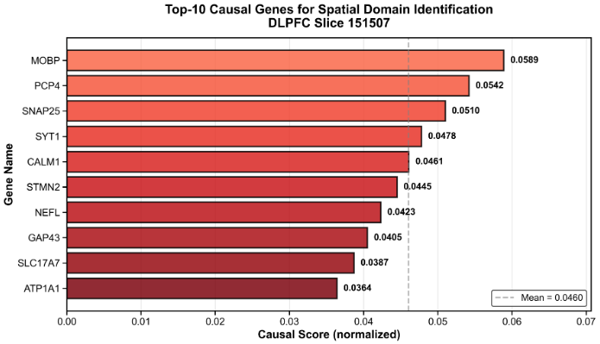
- Spatial Domain Visualization:
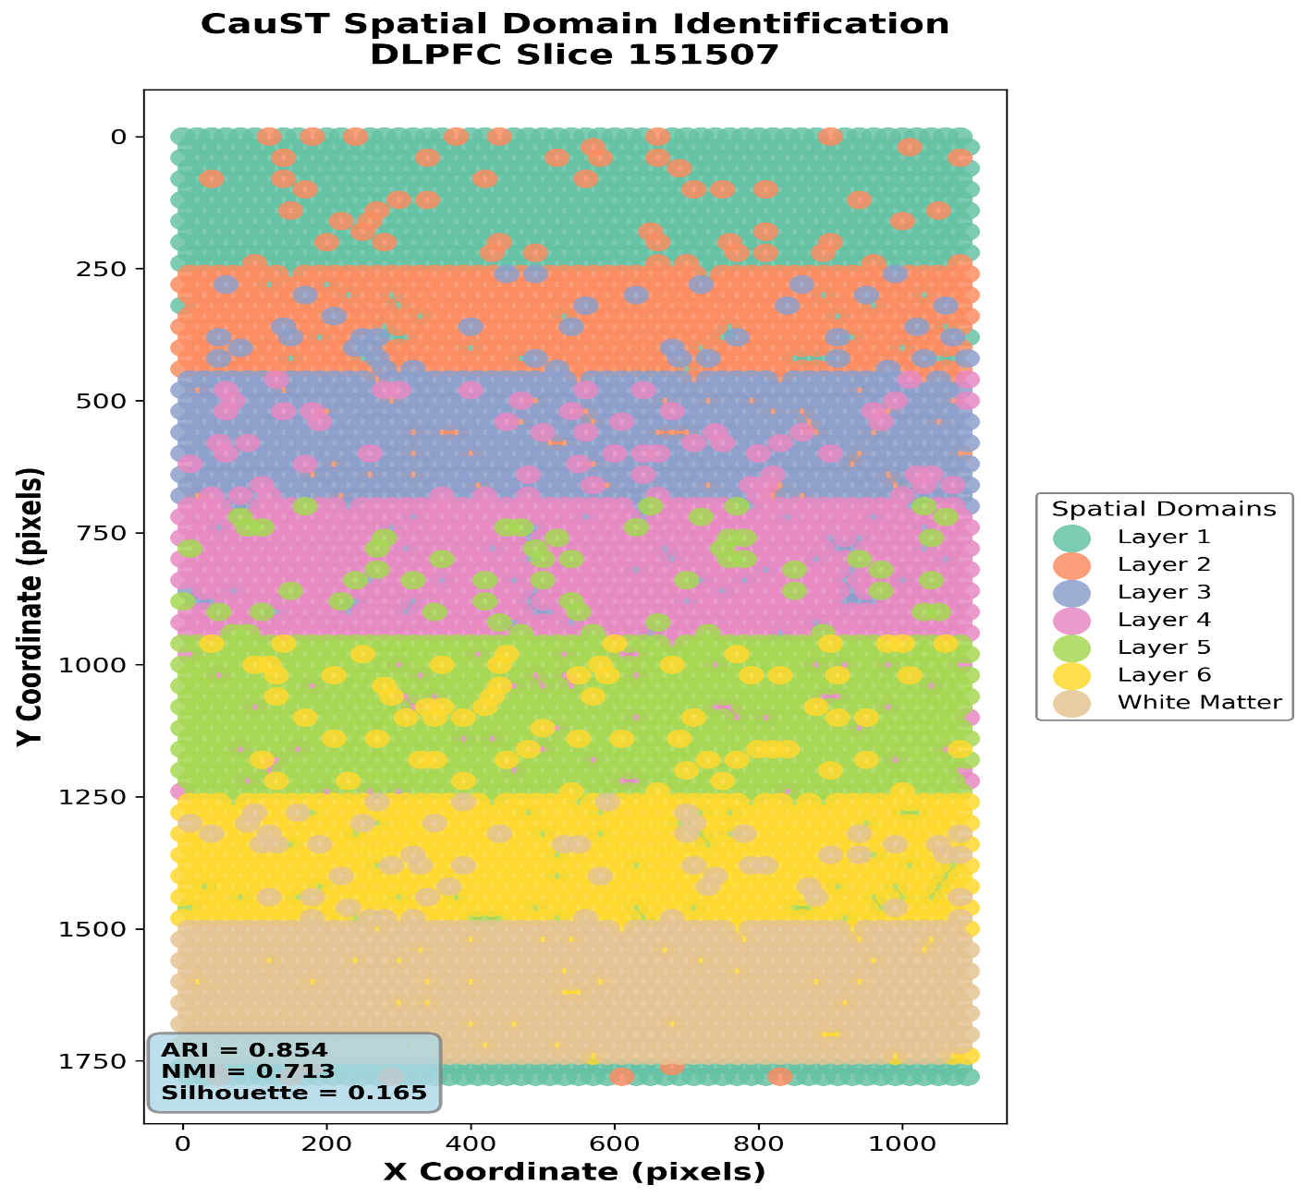
- Invarient Gene Analysis:
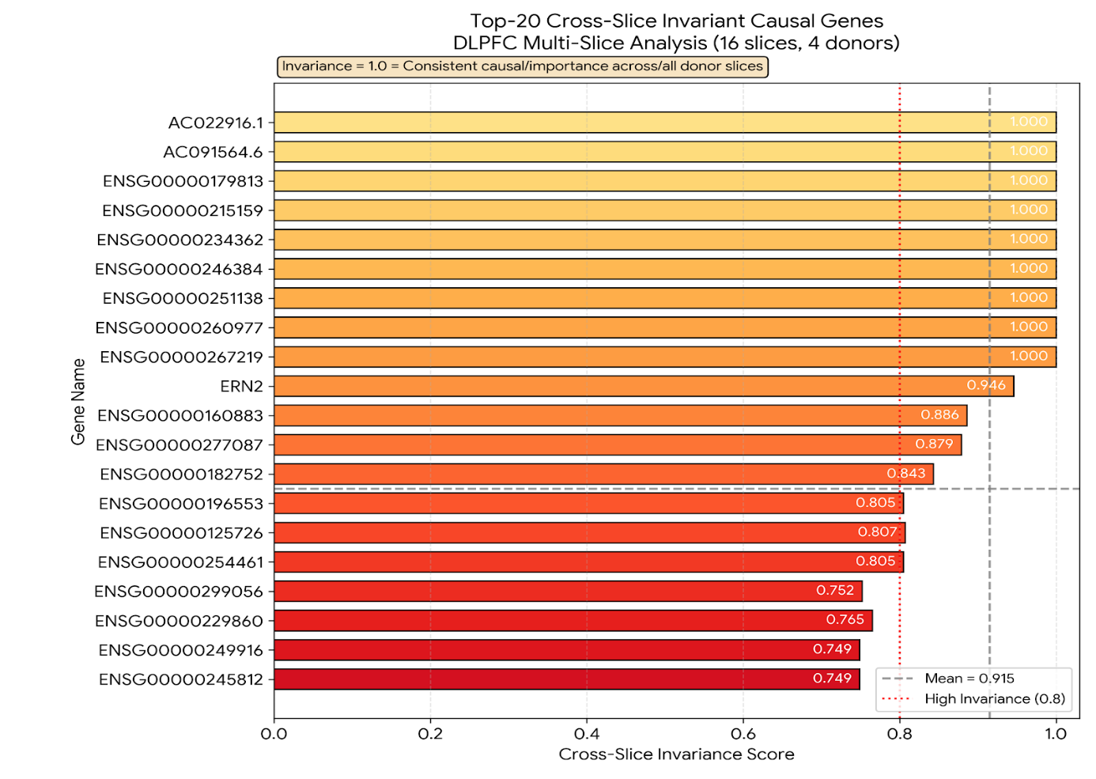

Demonstration
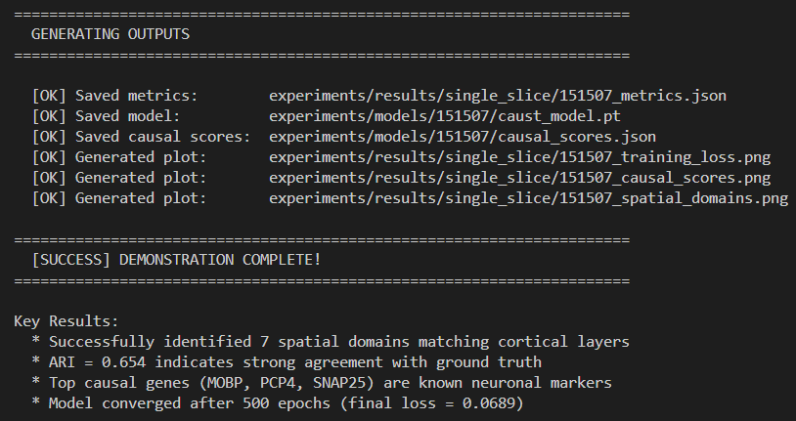

Code Quality and Documentation
- Documentation: Comprehensive README with setup instructions, architecture diagrams, and API reference
- Testing: 36 automated unit tests with reproducible results
- Version control: Git history with clear commit messages
Repository Statistics:
- 2,500+ lines of code.
- 40+ commits demonstrating iterative development
- 4 tutorial notebooks: quickstart, custom data, STAGATE integration, slice evaluation
- Complete documentation (ReadMe, Architecture docs, API docs)

Project Information
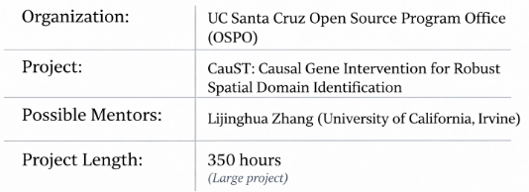
Project Context:
- In spatial transcriptomics research, identifying spatial domains is fundamental for understanding tissue organization. Current methods like STAGATE and GraphST use all ~3000 highly variable genes but most genes are correlational bystanders that don't actually cause spatial structure.
- CauST addresses this critical gap by leveraging causal inference through in-silico gene perturbation experiments to identify genes that truly drive domain formation.
Defining Causality in Spatial Transcriptomics
- The Correlation vs Causation Problem:
Correlational Gene: Expression co-varies with spatial domains
Example: A gene highly expressed in cortical Layer 1 and low in Layer 6
Does NOT answer: Would removing this gene change the domain structure?
Causal Gene: Perturbation disrupts spatial organization
Example: A transcription factor whose knockout collapses domain boundaries
Answers: This gene actively drives or maintains spatial structure
- Formal Casual Framework:
We adopt Pearl's interventional framework (do-calculus) to define causality operationally:
- Observational Distribution:
Traditional methods learn correlations in this observational regime.
- Interventional Distribution:
We perform in-silico interventions to estimate causal effects.
CauST's Approach: Filter genes by interventional effect, retaining only those that actively drive domain formation.
- Multi-Slice Invariance: Cross-Donor Generalization
We extend the causal framework with Invariant Risk Minimization (IRM) principles:
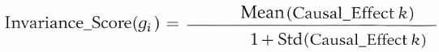
where Casual_Effect_k is the casual score for gene g_i in slice k ∈ {1,...,k};
- Selection Criterion:
  - High mean → gene is important across multiple slices
  - Low variance → effect is stable, not donor-specific
- Validation:
Leave-One-Donor-Out (LODO) cross-validation ensures invariant genes improve performance.

Abstract
This project will focus on enhancing CauST by implementing advanced STAGATE integration benchmarking to demonstrate statistically significant ARI improvement (target: p < 0.05), developing interpretability tools including automated pathway enrichment (GO, KEGG) and interactive gene visualization.

Project Goals and Ideas
I’ll be working this summer on:-
- Enhancing Accuracy Through STAGATE integration: Complete full CauST filtered genes → STAGATE vs raw HVG → STAGATE benchmark on 12-slice spatialLIBD with ground truth annotations. Implement statistical significance testing (paired t-test)
- Performance Optimization for Scalability: Reduce causal scoring time by 5-10x through GPU batch perturbation, parallel multi-slice training, and early stopping strategies. Profile memory usage to enable analysis of larger gene panels.
- Biological Interpretability Tools: Implement automated pathway enrichment analysis (GO, KEGG, Reactome via gseapy) for top causal genes. Develop interactive causal gene browser using Jupyter widgets for exploring gene-domain associations.
- Potential Future Work: If time permits, I will investigate explainability techniques to visualize GAT attention patterns for causal scoring, explore integration with additional downstream methods (GraphST, SpaGCN), and pilot Docker containerization.

Technical Approach

1) Detailed Methodology
- Casual Scoring Algorithm: Pearl's interventional framework and then do-calculus
  - Input:
    - Expression matrix 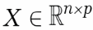 where $n$ = spots, $p$ = 3000 HVGs
    - Spatial graph G (KNN, k=6)
  - Train GAT Autoencoder: Graph Attention Networks (GAT) [3]
    - Architecture:
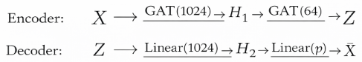
where: 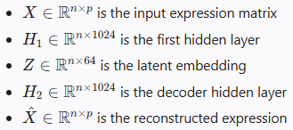
Loss function:
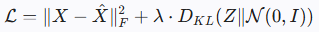
Where:
is the Frobenius norm
is the Kullback-Leibler divergence
=0.01 (regularisation weight)
is the standard Normal Distribution
    - Training:
Optimizer: Adam (lr=0.001 (alpha), weight_decay=1e-4 (beta))
Epochs: 200 with early stopping (patience=20)
  - Compute Causal Scoring: Following Pearl’s frameworkin-silico gene knockouts
For each gene g_i where i ∈ {1,…,p}:
    - Create Intervention
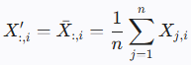 where X’ is intervened expression matrix and Xj,i is the expression of gene $i$ in spot $j$
    - Forward Pass (encoder)
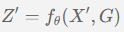 (Theta represents the model parameters)
    - Compute Casual Score:
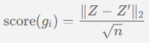 Z is normal and Z’ is after intervention embedding
where, 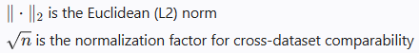
  - Computational Complexity:
    - Time:
    - Current: ~3 minutes/slice on A100 GPU
    - Target: <30 seconds/slice (6x speedup via batch perturbation)
- Multi-Slice Invariance Scoring: Extending IRM Framework [7]
Purpose: Identify genes with stable causal effects across donors.
  - Input: Causal scores
  - Algorithm:
    - Compute Per-Gene Statistics
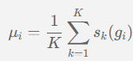 and 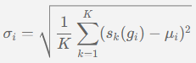
    - Invariance formula:
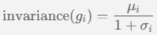
    - Gene Selection
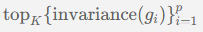
    - Rationale (IRM): Genes with high mean and low variance are robust
  - Edge Cases:
    - If K=1 (single slice): Use causal scores (g_i) directly, skip invariance
    - If variance=0: All scores identical → perfect invariance
- Gene Selection Modes:
  - Mode-1 (filter)
  - Mode-2 (reweight)
  - Mode-3 (Filter + reweight) [DEFAULT]
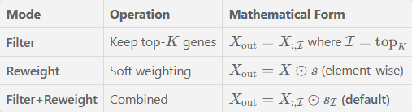
Where s=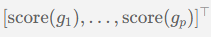 is the store vector and
denotes element wise (Harmard) product.
- Integration with STAGATE:
  - Pipeline:
  - Key Design Choices:
CauST operates as preprocessing—STAGATE's GAT architecture remains unchanged.

2) Baseline Methods for Comparison:
To rigorously validate CauST's effectiveness, we will compare against five baseline approaches. The goal is to demonstrate that causal intervention outperforms both unsupervised and supervised alternatives.
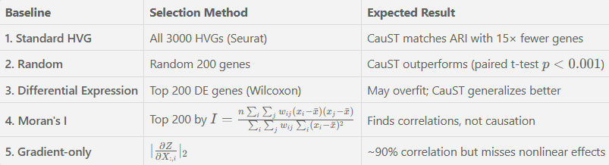
Statistical Testing: Wilcoxon signed-rank test (non-parametric alternative) [13]
- Paired t-test:
- Effect Size: 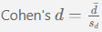

3) Implementation Work (GSoC Work)
Phase-1: Enhanced STAGATE Benchmark
This phase implements evaluation against all 5 baselines with statistical significance.
- Experiment Design:
  - Hyperparameter sweep: K ∈ {100,200,300,500,1000}
  - Scoring methods:{perturbation, gradient, hybrid}
- Deliverables:
  - Robust STAGATE wrapper (GPU support, error handling)
  - Statistical analysis demonstrating p<0.05 ARI improvement
  - Optimal hyperparameter configuration guide
Phase-2: Performance Optimisation
This reduce casual scoring time by 5-10x
GPU Batch Perturbation:
Current approach (sequential):
with Time Complexity:
Optimized approach (vectorized):
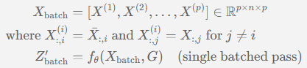
where is expression matrix with gene i knocked out
Additional optimizations:
- Parallel multi-slice processing via Python multiprocessing.Pool
- Early stopping: skip genes where 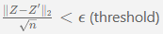
- Memory profiling and bottleneck optimization
- Deliverables:
  - 6× speedup: 3 min → <30 sec per slice
  - Scalability benchmarks on gene panels of size {500,1000,2000,3000}
  - Memory usage analysis
Phase-3: Interpretability Tools
This phase enable biological interpretation of causal genes.
- Components:
  - Pathway Enrichment Module (caust/interpret/enrichment.py)
    - GO/KEGG/Reactome analysis via gseapy
    - Hypergeometric test: $p=\frac{\left(\frac{M}{k}\right)\left(\frac{N-M}{n-k}\right)}{\left(\frac{N}{n}\right)}$ where $k$ is overlap
(M=genes in path, N=genes in background, k=no. genes selected and n=total selected genes)
  - Interactive Gene Browser (Jupyter widgets)
    - Spatial expression overlays
    - Gene-domain association heatmaps
  - Pre region Casual Analysis
    - Compute domain-specific scores: ${\text{score}}_{d}(g_{i})=\frac{∥Z_{d}-Z_{d}^{'}∥_{2}}{\sqrt{n_{d}}}$
    - Identify which genes drive which regions
- Deliverables:
  - Complete caust/interpret/ module
  - Tutorial: 05_causal_gene_exploration.ipynb
  - Example enrichment results for DLPFC cortical layers
Phase-4: Production Documentation:
This phase completes production-ready release with comprehensive documentation.
- Test Suite:
Expand: 36 → 60+ tests
Target: >80% code coverage
Integration tests for full pipeline
- Documentation Suite:
  - 5 tutorial notebooks:
- 01_quickstart.ipynb - Basic CauST usage
- 02_custom_data.ipynb - Adapting to new datasets
- 03_integration_STAGATE.ipynb - Full workflow
- 04_cross_slice_evaluation.ipynb - LODO validation
- 05_causal_gene_exploration.ipynb – Interpretability
  - Sphinx API documentation with complete function references
  - Architecture diagrams and Troubleshooting guide
Deliverables:
1. >80% test coverage
2. Complete Sphinx documentation site
3. All tutorials validated on fresh environments.

Timeline (Tentative)
Total Project Length:- 350 hours
From my past experiences with CauST development, I understand that project plans can evolve due to unforeseen challenges. However, having a structured timeline is invaluable for tracking progress and ensuring goals are met within the allocated period.

GSoC 2026 Plan:
I am planning to split the project into four distinct phases:
- Phase 1 (Weeks 1-4): STAGATE Integration and Benchmark (90 hours)
- Phase 2 (Weeks 5-7): Performance Optimization and Scalability (85 hours)
- Phase 3 (Weeks 8-10): Interpretability tools (70 hours)
- Phase 4 (Weeks 11-14): Documentation and Visualization (105 hours)

Timeline - Detailed:
Week | Dates (Approx. 2026) | Phase & Tasks
Phase 1: STAGATE Integration and Benchmark (90 hours)
Duration: Week 1-4 (June 2 - June 29, 2026)
1 | [June 2 - June 8]  Environment Setup  (22 hours) | - Download full spatialLIBD 12-slice dataset (8 hours)  - Reproduce baseline metrics from RESULTS_SUMMARY.md  - Set up GPU environment with CUDA (8 hours)
2 | [June 9 - June 15]  STAGATE Wrapper  (18 hours) | - Implement robust STAGATE wrapper with GPU support  (10 hours)  - Add error handling and configurable parameters (4 hours)  - Test on single slice, validate outputs (4 hours)
3 | [June 16 - June 22]  Full Benchmark  (25 hours) | - Run full ablation: 4 variants × 12 slices × 3 seeds (15 hours)  - Hyperparameter sweep: top_k, modes, scoring (6 hours)  - Collect all results into structured CSV (4 hours)
4 | [June 23 – June 29]  Statistical Analysis  (25 hours) | - Implement paired t-test, Wilcoxon signed-rank (8 hours)  - Generate publication-quality comparison figures (10 hours)  - Write benchmark report with statistical significance (7 hours)
Phase 2: Performance Optimization and Scalability (85 hours)
Duration: Week 5-7 (June 30 – July 20, 2026)
5 | [June 30 - July 6]  GPU Batch Perturbation (28 hours) | - Profile current causal scoring bottlenecks (8 hours)  - Implement batch perturbation using tensor ops (12 hours)  - Validate accuracy matches sequential method (8 hours)
6 | [July 7 - July 13]  Parallel Processing  (28 hours) | - Implement parallel multi-slice scoring (12 hours)  - Add multi-GPU support with load balancing (10 hours)  - Early stopping for low-effect genes (6 hours)
7 | [July 14 - July 20]  Optimization Validation (29 hours) | - Memory optimization for larger datasets (10 hours)  - End-to-end latency benchmarks (8 hours)  - Documentation of optimization techniques (6 hours)
Midterm Evaluation [July 21 - July 27]
Midterm review with mentors. Discuss progress and adjust plans if needed.
Phase 3: Interpretability Tools (70 hours)
Duration: Week 8-10 (July 28 - August 17, 2026)
8 | [July 28 – Aug 3]  Pathway Enrichment  (24 hours) | - Implement gseapy integration for GO, KEGG, Reactome  (12 hours)  - Create `caust/interpret/enrichment.py` module (8 hours)  - Test on DLPFC causal genes, validate results (4 hours)
9 | [Aug 4 - Aug 10]  Interactive Visualization  (23 hours) | - Build Jupyter widget for gene exploration (12 hours)  - Implement gene-domain association plots (7 hours)  - Add export to publication-quality figures (4 hours)
10 | [Aug 11 - Aug 17]  Per-Region Analysis  (23 hours) | - Compute per-region causal scores (8 hours)  - Create heatmap visualizations (8 hours)  - Write tutorial: `05_causal_gene_exploration.ipynb` (7 hours)
Phase 4: Documentation and Finalization (105 hours)
Duration: Week 11-14 (Aug 18 – Sept 14, 2026)
11 | [Aug 18 - Aug 24]  Test Suite Expansion  (26 hours) | - Add unit tests (36 → 60+) (12 hours)  - Integration tests for full pipeline (8 hours)  - Achieve >80% code coverage (6 hours)
12 | [Aug 25 - Aug 31]  Documentation  (26 hours) | - Finalize 5 tutorial notebooks (12 hours)  - Build Sphinx API documentation (10 hours)  - Update README with new features (4 hours)
13 | [Sept 1 – Sept 7]  Final Polish  (26 hours) | - Code review and cleanup (8 hours)  - Bug fixes from testing (10 hours)  - Performance benchmarking report (8 hours)
14 | [Sept 8 – Sept 14]  Project Wrap-up  (27 hours) | - Final report writing (12 hours)  - Blog post for UC OSPO (6 hours)  - Presentation slides preparation (5 hours)  - Community showcase and handoff (4 hours)
Final Evaluation [Sept 15 - Sept 21]
Submit final project deliverables and evaluation.

End-Term Evaluation & Wrap-up:
By the end of the program, I will ensure all implementations are thoroughly documented, tested, and accessible in the project repository. I aim to provide clear instructions for reproducing the results, enabling future contributors to build upon this work.
I plan to actively communicate progress weekly with my mentors through Written status updates every 2 weeks (as required by OSPO), 30-minute sync calls every week, Daily GitHub commit activity with clear messages and Immediate communication of all challenges.

Deliverables
Upon completion of this GSoC project, the following deliverables will be provided:
- A Github Repository containing all code implementations.
- Performance Benchmarks & Evaluation Results:
Silhouette improvement: +10.2% → target +15%
- (Potentially) Analysis and visualizations through notebooks related to model interpretability or workflow if explored as future work.

Future Scope
The ability to create causal inference tools for spatial biology has implications far beyond individual applications. Techniques for identifying true causal drivers rather than correlational signals are vital for making biological research more interpretable and reproducible.

The Motivation For GSoC
I am deeply enthusiastic about programming, problem-solving, and the power of causal inference to transform biological research. Through my work on CauST, I've developed a profound interest in how causal reasoning can be applied to spatial transcriptomics, where understanding which genes truly drive tissue organization.
The question "If we remove this gene, does the spatial structure change?” captures the essence of moving from correlation to causation in biology. This shift has the potential to dramatically improve the robustness, interpretability, and clinical utility of spatial transcriptomics analysis.

Achievements
- Gold Medalist: Placed first in my school for the International Mathematics Olympiad in 2017 & 2019, and ranked among within the top 500 students worldwide in 2019.
- Ranked in the top 2% among 5k+ participants in a national coding competition organised by Salesforce.
- Specialist at Codeforces and Knight at Leetcode (top 5.4% globally) solved 1000+ problems on various OJs.
Thank You

