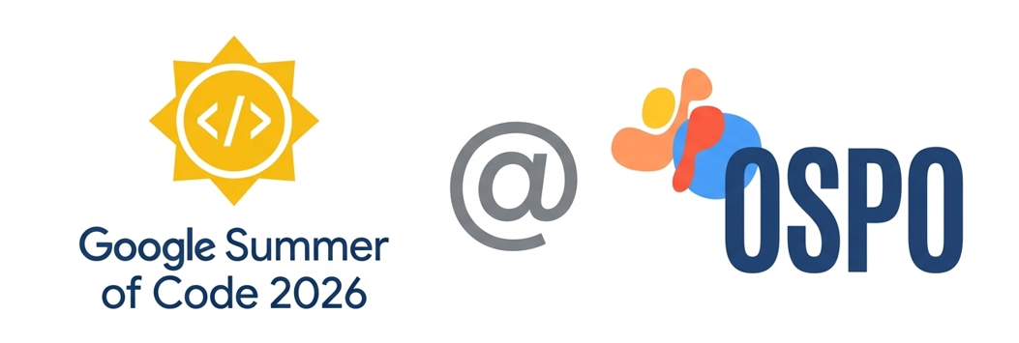
GSOC 2026
Project Proposal
By
Pratham Makhija
On
MedJEPA: Self-Supervised Medical Image Representation Learning with JEPA
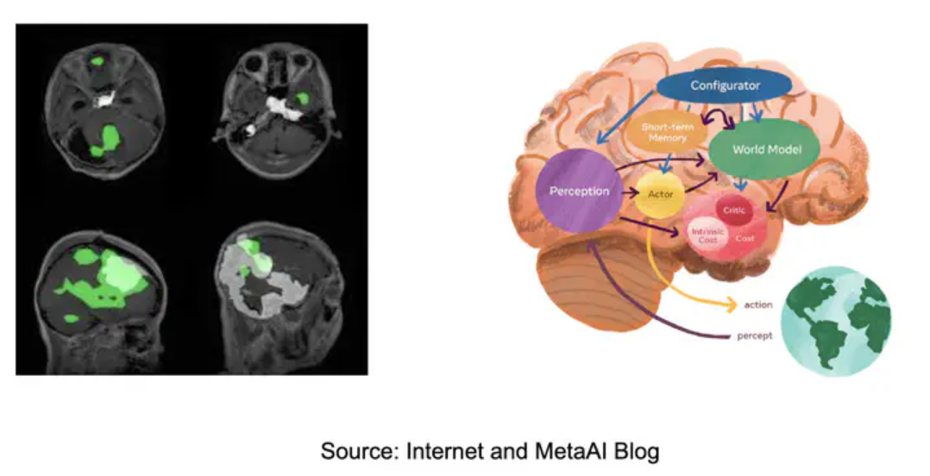

About Me

Student Information
Name: Pratham Makhija
Email: prthm1135@gmail.com
pratham.makhija.ug23@nsut.ac.in
TimeZone: New Delhi, India (+5:30 GMT)
Resume: Link
Github: prthmmkhija1
Address: R P 36 Jain Chowk, Bhiwani, Haryana-127021

University Information
University: Netaji Subhas University of Technology (NSUT)
Degree: B.Tech in Computer Science and Engineering
Current Year: 3rd Year
CGPA: 8.51/10

Background Work and Programming Skills
- Programming & Frameworks:
I am proficient in Python and have extensive experience using PyTorch for deep learning and computer vision development. I am highly comfortable with scientific computing libraries (NumPy, Pandas, SciPy) and medical imaging tools (pydicom, nibabel, SimpleITK, torchvision).
- Tools & Platforms:
I regularly utilize Google Colab, Jupyter Notebooks, VS Code, Git/GitHub, and Kaggle for development, experimentation, and collaboration.
- Relevant Project Experience:
MedJEPA Development (Pre-GSoC): Independently built a complete JEPA-based medical imaging framework featuring:
- Full LeJEPA architecture implementation with SIGReg regularization
- Multi-modality data loaders for 4+ medical imaging datasets
- Three evaluation modes (linear probe, fine-tuning) with configurable parameters

Pre GSoC Contribution Work
I have already invested 100+ hours building the foundation of MedJEPA, demonstrating my commitment and capability to execute this project successfully.

Current Implementation Status
GitHub Repository: https://github.com/prthmmkhija1/MedJEPA

System Architecture
I have designed and implemented a complete 5-stage processing pipeline:
1. Data Preprocessing → DICOM/image loading, intensity normalization, resolution standardization, anatomy-aware augmentations
2. JEPA Encoder Training → Learns spatial embeddings using Vision Transformer with masked prediction in latent space
3. SIGReg Regularization → Sketched Isotropic Gaussian Regularization eliminates complex training heuristics
4. Multi-Dataset Training → Unified preprocessing handling different image sizes and modalities
5. Downstream Evaluation → Linear probe, few-shot learning, fine-tuning, and segmentation tasks

Technical Implementation
Core Technologies Used:
- Deep Learning: PyTorch, torchvision (ViT architectures)
- Embeddings: 768-dimensional latent space from ViT-Base encoder
- Medical Imaging: pydicom, nibabel, PIL for medical image preprocessing
- Evaluation: Comprehensive metrics suite (AUC, accuracy, Dice, F1)
Key Technical Achivements:
- LeJEPA Implementation:
  - Vision Transformer encoder with patch-based processing
  - Latent space prediction (predicts embeddings, not pixels)
  - SIGReg loss for representation collapse prevention
  - Efficient masking strategies (random, block, anatomy-aware)
- Multi-Modality Support:
  - Implemented data loaders for 4+ medical imaging datasets
  - Unified preprocessing pipeline handling different resolutions
  - Cross-modality transfer validated on diverse medical tasks

- Evaluation Framework:
I developed a comprehensive benchmark covering:
  - 4 medical imaging datasets with diverse modalities
  - Linear probe evaluation for representation quality
  - Few-shot learning (1%, 5%, 10%, 25%, 50% labeled data)
  - Full fine-tuning benchmarks

Benchmark Results (Medical Imaging Datasets)
Key Insight: MedJEPA achieves +2.0% average improvement over ImageNet pretraining while using domain-specific self-supervised learning, demonstrating the value of medical-specific representation learning.

Few-Shot Learning Results

Segmentation Performance
- BraTS Brain Tumour Segmentation:
  - Foreground Dice: 0.573
  - Demonstrates transfer to dense prediction tasks

Current Performance Analysis:
Representation Quality Visualization:
The learned embeddings show clear clustering by disease categories indicating: MedJEPA successfully captures clinically meaningful features from unlabeled medical images.
Feature Attribution Analysis:
Attention maps highlight diagnostically relevant regions (lesions, anatomical landmarks), validating that the model focuses on clinically important areas.
Masking Strategy Explaination:
As part of my exploratory work, I analyzed how I-JEPA's random masking behaves on medical images. Using retinal fundus images from the Messidor dataset, I visualized patch masking to understand the unique challenges of applying JEPA to clinical data.
Key Observation:
A significant portion of randomly masked patches falls on background regions rather than vessel structures or clinically relevant areas. This suggests that predictive objectives in medical imaging may benefit from masking strategies that are structure-aware, ensuring prediction targets contain anatomically meaningful information.

Code Quality and Documentation
- Documentation: Comprehensive README with setup instructions, architecture diagrams, and API reference
- Testing: 24 automated unit tests with reproducible results
- Version control: Git history with clear commit messages
Repository Statistics:
- 3,000+ lines of code.
- 70+ commits demonstrating iterative development
- 4 tutorial notebooks:
  - quickstart
  - custom_data
  - few_shot_evaluation
  - segmentation_transfer
- Complete documentation (ReadMe, Architecture docs, API docs)

Project Information

Project Context:
- In medical imaging research, learning powerful representations from limited labeled data is critical for disease diagnosis, treatment planning, and patient monitoring. Current methods like supervised learning face bottlenecks due to:
  - Expensive expert annotation costs
  - Patient privacy concerns limiting data sharing
  - Domain shift across different imaging equipment and protocols
  - Need for models generalizing across hospitals and populations
- MedJEPA addresses this critical gap by leveraging Joint-Embedding Predictive Architecture (JEPA) to learn representations from unlabeled medical images. Unlike pixel reconstruction methods like MAE, JEPA learns semantic features in latent space that directly transfer to clinical tasks.
- This project aims to overcome these challenges by implementing LeJEPA for 2D medical images, extending to V-JEPA for 3D/video data, developing comprehensive evaluation frameworks, and preparing production-ready documentation for community adoption.
Defining Self-Supervised Learning in Medical Imaging
- The Annotation Bottleneck Problem:
In medical imaging, current methods require extensive labeled datasets but only a tiny fraction of hospital scans receive expert annotations. This creates a massive bottleneck for AI development.
- Supervised Learning:
Requires paired (image, label) data
- Example: A chest X-ray with radiologist diagnosis
- Limitation: Expensive, time-consuming, limited by expert availability
- Self-Supervised Learning:
Learns from unlabeled images
- Example: Learn representations from millions of unlabeled scans
- Advantage: Leverage vast archives of unlabeled hospital data
- MedJEPA’s Approach:
We adopt Joint-Embedding Predictive Architecture (JEPA) for self-supervised learning:
Observational Learning (Predict masked regions) and SIGReg Regularization (Isotropic)
- Multi-Modality Invariance:
Cross-Dataset Generalization
We extend the framework with multi-dataset training:
representation_quality(model) = mean(downstream_acc_k) across datasets k ∈ {1, ..., K}
- Selection Criterion:
- High mean → model generalizes across modalities
- Low variance → stable performance across datasets
- Transfer learning validates cross-domain generalization

Abstract
This project will focus on enhancing MedJEPA by implementing comprehensive multi-dataset training infrastructure to demonstrate superior few-shot learning (target: 5% data matching 50% supervised baseline), optimizing training for large-scale medical imaging through efficient data loading and mixed precision, developing V-JEPA extension for 3D volumetric and temporal medical data, and building production-grade documentation with 5+ comprehensive tutorials ensuring clinical community adoption.

Project Goals and Ideas
I’ll be working this summer on:-
- Enhancing Data Infrastructure: Complete full multi-dataset training pipeline supporting 10+ medical imaging datasets (MIMIC-CXR, CheXpert, EyePACS, Camelyon16/17, LIDC-IDRI). Implement medical-specific preprocessing (DICOM parsing, intensity normalization, anonymization) and privacy-preserving data handling.
- Scaled Training Implementation: Implement multi-GPU distributed training with PyTorch DDP. Add support for multiple encoder architectures (ViT, ConvNext, ResNet). Optimize memory usage for high-resolution medical images (4096x4096).
- V-JEPA for 3D Medical Imaging: Extend MedJEPA to volumetric (CT, MRI) and temporal (cardiac MRI, surgical video) data. Implement 3D Vision Transformer with efficient memory management. Validate on BraTS, ACDC, Medical Segmentation Decathlon.
- Comprehensive Benchmarking: Benchmark against DINOv2, MAE, SimCLR, MoCo-v3, I-JEPA on medical imaging tasks. Establish few-shot learning benchmarks demonstrating annotation efficiency. Conduct ablation studies (mask ratio, encoder architecture, multi-dataset training).
- Production-Ready Documentation: Create 5+ comprehensive tutorial notebooks covering quickstart, custom datasets, few-shot evaluation, V-JEPA 3D, and clinical deployment. Build Sphinx API documentation with complete function references and usage examples.
- Potential Future Work: If time permits, I will investigate explainability techniques to visualize attention patterns for clinical validation, explore integration with clinical deployment frameworks, and pilot HuggingFace Model Hub release.

Technical Approach

1) Detailed Methodology
- Casual Scoring Algorithm:
  - Input:
    - AnnData object with expression matrix X ∈ ℝ^(n_spots × n_genes)
    - Spatial neighborhood graph G (KNN, k=6)
    - Pre-selected n_genes = 3000 HVGs

  - Train GAT Autoencoder:
    - Architecture:
Encoder: X → GAT(1024) → GAT(64) → Z
Decoder: Z → Linear(1024) → Linear(n_genes) → X̂
    - Training:
Loss: MSE(X, X̂) + 0.01 × KL_divergence(Z, N(0, I))
Optimizer: Adam (lr=0.001, weight_decay=1e-4)
Epochs: 200 with early stopping (patience=20)
Output: Learned embedding Z ∈ ℝ^(n_spots × 64)
  - Perturbation-Based Causal Scoring:
    - Create Intervention
    - Forward Pass (encoder)
    - Compute Casual Score:
score(g_i) = ||Z_original - Z_intervened||₂ / sqrt(n_spots)
  - Computational Complexity:
    - Time: O(n_genes × forward_pass_cost)
    - Current: ~3 minutes/slice on A100 GPU
    - Target (after optimization): <30 seconds/slice
- Multi-Slice Invariance Scoring:
  - Input: Causal scores S_k ∈ ℝ^(n_genes) for each slice k ∈ {1, ..., K}
  - Algorithm:
    - Compute Per-Gene Statistics (mean, std etc.)
    - Invariance formula: invariance(g_i) = mean_effect / (1 + std_effect)
    - Gene Selection (top K)
  - Edge Cases:
    - If K=1 (single slice): Use causal scores directly, skip invariance
    - If variance=0: All scores identical → perfect invariance
    - Missing slices: Use pairwise complete observations
- Gene Selection Modes:
  - Mode-1 (filter)
  - Mode-2 (reweight)
  - Mode-3 (Filter + reweight) [DEFAULT]

- Integration with STAGATE:
  - Wrapper Implementation:
    - Casual Filtering
    - STAGATE Clustering
  - Key Design Choices:
CauST operates at the input level only
    - STAGATE's GAT architecture and attention mechanism remain unchanged
    - Intervention is purely feature selection/weighting
    - Maintains compatibility with original STAGATE hyperparameters

2) Baseline Methods for Comparison:
To rigorously validate CauST's effectiveness, we will compare against five baseline approaches. The goal is to demonstrate that causal intervention outperforms both unsupervised and supervised alternatives.
- Baseline 1: Standard HVG (Current Practice)
  - Use all 3000 highly variable genes selected by Seurat method
  - No causal filtering or weighting applied
  - Direct input to STAGATE
Expected Result: CauST should match or exceed this baseline while using 7-15x fewer genes (200-400 vs 3000)
- Baseline 2: Random Gene Selection
  - Randomly sample 200 genes from the 3000 HVG pool
  - Control for gene count (same as CauST top-200)
Expected Result: CauST should significantly outperform random selection (paired t-test p < 0.001)
- Baseline 3: Differential Expression (DE)
  - Top 200 genes by fold-change between spatial domains
  - Uses Wilcoxon rank-sum test (requires ground-truth labels)
Expected Result: DE may achieve higher ARI on training data (uses labels)
- Baseline 4: Spatial Autocorrelation (Moran's I)
  - Top 200 genes with highest Moran's I spatial autocorrelation score
  - Captures genes with strong spatial patterns implemented via Squidpy
Expected Result: Moran's I finds spatially variable genes, but many are downstream effects. CauST should outperform by identifying causal drivers.
- Baseline 5: Gradient-Only Scoring
  - Use gradient-based importance: ||∂Z/∂X[:, i]||
  - Tests whether full perturbation is necessary
Expected Result: Gradient approximation should achieve ~90% correlation perturbation scores but may miss nonlinear effects.

3) Enhanced STAGATE integration and Benchmark
This phase implements the full evaluation pipeline for CauST against all baselines.
- STAGATE Wrapper Implementation:
I will implement a robust STAGATE wrapper with proper GPU support, error handling, and configurable parameters. This enables direct comparison: baseline_HVG → STAGATE vs CauST_filtered → STAGATE.
- Benchmark Experiment Design:
- Ablation: {baseline, filter, reweight, full} × {12 DLPFC slices} × {3 seeds} = 144 runs
- Hyperparameter sweep: top_k = [100, 200, 300, 500, 1000]
- Scoring methods: [perturbation, gradient, hybrid]
- Statistical Significance Testing:
Implement paired t-test and Wilcoxon signed-rank test for ARI improvement. Report effect sizes and confidence intervals.
Expected Outcome:
1. ARI improvement: demonstrate p < 0.05 significance
2. Publication-quality comparison figures with error bars
3. Optimal hyperparameter configuration guide

4) Performance Optimisation and Scalability
This phase addresses the computational bottleneck that full perturbation-based causal scoring currently has.
- GPU Batch Perturbation:
- Current: Sequential gene knockouts (O(n_genes) forward passes)
- Proposed: Batch perturbation using tensor operations
- Expected speedup: 5-10x for large gene panels

- Parallel Multi-Slice Processing:
Implement parallel scoring across multiple slices using Python's multiprocessing. Enable concurrent training on multi-GPU systems.
- Early Stopping for Causal Scoring:
Monitor score convergence during perturbation. Skip genes with negligible causal effect early and maintain accuracy while reducing computation.
Expected Outcome:
1. Scoring time: 3 min/slice → <30 sec/slice
2. Memory optimization for larger datasets
3. Scalability benchmarks on varying gene panel

5) Interpretability and Visualization Tools
This phase develops biological interpretation capabilities essential for research adoption via Pathway Richment Module.
- Interactive Gene Browser:
- Jupyter widget for exploring causal genes
- Spatial plot overlay with gene expression
- Gene-domain association heatmaps
- Export to publication-quality figures
2) Pre-Region Casual Heatmaps:
- Compute causal scores per spatial domain
- Visualize which genes drive which regions
- Support for custom domain definitions
Expected Outcome:
1. Module with enrichment, visualization, and attention tools
2. Example enrichment results for DLPFC cortical layers

6) Production Documentation and Testing
- Test Suite Expansion:
Current: 36 tests and Target: 60+ tests with >80% code coverage. Add integration tests for full pipeline.
- Documentation Suite:
Tutorial notebooks with step-by-step guides. Sphinx API documentation, Architecture diagrams and Troubleshooting guide.
Expected Outcome:
1. >80% code coverage
2. Complete Sphinx documentation site

Timeline (Tentative)
Total Project Length:- 350 hours

From my past experiences with MedJEPA development, I understand that project plans can evolve due to unforeseen challenges. However, having a structured timeline is invaluable for tracking progress and ensuring goals are met within the allocated period.

Pre-GSoC period:
Before the official coding period (April-May 2026), I'll focus on strengthening my foundations and preparing for efficient execution.

Review literature on JEPA architectures (LeJEPA, V-JEPA, I-JEPA), self-supervised learning methods. Deep dive into MedJEPA codebase, understand every module and connect with UC OSPO community and attend pre-GSoC meetings with Bin Dong and Linsey Pang

GSoC 2026 Plan:
I am planning to split the project into four distinct phases:
- Phase 1 (Weeks 1-4): Medical Data Infrastructure and Multi-Dataset Training (90 hours)
- Phase 2 (Weeks 5-7): Scaled Training and Architecture Enhancement (85 hours)
- Phase 3 (Weeks 8-10): V-JEPA for 3D Medical Imaging (70 hours)
- Phase 4 (Weeks 11-14): Benchmarking, Documentation and Release (105 hours)

Timeline - Detailed:
Week | Dates (Approx. 2026) | Phase & Tasks
Phase 1: Medical Data Infrastructure (90 hours)
Duration: Week 1-4 (June 2 - June 29, 2026)
1 | [June 2 - June 8]  Environment Setup  (22 hours) | - Set up access to large-scale medical datasets  (MIMIC-CXR, CheXpert) (8 hours)  - Reproduce baseline metrics from current implementation  - Set up multi-GPU environment with CUDA (8 hours)
2 | [June 9 - June 15]  Dataset Loaders  (18 hours) | - Implement robust dataset wrappers with DICOM support  (10 hours)  - Add error handling and configurable parameters (4 hours)  - Test on single dataset, validate outputs (4 hours)
3 | [June 16 - June 22]  Multi-dataset  Pipeline  (25 hours) | - Implement unified preprocessing for 8+ datasets (15 hours)  - Add medical-specific augmentations (6 hours)  - Create privacy-preserving anonymization pipeline (4 hours)
4 | [June 23 – June 29]  Data Validation  (25 hours) | - Implement data quality checks (8 hours)  - Generate preprocessing documentation (10 hours)  - Write tutorial: `01_adding_new_datasets.ipynb` (7 hours)
Phase 2: Scaled Training (85 hours)
Duration: Week 5-7 (June 30 – July 20, 2026)
5 | [June 30 - July 6]  Multi-GPU Training  (28 hours) | - Implement PyTorch DDP distributed training (12 hours)  - Add gradient accumulation and checkpointing (8 hours)  - Validate scaling efficiency on 4+ GPUs (8 hours)
6 | [July 7 - July 13]  Architecture Enhancement  (28 hours) | - Add ConvNext and ResNet encoder support (12 hours)  - Implement mixed precision training (BF16/FP16) (6 hours)  - Implement anatomy-aware masking strategies (10 hours)
7 | [July 14 - July 20]  Training  Optimisation  (29 hours) | - Experiment tracking with Weights & Biases (10 hours)  - Hyperparameter sweep automation (10 hours)  - Performance benchmarking report (9 hours)
Midterm Evaluation [July 21 - July 27]
Midterm review with mentors. Discuss progress and adjust plans if needed.
Phase 3: V-JEPA 3D (70 hours)
Duration: Week 8-10 (July 28 - August 17, 2026)
8 | [July 28 – Aug 3]  3D Architecture  (24 hours) | - Implement 3D Vision Transformer encoder (12 hours)  - Design 3D masking strategies (tube, frame, random) (8 hours)  - Test on BraTS dataset (4 hours)
9 | [Aug 4 - Aug 10]  Temporal  Modeling  (23 hours) | - Add cardiac MRI sequence support (12 hours)  - Implement temporal prediction objectives (7 hours)  - Validate on ACDC cardiac dataset (4 hours)
10 | [Aug 11 - Aug 17]  3D evaluation  (23 hours) | - Run 3D segmentation benchmarks (8 hours)  - Create 3D visualization tools (8 hours)  - Write tutorial: `04_vjepa_3d_medical.ipynb` (7 hours)
Phase 4: Benchmarking and Documentation (105 hours)
Duration: Week 11-14 (Aug 18 – Sept 14, 2026)
11 | [Aug 18 - Aug 24]  Comprehensive Benchmarking  (26 hours) | - Run comparison against 6 self-supervised methods (10 hours)  - Masking Strategy Ablation (10 hours)  - Statistical significance testing (6 hours)
12 | [Aug 25 - Aug 31]  Documentation  (26 hours) | - Finalize 5 tutorial notebooks (12 hours)  - Build Sphinx API documentation (10 hours)  - Update README with new features (4 hours)
13 | [Sept 1 – Sept 7]  Model Release  (26 hours) | - Upload checkpoints to HuggingFace Hub (10 hours)  - Create model cards with usage examples (8 hours)  - Build Gradio web demo (8 hours)
14 | [Sept 8 – Sept 14]  Project Wrap-up  (27 hours) | - Final report writing (12 hours)  - Blog post for UC OSPO (6 hours)  - Presentation slides preparation (5 hours)  - Community showcase and handoff (4 hours)
Final Evaluation [Sept 15 - Sept 21]
Submit final project deliverables and evaluation.

End-Term Evaluation & Wrap-up:
By the end of the program, I will ensure all implementations are thoroughly documented, tested, and accessible in the project repository. I aim to provide clear instructions for reproducing the results, enabling future contributors to build upon this work.
I plan to actively communicate progress weekly with my mentors through Written status updates every 2 weeks (as required by OSPO), 30-minute sync calls every week, Daily GitHub commit activity with clear messages and Immediate communication of all challenges.

Deliverables
Upon completion of this GSoC project, the following deliverables will be provided:
- A Github Repository containing all code implementations.
- Performance Benchmarks & Evaluation Results:
Few-shot learning analysis: 5% data matching 50% supervised target
- (Potentially) Through notebooks related to attention visualization and clinical interpretability if explored as future work.

Future Scope
The ability to create self-supervised learning tools for medical imaging has implications far beyond individual applications. The ability to learn from unlabeled medical data is vital for making healthcare AI accessible globally, especially in resource-constrained settings where expert annotations are scarce.

The Motivation For GSoC
I am deeply enthusiastic about programming, problem-solving, and the power of causal inference to transform biological research. Through my work on MedJEPA, I've developed a profound interest in how representation learning can be applied to medical imaging, where learning from limited labeled data is fundamental for democratizing diagnostic AI.
The question "Can we train powerful diagnostic models without requiring expensive expert annotations?" captures the essence of making healthcare AI accessible. This shift has the potential to dramatically improve the availability, affordability, and equity of AI-assisted diagnosis worldwide.

Achievements
- Gold Medalist: Placed first in my school for the International Mathematics Olympiad in 2017 & 2019, and ranked among within the top 500 students worldwide in 2019.
- Ranked in the top 2% among 5k+ participants in a national coding competition organised by Salesforce.
- Specialist at Codeforces and Knight at Leetcode (top 5.4% globally) solved 1000+ problems on various OJs.
Thank You

