1. Create create an registration form as follows:

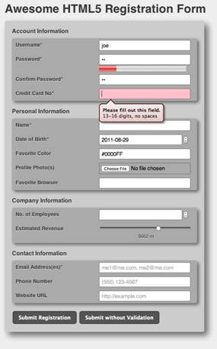

Display "Your account is successfully registered" on click of submit registration.

2. create a HTML5 web page using semantic markups as follows:

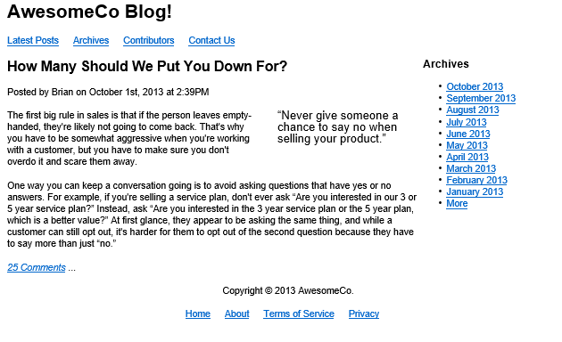

**CSS**

* 1. 1.Considering the lab assignments of HTML
  2. o Write a CSS rule that changes the color of all the elements with attribute CLASS =”Green-Move” to green and shift them down 25 pixels and right 15 pixels.
  3. o Set the page body's margins to 10 pixels on all sides with no padding. Use a Verdana sans-serif font and set the default font-size to 95%
  4. o Set all divisions to display with a 1 pixel, solid, black border (to help with debugging)
  5. o In the Header Area
  6. o Set its heading 1's text to display centered, in a 'Courier New' mono space font, and a font size of .8 em
  7. o Set its heading 2's text to display centered with a font size of 1.5 em
  8. o In the Navigation Area
  9. o Make its width 25% of the screen size and float it left
  10. o Style its unordered list of anchor elements to look like a menu
  11. o Do not add the background image or onfocus attribute (final optional steps) in tutorial
  12. o use a background color of red and a text color of white
  13. o center the text
  14. o In the Main Content Area
  15. o Set the right and left margins to 26% of the screen size
  16. o Make its heading 2's text centered with a font size of 1.2 em
  17. o For Printing, write the style rules to
  18. o Set display to none for the navigation and advertisement areas so that only the header and main content are printed.
  19. o You do not need to specify style rules for the header and main content elements.
  20. o The browser should use the default settings when printing your Web page
  21. • Create a form to submit a resume
  22. • Using in line CSS. Write all the above styling in CSS in different file (.css) and link it to your webpage such that changes made in CSS file are immediately reflected on the page. Group paragraphs into single class and add styling information to the class in CSS. Add few form elements such as radio buttons, check boxes and password field. Add a submit button at last.
  23. • Apply inline CSS to change colors of certain text portion, bold, underline and italics certain words in your HTML web page. Also change background color of each paragraph
  24. • Create a simple form to submit user input like his name, age, address and favorite subject, movie and singer.