1. Create create an registration form as follows:

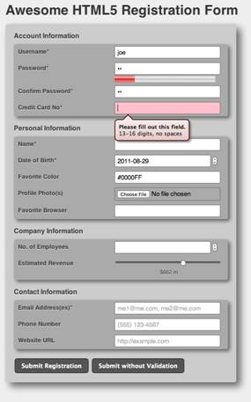

Display "Your account is successfully registered" on click of submit registration.

2. create a HTML5 web page using semantic markups as follows:

