Supplementary Information for Research Article -

S-Glutathionylation of Cysteine-217 allosterically inhibits Triose-phosphate Isomerase: A Molecular Dynamics Study

M.S. Shahul Hameed
School of Life Sciences, B.S.Abdur Rahman University, Chennai 600048, India

Corresponding author: M.S.Shahul Hameed. Tel: +91-44-22759223 ext 466;
E-mail: shahulhambiotech@gmail.com

Supplementary Figure

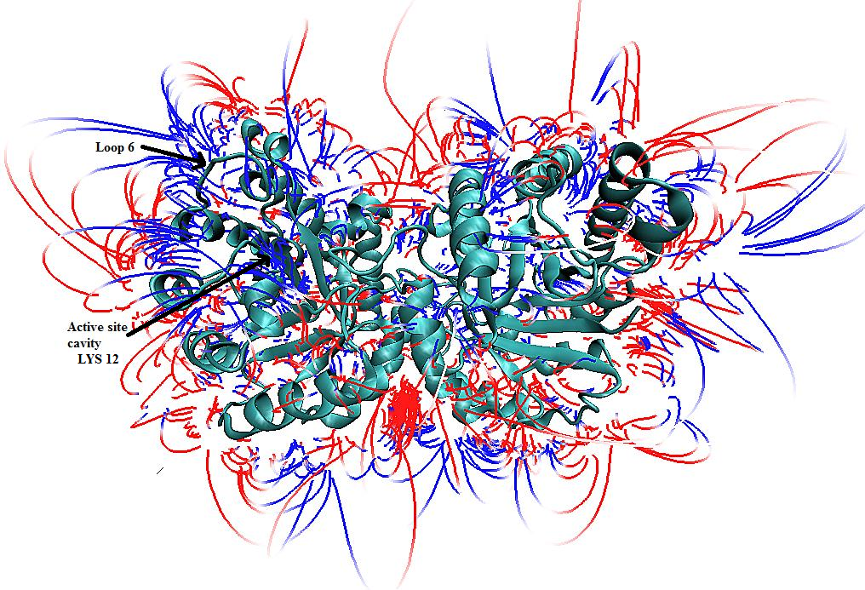

Supplementary Figure 1: Electrostatic maps calculated using APBS clearly depict the positively charged active site cavity containing Lys 12 ( blue coloured lines of force )

