# ADS1 ASSIGNMENT – VISUALIZATION

[GitHub Repository Link](https://github.com/pruthvi-sai/ADS1-Assignment1-Visualisation.git) – Contains code files, datasets and png files for the below plots.

Visualization 1:

POVERTY RATIO COMPARISION BETWEEN CHINA AND INDIA FROM 1980 TO 2020

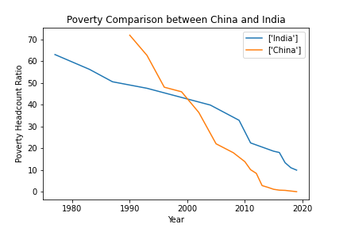

Firstly, we can observe from the above line plot that both the countries India and China have their poverty rate declining over the last 4 decades. Although the 80’s data is missing for China, we can see that China had a higher poverty rate than India in 1990. But over the decades, China has developed at a faster pace than India, thereby improving their poverty rate over India by 2020.

Visualization 2: WINE PRODUCTION METRICS BASED ON COUNTRIES AND PROVINCES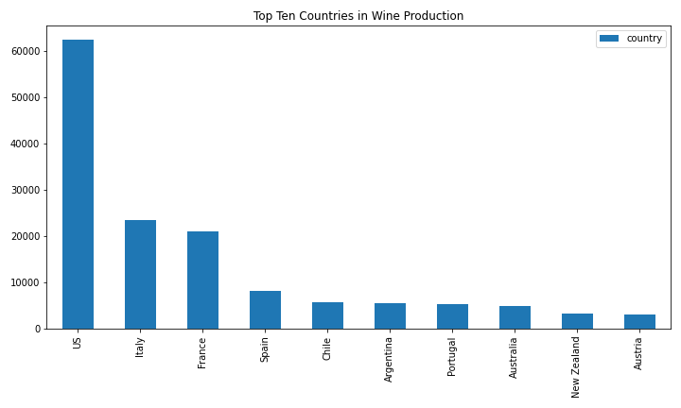From the above bar plot, the USA is the leader in the production of wine. Apart from the US, European countries like Italy and France seem to be almost maintaining similar production levels. A surprising observation from this graph is that Australia, which is a bigger country than most of these and has a bigger demand, is not producing up to its levels of demand.

The below plot is to rank provinces in the USA by their production metrics. This plot suggests that California is the highest producer of wine in the USA. The production from other provinces seems to be negligent when compared to the top 5 implying that California is responsible for the majority of the wine production in the US.

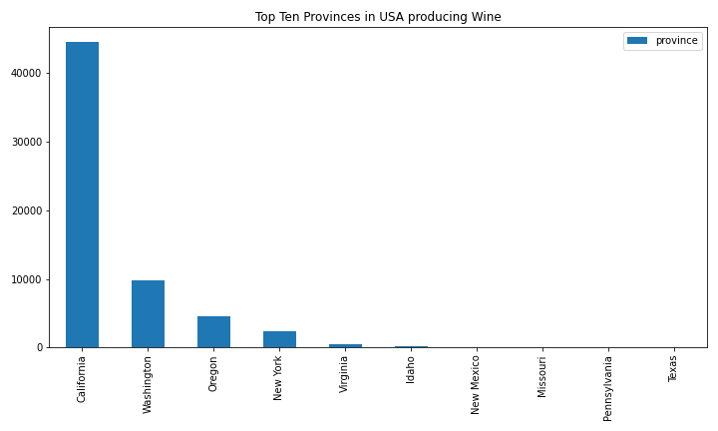

Visualization 3:

HR ANALYSIS OF LEVELS OF EDUCATION AND GENDER DISTRIBUTION IN A COMPANY

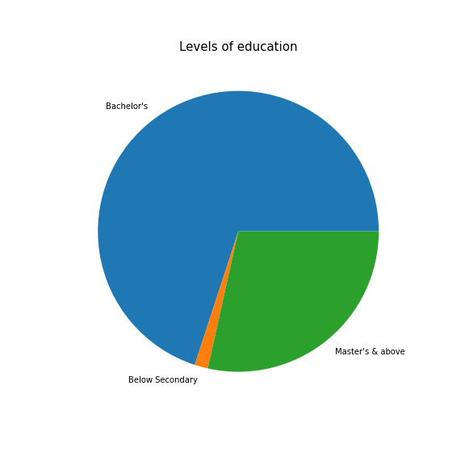 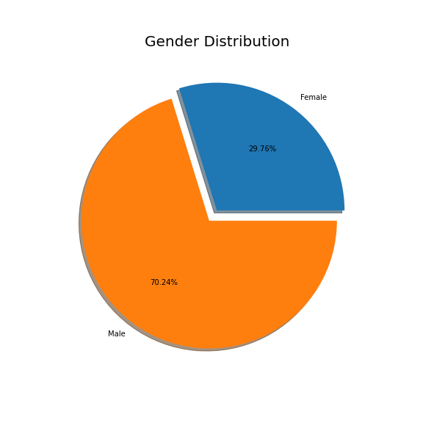

The above figure shows a pie chart for the levels of education and Gender distribution in a company. The first pie chart shows that the majority of the employees hold Bachelor’s degree. There is also a very tiny chunk of employees that fall under Below Secondary level of education. These must be the non-technical staff like security, maintenance, etc.

The second pie chart shows that around 70% of employees are Male, which will be taken into consideration by the HR team and take steps towards reducing that margin so that this parity in gender is reduced in their company.