**Lab assignment 4**

Create an android app using an api   
  
THE WEATHER APP

USED API : OPENWEATHER API

APP VIEWS :

1)LOGIN VIEW

2)TEMPARATURE PAGE VIEW

API URL : http://api.openweathermap.org/data/2.5/weather?q=cityname&appid=APPID

LOGIN PAGE :

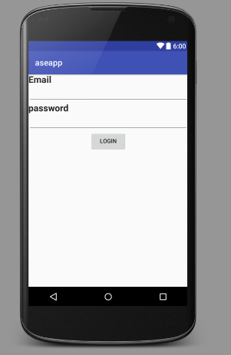

APP home page :

With and with out data

