

**Lovely Professional University**

**Academic Task No. 03**

**(Operating System)**

**School of computer Sciences and Engineering**

**PROJECT ON PROBLEM SOLVING ON CPU SCHEDULING**

**Student Name: Prudhvi Ranga.k**

**Roll number: - 42**

**Student ID: 11805385**

**Name of Faculty in-charge: - Mrs. Ashu**

**Course Code: - CSE 316**

**Course Title: - Operation System**

**Github link:**<https://github.com/pru143/OS_11805385_K18UW_42>

* **INDEX OF CONTENTS:**

1. **INTRODUCTION**
2. **METHODOLOGY**

**3. CODE SNIPPETS**

**I N T R O D U C T I O N**

Design a scheduler folowing non-preemptive scheduling approach to schedule the processes that arrives at different units and having burst time double the arrival time.Scheduler selects the process with largest burst time from the queue for the execution.Process is not being preempted until it finishes its service time.compute the average waiting time and average turn around time.what should be the average waiting time if processes are executed according to Shortest Job First scheduling approach with the same attribute values.

In the given problem , we need to design a scheduler which follows non-preemptive scheduling that is the process holds the CPU till it gets terminated or it reaches a waiting state. This scheduler schedules the processes that arrives at different units and having burst time double the arrival time. So, BURST TIME = 2(ARRIVAL TIME). In all these processes , the scheduler selects the process having the largest burst time from the queue for the execution. The process is not being preempted until it finishes its service time as it follows non-preemptive scheduling. Having the given information we need to compute the average waiting time and the average turn around time using the formulas which are basic prerequisites. We are also supposed to find out the average waiting time if the processes are executed according to Shortest Job First scheduling approach with the same attribute values.

**M E T H O D O L O G Y**

**FORMULAS USED :**

1. Turn Around Time(TAT) = Completion Time(CT) - Arrival Time(AT)
2. Waiting Time (WT) = Turn Around Time(TAT) - Burst Time(BT)

**METHODOLOGY USED:**

1. In the question, Burst Time(BT) = 2(Arrival Time)
2. In the question, Wait Time (WT) = Turn Around Time(TAT) - Burst Time(BT).
3. Make a structure of process that will withhold within it any important fields such as- Arrival Time, Burst Time, Completion Time, Turn Around Time and Waiting Time.
4. Now sort according to the burst time which can be computed by arrivaltime in the given condition and queue the processes having largest burst time.
5. Process every one of the units after finding the process with the Largest Burst Time. Increase the total time by 1 and reduce the Burst Time of that process with 1.
6. Completion Time of any process will equal Total Time at that time for any process with 0 as its Burst Time.
7. After completing the compution of Completion time we need to find out the turnaround time and waiting time.
8. Now, with the known info we’ll compute average turnaround time and average waiting time.
9. Also, we will find out the waiting time by assuming processes follow SJF scheduling with the same attributes.

**C O D E S N I P P E T S**

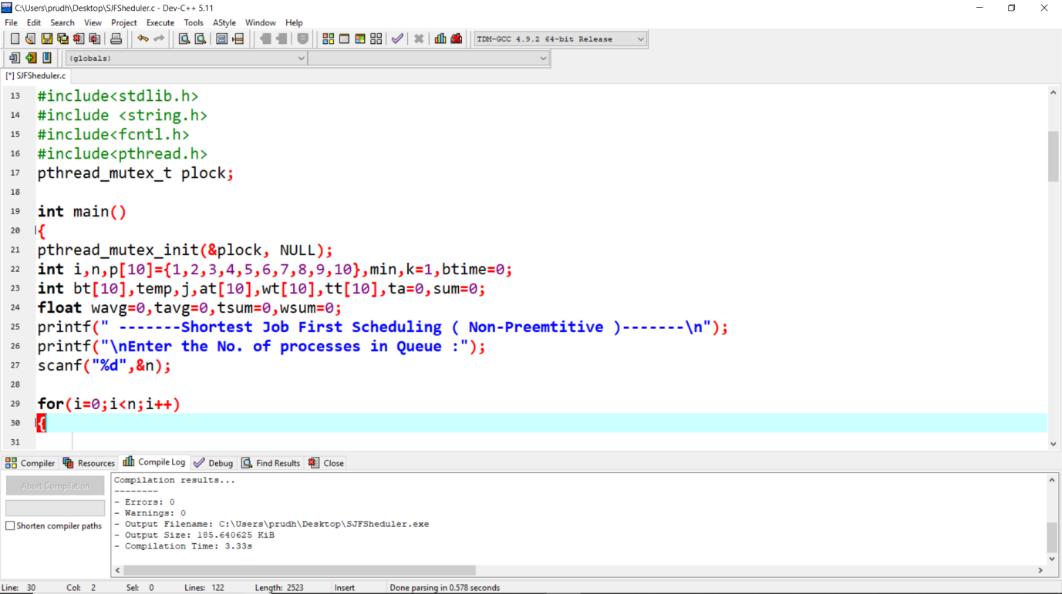

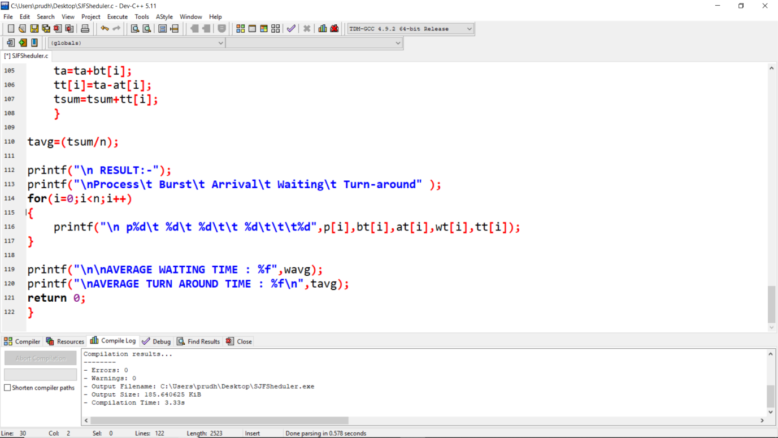

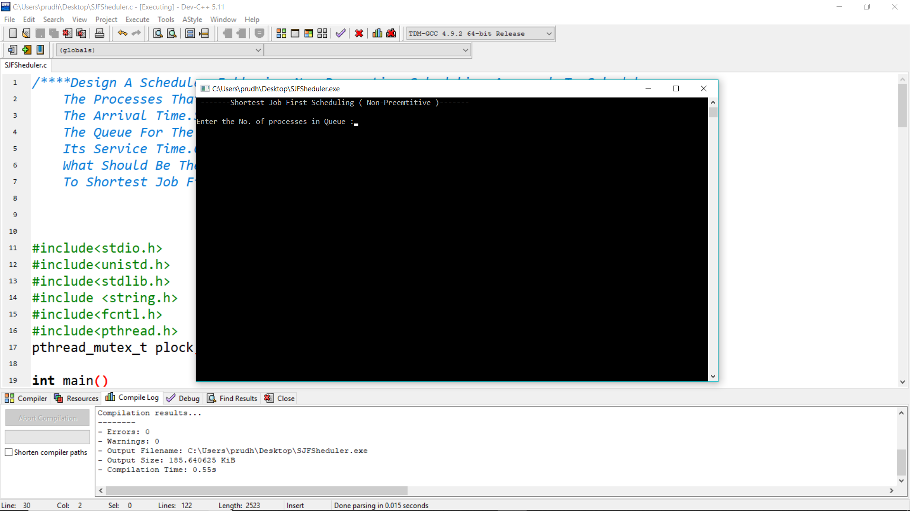

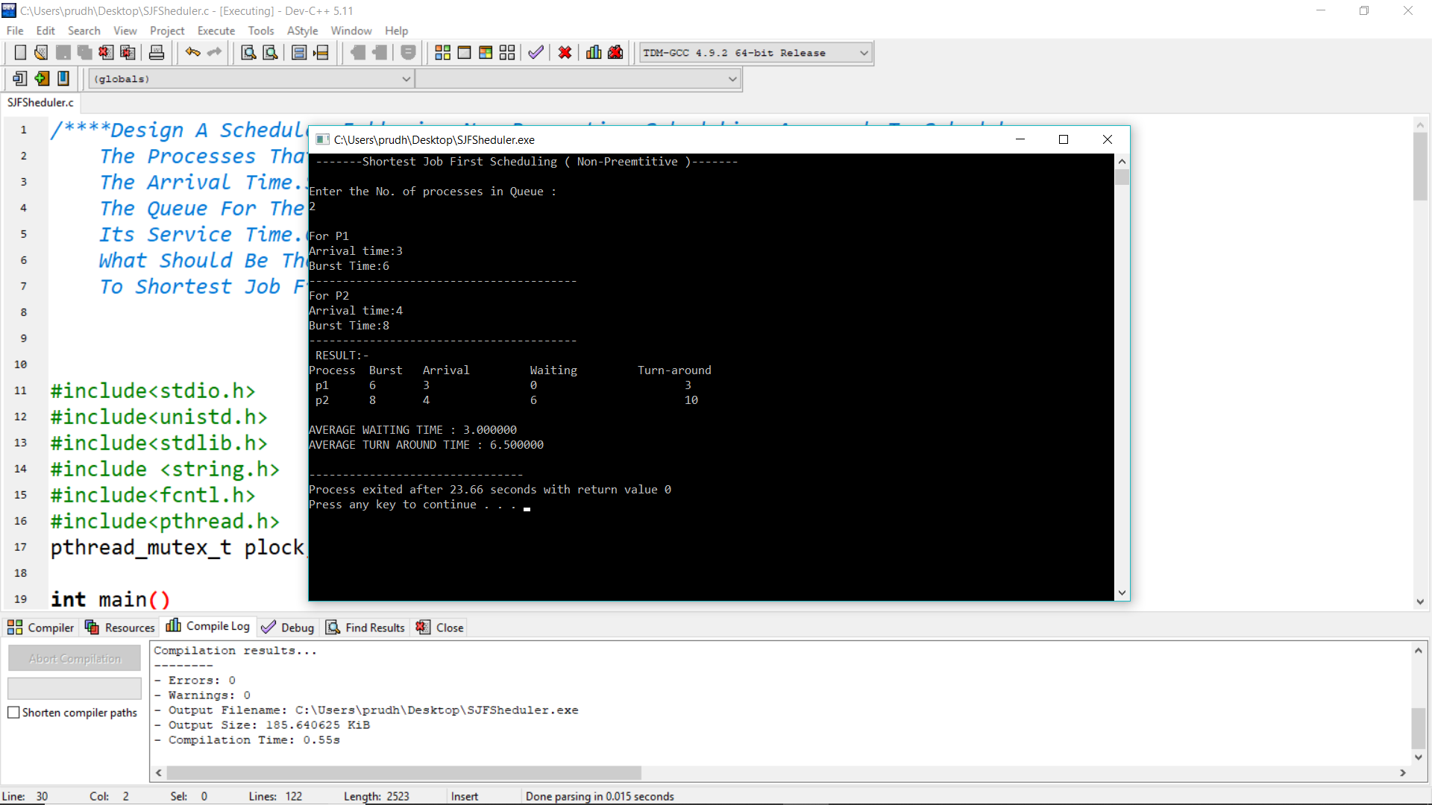

**GITHUB LINK:** <https://github.com/pru143/OS_11805385_K18UW_42>