1 a)  
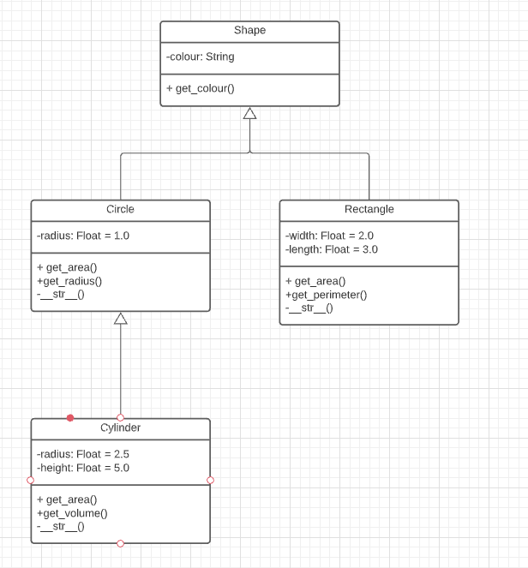

1b)

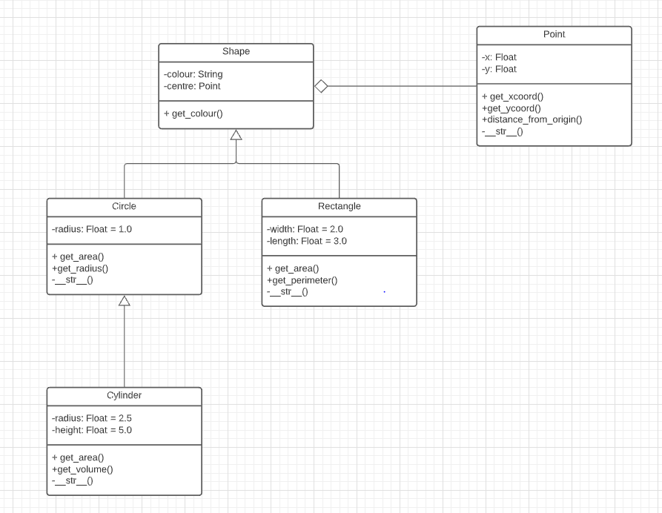

1c)

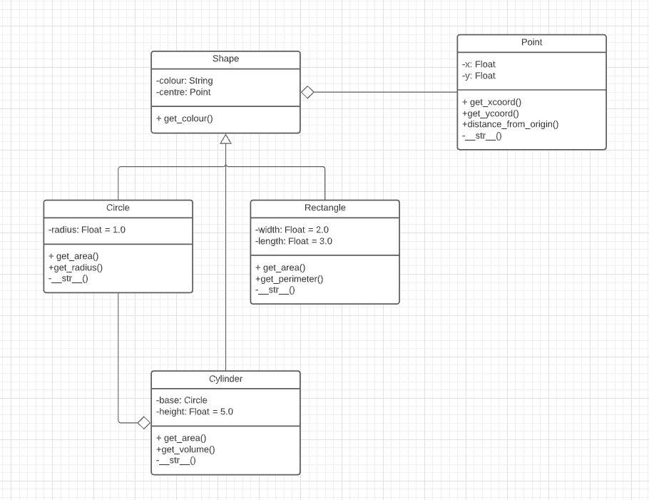

2a)

Minimum of 1 book per author, maximum of 3 books per author.

Together they can author minimum of 3 books and a maximum of 18 books.

Each author has a minimum of 0 readers and a maximum of 12 readers.

All together they can have a minimum of 0 readers and a maximum of 72 readers.

b)Together they can be reading a minimum of 6 books and a maximum of 30 books. The minimum number of authors they’re reading is 1 author and the maximum number of authors is 30.

4

