EE3093: C++ Assignment
UNIVERSITY OF ABERDEEN SESSION 2021-22
EE3093: Cpp Assignment
Degree Examination in EE3093 C/C++ PROGRAMMING
First Half Session: 2021-22
Release Date: 29 / 11 / 2021
Submission Date: 03 / 12 / 2021
This is an open book online assessment which is expected to take up to 3 hours to complete; submission will be accepted until the above submission deadline. Students who have not submitted after this time will be required to present for reassessment in the resit diet.
Please follow the instructions and answer the questions accordingly. Please upload files through MyAberdeen as instructed. You must not attempt to communicate with any candidate regarding this exam by any means including but not limited to, electronically, orally or passing/showing written material to another candidate and you must not attempt to view another candidate’s work. All submissions will be checked for plagiarism.
PLEASE READ AND FAMILIARISE YOURSELF WITH THE REGULATIONS DETAILED ON THIS PAGE BEFORE ATTEMPTING THIS EXAMINATION
Assessment weighting: The weighting of this assessment is 20% of course mark.
For details of the performance descriptors associated with each CGS grade, please refer to the Common Grading Scale site https://www.abdn.ac.uk/staffnet/teaching/common-grading-scale-2840.php.
Submission of work for assessment
Each student must submit their own solution or report on the assessment via MyAberdeen by the deadline stated on the exam paper or on the assignment specification. Students who submit their solution or report on the assessment after the stated deadline will be required to present for assessment in the resit diet.
If illness, injury, IT/internet related problem, or any other condition prevents you from completing an assessment, coursework, or examination, or if you consider that your performance may have been detrimentally affected having taken the exam or done the assignment, then you must complete the Absence form on MyAberdeen within three working days of the submission deadline of the alternative assessment.
Plagiarism, Collusion and Contract Cheating
Your solution to the assessment must be entirely your own personal work or, where the intellectual work of others is used, it must be clearly identified and referenced. This applies to everything you submit for assessment. Copying someone else’s work, colluding with someone else in doing the set exercise or exam, and plagiarism will be regarded as academic misconduct.
The rules approved by the University for the conduct of examinations are set out in a separate document entitled “Rules for the Conduct of Written Examinations for Degrees and Diplomas” which can be found at:
https://www.abdn.ac.uk/staffnet/teaching/assessment-policies-and-guidance-6099.php
Where there is reason to believe that cheating in a prescribed degree assessment (including the alternative assessment to end of course written exam) has occurred this will be dealt with in accordance with the Code of Practice on Student Discipline, which can be found at: https://www.abdn.ac.uk/staffnet/documents/academic-quality-handbook/Code of Practice in Student Discipline (Academic).pdf
The University’s definition of Plagiarism is the use, without adequate acknowledgement, of the intellectual work of another person in work submitted for assessment. This definition includes the unattributed use of course materials. A student cannot be found to have committed plagiarism where it can be shown that the student has taken all reasonable care to avoid representing the work of others as his or her own.

Student details
(1) Fill in the table below: Replace text within the # # symbols with your data (do not delete the # # symbols).
Student ID: | [#_5_ _1_ _9_ _8_ _5_ _9_ _6_ _1_ #]
Digit: | [ _1st_ _2nd_ _3rd_ _4th_ _5th_ _6th_ _7th_ _8th_ ]
(2) Update all fields in the document header: Double click on the page header; Press “CTR + A”; Press F9.

Marks: Total out of 22 CGS marks

Part 1 awards 13 CGS marks. Part 2 awards 5 CGS marks. Part 3 awards 4 CGS marks.

Instructions to users
- Ensure you have followed the instructions in the “Student Details” section of this document so that your student ID is (automatically) reported on each page of this document.
- Answer the questions indicated in the INSTRUCTIONS file (PDF). In that document, specific requirements for your implementation are set depending on your student ID. You must report in the present document the options that you have selected (based on your student ID).
- Source code (header/cpp) file should be clearly named and indicated in the present document.

Submission info
Your submission via myAberdeen should include:
- The StudentSelections document (this document), reporting the selections you made based on your student ID (as instructed throughout the document) and indicating the source code files that contribute to each answer. This StudentSelections document is used to report sample test results (see page limits indicated in the INSTRUCTIONS document). Prior to submission, convert this word file into a PDF file.
- Source code in header/cpp files. Each submitted file must be mentioned in this document. These files are submitted via myAberdeen (may be zipped together for simplicity; then a single zip file is submitted).

Part 1:

Report your selection for this section
Table 1: Fill in the table below to report your options for Part 1 and the names of the files implementing and testing part 1
Your selection | ID digit leading to that selection
WeatherTag_Option: ___0___ | Based on 8th ID digit being: __1____
WeatherMeasuremen_Option: ____1__ | Based on 7th ID digit being: ___6___
Name of submitted Files that implement your answers: | Source files: _____WeatherTag.h, WeatherMeasurement.h, main.cpp

Sample Test results
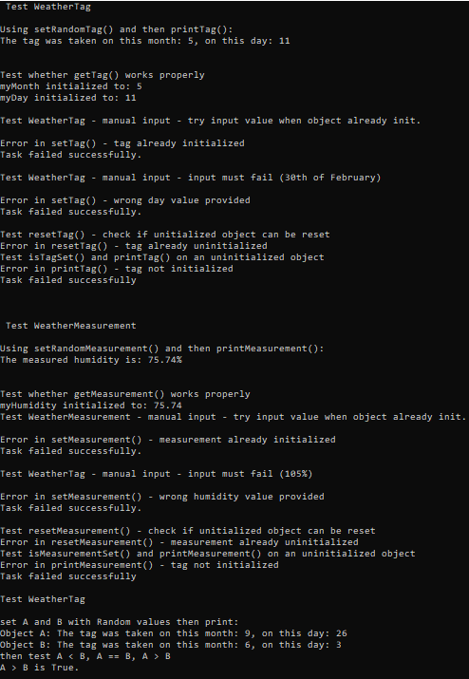
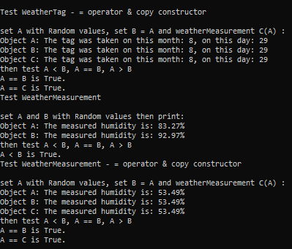

Marking (leave blank for staff)
Note: no mark awarded for implementing options not required (based on your ID).
Table 2: Marks allocation for Part 1 (out of 22 CGS marks for the entire assignment):
Part 1 | CGS Marks
setTag(…): implementation and test (via test routine) | ____/ 0.6
setRandomTag (): implementation and test (via test routine) | ____/ 0.6
resetTag (): implementation and test (via test routine) | ____/ 0.6
isTagSet(): implementation and test (via test routine) | ____/ 0.6
getTag(…): implementation and test (via test routine) | ____/ 0.6
printTag(): implementation and test (via test routine) | ____/ 0.6
operator < for weatherTag: implementation and test (via test routine) | ____/ 0.5
operator == for weatherTag: implementation and test (via test routine) | ____/ 0.5
operator > for weatherTag: implementation and test (via test routine) | ____/ 0.5
operator = for weatherTag: implementation and test (via test routine) | ____/ 0.5
Copy constructor for weatherTag: implementation and test (via test routine) | ____/ 0.5
setMeasurement(…): implementation and test (via test routine) | ____/ 0.6
setRandomMeasurement(): implementation and test (via test routine) | ____/ 0.6
resetMeasurement(): implementation and test (via test routine) | ____/ 0.6
isMeasurementSet(): implementation and test (via test routine) | ____/ 0.6
getMeasurement(…): implementation and test (via test routine) | ____/ 0.6
printMeasurement(): implementation and test (via test routine) | ____/ 0.6
operator < for weatherMeasurement: implementation and test (via test routine) | ____/ 0.5
operator == for weatherMeasurement: implementation and test (via test routine) | ____/ 0.5
operator > for weatherMeasurement: implementation and test (via test routine) | ____/ 0.5
operator = for weatherMeasurement: implementation and test (via test routine) | ____/ 0.5
Copy constructor for weatherMeasurement: implementation and test (via test routine) | ____/ 0.5
Reporting of test results (fit your sample results in max 1 side of the Selection Document) | ____/ 0.8
Tot Part 1 = ____/ 13 CGS Marks

Part 2:

Report your selection for this section
Table 3: Fill in the table below to report your options for Part 2 and the names of the files implementing and testing Part 2
Your selection | ID digit leading to that selection
Comparison_Option: __3___ | Based on 6th ID digit being: __9___
Name of submitted Files that implement your answers (no need to repeat a file already submitted in Part 1 that also forms part of your answer to Part 2 [and used via #include ], as long as the content is the same as those indicated in Part 1): | Source files: __________WeatherLog.h____________________

Sample Test results
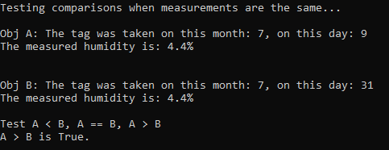
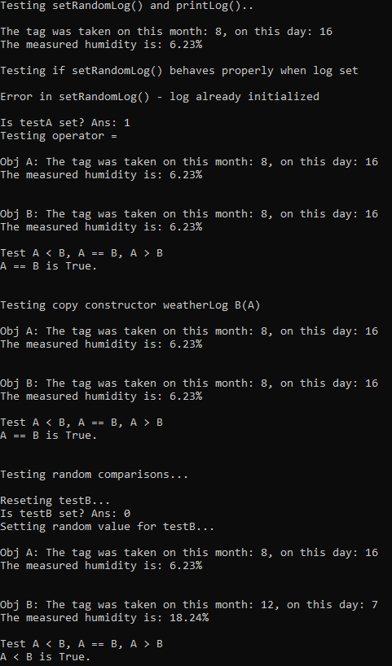

Marking (leave blank for staff)
Note: no mark awarded for implementing options not required (based on your ID).
Table 4: Marks allocation for Part 2 (out of 22 CGS marks for the entire assignment):
Part 2 | CGS Marks
setRandomLog(): implementation and test (via your test routine) | ____/0.5
isLogSet(): implementation and test (via your test routine) | ____/0.5
printLog(): implementation and test (via your test routine) | ____/0.5
operator == for weatherLog: implementation and test (via your test routine) | ____/0.5
operator < for weatherLog: implementation and test (via your test routine) | ____/0.5
operator > for weatherLog: implementation and test (via your test routine) | ____/0.5
operator = for weatherLog: implementation and test (via your test routine) | ____/0.5
Copy constructor for weatherLog: implementation and test (via test routine) | ____/0.5
Test Routine and test results (fit sample results in max 1 side of the Selection Document) | ____/1
Tot Part 2 = ____/5 CGS Marks

Part 3:

Report your selection for this section
Table 5: Fill in the table below to report your options for Part 3 and the names of the files implementing and testing Part 3
Your selection | ID digit leading to that selection
Filter_Option: __2___ | Based on 7th ID digit being: __6___
Name of submitted Files that implement your answers (no need to repeat a file already submitted in Part 1 or 2 that also forms part of your answer to Part 3 [and used via #include ], as long as the content is the same as those indicated in Part 1, 2): | Source files: ___WeatherLog.h_______________________
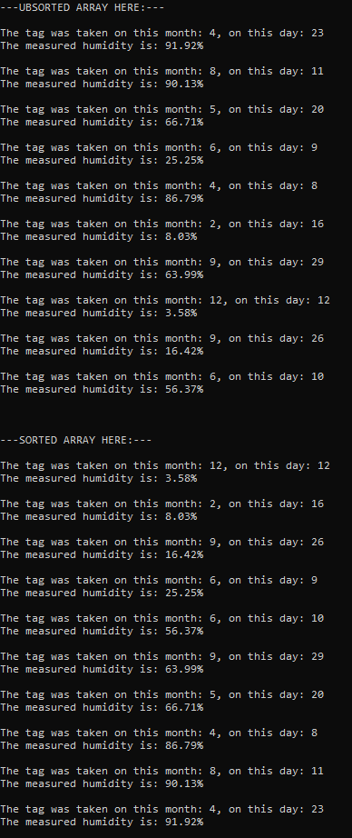

Sample Test results

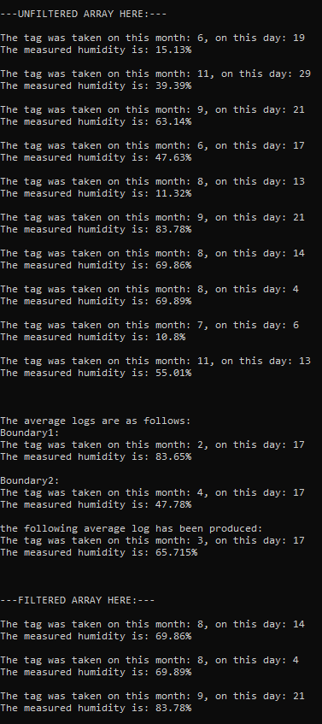

Marking (leave blank for staff)
Note: no mark awarded for implementing options not required (based on your ID).
Table 6: Marks allocation for Part 3 (out of 22 CGS marks for the entire assignment):
Part 3 | CGS Marks
sortWeatherLogArray (): implementation and test (via your test routine) | ____/1.4
filterWeatherLogArray (): implementation and test (via your test routine) | ____/1.4
Test Routine and test results (fit sample results in max 2 sides of the Selection Document) | ____/1.6
Tot Part 3 = ____/4 CGS Marks

Total Score (for staff)

Marking: leave blank for staff
Task: | Marks (up to)
Part 1 | _______ / 13
Part 2 | _______ / 5
Part 2 | _______ / 4
TOT | _______ / 22

