- name: Install Nginx On Web and App Hosts

hosts: web:app

tasks:

- name: Apt Update

shell: apt update

- name: Install Nginx

shell: apt install nginx -y

- name: Start Nginx Service

shell: service nginx start

- name: Create dbadmin in DB Servers

hosts: db

tasks:

- name: Create dbadmin

user:

name: dbadmin

state: present

-------------------------------------------------

- name: Play For Creating Users in Ubuntu & RHEL

hosts: all

tasks:

- name: Create Users ubuntu1

user:

name: ubuntu1

state: present

when: ansible_facts['distribution'] == "Ubuntu"

- name: Create Users rhel1

user:

name: rhel11

state: present

when: ansible_facts['distribution'] == "RedHat"

- name: Set a message of the day

copy:

dest: /etc/motd

src: /tmp/motd

owner: root

group: root

mode: 0644

- name: Perform full patching

package:

name: '*'

state: latest

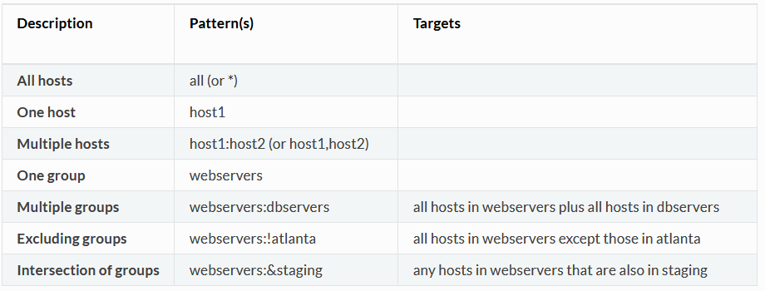

#Play for install & configure Nginx

- name: Play for Installing Nginx

tags: nginx

hosts: web

tasks:

- name: Perform APT UPDATE

shell: apt update

- name: Install Nginx

shell: apt install nginx -y

- name: Start Nginx Service

shell: service nginx start

#Play for creating testuser 1 & 2

- name: Play for Creating Testuser 1 & 2

tags: testusers

hosts: web:app:!db

tasks:

- name: Creating testuser1

user:

name: testuser1

state: present

- name: Creating testuser2

user:

name: testuser2

state: present

#Play for creating devuser 1 to 5

- name: Play for Creating devuser 1 to 5

tags: devusers

hosts: web:app:db

tasks:

- name: Creating devuser 1 to 5

user:

name: "{{ item }}"

state: present

with_items:

- devuser1

- devuser2

- devuser3

- devuser4

- devuser5

#Install AWS CLI on App Servers

- name: Install AWS CLI on App Servers

tags: awscli

hosts: app

tasks:

- name: Install unzip on app servers

shell: apt install unzip -y

- name: Download AWS CLI

get_url:

url: https://awscli.amazonaws.com/awscli-exe-linux-x86_64.zip

dest: ./awscliv2.zip

- name: Unzip file & Install

shell: unzip awscliv2.zip && ./aws/install