<https://devopscube.com/setup-ansible-aws-dynamic-inventory/>

<https://devopscube.com/ansible-dymanic-inventry-google-cloud/>

<https://docs.microsoft.com/en-us/azure/developer/ansible/dynamic-inventory-configure?tabs=azure-cli>

Deploy ubuntu t2.medium

From root user, create new user with name ansibleadmin.

Give sudo rights and password less sudo for ansible.

Install ansible from ansibleadmin user.

Generate ssh-keys from ansible user.

New AWS AMI need to be created using packer.json & packer-vars.json

Ansible Controllers Needs Following Packages:

sudo apt-get install python3 -y

sudo apt-get install python3-pip -y

sudo apt-get install unzip jq -y

sudo pip3 install boto3

Install aws cli version 2.0

Assign EC2 Full Access Role to controller if you dont want to use Access & Secret Keys.

We can use static and dynamic inventory at the same time by enabling plugins as shown below.

enable_plugins=host_list, script, auto, yaml, ini, toml, aws_ec2



*ansible -i /opt/ansible/inventory/aws_ec2.yaml tag_ManagedBy_Terraform -m ping*

*ansible -i invfile pvt -m ping*

*ansible-playbook -i /opt/ansible/inventory/aws_ec2.yaml Playbooks/8.Dyanmic-Inventory/dynamic_nginx-jinja2.yml -vv*

Plugin:

plugin: gcp_compute

plugin: azure_rm

plugin: aws_ec2

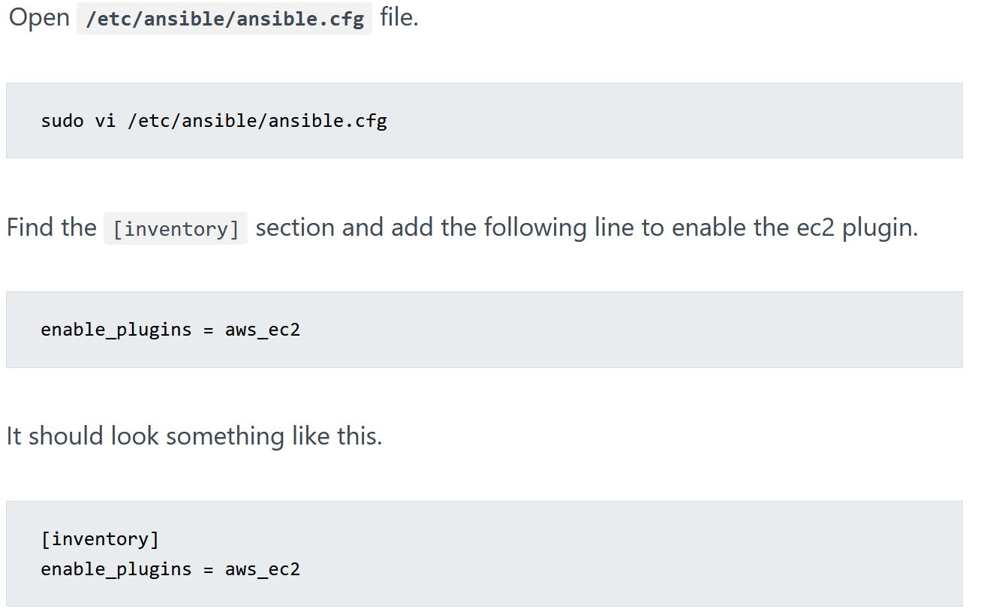

[inventory]

enable_plugins = aws_ec2

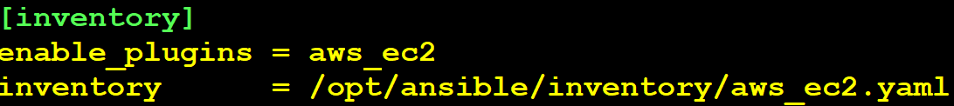

inventory = /opt/ansible/inventory/aws_ec2.yaml

private_key_file=/home/ansibleadmin/.ssh/ansiblekey.pem

export dynamic='/opt/ansible/inventory/aws_ec2.yaml'

sudo mkdir -p /opt/ansible/inventory

cd /opt/ansible/inventory

sudo nano aws_ec2.yaml

---

plugin: aws_ec2

regions:

- us-east-1

keyed_groups:

- key: tags

prefix: tag

- prefix: instance_type

key: instance_type

- key: placement.region

prefix: aws_region

ansible-inventory -i /opt/ansible/inventory/aws_ec2.yaml --list

ansible -i /opt/ansible/inventory/aws_ec2.yaml tag_Owner_Sree -m ping

ansible-inventory -i /opt/ansible/inventory/aws_ec2.yaml --graph

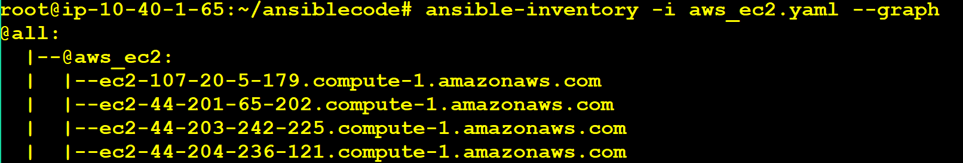

export dynamic='/opt/ansible/inventory/aws_ec2.yaml'

ansible-inventory -i $dynamic --graph

ansible-playbook -i $dynamic Playbooks/dynamic-inv-playbook.yml --syntax-check

ansible-playbook -i $dynamic Playbooks/dynamic-inv-playbook.yml

ansible-playbook Playbooks/dynamic-role-mysql.yml -i $dynamic -e "variable_host=tag_Owner_Sree" --ask-vault-pass

ansible-playbook Playbooks/dynamic-nginx.yml -i $dynamic -e "variable_host=tag_Owner_Sree"

#Below code is available from DevSecOps B36 Batch

ansible-playbook Playbooks/4.Jinja/dynamic_nginx-jinja2.yml -i aws_ec2.yaml -e "variable_host=instance_type_t2_small"

ansible-playbook Playbooks/8.Dyanmic-Inventory/dynamic_mysql.yml -i aws_ec2.yaml -e "variable_host=tag_Env_production"

To use above command we need to update hosts in playbook file as:

"{{ variable_host | default('tag_Env_Prod') }}"

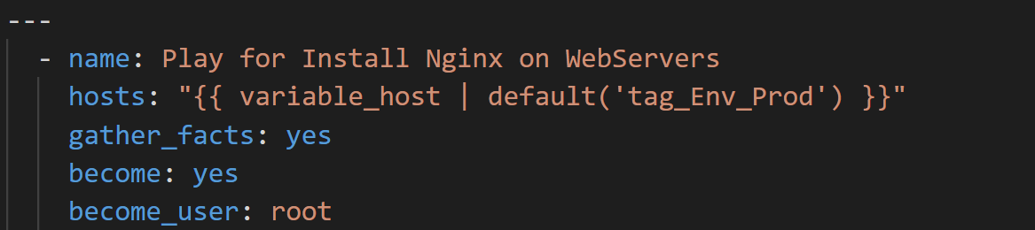

Deploy 3 Servers with Tags Owner=Sree

export dynamic='/opt/ansible/inventory/aws_ec2.yaml'

ansible-inventory --graph -i $dynamic

ansible tag_Owner_Sree -m shell -a 'sudo apt install -y nginx jq unzip'

ansible tag_Owner_Sree -m shell -a 'echo "<h1>Welcome To DevOps In Telugu</h1>" > /var/www/html/index.nginx-debian.html' --become

packer.json

{

"_comment": "Create Aws AMI with Ubuntu 20.04",

"variables": {

"region": "",

"source_ami": "",

"instance_type": "",

"vpc_id": "",

"subnet_id": ""

},

"_comment1": "packer build -var \"aws_secret_key=foo\" packer.json",

"_comment2": "packer build -var-file packer-vars.json packer.json",

"builders": [

{

"type": "amazon-ebs",

"region": "{{user `region`}}",

"source_ami": "{{user `source_ami`}}",

"instance_type": "{{user `instance_type`}}",

"ssh_username": "ubuntu",

"ami_name": "DevOpsClass-B25-Build-{{isotime | clean_resource_name}}",

"vpc_id": "{{user `vpc_id`}}",

"subnet_id": "{{user `subnet_id`}}",

"tags": {

"Name": "DevOpsClass-B25-Build-{{isotime | clean_resource_name}}"

}

}

],

"provisioners": [

{

"type": "shell",

"inline": [

"sleep 15",

"sudo useradd -m ansibleadmin --shell /bin/bash",

"sudo mkdir -p /home/ansibleadmin/.ssh",

"sudo chown -R ansibleadmin /home/ansibleadmin/",

"sudo touch /home/ansibleadmin/.ssh/authorized_keys",

"sudo usermod -aG sudo ansibleadmin",

"echo 'ansibleadmin ALL=(ALL) NOPASSWD: ALL' | sudo tee -a /etc/sudoers",

"echo 'ssh-rsa ' | sudo tee /home/ansibleadmin/.ssh/authorized_keys"

]

}

]

}

packer-vars.json

{

"region": "us-east-1",

"source_ami": "ami-04505e74c0741db8d",

"instance_type": "t2.micro",

"vpc_id": "vpc-0f289bdbc4725af60",

"subnet_id": "subnet-0d6dcc6af907c7833"

}