Docker Container Lifecycle:

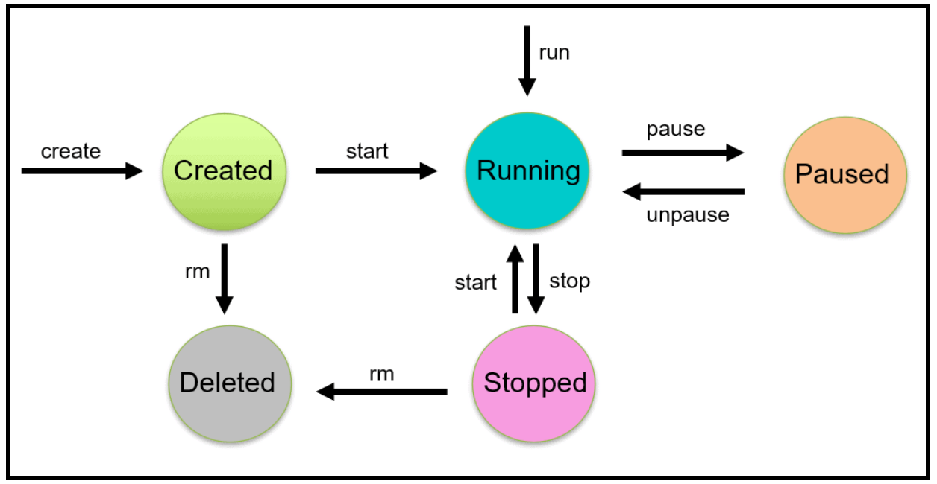

<https://k21academy.com/docker-kubernetes/docker-container-lifecycle-management/>