FORK vs CLONE

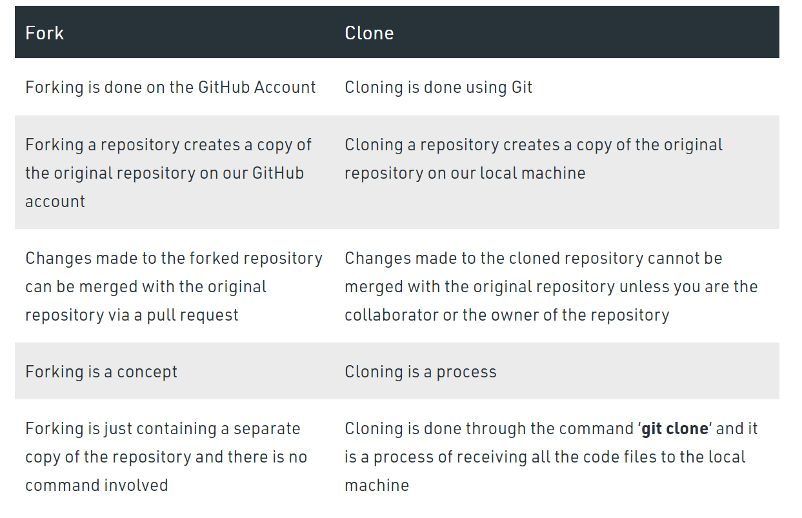

**Concept:** Fork a repository

Fork is an operation been perform over the projects as real big projects contain chunks of pieces of code consisting of 1000 lines. Here if we try to do changes and if something goes wrong then it becomes very tedious for a programmer or community to correct it. So using this Fork operation we are creating a copy of the repository in which changes are supposed to be made and reflected without affecting the original project.

There is a connection that exists between the fork of a repository and the original repository itself.

**Process:** Clone a Repository

When we create a new repository on GitHub or Any repository on Github, it exists as a remote location where our / any other repository is stored. Cloning a repository creates a local copy on our computer so that we can sync between both the local and remote locations of the repository.

we can not contribute to the repository unless we are made the collaborator of the repository. Cloning is an ideal case when one wants to get his own copy of a repository where he may not be contributing to the original project.