Install Git Secrets in your system by running following commands:

git clone <https://github.com/msalemcode/git-secrets.git>

cd [git-secrets](https://github.com/msalemcode/git-secrets.git)

.\install.ps1

Enabling Git Secrets inside a repo:

git clone [git@github.com](mailto:git@github.com):SreeVeerDevOps/devsecopsb35-GitTerraformAzure.git secrettesting

cd secrettesting

git secrets -- install #This will add the pre-commit hook in the.git repo.

git secrets --register-azure

git secrets --register-aws

git secrets --register-gcp

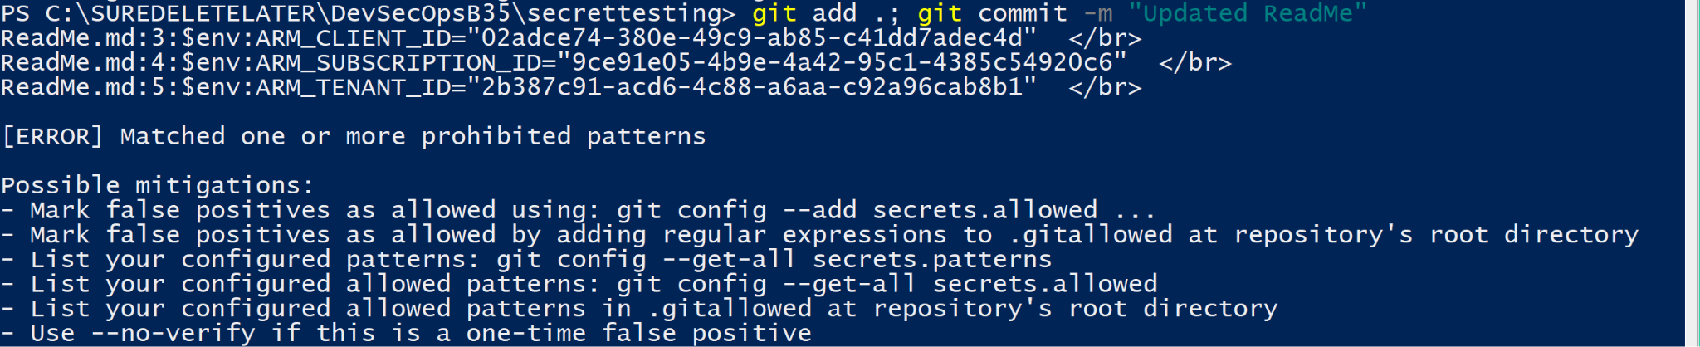

We can allow the secrets by adding the switch --no-verify

git add .; git commit -m "Updated ReadMe" --no-verify

cd <code-repo>

git init

git add .

Git commit -m “Testing Secrets”

