<https://medium.com/@patrickporto/4-branching-workflows-for-git-30d0aaee7bf>

<https://pradeeploganathan.com/git/git-branching-strategies/>

<https://www.gitkraken.com/learn/git/best-practices/git-branch-strategy>

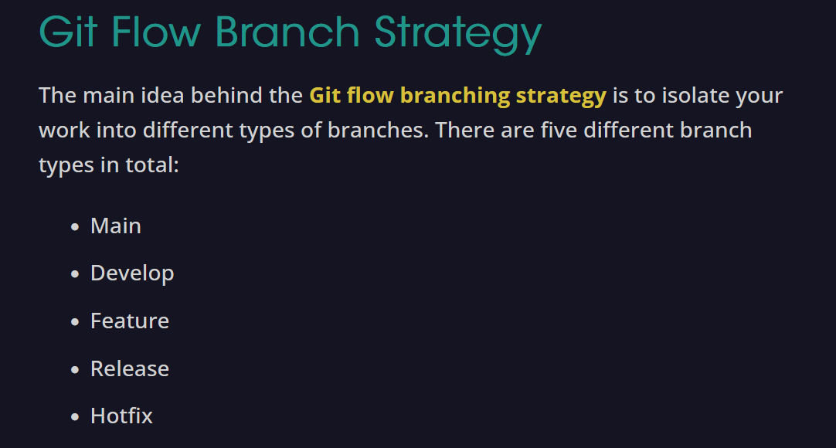

<https://stackoverflow.com/questions/58096933/what-is-the-difference-between-git-feature-release-and-hotfix>

