Installing Trufflehog:

Download binary from following URL and extract to Tools folder.

<https://github.com/trufflesecurity/trufflehog/releases>



We can scan following using TH:

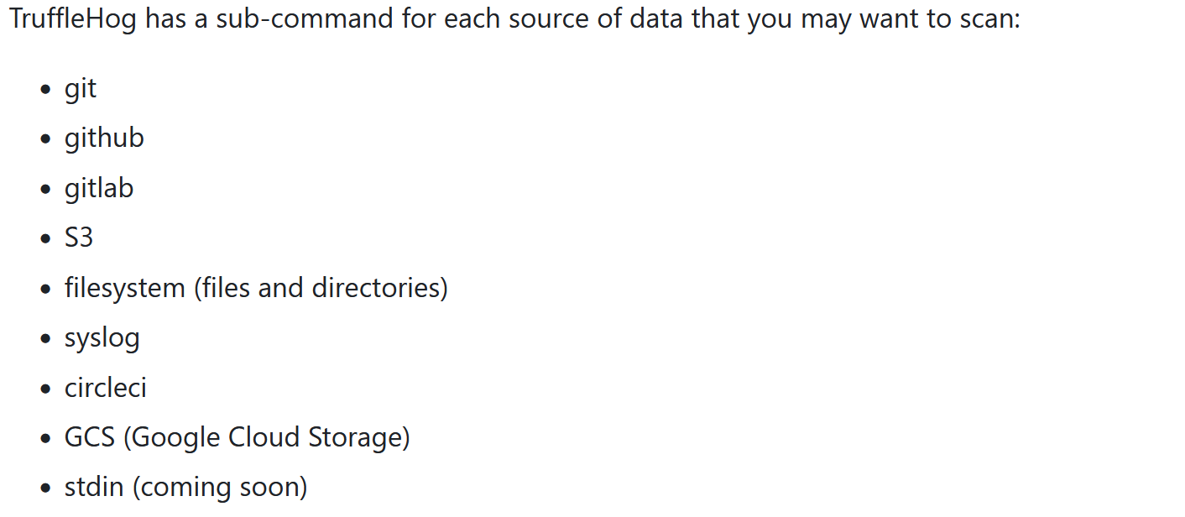

trufflehog.exe filesystem .\secrettesting\ #Scanning file system for secrets.

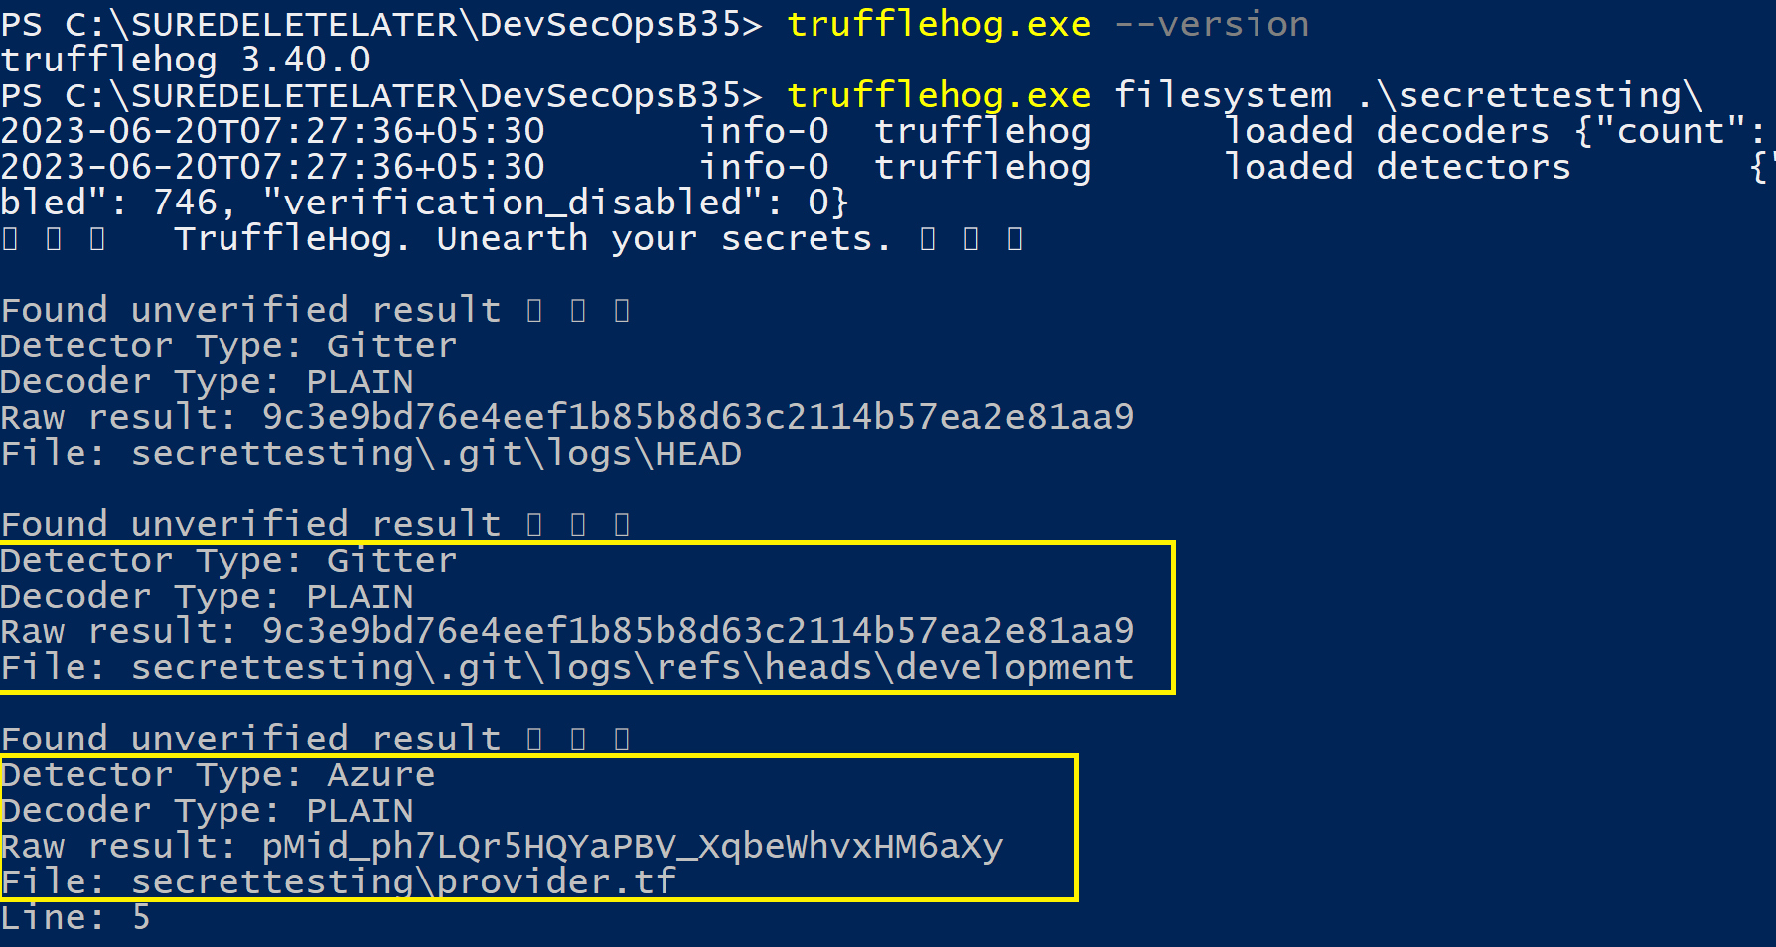

trufflehog git https://github.com/trufflesecurity/trufflehog.git

https://www.phpflow.com/misc/devops/how-to-manually-install-jenkins-plugin/