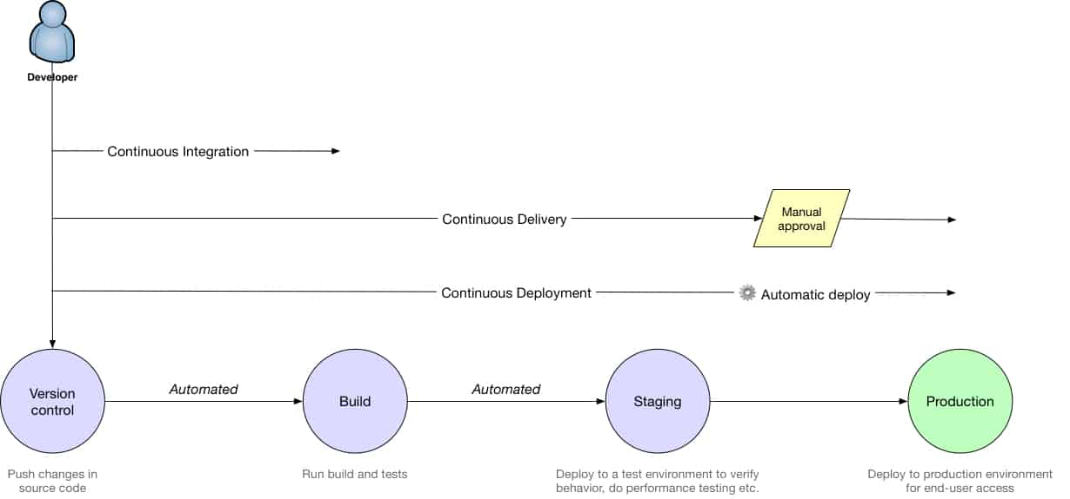

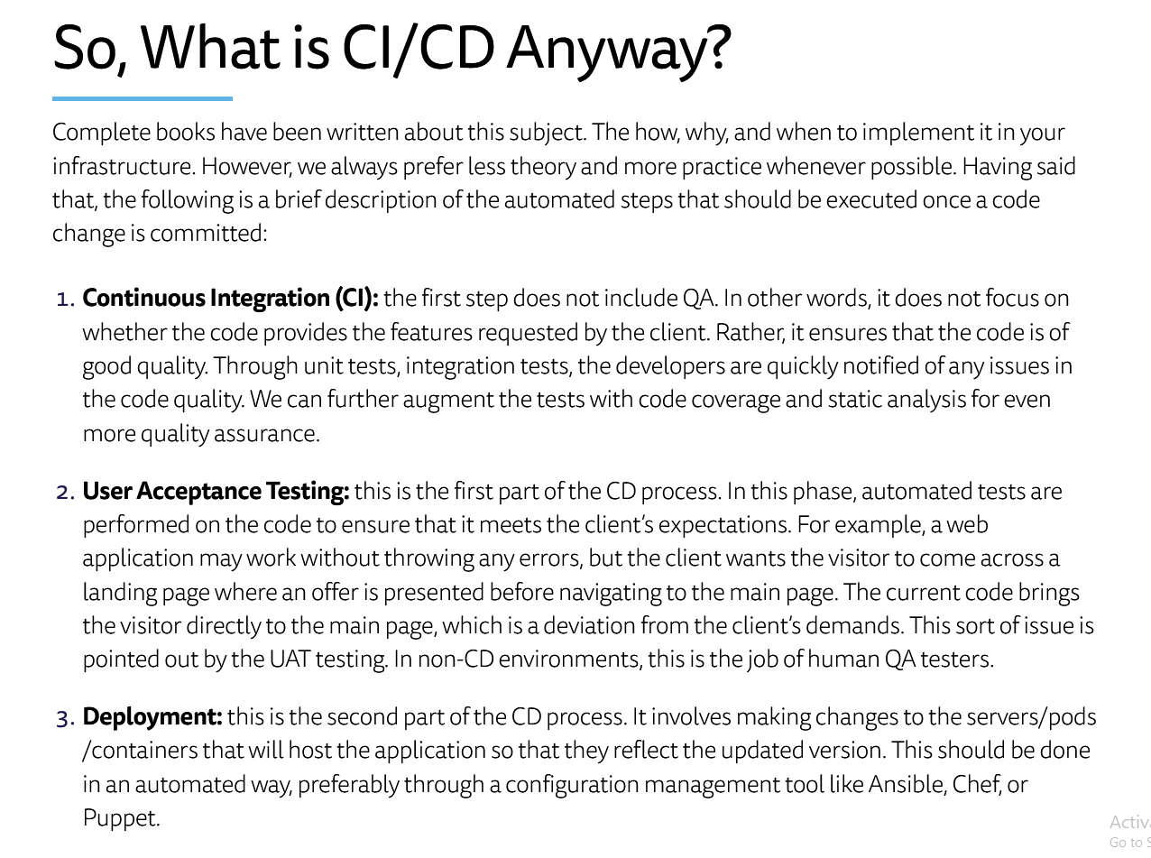

<https://www.atlassian.com/continuous-delivery/principles/continuous-integration-vs-delivery-vs-deployment>

<https://www.magalix.com/blog/create-a-ci/cd-pipeline-with-kubernetes-and-jenkins>

<https://nvie.com/posts/a-successful-git-branching-model/>

