<https://blog.knoldus.com/multibranch-pipelinewith-github-webhook/>

It is possible to trigger particular branch in a multi-branch pipeline based on PR or Commit. FOr that we need to enable webhook first on the repository.

http://<Jenkins FQDN or Public IP Address:8080/github-webhook/

Create a new GitHub repo with master branch containing following code:

pipeline {

agent any

stages {

stage('Clone Git Repo') {

when {

expression {

env.BRANCH_NAME == 'master'

}

}

steps {

checkout([$class: 'GitSCM', branches: [[name: '*/master']], extensions: [], userRemoteConfigs: [[credentialsId: 'GitHubAccesss', url: 'git@github.com:SreeVeerDevOps/devopsb18-multi-branch-pipeline.git']]])

}

}

stage('Terraform & Packer Checking') {

when {

expression {

env.BRANCH_NAME == 'master'

}

}

steps {

sh "terraform version"

sh "packer version"

}

}

}

}

Clone the repo in to multiple branches as Testing, Dev, UAT.

Make some changes to any of the above branches and create a PR to merge in to the Master branch. This will make the Webhook to trigger the pipeline and only master repo will be executed since the when condition matches with master only.

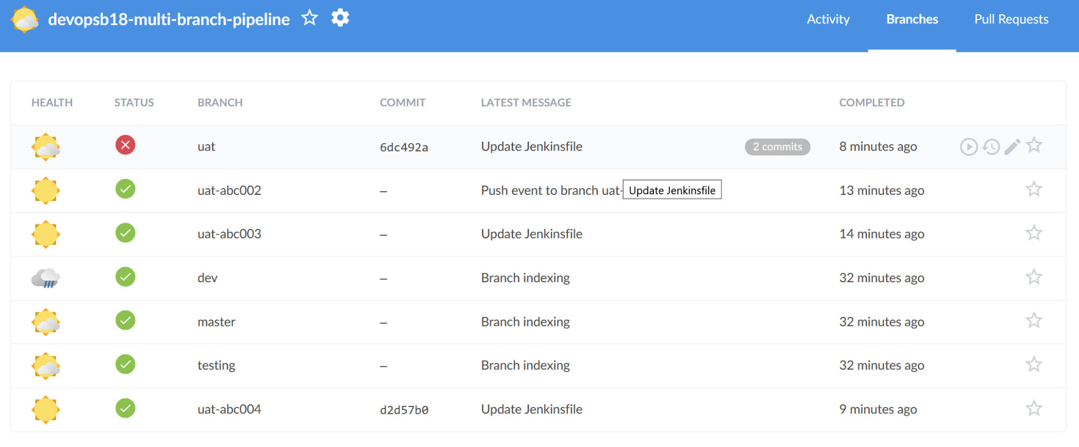

Jenkins Multibranch - Tested on Feb 7th 2022:

pipeline {

agent any

stages {

stage('Testing Creds') {

steps {

sh 'ls -al'

sh 'AWS_PROFILE=prod terraform init'

}

}

stage('Terraform Plan') {

steps {

sh 'ls -al'

sh 'AWS_PROFILE=prod terraform init'

sh 'AWS_PROFILE=prod terraform plan'

}

}

stage('Terraform Apply') {

steps {

sh 'ls -al'

sh 'AWS_PROFILE=prod terraform init'

sh 'AWS_PROFILE=prod terraform apply --auto-approve'

}

}

stage('Terraform Destroy') {

steps {

sh 'ls -al'

sh 'AWS_PROFILE=prod terraform init'

sh 'AWS_PROFILE=prod terraform destroy --auto-approve'

}

}

}

}