Create Slack Channel and Integrate Jenkins Plugin in Slack:

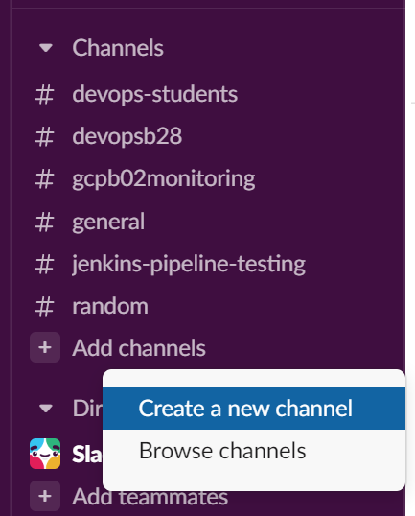

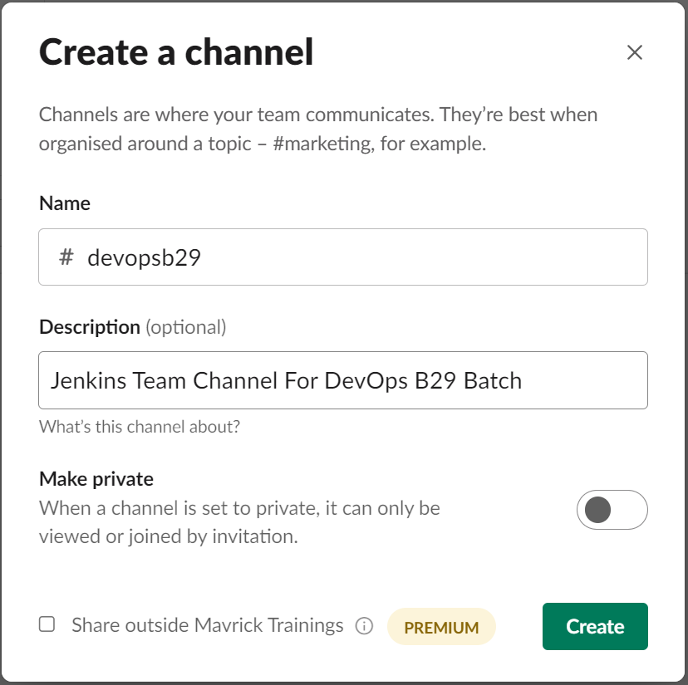

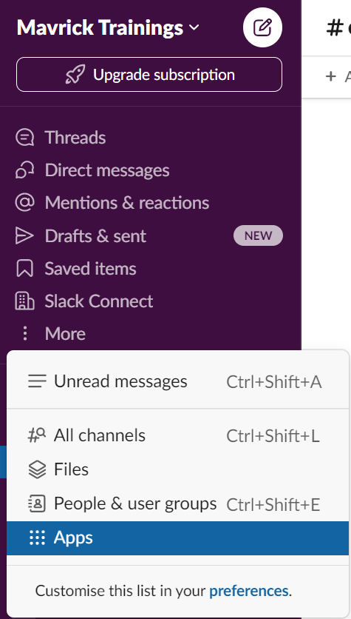

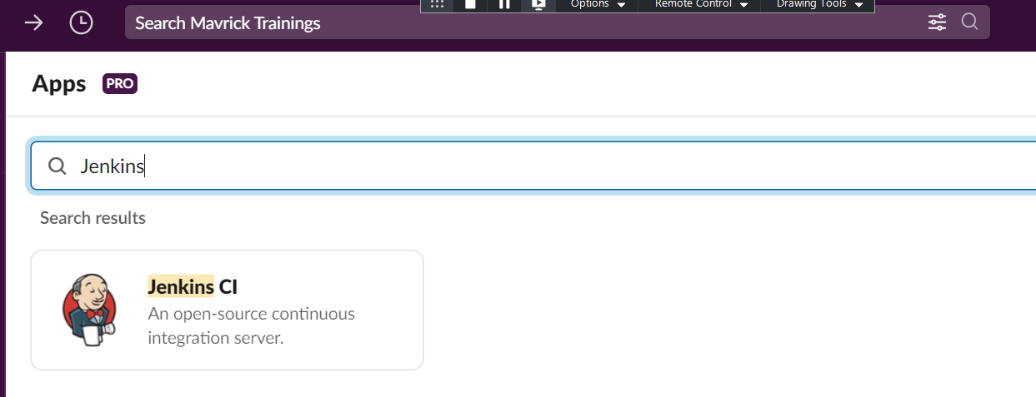

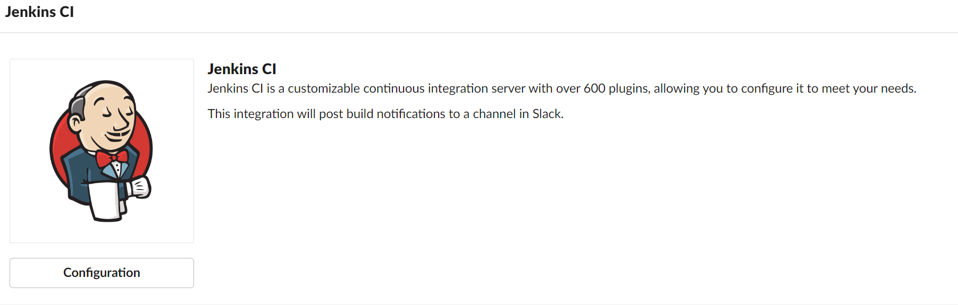

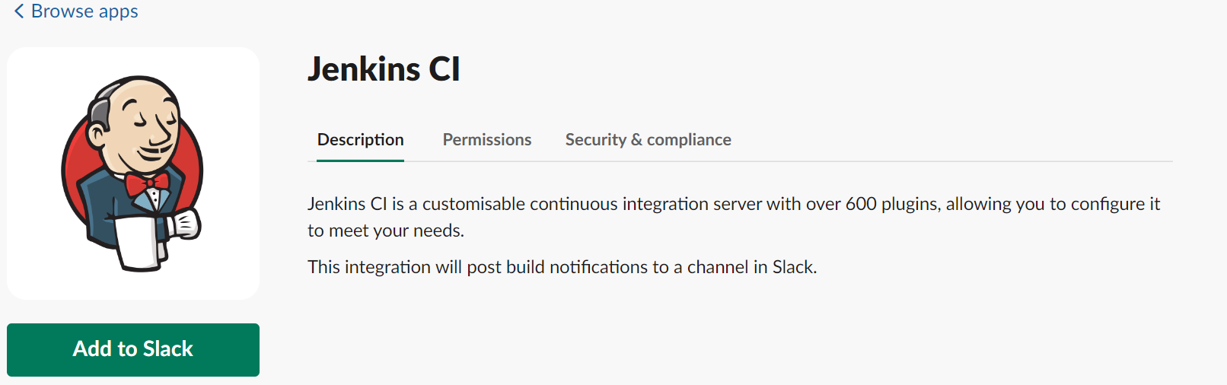

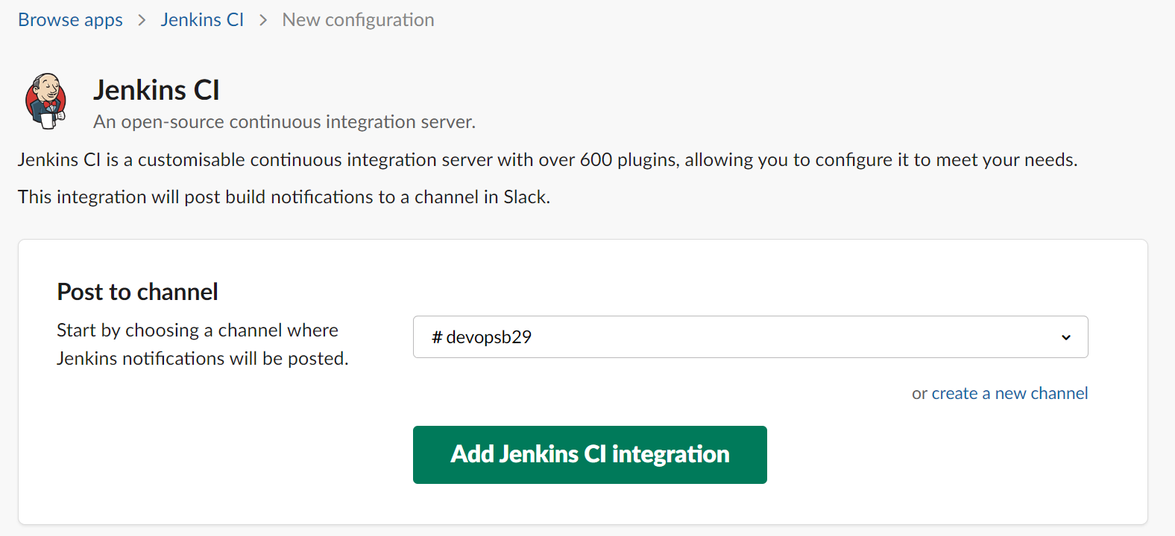

Copy Integration Token below from the Slack Window after Jenkin CI Plugin Integration.

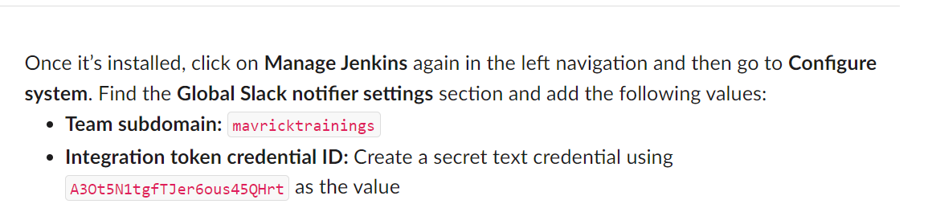

Install Slack Plugin:

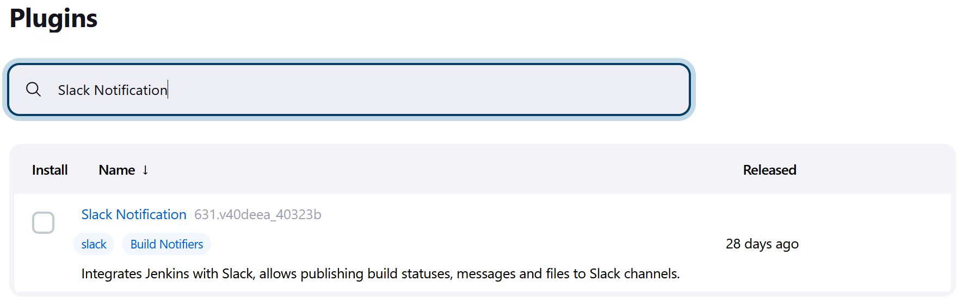

Create a Secret Text Credentials for Slack API Key.

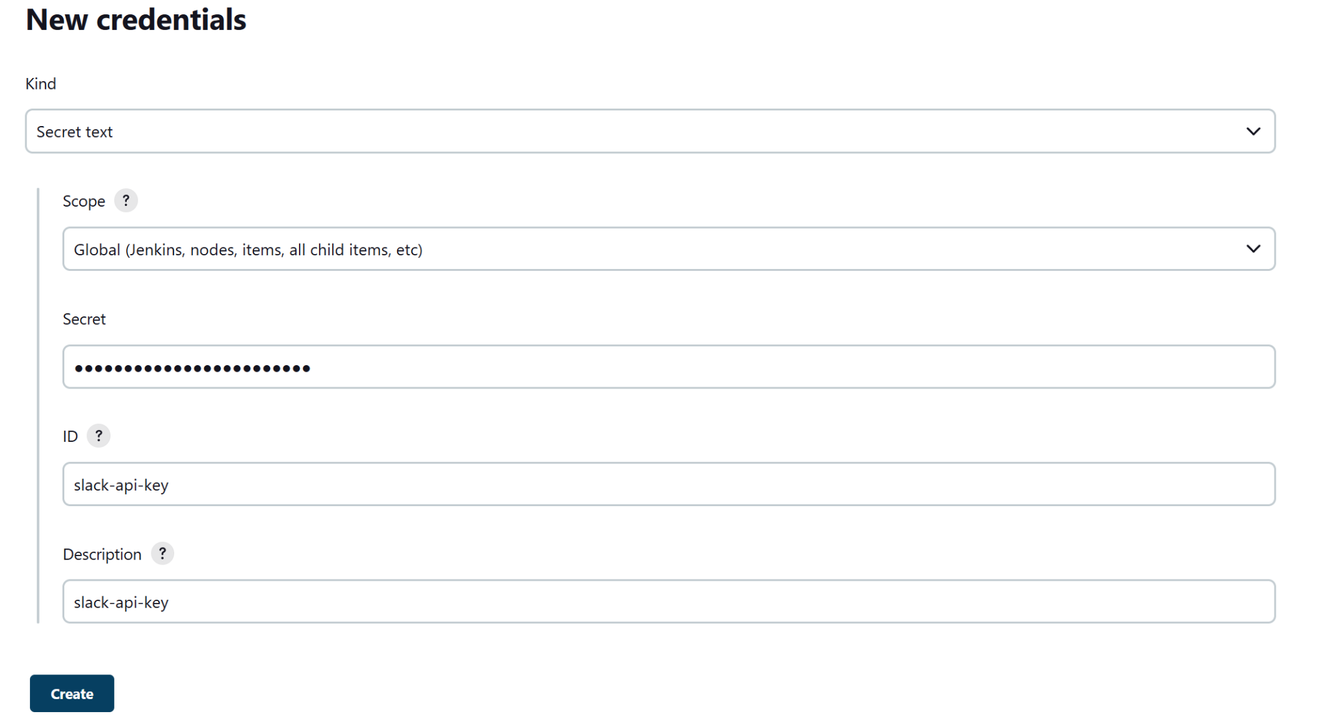

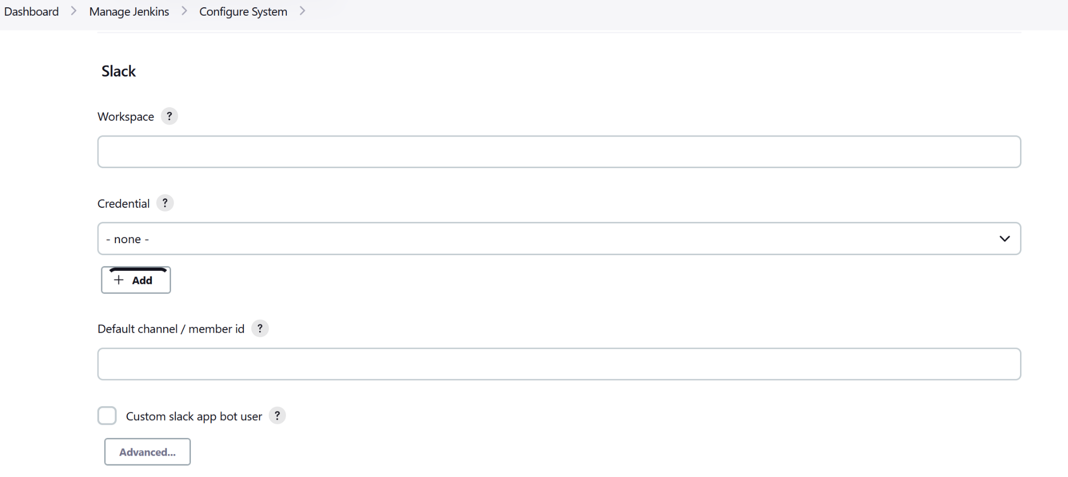

Create a Credential with Secret Test with the Slack Token:



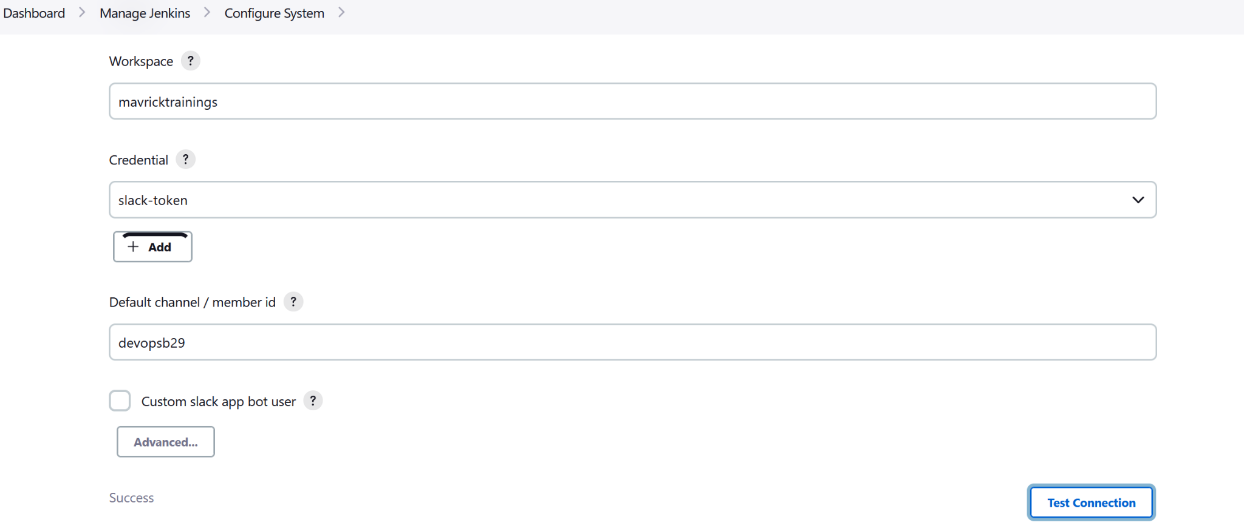

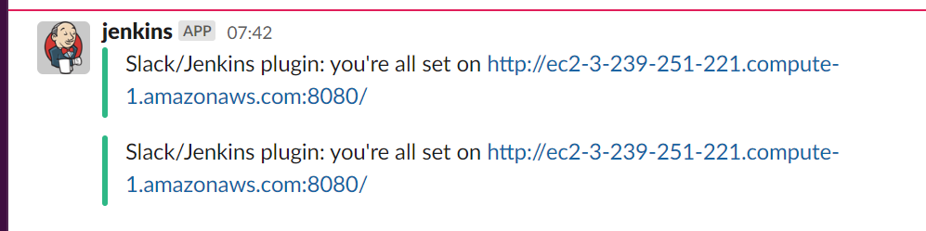

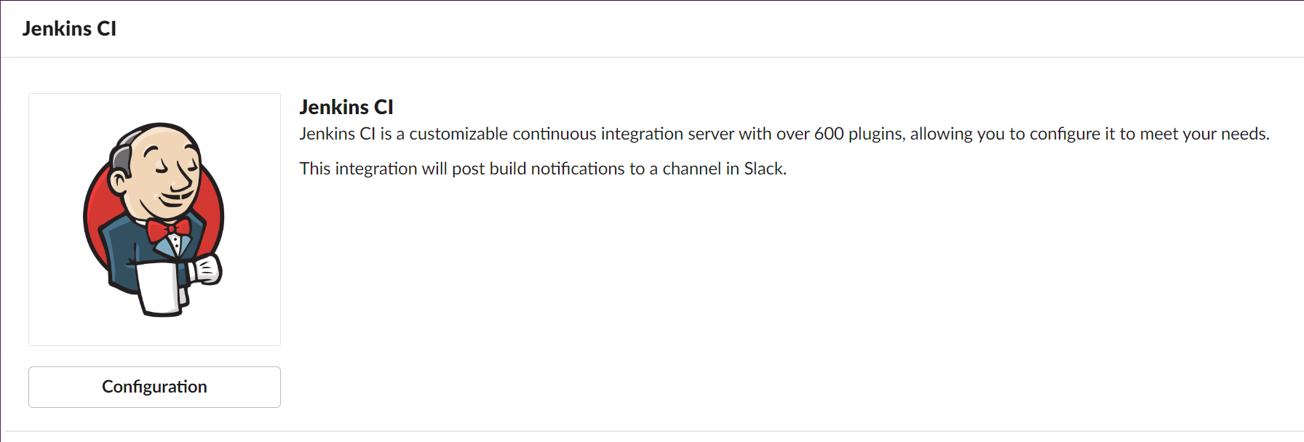

<https://kunzleigh.com/creating-a-slack-notifier-using-jenkins-pipeline/>

<https://eavnitech.com/blog/send-notification-to-slack-from-the-Jenkins-CI-job-and-jenkinsfile/>

