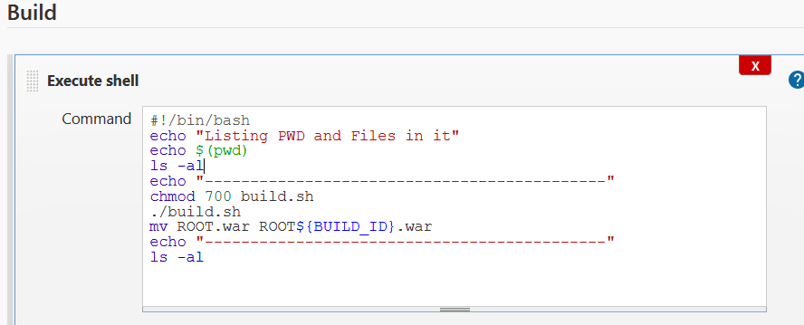

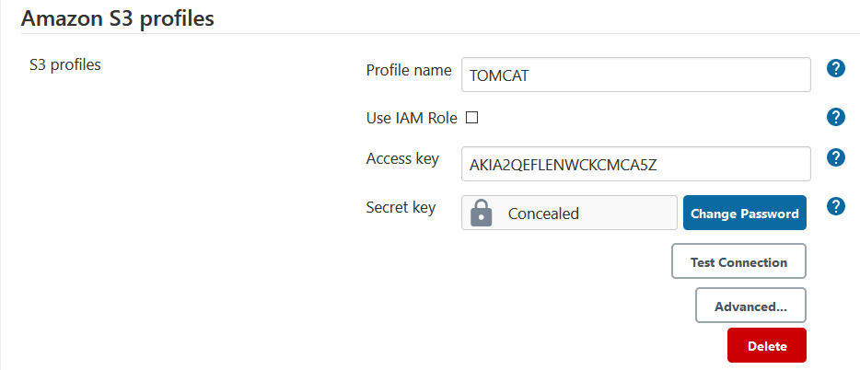

AT PROJECT LEVEL:

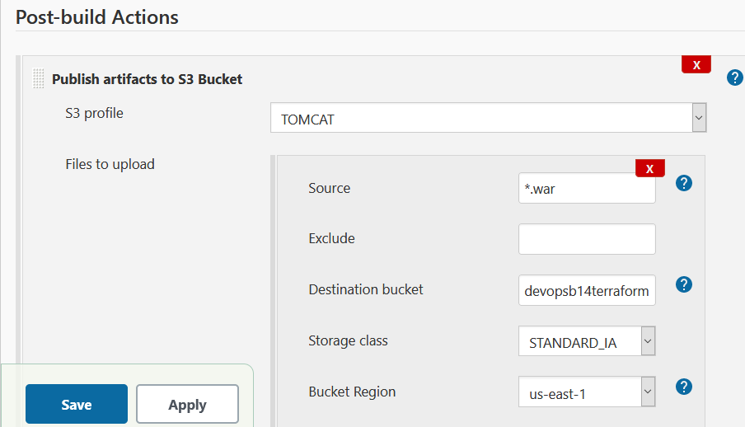

CODE FOR LAMBDA:

1. Give S3 Pull Access and Add PUT notification for S3 towards Lambda function.

import json

import boto3

# boto3 S3 initialization

s3_client = boto3.client("s3")

def lambda_handler(event, context):

destination_bucket_name = 'devopsb14terraformflowlogs'

# event contains all information about uploaded object

print("Event :", event)

# Bucket Name where file was uploaded

source_bucket_name = event['Records'][0]['s3']['bucket']['name']

# Filename of object (with path)

file_key_name = event['Records'][0]['s3']['object']['key']

# Copy Source Object

copy_source_object = {'Bucket': source_bucket_name, 'Key': file_key_name}

# S3 copy object operation

s3_client.copy_object(CopySource=copy_source_object, Bucket=destination_bucket_name, Key=file_key_name)

return {

'statusCode': 200,

'body': json.dumps('Hello from S3 events Lambda!')

}