<https://maven.apache.org/guides/getting-started/maven-in-five-minutes.html>

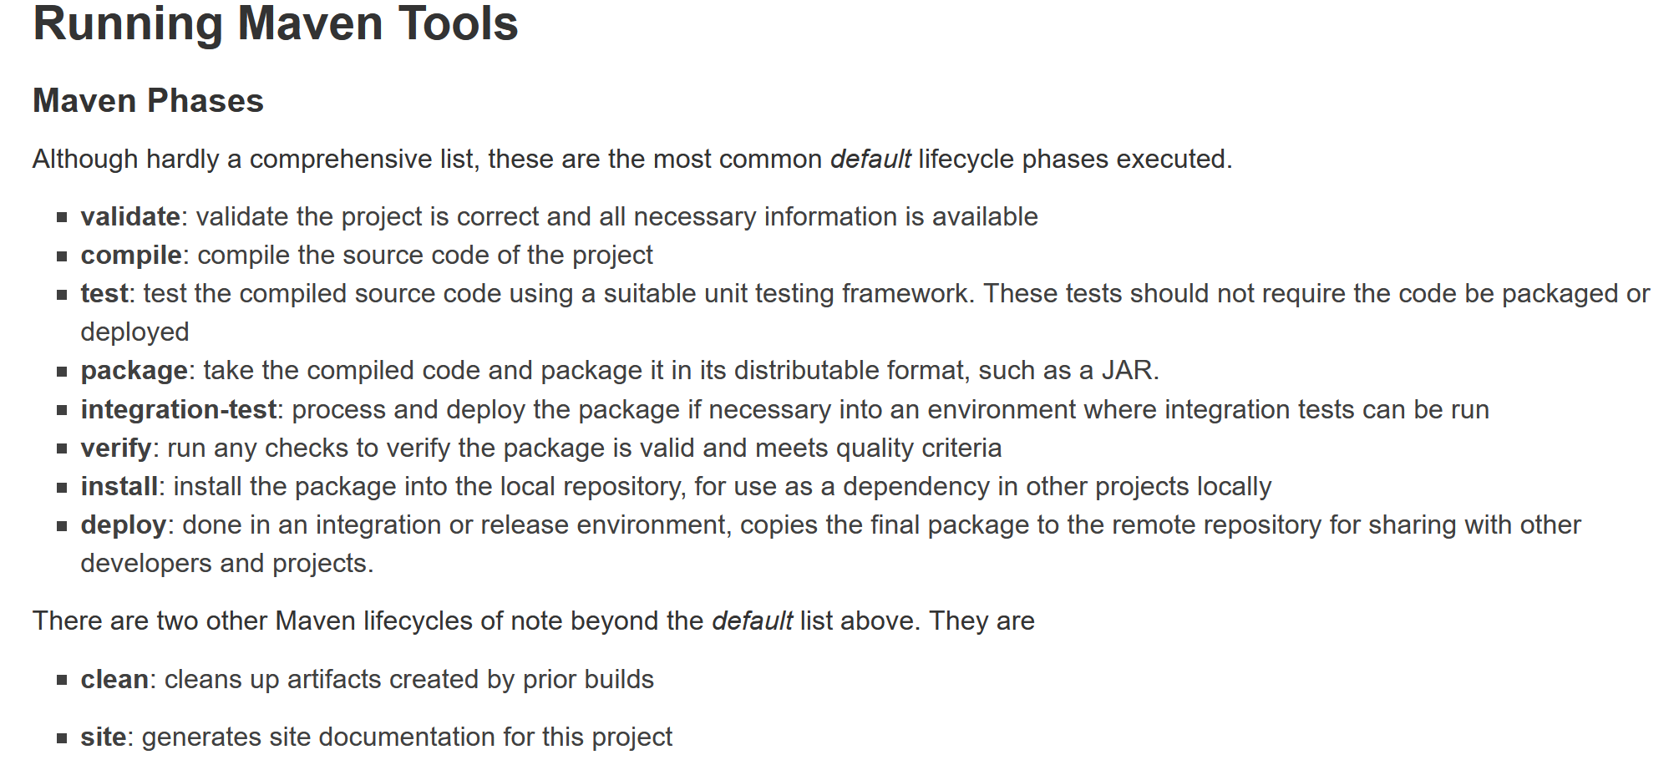

Installing maven:

Ubuntu 18.04

apt update

apt install -y maven

apt install -y tree

Creating project

mvn archetype:generate -DgroupId=com.mycompany.app -DartifactId=my-app -DarchetypeArtifactId=maven-archetype-quickstart -DarchetypeVersion=1.4 -DinteractiveMode=false

tree my-app

cd my-app

mvn package

java -cp target/my-app-1.0-SNAPSHOT.jar com.mycompany.app.App

mvn clean