NeoMart Retail Performance
Executive Summary - Full-Year Sales, Profit & Operations Review
1. What Happened
NeoMart closed the year with strong overall sales momentum; total revenue climbed from a January dip to a year-high in December but performance was uneven beneath the surface. The South region drove the most revenue yet posted the weakest customer satisfaction and slowest deliveries. Electronics was by far the most profitable category, while heavier discounting steadily eroded margins.
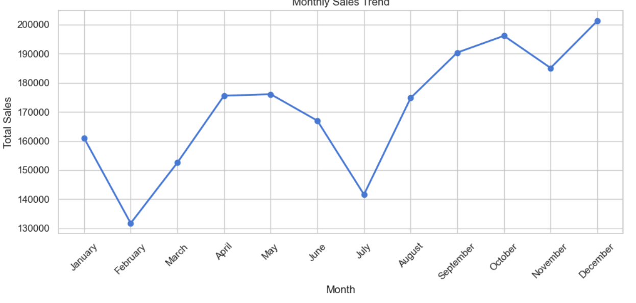  Fig 1. Monthly sales dipped in Feb & Jul, surged to a Dec peak | 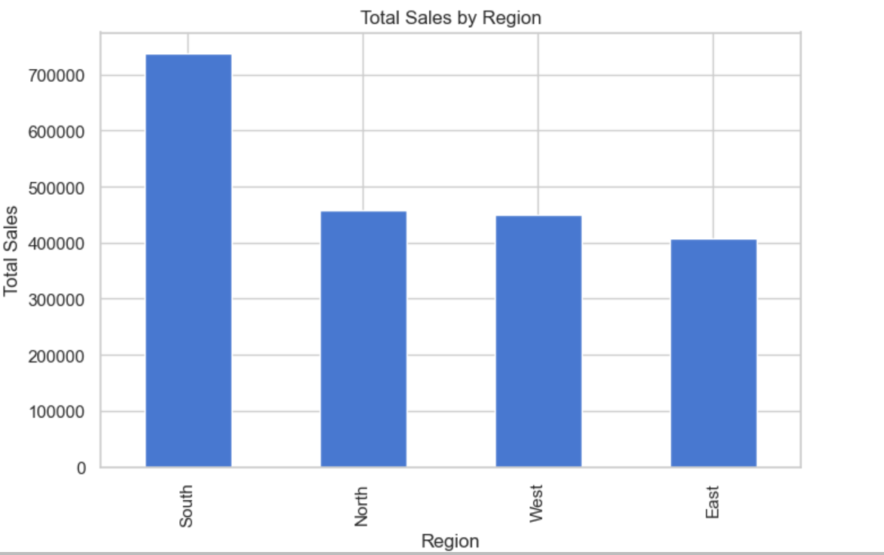  Fig 2. South leads sales; East lags all regions
2. Why It Happened
- Seasonality & promotions: the mid-year slump (Jun–Jul) and year-end surge point to seasonal demand and holiday promotions driving the swings, rather than steady organic growth.
- Discounting is cutting into profit: Discount and Profit are moderately negatively correlated (r = –0.45) , heavier discounts are also linked to lower customer satisfaction (r = –0.64) and longer delivery times (r = 0.65), suggesting discount-driven orders strain fulfillment.
- South region's growth outpaced its logistics: South delivers the most revenue but has the longest, most variable delivery times (median 7.7 days vs 4 elsewhere), which tracks with its lower, more volatile satisfaction scores (median 3.2 vs 4.2 elsewhere).
- Uneven product mix: Electronics generates the most profit, Office Supplies is mid-tier, and Furniture trails well behind, likely reflecting pricing, cost structure, or slower inventory turns.
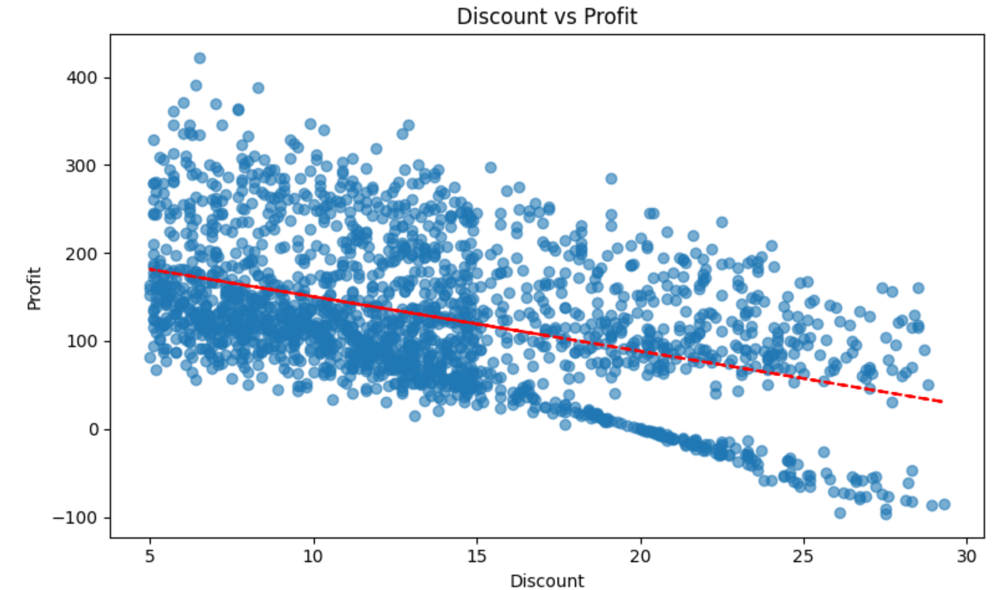  Fig 3. Profit trends down as discount level rises | 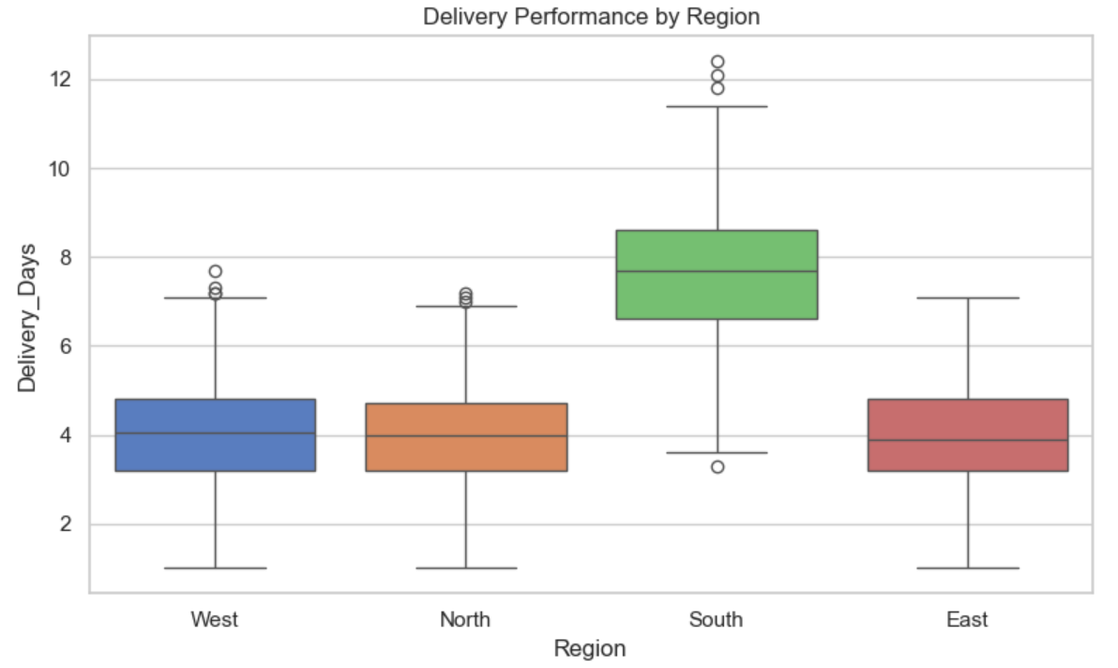  Fig 4. South's delivery times run far longer & less predictable
3. What Management Should Do Next
- Tighten discount strategy: cap or target discounts (e.g., loyalty/clearance only) instead of broad markdowns to protect margin discount levels above 15% show the steepest profit erosion.
- Fix South region logistics: audit warehouse and carrier performance to close the 3–4 day delivery gap versus other regions; this is the most likely lever to lift South's satisfaction scores.
- Grow the East region: launch targeted marketing and promotions to close the sales gap with North and West, its closest peers.
- Double down on Electronics, fix Furniture: protect inventory and marketing investment in Electronics; review Furniture's pricing and supplier costs to lift its margin.
- Institutionalize monitoring: track satisfaction and delivery KPIs by region monthly so issues like South's are caught before they affect full-year results.

