**Nihon, Arigato – A Japanese Café**

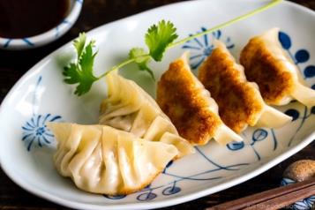**MENU**

**Minced Pork Gyoza - $20**

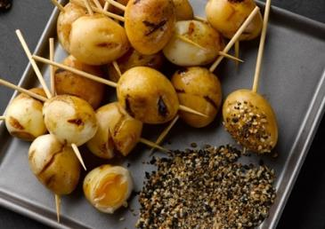

**APPETIZERS:**

**Soy Grilled Quail Egg - $20**

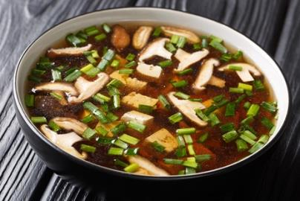

**Ginger Miso Soup - $18**

**Hamachi - $30**

**DISHES:**

**Okinawan Ramen - $30**

**Okonomiyaki - $25**

**DESSERT:**

**Matcha Cheesecake - $20**

**DRINKS:**

**Asahi Beer - $10**

* ETHICALLY SOURCED FISH FROM JAPAN
* NON-GMO, ORGANIC VEGETATION ONLY
* FRESH VEGETATION DELIVERED DAILY

HIGH QUALITY FOOD AT SMALL AMOUNTS