**IT Returns Processing Database**

**Objective:**

What details to be updated and how to file IT returns Create a database that best suggest to process IT returns

**ABSTRACT:**

The project aims to create a database for IT returns, which will serve as a central repository for storing and managing tax-related information for individuals and businesses. The database will be designed to accommodate various types of tax returns and support efficient data retrieval and analysis. The system will also incorporate data validation and security features to ensure the accuracy and confidentiality of the stored information. Overall, the database will enhance the efficiency and effectiveness of the tax administration process and improve the quality of service provided to taxpayers.

To create a database that best suggests to process the IT returns, you need to consider the following details to be updated:

1. Personal Information: The database should contain all personal information, such as name, address, contact number, email address, etc., of the taxpayer. This information should be updated annually or whenever there is a change in personal details.

2. Income Details: The database should contain all income-related details, including salary, business income, capital gains, rental income, interest income, etc. It should also include details of tax deductions, such as investments made in tax-saving instruments.

3. Tax Payment Details: The database should contain all details related to tax payments made by the taxpayer, including advance tax, self-assessment tax, TDS, etc.

4. Filing Status: The database should maintain a record of the filing status of the taxpayer, such as whether the return was filed on time or not, whether it was e-filed or paper filed, etc.

5. Audit Details: The database should maintain details related to any audit conducted by the Income Tax Department, such as the date of audit, the auditor's name, and the outcome of the audit.

To file the IT returns, you can follow these steps:

1. Gather all relevant information related to income, deductions, and tax payments.

2. Choose the appropriate ITR form based on your income sources and file the return.

3. Verify the return by either e-verification or sending a physical copy of the ITR-V to the CPC.

4. Keep a copy of the filed return and all supporting documents for future reference.

5. In case of any discrepancies or errors, rectify them as soon as possible by filing a revised return.

By maintaining a database with all relevant details, you can easily file your IT returns and avoid any errors or discrepancies. It will also help in efficient processing of your returns by the Income Tax Department.

**ER Diagram:**

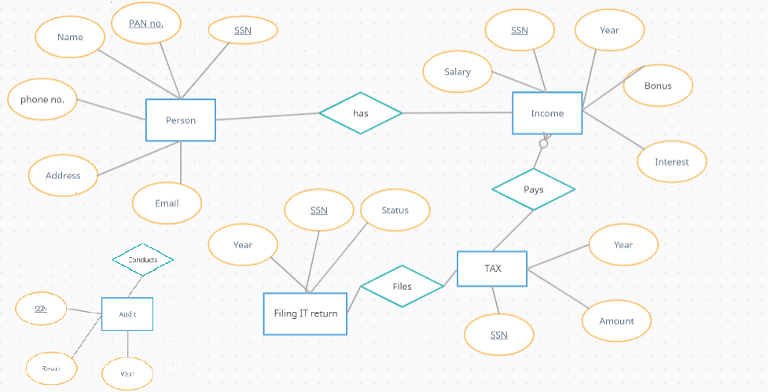

**DDL Operations:**

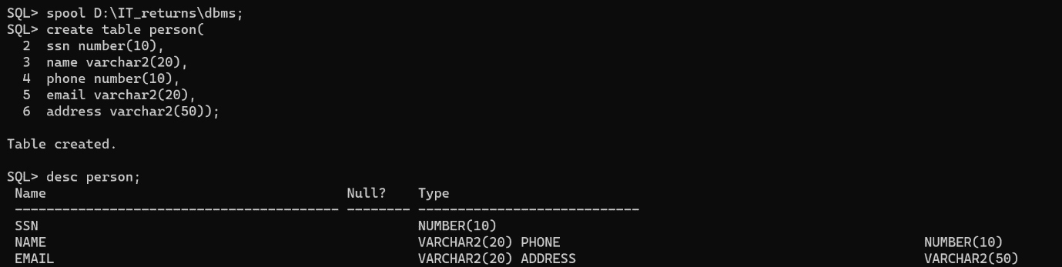

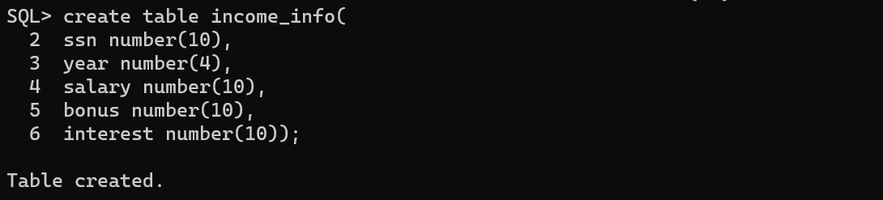

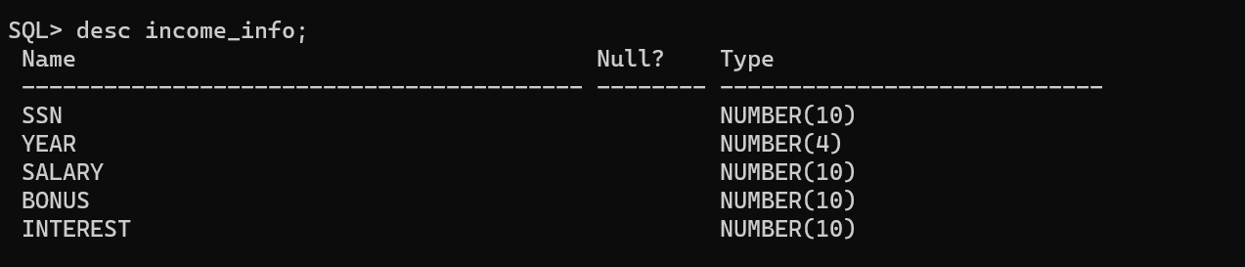

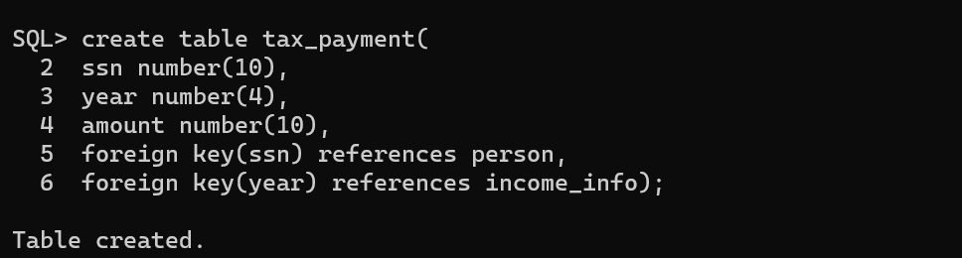

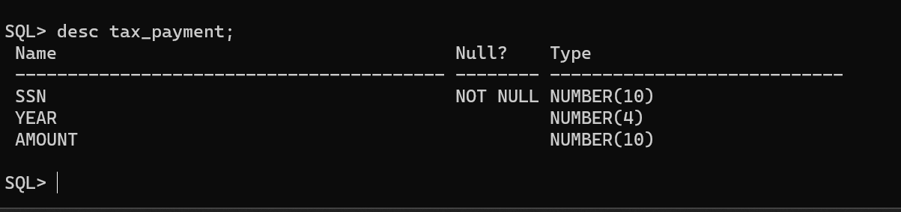

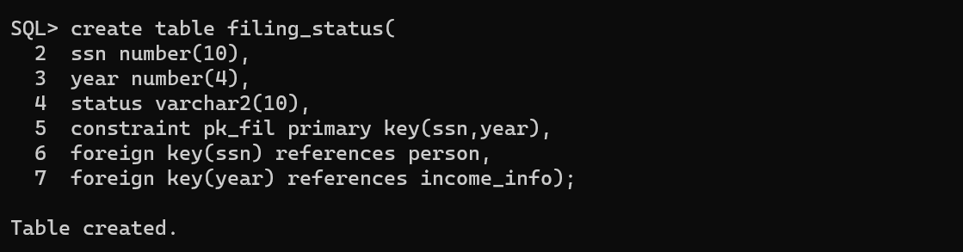

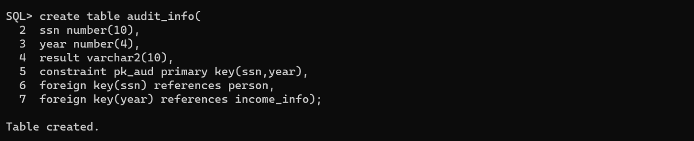

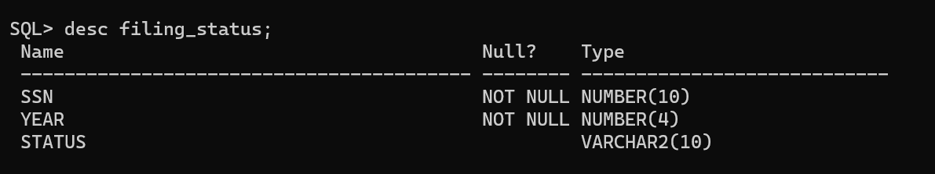

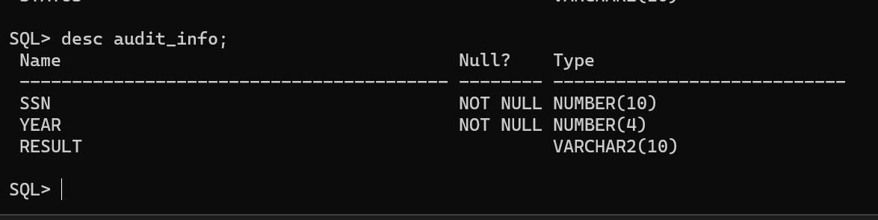

**KEY CONSTRAINTS:**

SQL> alter table income_info add constraint pk_inc primary key(ssn);

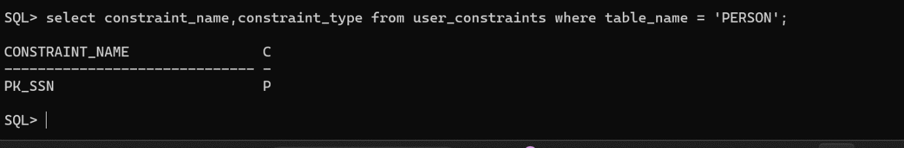

SQL> alter table income_info add constraint pk_inc primary key(ssn,year);

SQL>alter table income_info add foreign key(ssn) references person;

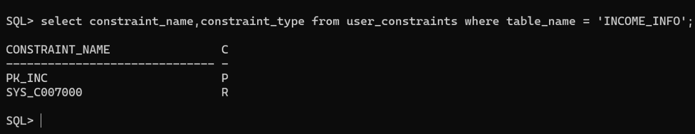

SQL> alter table tax_payment add constraint pk_tax primary key(ssn,year);

SQL> alter table tax_payment add foreign key(ssn) references person;

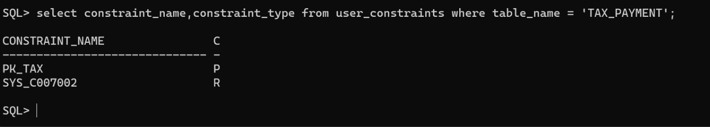

SQL> alter table filing_status add constraint pk_fil primary key(ssn,year);

SQL>alter table filing_status add foreign key(ssn) references person;

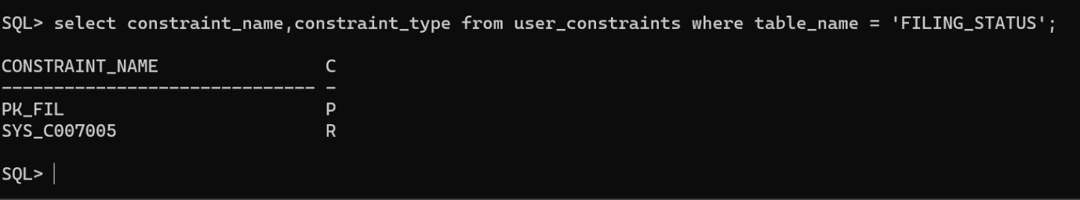

SQL>alter table audit_info add constraint pk_aud primary key(ssn,year);

SQL> alter table audit_info add foreign key(ssn) references person;

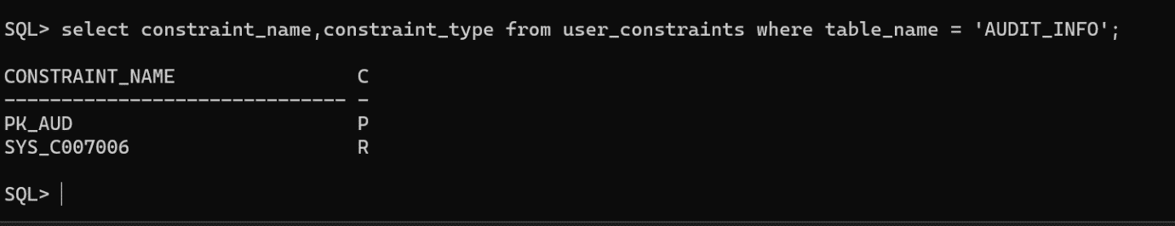

**DML Operations:**

SQL> insert into person values (&ssn,'&name',&phone,'&eamil','&address');

Enter value for ssn: 1100

Enter value for name: prudhvi

Enter value for phone: 6309825369

Enter value for eamil: prudhvi2003@gmail.com

Enter value for address: plot no 527 kukatpally hyd

old 1: insert into person values (&ssn,'&name',&phone,'&eamil','&address')

new 1: insert into person values (1100,'prudhvi',6309825369,'prudhvi2003@gmail.com','plot no 527 kukatpally hyd')

1 row created.

SQL> /

Enter value for ssn: 1101

Enter value for name: anurag

Enter value for phone: 8919552101

Enter value for eamil: anurag@gmai.com

Enter value for address: plot no 123,chikadapally,secundrabad

old 1: insert into person values (&ssn,'&name',&phone,'&eamil','&address')

new 1: insert into person values (1101,'anurag',8919552101,'anurag@gmai.com','plot no 123,chikadapally,secundrabad')

1 row created.

SQL> /

Enter value for ssn: 1102

Enter value for name: anish

Enter value for phone: 6303740135

Enter value for eamil: anish@gmail.com

Enter value for address: plot no 558,kollur,shankarpally

old 1: insert into person values (&ssn,'&name',&phone,'&eamil','&address')

new 1: insert into person values (1102,'anish',6303740135,'anish@gmail.com','plot no 558,kollur,shankarpally')

1 row created.

SQL> 1103

SP2-0226: Invalid line number

SQL> /

Enter value for ssn: 1103

Enter value for name: shruthi

Enter value for phone: 9328945636

Enter value for eamil: shruthi@gmail.com

Enter value for address: plot no 662,saroornagar,hyd

old 1: insert into person values (&ssn,'&name',&phone,'&eamil','&address')

new 1: insert into person values (1103,'shruthi',9328945636,'shruthi@gmail.com','plot no 662,saroornagar,hyd')

1 row created.

SQL> /

Enter value for ssn: 1104

Enter value for name: shriya

Enter value for phone: 7894561230

Enter value for eamil: shriya@gmail.com

Enter value for address: plot no 990,attapur,hyd

old 1: insert into person values (&ssn,'&name',&phone,'&eamil','&address')

new 1: insert into person values (1104,'shriya',7894561230,'shriya@gmail.com','plot no 990,attapur,hyd')

1 row created.

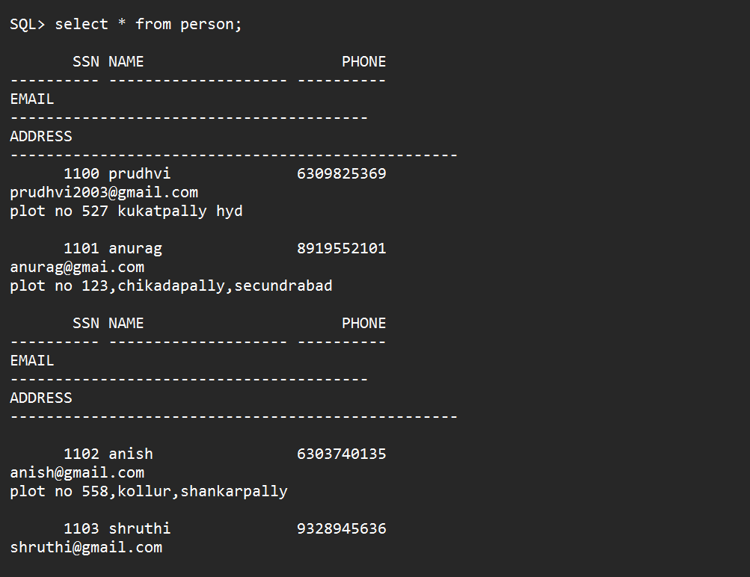

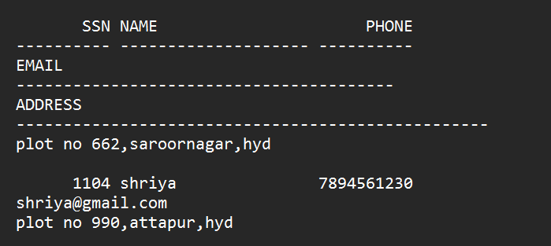

SQL> insert into income_info values(&ssn,&year,&salary,&bonus,&interest);

Enter value for ssn: 1100

Enter value for year: 2019

Enter value for salary: 1500000

Enter value for bonus: 300000

Enter value for interest: 200000

old 1: insert into income_info values(&ssn,&year,&salary,&bonus,&interest)

new 1: insert into income_info values(1100,2019,1500000,300000,200000)

1 row created.

SQL> insert into income_info values(&ssn,&year,&salary,&bonus,&interest);

Enter value for ssn: 1101

Enter value for year: 2019

Enter value for salary: 1200000

Enter value for bonus: 200000

Enter value for interest: 100000

old 1: insert into income_info values(&ssn,&year,&salary,&bonus,&interest)

new 1: insert into income_info values(1101,2019,1200000,200000,100000)

1 row created.

SQL> /

Enter value for ssn: 1102

Enter value for year: 2019

Enter value for salary: 800000

Enter value for bonus: 200000

Enter value for interest: 200000

old 1: insert into income_info values(&ssn,&year,&salary,&bonus,&interest)

new 1: insert into income_info values(1102,2019,800000,200000,200000)

1 row created.

SQL> /

Enter value for ssn: 1103

Enter value for year: 2019

Enter value for salary: 2000000

Enter value for bonus: 500000

Enter value for interest: 600000

old 1: insert into income_info values(&ssn,&year,&salary,&bonus,&interest)

new 1: insert into income_info values(1103,2019,2000000,500000,600000)

1 row created.

SQL> /

Enter value for ssn: 1104

Enter value for year: 2019

Enter value for salary: 1800000

Enter value for bonus: 200000

Enter value for interest: 50000

old 1: insert into income_info values(&ssn,&year,&salary,&bonus,&interest)

new 1: insert into income_info values(1104,2019,1800000,200000,50000)

1 row created.

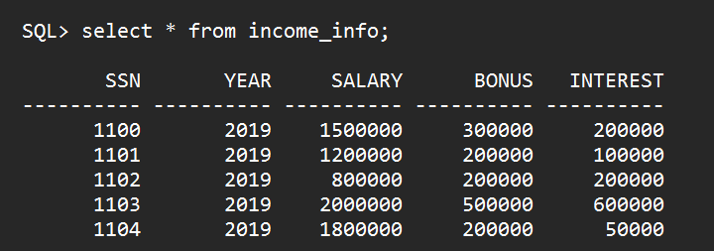

SQL> insert into tax_payment values(&ssn,&year,&amount);

Enter value for ssn: 1100

Enter value for year: 2019

Enter value for amount: 300000

old 1: insert into tax_payment values(&ssn,&year,&amount)

new 1: insert into tax_payment values(1100,2019,300000)

1 row created.

SQL> /

Enter value for ssn: 1101

Enter value for year: 2019

Enter value for amount: 200000

old 1: insert into tax_payment values(&ssn,&year,&amount)

new 1: insert into tax_payment values(1101,2019,200000)

1 row created.

SQL>

SQL> /

Enter value for ssn: 1102

Enter value for year: 2019

Enter value for amount: 500000

old 1: insert into tax_payment values(&ssn,&year,&amount)

new 1: insert into tax_payment values(1102,2019,500000)

1 row created.

SQL> /

Enter value for ssn: 1103

Enter value for year: 2019

Enter value for amount: 250000

old 1: insert into tax_payment values(&ssn,&year,&amount)

new 1: insert into tax_payment values(1103,2019,250000)

1 row created.

SQL> /

Enter value for ssn: 1104

Enter value for year: 2019

Enter value for amount: 200000

old 1: insert into tax_payment values(&ssn,&year,&amount)

new 1: insert into tax_payment values(1104,2019,200000)

1 row created.

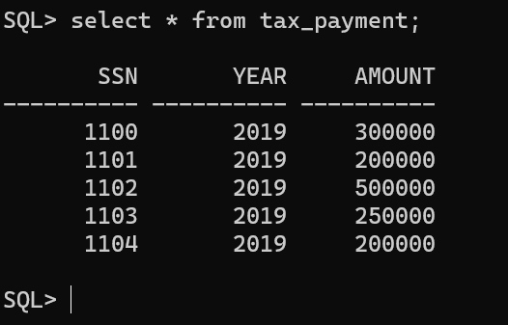

SQL> insert into filing_status values(&ssn,&year,'&status');

Enter value for ssn: 1100

Enter value for year: 2019

Enter value for status: single

old 1: insert into filing_status values(&ssn,&year,'&status')

new 1: insert into filing_status values(1100,2019,'single')

1 row created.

SQL> /

Enter value for ssn: 1101

Enter value for year: 2019

Enter value for status: couple

old 1: insert into filing_status values(&ssn,&year,'&status')

new 1: insert into filing_status values(1101,2019,'couple')

1 row created.

SQL> /

Enter value for ssn: 1102

Enter value for year: 2019

Enter value for status: business

old 1: insert into filing_status values(&ssn,&year,'&status')

new 1: insert into filing_status values(1102,2019,'business')

1 row created.

SQL> /

Enter value for ssn: 1103

Enter value for year: 2019

Enter value for status: single

old 1: insert into filing_status values(&ssn,&year,'&status')

new 1: insert into filing_status values(1103,2019,'single')

1 row created.

SQL> /

Enter value for ssn: 1104

Enter value for year: 2019

Enter value for status: family

old 1: insert into filing_status values(&ssn,&year,'&status')

new 1: insert into filing_status values(1104,2019,'family')

1 row created.

SQL> select * from filing_status;

SSN YEAR STATUS

---------- ---------- ----------

1100 2019 single

1101 2019 couple

1102 2019 business

1103 2019 single

1104 2019 family

SQL> insert into audit_info values(&ssn,&year,'&result');

Enter value for ssn: 1100

Enter value for year: 2019

Enter value for result: success

old 1: insert into audit_info values(&ssn,&year,'&result')

new 1: insert into audit_info values(1100,2019,'success')

1 row created.

SQL> /

Enter value for ssn: 1101

Enter value for year: 2019

Enter value for result: success

old 1: insert into audit_info values(&ssn,&year,'&result')

new 1: insert into audit_info values(1101,2019,'success')

1 row created.

SQL> /

Enter value for ssn: 1103

Enter value for year: 2019

Enter value for result: success

old 1: insert into audit_info values(&ssn,&year,'&result')

new 1: insert into audit_info values(1103,2019,'success')

1 row created.

SQL> /

Enter value for ssn: 1104

Enter value for year: 2019

Enter value for result: success

old 1: insert into audit_info values(&ssn,&year,'&result')

new 1: insert into audit_info values(1104,2019,'success')

1 row created.

SQL> /

Enter value for ssn: 1102

Enter value for year: 2019

Enter value for result: failed

old 1: insert into audit_info values(&ssn,&year,'&result')

new 1: insert into audit_info values(1102,2019,'failed')

SQL> select * from audit_info;

SSN YEAR RESULT

---------- ---------- ----------

1100 2019 success

1101 2019 success

1103 2019 success

1104 2019 success

1102 2019 failed