**Procedure to do Check-in using GIT**

1. **Download Latest Source:**

* Create a new folder 🡪 Right Click 🡪 Git Bash here.  
  Or use Address bar 🡪 cmd to open the command prompt
* Clone the latest Updated source from Azure Devops Branch
* **Cmd:** git clone (required link) - -branch (Repository name/main)
* **Eg:** git clone <https://HEXA-STEP-SATELLITE-SYSTEMS@dev.azure.com/HEXA-STEP-SATELLITE-SYSTEMS/QA_Automation/_git/AduitAutomation>--branch main
* Required link can be copied from

* Updated source (AduitAutomation) is downloaded in Newly created folder

1. **Create new branch:**

* **Cmd:** cd AduitAutomation/
* Create the branch
* **Cmd:** git checkout -b (new branch name)
* **Eg:** git checkout -b Dinesh_dev

* **Cmd:** git status 🡪 will get the status(modified/added/deleted) of Dinesh_dev branch from main branch

No changes will be observed as of now.

1. **After the work completion:**

* Work or add or modify the required changes in AduitAutomation local folder.
* **Cmd:** git status 🡪 now changes are visible.

1. **Push local changes to our Repository:**
   1. **Add:**

* **Cmd:** git add *
* Or if required to push only one file change - copy paste the particular link
* **Cmd:** git add (copy paste the particular link)
  1. **Commit:**
* **Cmd:** git commit -m “(give a single line message about your change)”
* **Eg:** git commit -m “Added PageObject”

* 1. **Push:**
* **Cmd:** git push -u origin (created branch name)
* **Eg:** git push -u origin Dinesh_dev

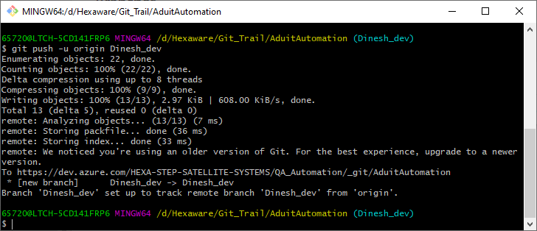

Now all the changes will be available in newly created branch (Dinesh_dev)

1. **Create Pull Request:**

* Go to Azure devops UI
* Select 🡪 QA_Automation 🡪 Repos 🡪 Pull request 🡪 New pull Request

* Select the Source(Dinesh_dev) and Destination Branch (STEPERP_Automation) as required
* Fill the description and Add the Reviewer as required.
* Click Create to create the Pull request
* Once the Reviewer approves the pull request and clicks merge, then the changes are merged to the main branch (STEPERP_Automation)

Repeat the same process whenever your changes are to be merged.

Once completed cloning process then :

**Daily Routine for Check-in and Check-out :**

* **git checkout main**
* **git fetch**
* **(in case if git stash need use this command) git stash**
* **git pull**
* **git checkout (our branch name)**
* **git merge origin/main**