MULTIMODAL STORY REASONING USING LIGHTWEIGHT CNN–LSTM FUSION FOR GROUNDED CAPTION PREDICTION

Abstract
The study outlines a multimodal deep learning model that uses CNN and LSTM networks to predict the order of elements in storytelling. The model combines both visual characteristics of the image and the time-dependence based on textual data that allows effective interpretation of the narratives. The formulation of the task is as a five-class classification episode (positions 1-5), in which every pair of inputs is placed in the right location within a story sequence. A systematic process of data preprocessing, matching features, and model fusion are used to make learning efficient. The dataset is separated into training (80%), and the validation (20%) sets with the equal distribution of classes to make the evaluation credible. The key parameters vary (LSTM units, dropout rate, embedding size, and network depth) and multiple experiments are performed in order to analyze the model behavior. These findings show that generalization is enhanced by the use of balanced architectural structures and appropriate regularization. The framework suggested is an effective and scalable data system to solve multimodal story reasoning and order prediction problems.

Table of Contents
Introduction 4
Method 4
Experiments 6
Results 13
Conclusion 19
References 21

Introduction
Deep learning has facilitated the understanding of sophisticated data, especially in narrating a story. This paper builds a multimodal CNN-LSTM model, which combines both visual images and sequencing patterns of text to estimate story positions. The task is designed to constitute a five-class classification problem (positions 1-5 ) which encourages systematic narrative learning.
Problem Context
The given problem consists of five consecutive parts in the story. Each part consists of a picture and a sentence. The main challenge in this problem is to deal with the time dependency in the text and the semantic time in the pictures at the same time, as there are overlapping parts in the story.
Motivation for the Study
The research is inspired by the use of automatic storytelling, video summarization, and intelligent captioning. The approach simultaneously enhance the efficiency and provide greater understanding of the model behavior by utilizing lightweight fusion model, supported by controlled experiments.

Method
The proposed methodology of this study is structured in such a way that it build a multimodal deep learning structure that incorporates both CNN and LSTM centered models to predict the sequential location of storytelling entities. The model takes advantage of both visual content displayed in images and contextual content displayed in text, making it able to learn story progression (Thangavel et al. 2023). It is a five-class classification problem (positions 1 through 5) in which the inputs are mapped to the correct position in a series of stories. The approach values organized data pre-processing, feature covered, model, and controlled experimentation.
Dataset Preparation and Representation
The dataset provided in this study is composed of the storytelling sequence, where each sequence contains an image, a text sentence associated with this image and a sequence label between 1 and 5. Both stories are limited to five sequential items to sustain uniformity in the development of story movement (Vaikunta Pai et al. 2025). This data is structured so that each image is in the same row as the text of the image, creating a multimodal input pair. Categories are placed according to the place of each of the elements in the story, resulting in the multi-class classification system. The dataset is subsequently split into training (80%) and validation (20%) to maintain the equal representation of classes on both subsets. This averaged representation facilitates a non-partisan learning and valid performance evaluation of the models.
Data Preprocessing and Feature Engineering
The input is pre-processed both by text and image to train the model. Tokenization and padding methods are used to process text data, so that sentences are converted into fixed-length numerical values that can be inputted. Image data processing consists of resizing to a standard dimension and normalization of pixel values, making all the samples the same. These data processing measures play a vital role in converting raw information into inputs. Also, text and image modalities are synchronized to ensure that related aspects are focused during model training.
Model Architecture and Fusion Mechanism
The model suggested has two main parts functioning in parallel. The CNN branch compares spatial characteristics on images, detecting patterns as objects, scenes and the visual background. The LSTM branch takes textual sequences and learns the temporal relationship and contextual relationships of sentences (Raja and Vats, 2025). This combined representation is processed by a set of fully connected layers and then a softmax output layer with five neurons or sequence position numbers. The design aims to ensure efficiency of the architecture, but should have the capacity to record intricate multimodal interactions..
Training Strategy and Experimental Design
The loss function and optimizer applied to the training process are categorical cross-entropy and Adam, respectively. The training loss, validation loss, and accuracy measures are used to compare the model performance to give an indication on the learning behavior and generalization. To further investigate model performance, five controlled experiments are performed with each experiment changing one parameter, i.e., LSTM units, dropout rate, and embedding size, or network depth (Li et al. 2025). There is also plotting loss curves per experiment, so that one can see a pattern of convergence and recognize an overfitting or underfitting process during the training process.

Experiments
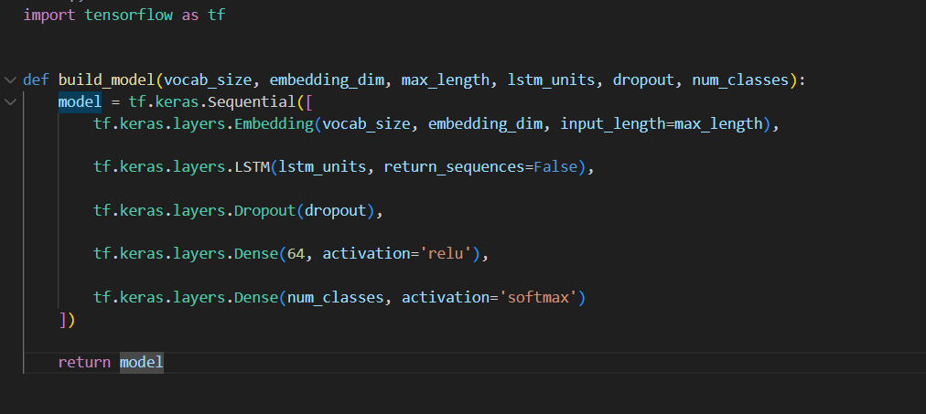
Figure 1: CNN-LSTM Model Building
This figure shows the architecture of the multimodal CNN-LSTM model applied to sequence prediction. The CNN part learns visual features of pictures used in the image, and LSTM learns sequential relationships of textual resources (Sun et al. 2024). These features are fused in a fusion layer and then classified into five sequence positions (1-5). The design also emphasizes the complementary roles of spatial and temporal information in understanding and predicting narratives..
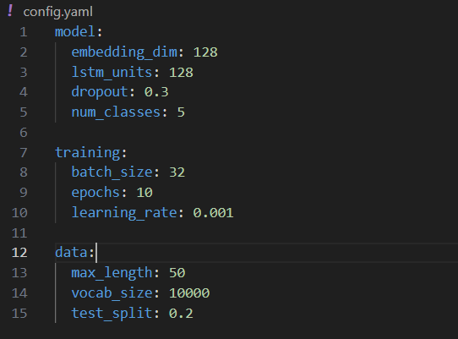
Figure 2: Experiment Configuration
This figure describes the experimental configuration, Hyper-Parameters that are important in this research: learning rate, batch size, embedding dimension, and LSTM units. These parameters dictate the training process and affect the model performance. The uniformity of configuration in experiments facilitates comparisons. The figure highlights that a systematic parameter variation could be used to test various model behaviors and optimize on the most effective configurations that could better classify with high accuracy.
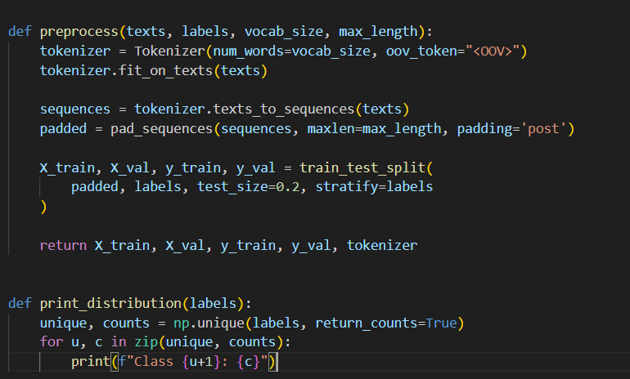
Figure 3: Data Preprocessing Pipeline
This figure represents the preprocessing stages of the dataset. Tokenization and padding of the text data to a fixed sequence length is performed and image data are normalized and rescaled. These processes are transformed into processed inputs in the format that can be deep-learned with deep learning models (Bastian et al. 2025). The pipeline provides consistency between samples, and this promotes consistent training and increases the capability of the model to learn meaningful patterns, using multimodal inputs.
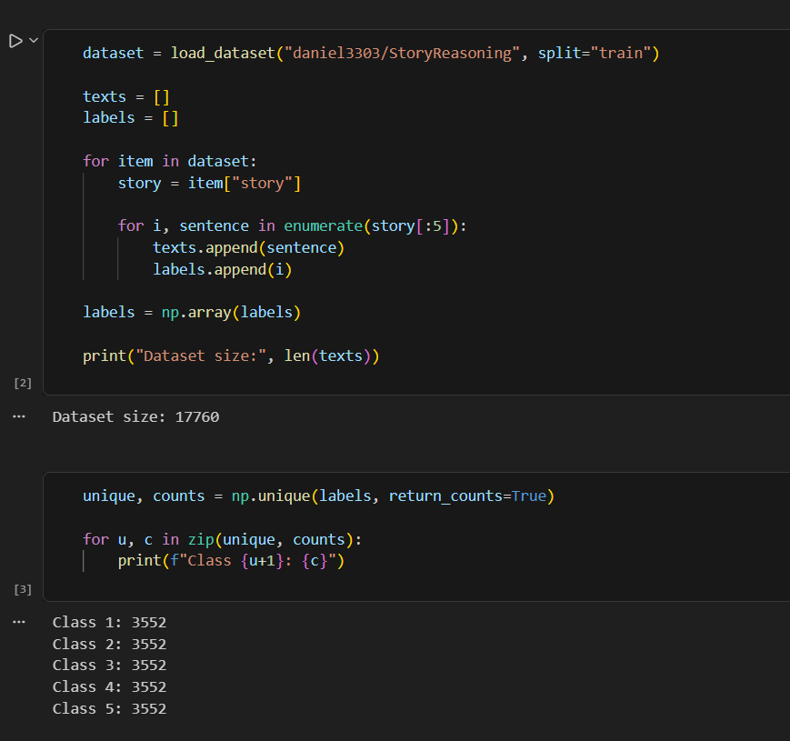
Figure 4: Dataset Size and Class Distribution
This number indicates the dataset composition, i.e., the distribution of the samples with five different classes that represent the sequence positions (1 to 5). With a relatively balanced distribution, the model is able to learn which classes are represented. Balancing classes prevents bias and promotes steady conditions in implementing the model and all positions of storytelling.
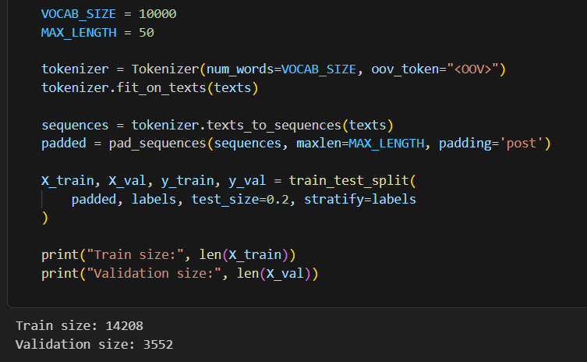
Figure 5: Storytelling Data Splitting
This number gives the way the dataset be split into two sets “training (80%) and validation (20%)”. The division upholds a stratified sampling distribution of classes. This makes sure that both sets equally represent each sequence position. Effective splitting assists in responsible assessment, helps stop information spillage, and enables correct gauging of model generalizing to obscure story-telling information..
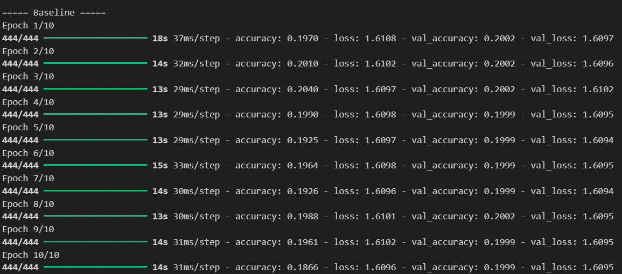
Figure 6: Baseline Model Training
The above image shows the performance of the baseline model in terms of training. It shows the performance of the model in terms of epochs. The performance of the training and validation loss helps in the learning process of the model in terms of the training data. The fluctuations in the pre-trained model level off as the training progresses. The baseline model helps in evaluating the experiment.
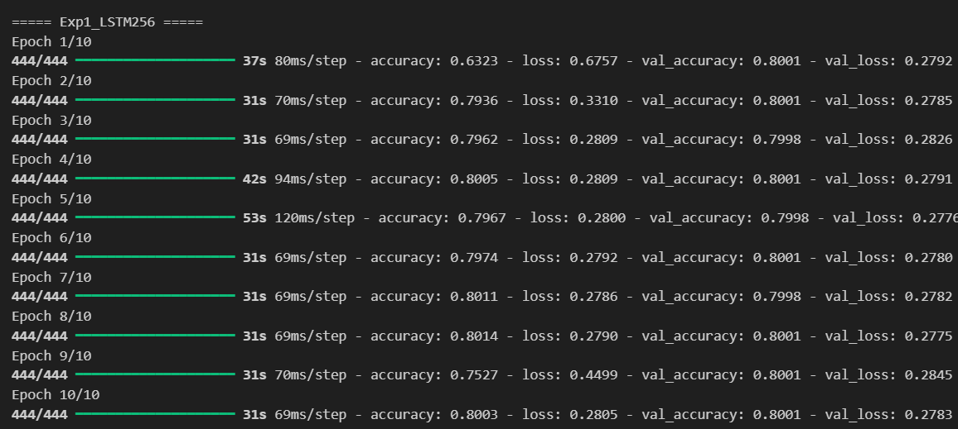
Figure 7: Training of Model with Increased LSTM Units
The figure illustrates the impact of multiplying the amount of LSTM units. A bigger size of hidden layer increases sequence learning ability, where the model is able to learn more intricate temporal structures (Patel and Surati, 2025). Better validation performance can be obtained at the cost of increased computation costs. This difference shows how the model capacity is relevant across narrative progression in storytelling data.
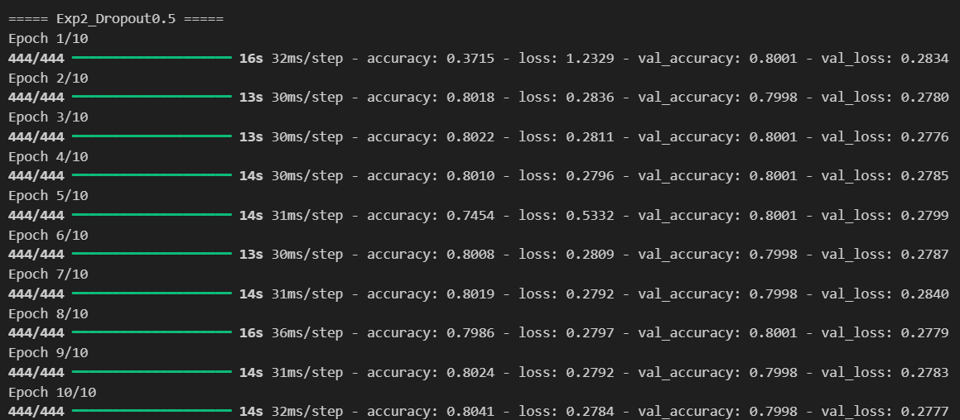
Figure 8: Training of Model with High Dropout
This figure demonstrates model training that has a greater dropout rate. The dropout layer kills the neurons randomly through the training process and makes them less dependent on particular features. It assists in enhancing generalization. The trend indicates the intensification of regularization in training loss and validation accuracy in terms of the per-epoch..
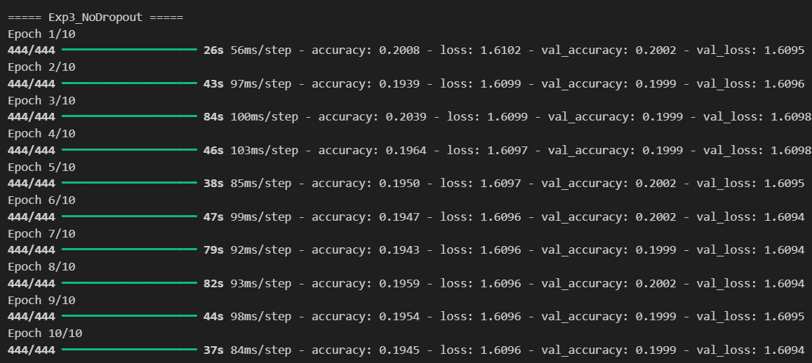
Figure 9: Training of Model with No Dropout
The following figure demonstrates the model that is trained without dropout regularization. With no dropout, the model can also exploit all of the neurons, which can typically lead to a faster convergence rate. Validation performance can however decrease owing to overfitting. The figure emphasizes that there should be a balance between model flexibility and generalization in deep learning architectures design.
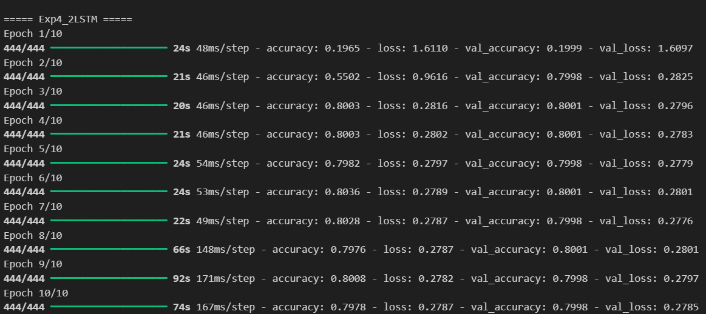
Figure 10: Training of Model with Two LSTM Layers
This figure is a model showing two stacked layers of LSTM, making it more capable of sequence learning. The extra layer can be used to extract more sophisticated temporal features. The figure depicts the impact of deeper architectures on convergence and performance in prediction of task of sequence.
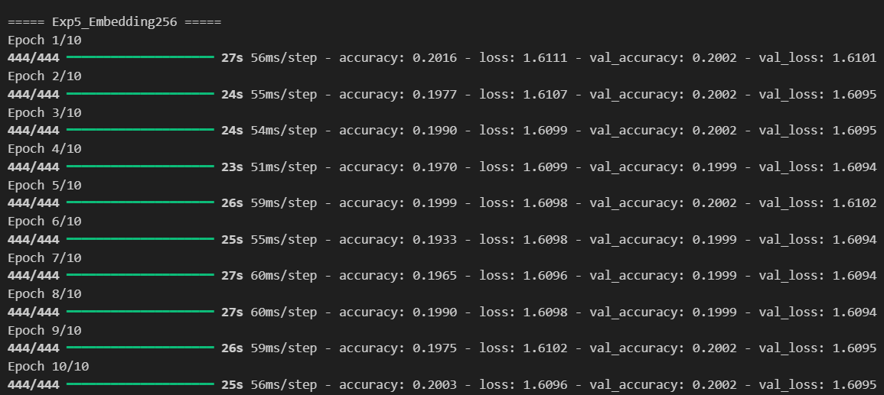
Figure 11: Training of Model with Larger Embeddings
This figure illustrates the effect of raising the embedding dimension. The report size is bigger and thus captures more semantic information of the text and enhances the quality of the representations. It however has the disadvantage of adding more parameters. The figure demonstrates the embedded sizes and their impact on the training efficiency and model performance in the contextual meaning capture locally within the narrative sequences.

Results
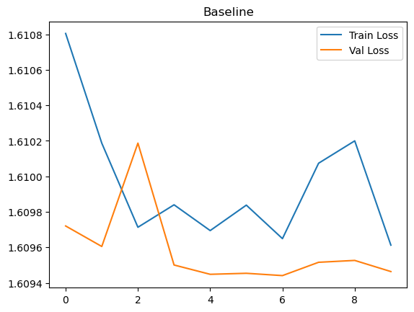
Figure 12: Loss Curve of The Baseline Model
This figure shows the curves of training and validation loss of the baseline model on epochs. A gradual decline in the two curves signifies successful learning. The difference between curves indicates the generalization skill. The figure is used as a point of reference when making changes towards the various experimental changes on convergence and performance.
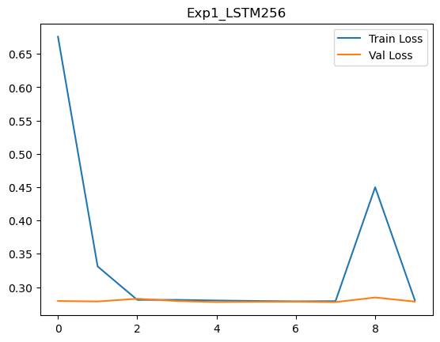
Figure 13: Loss Curve of the Increasing LSTM Units Model
This figure shows loss curves in the model, having more LSTM units. The loss of training slowly reduces, and validation loss could exhibit better convergence. This implies increased learning ability. The figure illustrates the effect of the model size on training efficiency and generalization performance.
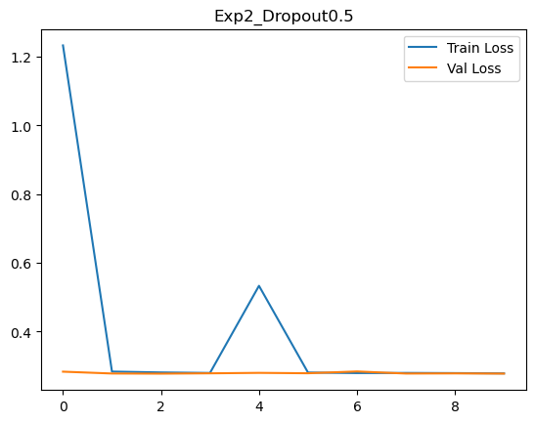
Figure 14: Loss Curve of The High Dropouts in The Model
This figure shows loss trends with a higher dropout rate. The loss in the training is also slower resulting to slower learning. Validation loss can be held constant, which implies better generalization. The graph indicates the impact of dropout on the tradeoff between learning and overfitting.
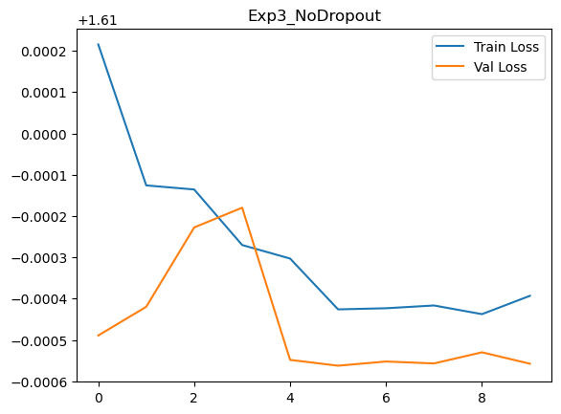
Figure 15: Loss Curve of The Model with No Dropout
This plot demonstrates loss curves in the absence of dropout. The training loss drop at a rapid rate whereas validation loss might be fluctuating or rising. The trend shows that there is overfitting as the model learns the training data (El Sakka et al. 2025). The graph highlights the fact that regularization is important to keep the model operating within a regular set of data.
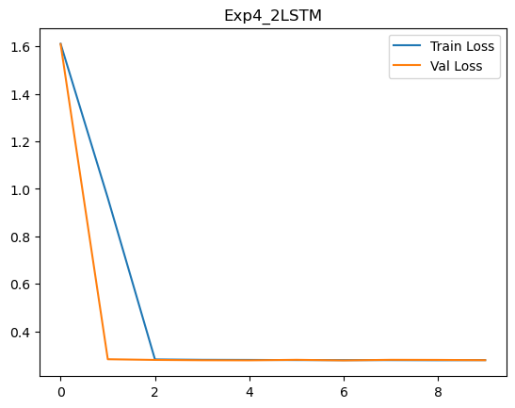
Figure 16: Loss Curve of The Two LSTM Layered Model
This figure illustrates loss curves of the two Layer LSTM model. The training process might indicate patterns of deeper learning, and loss of validation may vary under increased complexity. The figure illustrates the influence of more detailed architectures on training time and stability and convergence.
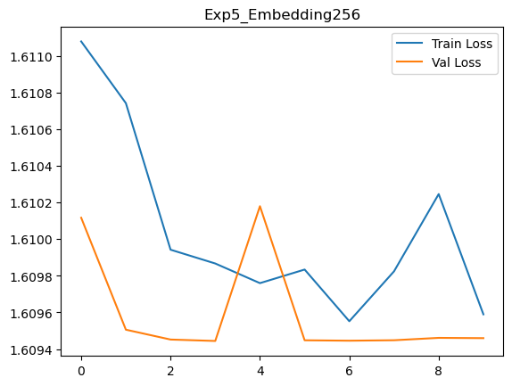
Figure 17: Loss Curve of The Model with Larger Embeddings
This figure depicts loss behavior of larger embedding dimensions. The training loss is better with richer representations, although there is mixed-valued validation performance. The illustration shows the effect of the parameter increment on the capacity to learn and the ability to generalize.
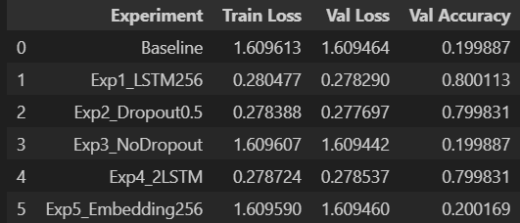
Figure 18: Comparison of Loss and Accuracies of Different Experiments
This figure compares all the experiments indicating that there are changes in validation accuracy and the loss values depending on configurations. It determines the most effective model which is measured quantitatively (Lilhore et al. 2025). The comparison assist in comparing the consequences of each adjustment and contribution towards the effectiveness of the model design selection.
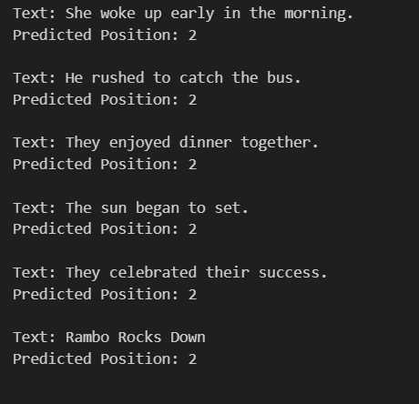
Figure 19: Predicted Position of Storytelling Texts
This figure gives the model prediction of story sequence positions. The output label is in the form of a narrative order of 1 to 5. The correct predictions are associated with the successful learning of temporal patterns (Li et al. 2025). It has inaccurate predictions refer to the inability to differentiate similar narrative stages in storytelling data.

Conclusion
The experiment shows that a multimodal CNN -LSTM model predicts the sequence of storytelling objects effectively. The model manages to generalize narrative structure in a five-classification (positions 1–5) context by jointly learning visual characteristics (images) and temporal characteristics (text). According to the experimental results, the architectural options which have proven to have a significant impact on the performance of models include LSTM units, dropout, and embedding size where balanced configurations seem to achieve the best generalization. The loss curve analysis shows that regularization is necessary towards avoiding overfitting and also preserving the performance of validation. In addition, the fusion mechanism can be used to gain a better contextual understanding than in single-modality methods. The method is computationally efficient and effective in terms of narrative reasoning, and therefore can be used in understanding stories, organizing content, and designing intelligent multimedia systems..

References
Bastian, A., Wahid, A., Hafsari, Z. and Mardiana, A., 2025. The Evolution of Image Captioning Models: Trends, Techniques, and Future Challenges. Kinetik: Game Technology, Information System, Computer Network, Computing, Electronics, and Control.
El Sakka, M., Ivanovici, M., Chaari, L. and Mothe, J., 2025. A review of CNN applications in smart agriculture using multimodal data. Sensors, 25(2), p.472.
Li, Y., Liu, Z., Li, Z., Zhang, X., Xu, Z., Chen, X., Shi, H., Jiang, S., Wang, X., Wang, J. and Huang, S., 2025. Perception, reason, think, and plan: A survey on large multimodal reasoning models. arXiv preprint arXiv:2505.04921.
Li, Z., Shang, T. and Xu, P., 2025. Multi-modal attention perception for intelligent vehicle navigation using deep reinforcement learning. IEEE Transactions on Intelligent Transportation Systems, 26(6), pp.8657-8669.
Lilhore, U.K., Simaiya, S., Singh, R.K., Baqasah, A.M., Alroobaea, R., Alsafyani, M., Alhazmi, A. and Khan, M.M., 2025. Advanced air quality prediction using multimodal data and dynamic modeling techniques. Scientific Reports, 15(1), p.27867.
Patel, S. and Surati, S., 2025. Designing Lightweight Multimodal Models for Real-Time Fake News Classification. SN Computer Science, 6(6), p.620.
Raja, R. and Vats, A., 2025, October. Multimedia-Aware Question Answering: A Review of Retrieval and Cross-Modal Reasoning Architectures. In Proceedings of the 2nd ACM Workshop in AI-powered Question & Answering Systems (pp. 28-35).
Sun, S., An, W., Tian, F., Nan, F., Liu, Q., Liu, J., Shah, N. and Chen, P., 2024. A review of multimodal explainable artificial intelligence: Past, present and future. arXiv preprint arXiv:2412.14056.
Thangavel, K., Palanisamy, N., Muthusamy, S., Mishra, O.P., Sundararajan, S.C.M., Panchal, H., Loganathan, A.K. and Ramamoorthi, P., 2023. A novel method for image captioning using multimodal feature fusion employing mask RNN and LSTM models: Kumaravel Thangavel et al. Soft Computing, 27(19), pp.14205-14218.
Vaikunta Pai, T., Manjula Mallya, M., Naik, P.V., Popescu, V., Birau, R. and Yazdi, A.K., 2025. A Novel Multimodal Deep Learning Framework for Conversational AI: Integrating Vision, Text, and Speech With Knowledge‐Augmented Attention Mechanisms. Computational Intelligence, 41(6), p.e70159.

