Emotion Detection from Text

By
Tamanna Nishat Rini (CSE100100612)
Md. Abu Naim Murad (CSE100100613)

Supervised By
Md. Raihan-ul-Masood
Assistant Professor
Department of Computer Science & Engineering

Department of Computer Science and Engineering
Northern University Bangladesh (NUB)
June, 2014

DECLARATION
We, hereby, declare that the work presented in this project is the outcome of the investigation performed by us under the supervision of Md. Raihan-ul-Masood Assistant Professor, Department of Computer Science & Engineering, Northern University Bangladesh. We also declare that no part of this project has been or is being submitted elsewhere for the award of any degree or Diploma.

Countersigned Signature
…………………….. …………………………….
(……………………..) (Tamanna Nishat Rini)
Supervisor
……………………………….
(Md. Abu Naim Murad)

Candidates

Abstract
Detecting emotion from text is a relatively new classification task and advancements in textual analysis have allowed the area of emotion detection to become a recent interest in the field of natural language processing. There is still a question on how to detect emotion from a text input. To solve this problem, this project generates an Emotion Detection Model to extract emotion from text at the sentence level. The proposed methodology does not depend on any existing affect lexicons such as WordNet Affect. Our method detects emotion from a text-input by searching direct emotional key words from that input. To make the detection more accurate, emotion-affect-bearing words and phrases were also analyzed. The experiments show that the method could generate a good result for emotion detection from text input. To detect emotion from text we have considered Ekman’s six emotions class (joy, sadness, anger, disgust, fear, surprise). Our approach showed above 77% accuracies in detecting emotion from text input.

Acknowledgements
First of all we would like to thank the Almighty ALLAH. Today we are successful in completing our work with such ease because he gave us the ability, chance and a cooperating supervisor.
We would like to take the opportunity to express our gratitude to our respectable supervisor Md. Raihan-ul-Masood, Assistant Professor, Department of Computer Science & Engineering , whose hearted and invaluable support with best concern and direction acted as necessary resource to carry out our work and hence complete our project. He not only gave us time but also gave us proper guidance and valuable advice whenever we faced difficulties.
We are also thankful to our teachers who helped us in a number of ways by providing various resources and moral supports.
We are also thankful to all of our beloved classmates during our whole university period.
Finally we are grateful to our family. They always with us in every step of life whether we succeed or failed.

Table of Contents
Chapter 1: Introduction 7
- 1.1 : Related Work 7
- 1.2 : Difficulties 8
Chapter 2: Language Processing 10
- 2.1 : Natural Language Processing (NLP) 10
  - 2.1.1 : Keyword Analysis 10
  - 2.1.2 : Parsing 11

- 2.2 : Semantic Analysis 11

- 2.3 : English Sentences (Structure & Examples) 11
  - 2.3.1 : Simple Sentence 12
  - 2.3.2 : Compound Sentence 12
  - 2.3.3 : Complex Sentence 13

- 2.4 :Subjectivity 14
Chapter 3: Emotion Estimation 16
- 3.1 : Word Processing Module 16
  - 3.1.1 : Keyword Extraction 17

- 3.2: Sentence Analysis module 18
  - 3.2.1: Detecting Emotion From Exclamatory Sentence 18
  - 3.2.2 : Detecting Emotion From Compound Sentence 19
Chapter 4: Methodologies 21
- 4.1 : Emotional Lexicon 21
- 4.2 : Emotion Labeled Datasets 22
- 4.3 : Emotion Detection Model 22
  - 4.3.1 : Extracting Emotional Keywords (KW Analysis) 22
  - 4.3.2 : Extracting Affect – word & Phrases (ABW Analysis) 23
  - 4.3.3 : Extracting Exclamatory Keywords (EXLA Analysis) 24

Chapter 5: Experiment 25
Chapter 6: Result & Discussion 27
Chapter 7: Conclusion 29
Chapter 8: Future Work 30
References 31

Chapter 1: Introduction
Emotion is one type of affect, other type of being mood, temperament and sensation. Emotions have been widely studied in psychology and in behavior sciences, as they are an important element of human nature. Nowadays they have also attracted the attention of researchers of computer science, especially in the field of human computer interactions. Advancement in textual analysis have allowed the area of emotion detection to become a recent interest in computational linguistic. Emotion detection is the newer area of textual analysis and therefore, has weaker standard methods.
Emotion can be expressed as happiness, sadness, anger, disgust, fear, surprise and so forth. While board topic of emotion has been studied in psychology for decades, very little effort has been spent on attempting to detect emotion from text. In this work, we assume that emotion reaction of an input sentence is essentially represented by its word appearance.

1.1: Related Work: The concept of affective computing in 1997 by Since Picard proposed that the role of emotion in human computer interaction. This domain attracted many researchers from computer science, biotechnology, psychology, and cognitive science and so on.
This sub-section outlines some lexical resources that researchers have compiled over the years to support affective computing and a verity of recently proposed methodologies.
- Lexical resources: One of the first such resources was a list of 1,336 adjectives manually labeled in “Predicting the semantic orientation of adjectives” in the year 1997. WordNet-Affect was introduced hierarchy of affective domain labels in “Wordnet-affect: an affective extension of wordnet” in the year 2004. The subjectivity lexicon developed by is comprised of 8,000 words. Motivated by the assumption that different senses of the same term may have different opinion-related properties developed SentiWordNet, a lexicon based on wordnet in the year 2006. An automatically generated lexicon called SentiFul database was introduced in “Sentiful Generating a reliable lexicon for sentinel analysis” in the year 2009.
- Emotion Detection Approaches: Emotion detection approaches can be broadly classified into keyword-based, linguistic rules-based and machine learning technique.
- Keyword-based Approaches using Affect Lexicon: Keyword based approaches are applied at the basic word level. Such a simple model cannot cope with cases where affect is expressed by interrelated words.
- Linguistic Rules-based Approaches: The ESNA system was developed to classify emotions in news headlines. Chaumartin manually added seed words to emotion lists and created a few rules in their system UPAR7, which identifies what is being said about the main subject and boosts its emotion rating by exploiting dependency graph.
- Machine Learning Approaches: To overcome the limitations faced by rule-based methods, researches devised some statistical machine learning technique which can be sub-divided into supervised and unsupervised techniques.
- Supervised machine learning with affect lexicons: One of the earliest supervised machine learning methods was employed by Alm, where they used a hierarchical sequential model along with SentiWordNet list for fine-grained emotion classification. Blog sentences have been classified using Support Vector Machine (SVM).
- Unsupervised machine learning with affect lexicons: An evaluation of two unsupervised techniques using WordNet-Affect exploited a vector space model and a number of dimensionality reduction methods. News headlines have been classified using simple heuristics and more refined algorithms.

1.2: Difficulties: Many current approaches to emotion detection are based on supervised learning methods, in which large set of annotated data (where text has been labeled with emotions) is needed to train the model. Although the supervised learning methods can achieve good results, the availability of large annotated data set is very low and a model trained on one domain does not translate well to another.
Some methods do not use supervised learning, but most of these methods use manually designed dictionaries of emotion keywords. A problem with such an affect lexicon-based method is that the number of emotion categories is fixed and limited in the dictionary. Another problem is that if a sentence expresses emotion using words that do not appear in the dictionary, then it would be considered to be unemotional.
There are also methods that rely on linguistic rules, but designing such rules is not a trivial task. In addition, most of the current emotion detection methods look at individual words without considering the context a word is in. However, a word can invoke different emotions in different context.

The work is organized as following:
- Chapter 2 entitled ‘Language Processing’ describes about the Natural Language Processing (NLP) and the basics of different type of English sentences.
- Chapter 3 entitled ‘Methodologies’ describes about different emotion detection’s approaches.
- Chapter 4 entitled ‘Emotion Estimation’
- Chapter 5 entitled ‘Experiment’
- Chapter 6 entitled ‘Result & Discussion’
- Chapter 7 entitled ‘Conclusion’
- Chapter 8 entitled ‘Future Plan’ describes the future plan of our project.

Chapter 2: Language Processing
2.1: Natural Language Processing: Natural language processing (NLP) is the computerized approach to analyze text that is based on both a set of theories and a set of technologies. It is concerned with the interactions between computers and human (natural) languages. NLP is presenting naturally occurring texts at one or more level of linguistic analysis for the purpose of achieving human-like language processing for a range of tasks or applications.
NLP has two major methods of analysis.
- Keyword Analysis or Pattern matching technique.
- Syntactic driven parsing technique.
2.1.1: Keyword Analysis: In keyword analysis or Pattern matching technique, the system scans the input sentences for “selective” keywords and once they are encountered, the system responds with a ‘’built-in” reply.

Start
Accept the given sentence

Scan the sentence

Identify keywords
More than one?
Present
NO YES
Prioritize them

Give a non-committal reply
Suitable reply

End

Fig: Flow chart for Keyword Analysis
2.1.2: Parsing: Parsing is the process of analyzing a sentence by taking it apart word-by-word and determining its structure from its constituent parts and sub-parts.
Parsing would seem to be a rather easy mechanical process. Given a lexicon telling the computer the Parts of Speech for a word, the computer would be able to just read through the input sentence word by word and in the end produce a structural description.
But problems arise for several reasons. First of all, a word may function as different parts of speech in different contexts. For example:
“He wanted some oil for his bicycle”
Here, the word “oil” treats as a noun, whereas
“This is an oil painting.”
Here, the word “oil” treats as an adjective. So it is not possible to know how the word “oil” is used until we read the entire sentence.
So we have to determine which Parts of Speech is relevant in the particular context at hand.
2.2: Semantic Analysis: Semantics and its understanding as a study of meaning covers most complex tasks like: finding synonyms, word sense disambiguation, constructing question-answering systems, translating from one NL to another, populating base of knowledge. Basically one needs to complete morphological and syntactical analysis before trying to solve any semantic problem.
2.3: English Sentences (structures & examples): Sentence is the basic unit of language which expressed a complete thought. The first word of a sentence is capitalized and the sentence is terminated with a period, a question mark or an exclamation point. The basic parts of a sentence are the subject, the verb and (often, not but always) the object. The subject is usually a noun-a word that names a person, place, or thing. The verb (or predicates) usually follows the subject and identifies an action or a state of being. An object receives the action and usually follows the verb. In English for instance, subjects and verbs should be closed together or otherwise it would be impossible to understand the sentences.

The three basic sentence structures are the:
- Simple Sentence
- Compound Sentence
- Complex Sentence
2.3.1: Simple Sentence: A simple sentence, also called an independent clause, contains a subject and a verb, and it expresses a complete thought. The basic syntactic orders of simple sentence are:

- Subject + Verb + Complements.
- Subject + Auxiliary Verb + Verb + Complements.
Examples:
- I am very happy.
- I have been in England before.
- I come.
- The boy cried.
- Canada is a rich country.
- The girl ran into her bedroom.
- Some students like to study in the morning.
- Murad and Mannan play football every afternoon.
- Alicia goes to the library and studies everyday.
- Riche reads newspaper.
- Joe waited for the train.
- The train was late.
- You can give me a cheque.
- The children were laughing.
- John wanted a new bicycle.
- All the girls are learning JAVA.
2.3.2: Compound Sentence: A compound sentence contains two independent clause joined by a coordinator. The coordinators are as follows: for, and, not, but, or, yet, so. (Hint: The first letter of each of the coordinators spells FANBOYS.) Except for very short sentences, coordinators are always preceded by a comma. The basic syntactic order of compound sentence is:
- Subject + Verb + Complements + conjunct. + Subject + Verb + Complements

Examples:
- You are the student whose exam was lost last year.
- She works in the city but she lives in the suburbs.
- My friend invited me to a birthday party, but I don’t want to go.
- He ran out and fell over the suitcase.
- Either the students or the teacher takes a day off every month.
- He could neither eat nor sleep.
- Do you want to stay here, or would you like to come with me?
- She has five children, so she is incredibly busy.
- Aruna ate breakfast, then she went to school.
- I tried to speak Spanish, and my friend tried to speak English.
- Alejandro played football, for Aruna went shopping.
- We stayed behind and finished the job.
- We stayed behind and finished the job, then we went home.
- Rini shouted and everybody waved.
- We looked everywhere but we couldn’t find him.
- They are coming by car so they should be here soon.
- I like chocolate ice cream but my friend likes strawberry.
- I am on a diet yet I really want a cookie.
- They wanted to go to Canada, because they wanted to see Niagara Falls.
The above sentences are compound sentences. Each sentence contains two independent clauses and they are joined by a coordinator with a comma preceding it.
2.3.3 Complex Sentence: A complex sentence is a sentence consists of one independent clause and at least one dependent clause. A complex sentence always has a subordinator such as: because, since, after, although, when, as, as if, before, after, while, when, whenever, during, as soon as, as long as, until, unless, where, wherever, etc. When a complex sentence begins with a subordinator, a comma is required at the end of the dependent clause. When the independent clause begins the sentence with subordinators in the middle, no comma is required. The basic syntactic orders of complex sentence are:
- Main clause + subordinating conjunction + adverbial clause
- Main clause + subordinating conj. + Adv. clause + subordinating conj. + Adv. Clause
- Subordinating conj. + Adv. Clause + Main Clause
- Subordinating conj. + Adv. Clause + Main Clause + Subordinating Conj. + Adv. Clause + Coordinating Conj. + Adv. Clause
Examples:
- John cannot set up his computer because the setting is complicated.
- She became the queen when her father died, because she was the eldest child.
- When he handed in his homework, he forgot to give the teacher the last page.
- The teacher returned the homework after she noticed the error.
- The students are studying because they have a test tomorrow.
- After they finished studying, Juan and Maria went to the movies.
- Juan and Maria went to the movies after the finished studying.
- Her father died when she was very young.
- She has a difficult childhood because her father died when she was very young.
- Although a few snakes are dangerous most of them are quite harmless.
- Although she has always lived in France, she speaks fluent English because her mother was American and her father was Nigerian.
- Because my coffee was too cold, I heated it in the microwave.
- Though he was very rich, he was still very unhappy.
- When the cost goes up, the customers buy less clothing.
- As she was bright and ambitious, she became manager in no time.
- Wherever you go, you can find beauty.
- After twenty years, she still had feelings for him.

2.4: Subjectivity: Emotion detection is a NLP application that benefits from being able to distinguish subjective from objective language. Subjective language is a language used to express opinions, evaluations, emotion or speculations. Objective language is unbiased and not influenced by the writer opinions. Both types of language are useful in text analysis: Subjective language is useful for automatic subjectivity analysis and Objective language is useful for information extraction.
Emotions are expressed in subjective language so it would appear that subjective analysis is the only area beneficial in emotion detection.

Basic emotion’s model | List of the basic emotions
Ekman | Anger, Disgust, Fear, Joy, Surprise, and Sadness
Izard | Anger, Contempt, Disgust, Distress, Fear, Guilt, Interest, Joy, Shame and Surprise.
Plutchik | Anger, Anticipation, Disgust, Fear, Joy, Sadness, Surprise and Trust

Table 1: Basic Set of emotions

Chapter 3: Emotion Estimation
Emotion detection is modeled as a classification problem where one or more nominal labels are assigned to a sentence from a pool of target emotion labels.
Our emotion detection framework contains two main modules:
1. Word-processing module and
2. Sentence Analysis.
The module named sentence analysis which is an easy but a lengthy process. In this module, we take 1000 sentences for testing purpose. These sentences are without emotional keywords where emotions are to be set manually.
3.1: Word-processing Module: The Word-processing part consists of tokenization, Parts-of-speech tagging, negative sentence extracting, and searching keywords from positive sentence. This enables us to extract emotion-bearing words from a given sentence.
Extract Word from the sentences
Input Paragraph
Extract Positive Sentences

Find Emotional keywords
POS tagging to the word
Classifying Target POS (Noun, Adj. Adv.)

Emotion Database

Fig 1: Block Diagram of the Word-processing module

3.1.1: Keyword Extraction: In this step we try to identify the basic emotional (happy, sad, angry, disgust, fear, surprise) key terms from the input sentences.
Noun, Adverb and Adjectives are the useful POS to find emotion from text.
In order to find them we applied POS tagger or Parts-Of-Speech tagger and extracted the key terms that we want. Parts-of-speech tagging is the process of assigning a parts-of-speech like noun, verb, adverb, preposition, adjective or other lexical class marker to each word in a sentence.
Then we need to identify the positive and negative sentences from the given paragraph. Then the next step is to search direct emotional keywords from the positive sentence. Otherwise, it will look for the synonyms of the six basic emotional words.
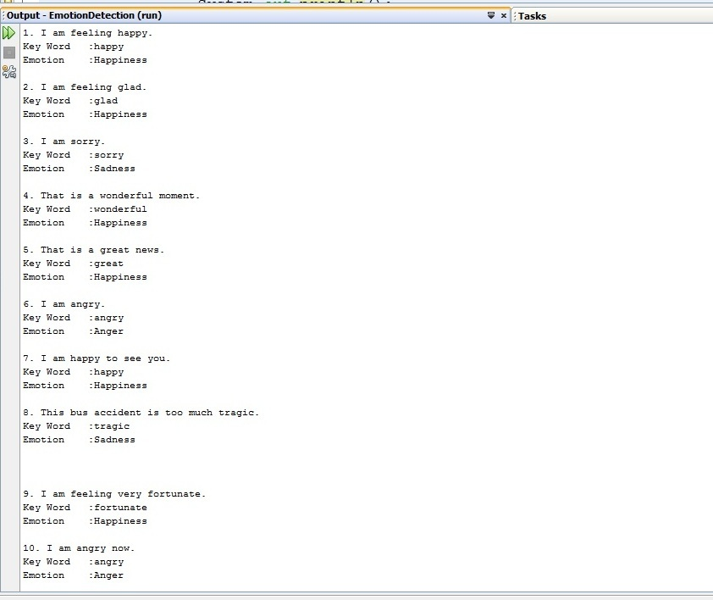
Fig 2: Sample output of keyword analysis
3.2: Sentence Analysis Module: In this sentence analysis module, our aim is to detect emotion from a sentence where there is no emotional keyword in the sentence. For this purpose, we analyze different categories of sentence.
3.2.1: Detecting emotion from exclamatory sentence: Any sentence expressing sudden emotion is called exclamatory sentence. The function of an exclamatory sentence is to show strong feelings. Exclamatory sentences are usually used to show feelings such as sadness, happiness, anger and frustration.
One of the easiest ways to convey a very strong feeling or opinion about something is to use an exclamatory word. These words are very similar to interrogative words, but instead of asking a question, they simply state an idea or opinion.
Exclamatory words that can stand alone as a sentence while expressing emotions or reactions are called interjections. Interjections don’t require a subject or verb to express a thought. They can be inserted in a sentence by using commas.
For example:
- Wow, that was a thrilling ride!
- Brilliant, you solved the puzzle!
- Awesome, you got the job!
- Ouch, that really hurts!
- I don’t know what you feel but, sheesh, I think the food was too expensive!
- Hurray, we won the game.
- Damn, the car won't work!
- Aww, it hit him right in the nuts!
- Bah, I never liked him anyways.
- Boo, get off the stage!
- Oh! What a fool he is!
- Ah! All the questions are easy.
- Bravo! Well done.
- Ahh, that feels wonderful.
- Alas! I'm lost in the wilderness.
- Alas! I am undone.

To detect emotional sense from a sentence we make a database that contains a lot of exclamatory words (alas, oh, oops etc.). If the sentence contains any of the exclamatory word, it will give the desired emotion based on that exclamatory word.

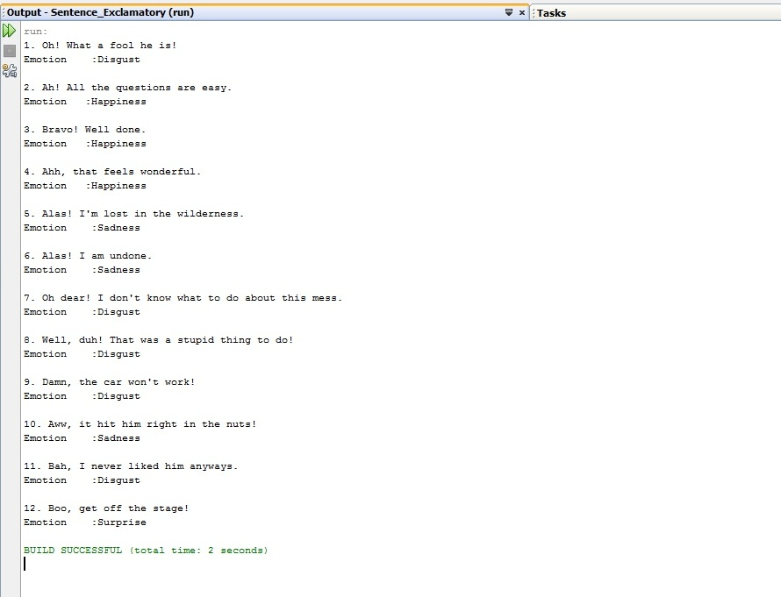 Fig 3: Sample sentences with corresponding emotion.

3.2.2: Detecting emotion from compound sentences: A compound sentence consists of two or more simple sentences joined by a comma followed by a coordinating conjunction (and, or, but, for, nor, yet, so). To detect emotion from compound sentence we have to consider the condition of the tense.
Tense is a category that locates a situation in time, indicating when the situation takes place. Tenses are especially important because they tell us not only about the aspect of the verb.

There are basically three types of English tenses:
- Present Tense
- Past Tense
- Future Tense
Present tense is used to express actions that occur in the present. Past tense is a verb tense expressing activity, action state or being in the past. Futurity in English is expressed either by using words that imply future action or by employing an auxiliary construction combined with the main verb which represents the true action of the sentence. The most common auxiliary verbs are used to express futurity are “will”, “can”, “should”, “may”, “ must” , and “shall’.

Here, we only consider the present and past tenses to detect the emotion from compound sentence.

If there is an emotional keyword found in a clause of a compound sentence, at first we will try to identify the situation of tense of that clause. If the clause’s tense is present tense, we will take the emotion from that clause. If the sentence is negative sentence and the negation word is present just before the keyword, the emotion will be neutral.

Chapter 4: Methodologies
Emotion detection methodologies use the concepts and algorithm that are created for subjectivity and sentiment analysis. There are so many emotion detection approaches that are being explored, but there are no fore-running methods.
4.1: Emotional Lexicon: The first step in detecting emotion from text is discovering keywords or phrases that associate with emotions. A list of emotions and words that express each emotion is called emotional lexicon. In general, these lists start with identifying seed words, or words that highly associate with one emotion, and expand by using synonyms.
Often different emotions are expressed through different words. For example, delightful and yummy indicates the emotion of joy, gloomy and cry indicates the emotion of sadness etc. Words may evoke different emotions in different contexts, and emotion evoked by a phrase or a sentence is not simply the sum of emotions conveyed by the words in it. The emotion lexicon will be useful for evaluating automatic methods that identify the emotion evoked by a word.
The WordNet Affect Lexicon is a manually created collection of words. The creation process involved annotating a few seed words with Ekman’s six basic emotions then expanding the basic collection by marking the WordNet synonyms of the each word with the same emotion. The full list reached a few hundred of words.
The General Inquirer is an emotional lexicon that classifies words into a lager number of categories. The collection contains 11,788 emotion labeled words and 182 word tags, which include positive and negative semantic and affect categories like pleasure, arousal, feeling and pain that have not been analyzed yet.
Even though a growing emotion lexicon would be beneficial in detecting emotion, an annotated collection of words and phrases would only increase detection accuracy to a certain extent. Emotional lexicons by themselves are not successful in classifying sections of text to their appropriate emotion. In fact, most of the time emotion is not expressed through the emotion-labeled words.
4.2: Emotion Labeled Datasets: Emotion labeled datasets are blocks of text that have been annotated with emotion tags. Manually annotating datasets of text is expensive and time consuming. However, because comparing results to annotated texts is the most stabilized method of checking the accuracy of an algorithm, annotated datasets have been established and consistently used throughout emotion detection studies.
One of the most common dataset, used in many emotion detection studies, is SemEval-2007-Task, an effective text that consists of newspaper headlines. The annotations are labeled with Ekman’s six basic emotions along with a neutral category. Additionally, this dataset allowed one sentence to be tagged with multiple emotions. The dataset is composed of 1,250 annotated headlines that is split between a developmental set of 250 headlines and a test set of 1000 news headlines.
Another annotated dataset is the International Survey on Emotion Detection Antecedents and Reactions (ISEAR). The ISEAR is the compilation of 7,666 sentences provided by 1,096 culturally divergent participant who were questioned about experiences and reactions that are related to the emotions of anger, joy, sadness, fear, disgust and guilt.
Even though there are annotated datasets out there to test algorithms on, the necessity of an annotated dataset decreases the text used in emotion detection fields, especially for machine learning algorithms that require a large annotated datasets for training.
4.3. Our emotion detection model: Our emotion detection model includes two main modules: Word-processing and Sentence Analysis. This emotion detection model helps us to extract six basic emotional keywords and their synonyms, relevant emotion-bearing words and syntactic relations among them.
4.3.1. Extracting emotional keywords (KW Analysis): In this step the input sentence is tokenized into single words. These words are tagged with a POS tagger. The tagger learns a sentence structure for a language as a set of transition rules. These rules are then applied to the words to label each word as a noun, adjective, verb etc. Once they are labeled they are checked for emotional keywords. We have created SIX_EMOTIONS database for this checking purpose which contains 210 emotional keywords. Once an emotional keyword is found from comparison, then that emotional key word is assigned to an emotional result.
Emotion Class | Related keywords
Joy | Happiness, happy, joyous, blissful, great, good, glad etc.
Anger | Wild, furious, bad, livid, hot, stormy, sore, angry etc.
Sadness | Sad, sorry, tragic, depressed, unhappy, pensive, pitiful etc.
Disgust | Disturbed, annoying, suck, repel, offended, disgust etc.
Fear | Panic, fear, worship, terror, horror, alarm, fright etc.
Surprise | Surprise, break, seek, amazement, wonder, astonished, popeyed etc.

Table 2: Some examples from the SIX_EMOTIONS dataset

4.3.2. Extracting affect-word & phrases (ABW Analysis): The second step of our emotion detection model is to extract the content-word and phrases. Sometimes words in a sentence affect more than a single keyword. Consider a sentence, “The players of Bangladesh Cricket Team were greeted with joyless cheer”. Our lexical resource SIX_EMOTIONS lists the word ‘cheer’ under the emotion category “happiness”. However in this sentence, emotional keyword ‘cheer’ is highly influenced by the word ‘joyless’, which make the emotional state of this sentence completely different. To solve this problem we make an emotion labeled dataset named SENTENCE_DB with 151 sentences for testing purpose. In this dataset, an input sentence is tagged with an emotion manually. The input sentence is tokenized into 2-words, 3-words, 4-words and 5-words phrases. Then these phrases or affect bearing word are compared with the phrases of the emotion labeled dataset. Once an emotional phrase is found in the dataset then that sentence is assigned to a corresponding emotional result.
Emotional Class | Related Sentences
Joy | We won the game.
Anger | You didn’t have the permission to stay out this late.
Sadness | I am lost in the wilderness.
Disgust | We were stuck in traffic jam for almost three hours.
Fear | My mother is scared stiff of heights.
Surprise | The minister’s resignations came as a bolt from the blue.

Table 3: Some examples from the Sentence_DB dataset
4.3.3: Extracting exclamatory keywords (EXLA Analysis): To detect emotion from exclamatory sentences, our emotion detection model aims to find out exclamatory keywords. This method is almost as similar as “extracting keywords” method but the POS tagging feature is absent in this method. First of this step, the input sentence is tokenized into single words. Then each word is compared with the elements of another emotion labeled dataset named Excla_DB. Once a matched is detected between an input word and an element of the dataset, then that entire sentence is tagged with an emotional reply by the method itself.

Emotion Class | Related exclamatory keywords
Joy | Yahoo, yay, yaay, hurrah, etc.
Anger | Grrr, grr.
Sadness | Oww, alas, aw, ouch, etc.
Disgust | Do’h, ewww, piff, yuck, oh, uff, etc.
Fear | Aah, yikes
Surprise | Boo, wow, ooh-la-la, oops, whoa etc.

Table 4: Some examples from the Excla_DB dataset

Chapter 5: Experiment
To test the emotion detection result, we make some experiments. There are almost 154 sentences in our emotional dataset with 500 words. All of the sentences were labeled with different emotion state manually. Following table shows the tagged result.
Emotion | Joy | Sadness | Anger | Disgust | Fear | Surprise
Number | 31 | 34 | 28 | 25 | 17 | 11

Table 5: The number of manually emotion labeled sentences
To get more accurate emotion estimation, we need to consider that, how the content words behave in the sentence. The first comparing is conducted between an input sentence and the emotional state description column of our emotional datasets. The testing result is shown in the following figure:
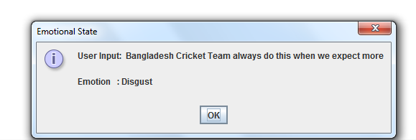
Fig 4: Sample input data with corresponding emotion state

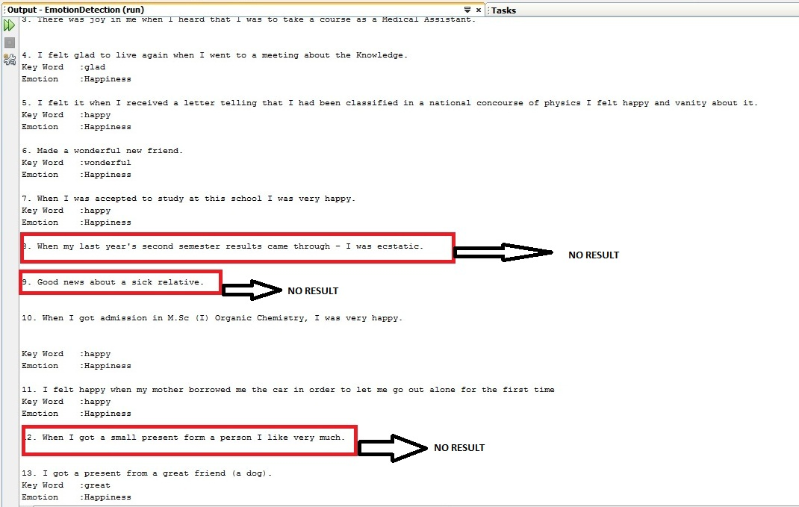

Figure 6: Sample output for our experiments
The above figure shows that, for some sentences our emotion detection model doesn’t produce any result. This is because of the absence of a particular keyword in our dataset. This is one of the drawbacks of our system.

Chapter 6: Result & Discussion
The testing phase of our emotion detection model is done by taking some sample sentences from the ISEAR dataset. The testing results are shown in the figure 5:
In this figure the blue line denotes the total number of input data, the red line denotes the total number of correct sentence which was detected by the methods and the green line denotes the success rate of our three methods.

Figure 5: Emotion Detection Graph

In most emotion detection approaches, the results are presented with the common measures of precision, recall and f-score. In our experiments, we use only precision to present the results. Here precision is the number of correctly detected sentence retrieved by the methods divided by all the input sentences retrieved by the methods.

The overall results of our methods are shown in the Table 2:
Methods | Number of sentence | Precision
KW Analysis | 100 | 0.7623
EXLA Analysis | 100 | 0.9523
ABW Analysis | 100 | 0.6333

Table 6: Result for the three methods using precision.
In our emotion detection model, when there are two direct emotional keywords a present then the KW Analysis method is failed to detect the correct emotion. This problem is also happened in case of EXLA Analysis and ABW Analysis too. This is probably due to the inability to develop adequate models for less represented emotions because of scarcity of data. Nonetheless our emotion detection model’s performance is 78% average for precision of the emotional class. The success rate of our emotion detection methods are shown in the following figure:

Fig 6: Success Rate of the emotion detection methods.

Chapter 7: Conclusion
In our project, we propose three emotion detection methods to extract emotion from text input. Both the keywords and Affect Bearing Word (ABW) are the main topic of our project to detect emotion from text. Experiments proved that human emotion was deeply depended on the content word of the sentence. As we know, it is still difficult to do the semantic parsing with machine learning method. Nevertheless, some part of the semantic information and emotional keywords such as exclamatory keywords & direct emotional keywords have been work out in the system. The result shows that we have got relatively good results for emotion detection from text input.

Chapter 8: Future Work
The future of emotion detection is promising. Although not enough time has spent to have established standards in this field, the algorithms are continuing to increase in accuracy. In future we will try to increase the resources of our affect lexicon and emotional dataset to increase the performance of our methods as well as to increase the accuracy of the entire system.
There are many advantages in being able to identify emotion from text input. To being able to build such kind of applications, the ability to detect emotion from text can enhance the human-computer interaction. If the computer can tell a person’s mood or emotional state, it would be able to switch to an accommodating form of interaction.

References
[1] Kaitlyn Mulcrone. Detecting Emotion in Text.
[2] J. Wiebe, T. Wilson, R. Bruce, M. Bell and M. Martin. Learning subjective language. Comput. Linguistic, 30(3): 277-308, Sept. 2004
[3] Jianhua Tao. Context Based Emotion Detection from Text Input.
[4] A. Balahur, J.M. Hermida, and A. Montoyo. Detecting implicit expressions of sentiment in text based on commonsense knowledge. In Proceedings of the 2nd Workshop on Computational Approaches to Subjectivity and Sentiment Analysis, WASSA ’11, pages 53-60, Stroudsburg, PA, USA, 2011. Association for Computational Linguistics.
[5] F. Keshtkar and D. Inkpen. A corpus-based method for extracting paraphrases of emotion terms. In Proceedings of the NAACL HLT 2010 Workshop on Computational Approaches to Analysis and Generations of Emotion in Text, CAAGET ’10, pages 34-44, Stroudsburg, PA, USA, 2010. Association for Computational Linguistics.
[6] S.M. Kim, A. Valitutti, and R.A. Calvo. Evaluation of unsupervised emotion models to textual affect recognition. In Proceedings of the NAACL HLT 2010 Workshop on Computational Approaches to Analysis and Generations of Emotion in Text, CAAGET ’10, pages 62-70, Stroudsburg, PA, USA, 2010. Association for Computational Linguistics.
[7] S. Mohammad. From once upon a time to happily ever after: tracking emotions in novels and fairy tales. In Proceedings of the 5th ACL-HLT Workshop on Language Technology for Cultural Heritage, Social Sciences and Humanities, LaTeCH ’11, pages 105-114, Stroudsburg, PA, USA, 2011. Association for Computational Linguistics.
[8] S. Mohammad and P.D. Turney. Emotions evoked by common words and phrases: using mechanical turk to create an emotion lexicon. In Proceedings of the NAACL HLT 2010 Workshop on Computational Approaches to Analysis and Generations of Emotion in Text, CAAGET ’10, pages 26-34, Stroudsburg, PA, USA, 2010. Association for Computational Linguistics.
[9] J.Wiebe and E. Riloff. Finding mutual benefit between subjectivity analysis and information extraction. Affective Computing, IEEE Transactions on, 2(4): 175-191, oct-dec. 2011.
[10] Carlo Strapparava and Rada Mihalcea. Learning to Identify Emotion in Text.
[11] Ameeta Agarwal and Aijun An. Unsupervised Emotion Detection from Text using Semantic and Syntactic Relations.

