- Uses a local and global variable to prove that fork creates a copy of the parent process and child has its own copy of variables to work on.
- Uses fork() API to create a child process
- make a child process zombie and try to make parent of zombie process as init.

Answer 1 :
#include <stdio.h>
#include <unistd.h>

int A=0;
int B=0;
int main()
{
int pid;

pid = fork();
printf("Program 1: Getting parent and child process\n");
if (pid == 0)
{

printf("child pid = %d and parent pid = %d A is %d B is %d \n",getpid(), getppid(),A,B);
}

else
{
A++;
printf("parent pid = %d child pid = %d A is %d\n",getppid(),
getpid(),A);
sleep(10);
}

return 0;
}
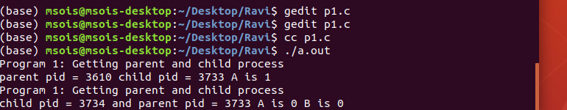

answer 2 :
#include<stdio.h>
#include<unistd.h>
int main(int argc,char *argv[])
{
char *name=argv[0];
int child_pid=fork();
if(child_pid==0)
{
printf("child of %s is %d \n",name,getpid());
return 0;
}
else
{
printf("my child is %d\n",child_pid);
system("ps");
return 0;
}
}

output :
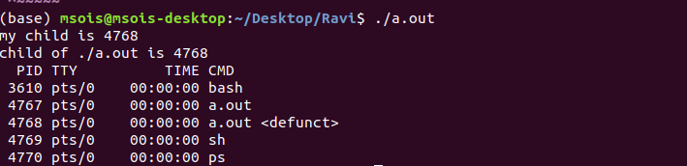

answer 3:

#include<stdio.h>
#include<unistd.h>
int main(void)
{
pid_t pid;
int status;

if ((pid = fork()) < 0)
perror("fork error");
else if (pid == 0){ /* child process*/
exit(0);
}
printf("child process ID: %d\n", pid);
sleep(10);

return 0;
}

