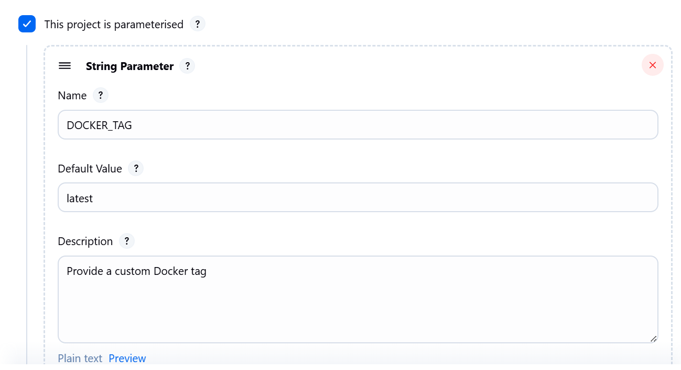

pipeline {

agent any

stages {

stage('Build Docker Image') {

steps {

script {

// If no custom tag is provided, it will default to 'latest'

def tag = params.DOCKER_TAG

echo "Building Docker image with tag: ${tag}"

// Build the Docker image with the provided tag

sh "echo myimage:${tag} ."

}

}

}

stage('Deploy') {

steps {

echo 'Deploying Docker image...'

}

}

}

post {

always {

echo 'Pipeline execution complete.'

}

}

}

Using Jenkins in built variables

pipeline {

agent any

parameters {

string(name: 'DOCKER_TAG', defaultValue: '', description: 'Enter a custom Docker tag')

}

stages {

stage('Build Docker Image') {

steps {

script {

def tag = params.DOCKER_TAG ?: "latest-${BUILD_NUMBER}"

echo "Building Docker image with tag: ${tag}"

sh "echo myimage:${tag} ."

}

}

}

stage('Deploy') {

steps {

echo 'Deploying Docker image...'

}

}

}

post {

always {

echo 'Pipeline execution complete.'

}

}

}

==========================================================