Maven : Maven is a build tool used for java projects

What does it require ---it requires jdk to be installed of specific version suitable to the project

How can we find different jdks in ubuntu

Apt search jdk---will show different jdk versions available in the market

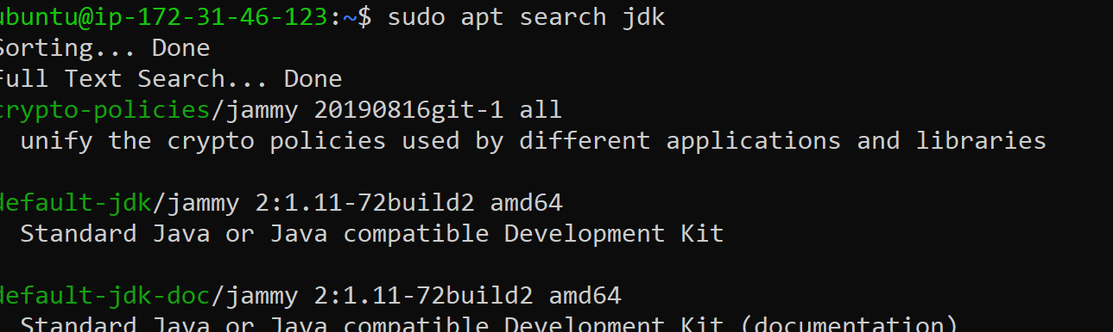

Installation of Maven

1. apt update -y
2. Ubuntu will default have the git installed check for git -version

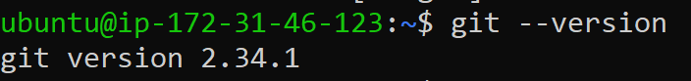

As we clone a repository from git hub we need to install git

1. jdk----java development kit

Maven relies on the JDK for the essential tools and libraries required to compile, test, and execute Java code. The specific version of the JDK you use can impact the language features available, runtime behavior, and compatibility with dependencies and plugins.

It had javac compiler

JRE--jva run time engine---which has all the libraries in it



After downloading we can check java --version

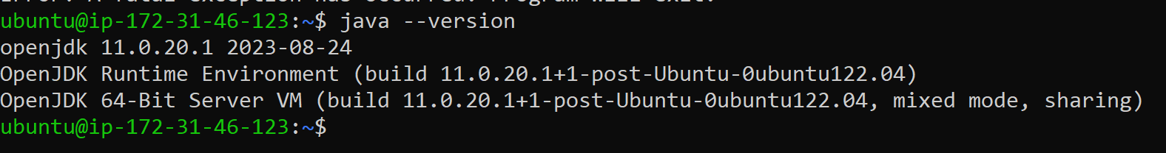

Installing Maven



How to check maven is installed or not

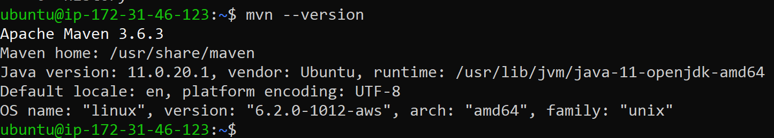

Even though if you don’t install java maven will install java as a dependency

Above version is 3.6.3

What if we want to download a specific version--like 3.9

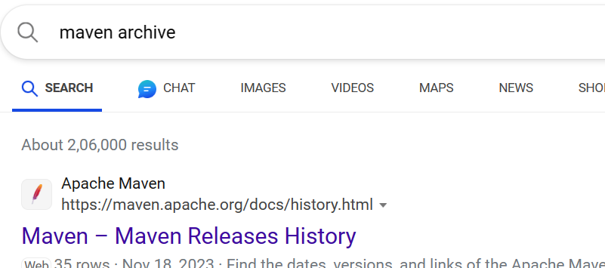

We have to download tar file using wget command

[Maven – Download Apache Maven](https://maven.apache.org/download.cgi)

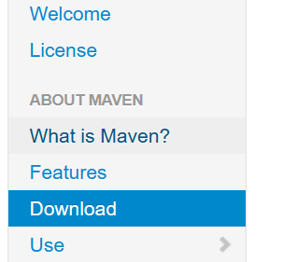

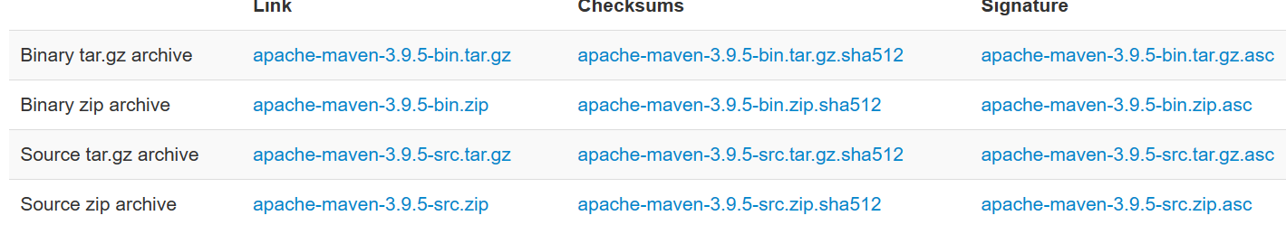

Copy the tar.gz or any link

Use wget command

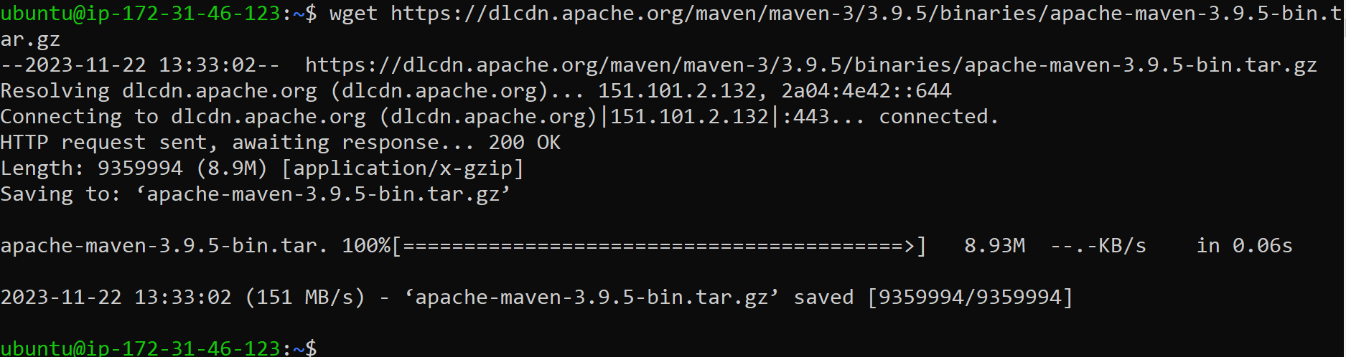

I am downloading version 3.9.5 here

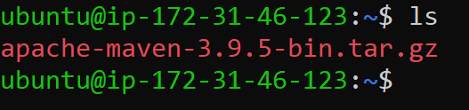

Extracting the tar file



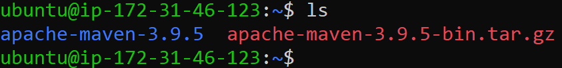

You can remove tar.gz using rm-rf

How can check mvn is present or not---got to below location I.e bin

You should be able to see mvn in bin

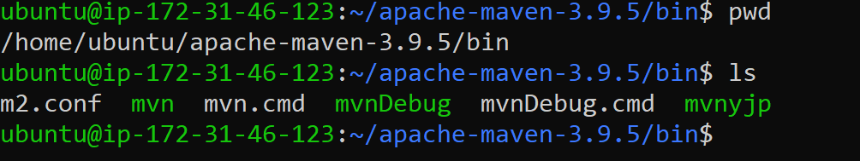

But we have to move this to opt



We can check version using /opt/apache-mavem-3.9.5/bin/mvn --version

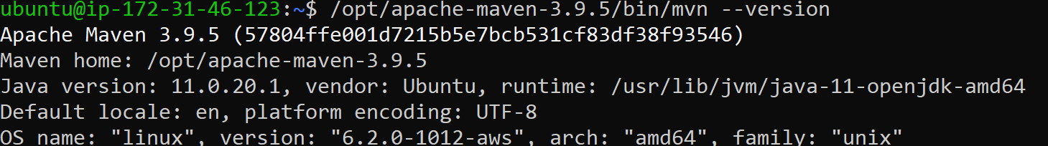

Practicing commands

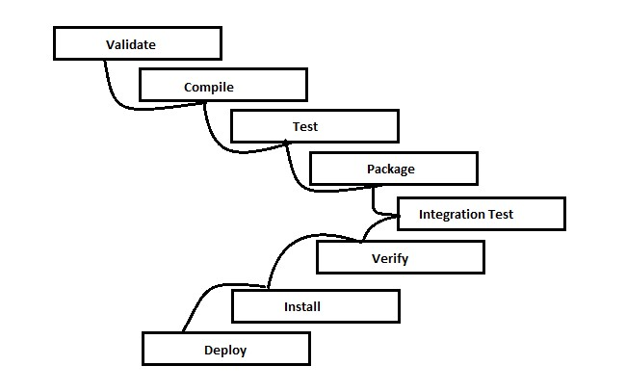

If you run compile it will do validate first

If you run test directly it runs validate first and compiles next

If you run package it ill run validate compile test

Same for the remaining

If you runmvninstall directly

It wil run validate compile test package integration test verify and then runs install

Mvn clean--it deletes target folder if it is present

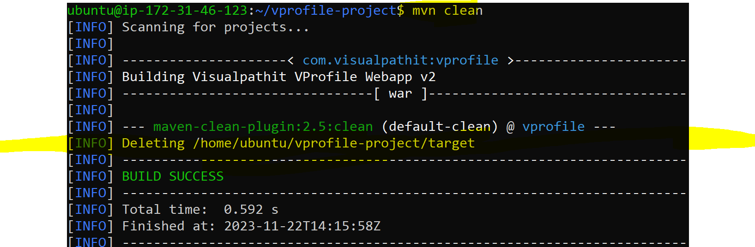

Git clone clone the repository

Copy the https link of repository

Fork vprofile project

https://github.com/prudhvisurya996/vprofile-project.git

Make sure you are in the folder where you have pom.xml file

As Maven reads pom.xml file

Project Object Model

If the user is ubuntu dependies are stored in /home/ubuntu/.m2/repository/*

If the user is jenkins dependies are stored in /home/jenkins/.m2/repository/*

Same for all the users

If we remove the dependies rm -rf /home/ubuntu/.m2/repository/*

And when we run mvn clean install

Clean will delete previous builds and install will check the dependies in the above folder again installs it if the dependies are deleted

Mvn clean will remove the target folder

Mvn validate will validate the structure of the java code

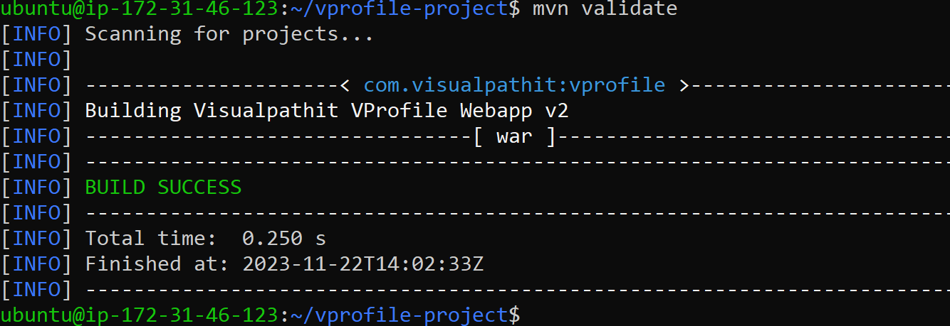

Mvn compile compiles the code using javac compiler whichconverts java code to machine code

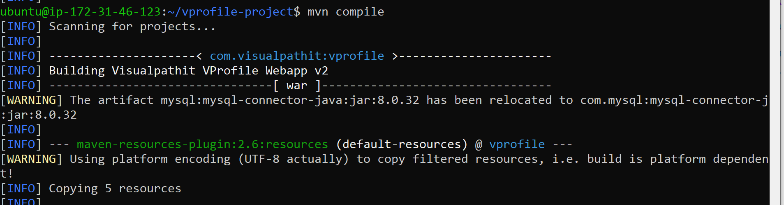

Mvn test ;test the compiled source code using a suitable unit testing framework these tests doenot require the code to be packaged or deployed

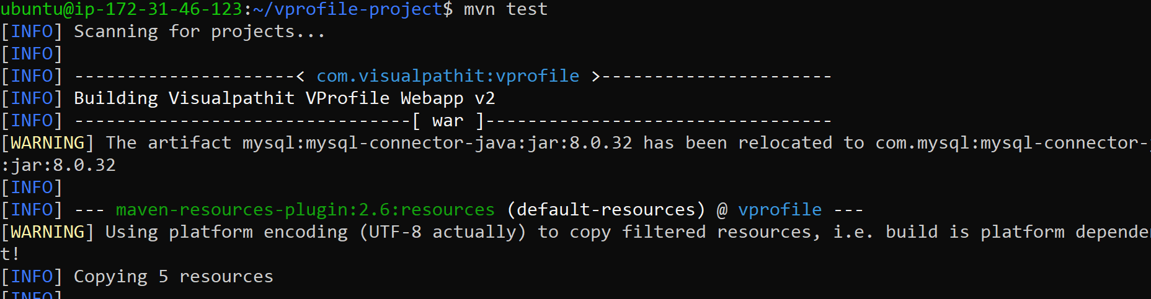

Mvn package packages it into distributble format .JAR .WAR or .EAR



Vprofile-v2.war

Here vprofile is the artifactid name and v2 is version and .war is the package name mentioned is the pom.xml file







Format os **artifactid-version.packaging**

Mvn verify : will run any checks on results of integration tests to ensure quality criteria is met

Mvn install install the package and pom.xml file in local repository so that it can be used in other projects

**/home/ubuntu/vprofile-project/target/vprofile-v2.war ---github repo**

**/home/ubuntu/.m2/repository/com/visuapathit/vprofilr/v2/vprofile-v2.war---local repo**

If you remove the local repo and run mvn install it will again install the package into local repo

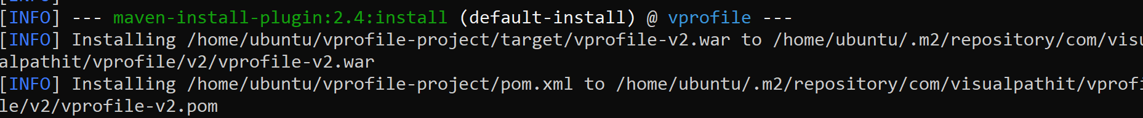

Mvn deploy; done in the build environment copies the final package to the remote repository

For sharing with other developers and projects

Suppose you make changes in pom.xml file then the changes are impacted in the ouptut

Here I am chaning v2 version to v3

Artifact id from vprofile to surya

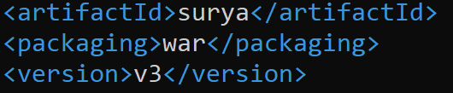

After running mvn clean install

You can see following results



Vprrofilr changed to surya

V2 changed to v3

This is how we change in pom.xml file in real time

What does pom.xml file consists of

Pom.xml is created by developer not by the devops engineer