Creating a Virtual Machine using Azure Portal,Azure CLI, Azure PowerShell

**Contents**

1. Introduction 3
2. Documentation 4
   1. Microsoft Documentation 4
3. Creating Virtual Machine on Azure Portal 5
   1. Connect to your Virtual Machine 18
4. Create Virtual Machine using Azure CLI 21
   1. Pre-requisite 21
   2. Create Virtual Machine 21
   3. Connect to virtual machine 26
5. Create VM using Azure PowerShell CoRE 30
   1. Pre-requisites 30
   2. Create Windows VM 30
6. HOW TO REMOVE RESERVE IP OPTION 36
7. Summary 42

# INTRODUCTION

Azure Virtual Machines (VM) is one of several types of on-demand, scalable computing resources that Azure offers. Typically, you choose a VM when you need more control over the computing environment than the other choices offer. This article gives you information about what you should consider before you create a VM, how you create it, and how you manage it.

An Azure VM gives you the flexibility of virtualization without having to buy and maintain the physical hardware that runs it. However, you still need to maintain the VM by performing tasks, such as configuring, patching, and installing the software that runs on it.

Azure virtual machines can be used in various ways. Some examples are:

* + **Development and test** – Azure VMs offer a quick and easy way to create a computer with specific configurations required to code and test an application.
  + **Applications in the cloud** – Because demand for your application can fluctuate, it might make economic sense to run it on a VM in Azure. You pay for extra VMs when you need them and shut them down when you don’t.
  + **Extended datacenter** – Virtual machines in an Azure virtual network can easily be connected to your organization’s network.

The number of VMs that your application uses can scale up and out to whatever is required to meet your needs.

## In this Activity Guide we cover Step-by-Step of:

* How to create a Virtual Machine on Azure Portal and to connect it.
* How to create a Virtual Machine using Azure CLI and to connect it.
* How to create a Virtual Machine using Azure PowerShell and to connect it.
* How to Remove RESERVE IP Option

# DOCUMENTATION

# Microsoft Documentation

* + 1. Create a Virtual Machine using Azure Portal: [https://docs.microsoft.com/en-us/azure/virtual-](https://docs.microsoft.com/en-us/azure/virtual-machines/windows/quick-create-portal) [machines/windows/quick-create-portal](https://docs.microsoft.com/en-us/azure/virtual-machines/windows/quick-create-portal)
    2. Azure CLI: <https://docs.microsoft.com/en-us/cli/azure/?view=azure-cli-latest>

# CREATING VIRTUAL MACHINE ON AZURE PORTAL

1. In the [Azure portal](https://portal.azure.com/), search for Virtual Machine and select **Virtual Machine**.(Please make sure you have a subscription before doing all this. If you created a free account for the first time, you’ll already have a FREE TRIAL subscription for 1 month).

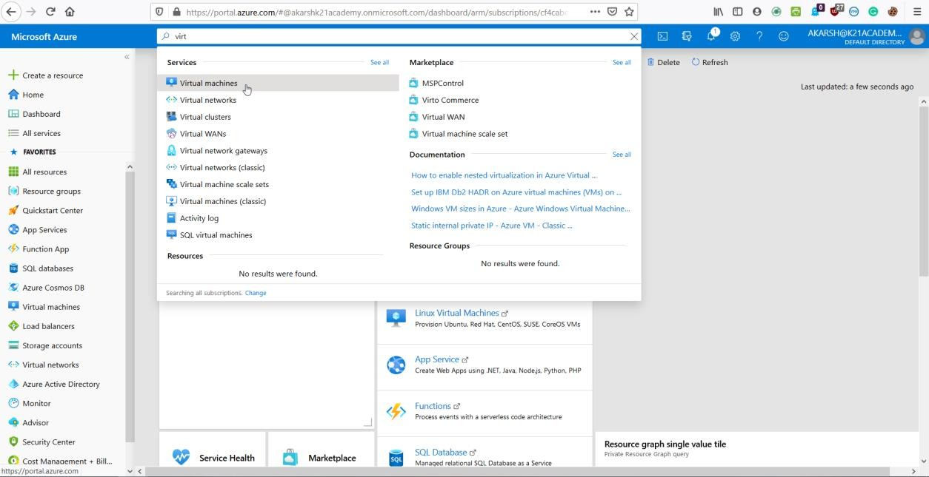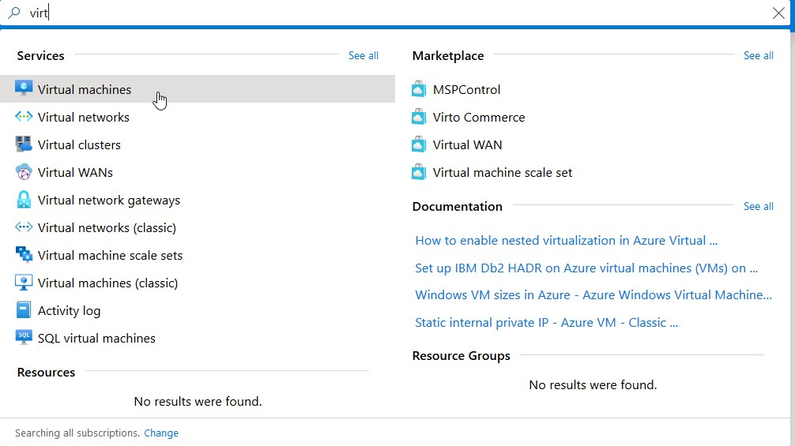

1. Select **Add.**

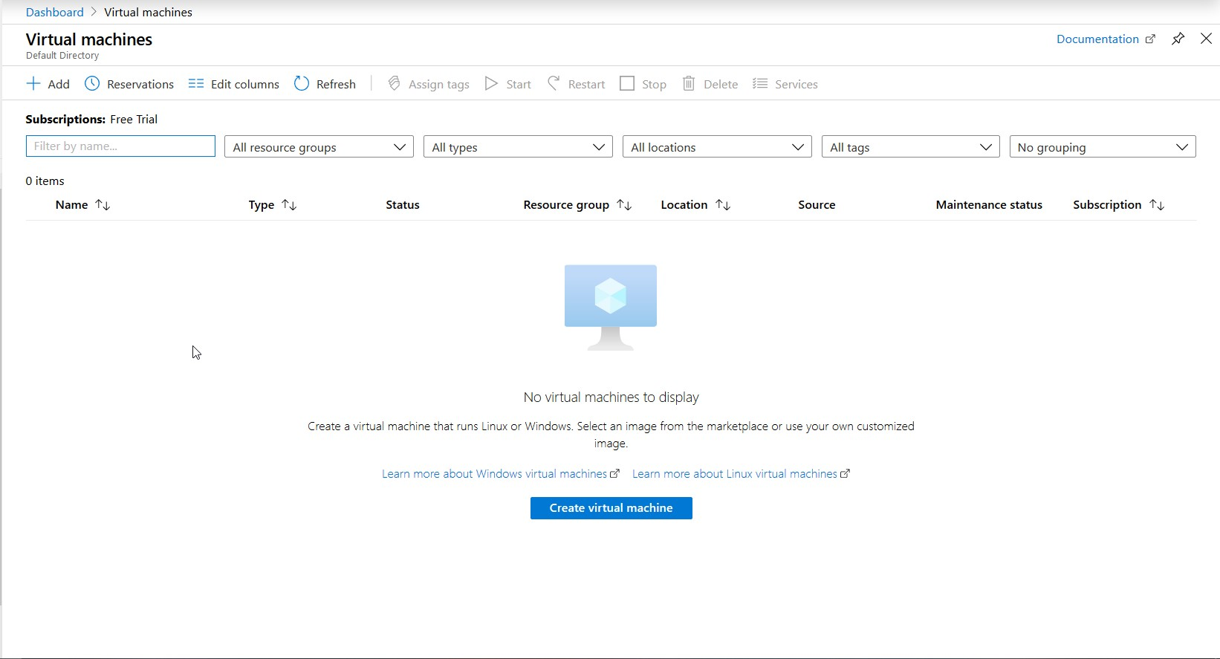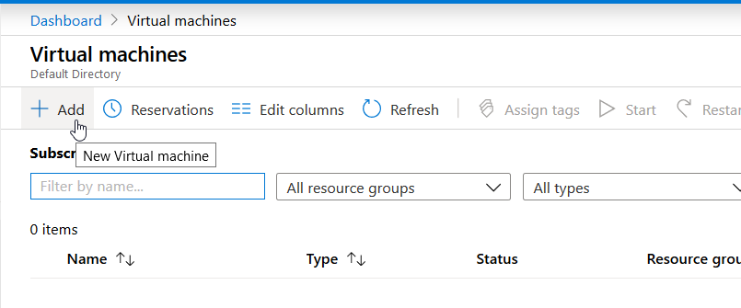

1. Enter the following values:
   * **Subscription**: Select your Azure subscription.
   * **Resource group**: Enter a new resource group name.
   * **Virtual Machine name**: It should be a **unique** name throughtout the Azure network.
   * **Region**: Select an Azure location, such as **Western India, Central US etc**.

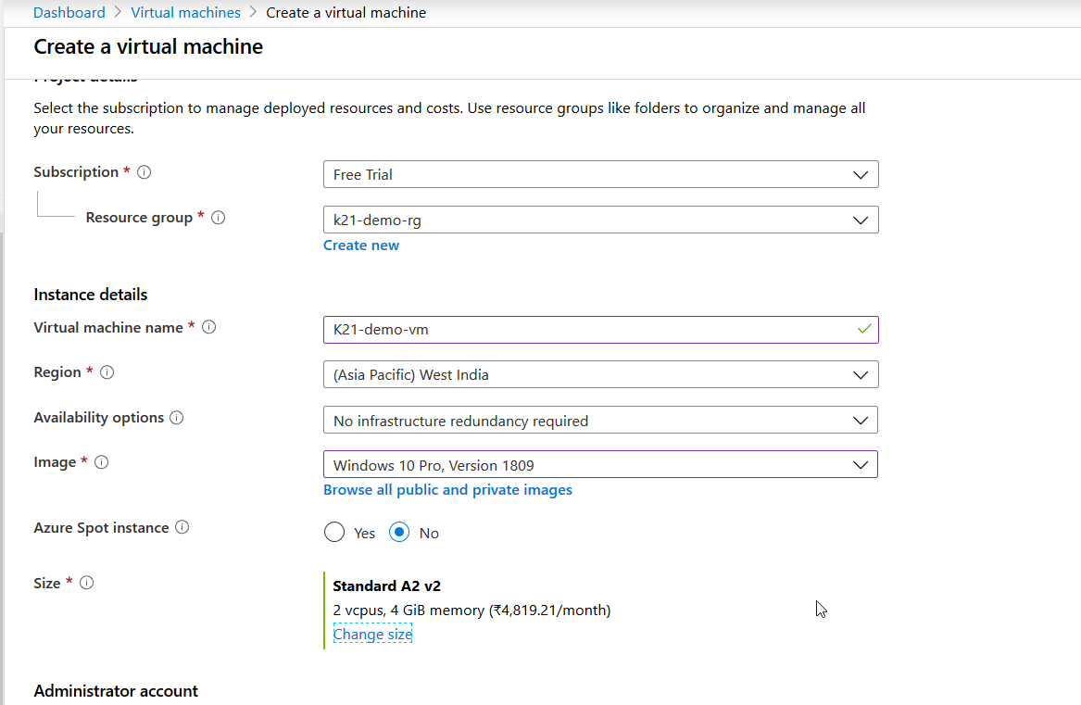

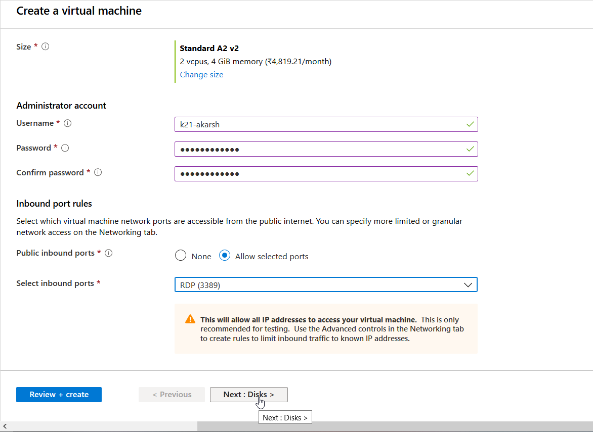

1. Select the type of disk you want to use. Click Next.

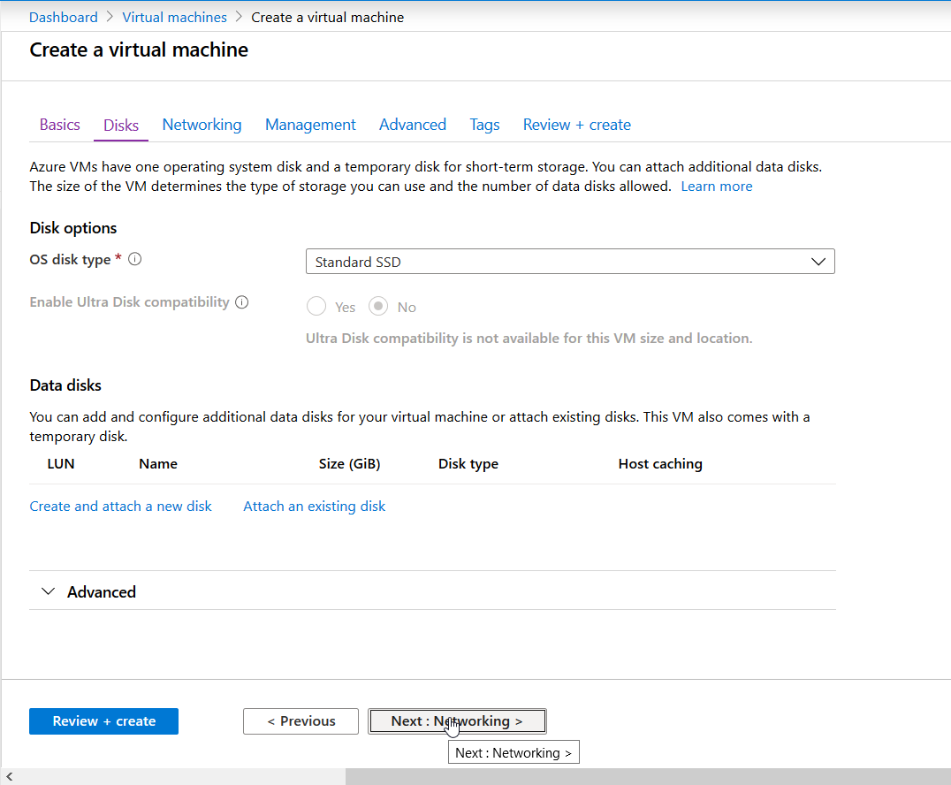

1. Now if you don’t see your already created Virtual Network then you must be deploying your virtual machine in a different region than that of the Virtual Network.

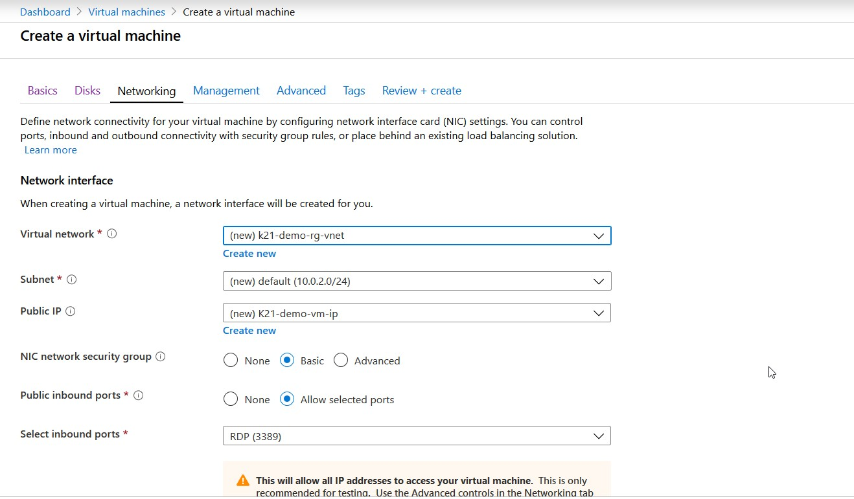

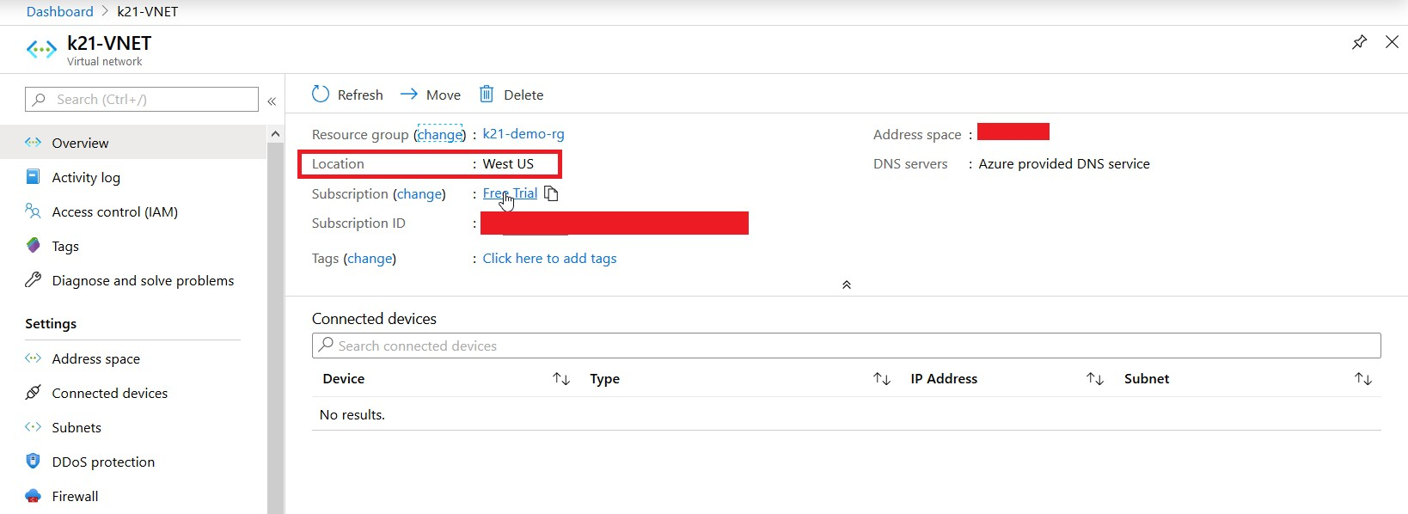

Here my VNet is in West US but I was trying to deploy my VM in West India. So, lets change the region of my VM so I can select my already created VNET.

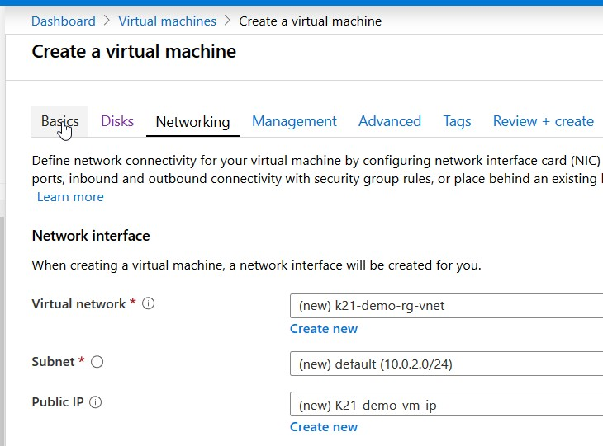

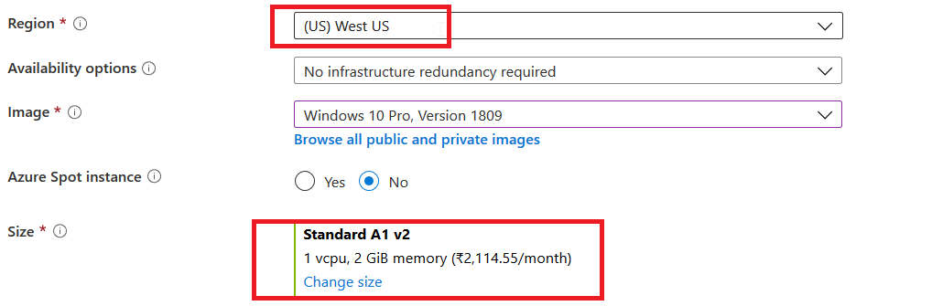

Make sure you change the Size of VM again after configuring the region.

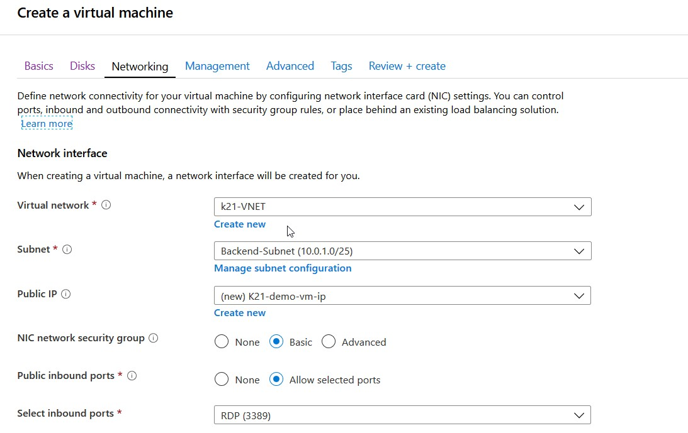

Now as you can see I can select my already created VNET.

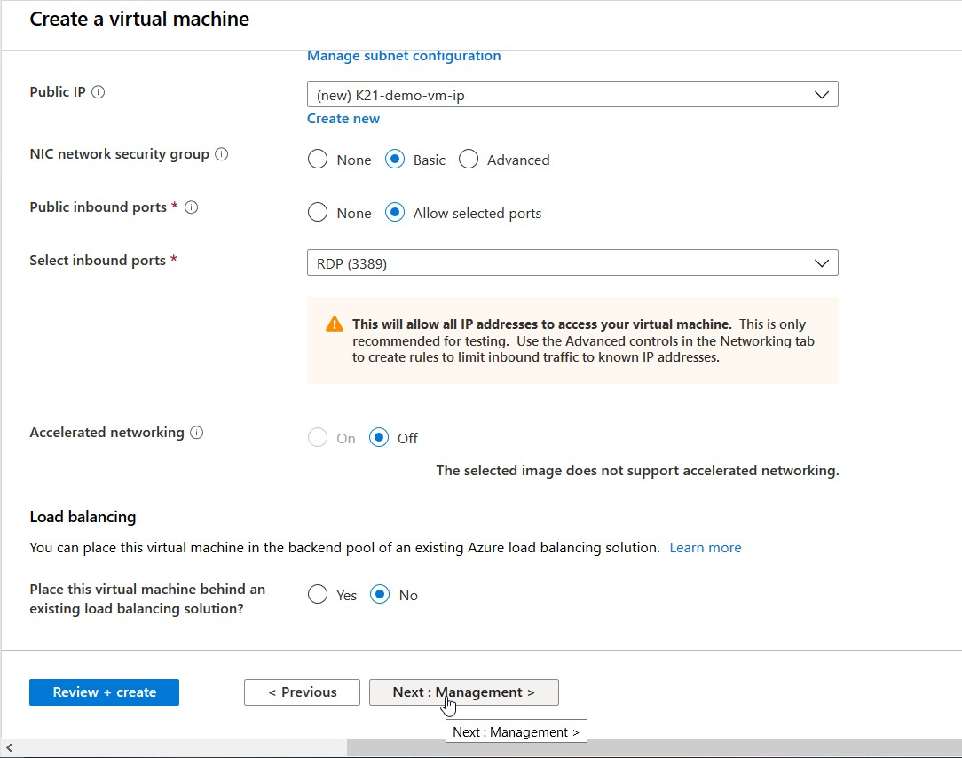

1. Click on Next option. **(Management)**

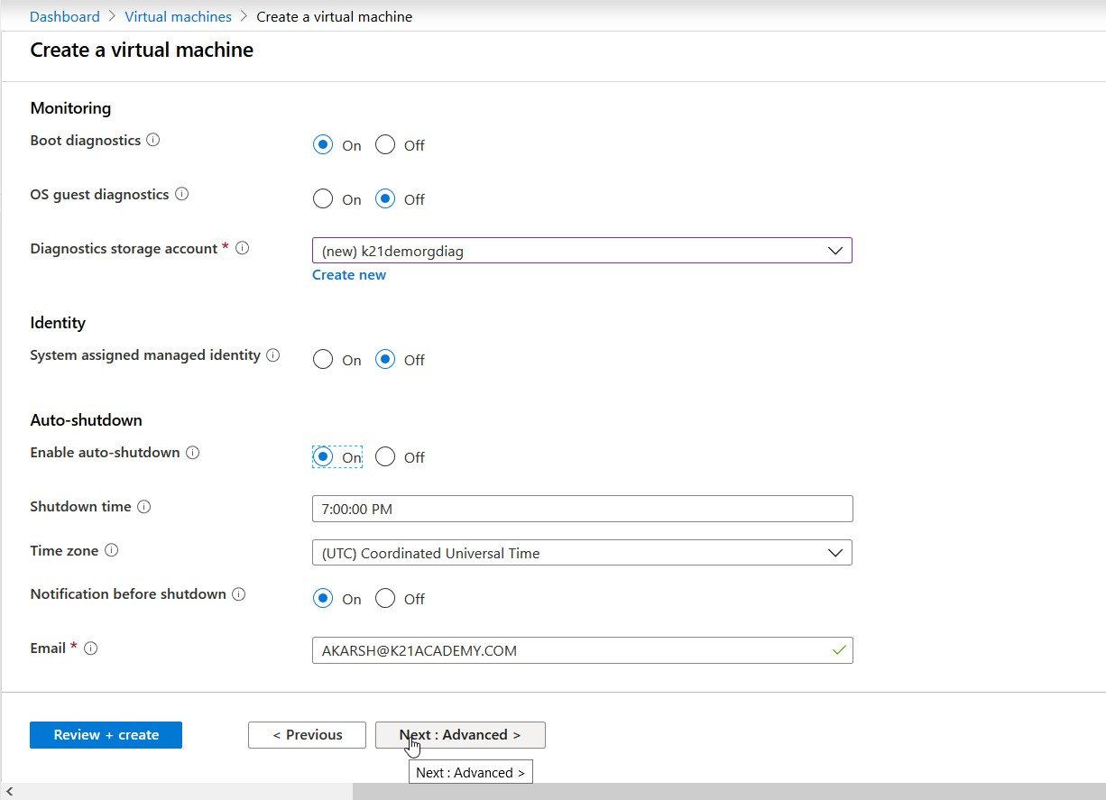

1. Click on Next option. **(Advanced).** Here you can install any extensions which you want such as antivirus etc. Click Next.

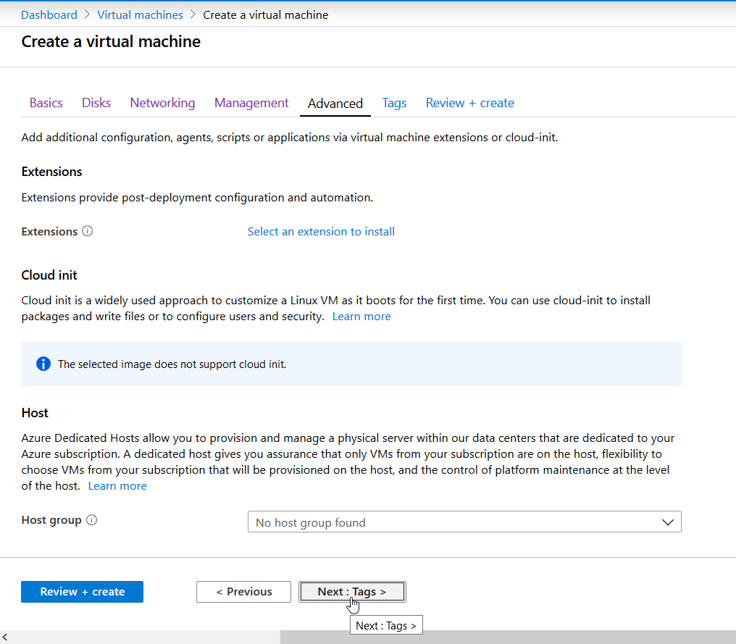

1. Select the tags if you want otherwise press **Review + Create**. Tags can help you to inteify you resource groups uniquely.

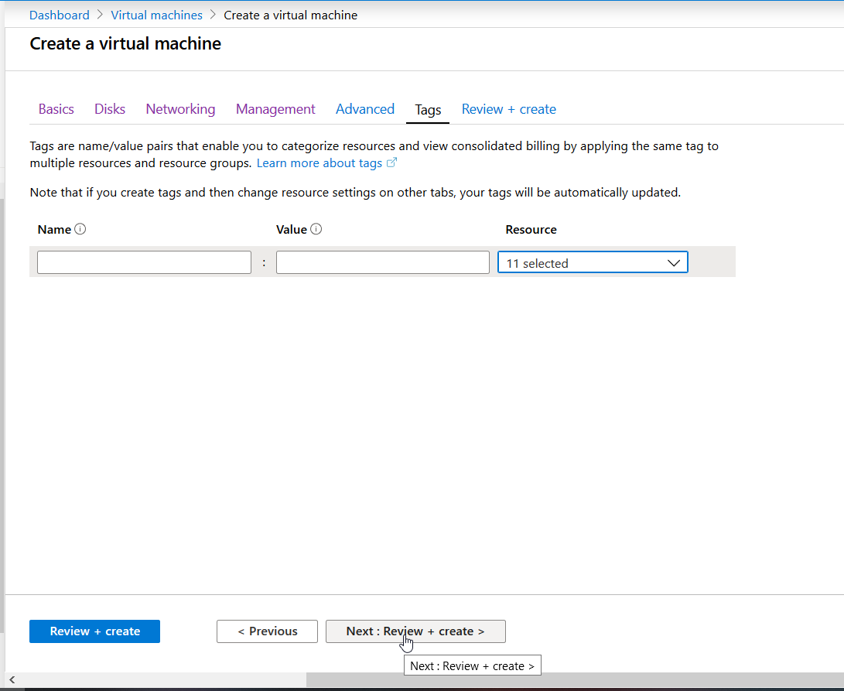

1. Select **Review + Create**

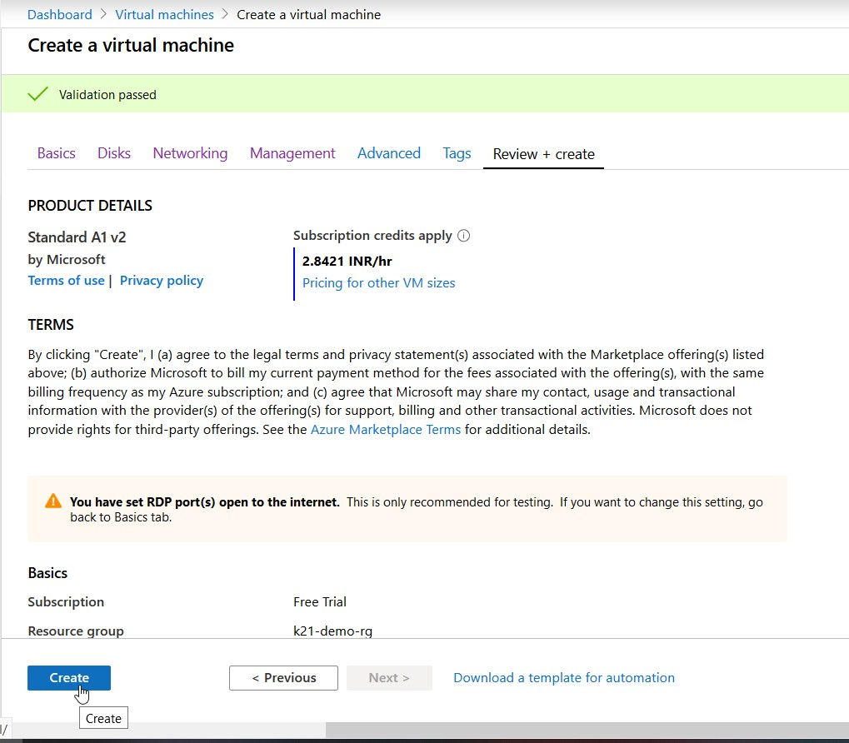

1. Select **Create**. It takes a few seconds to create a VM.

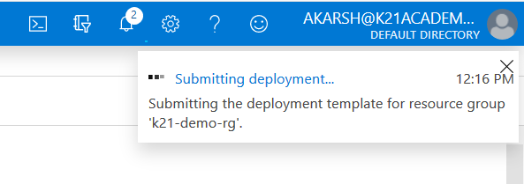

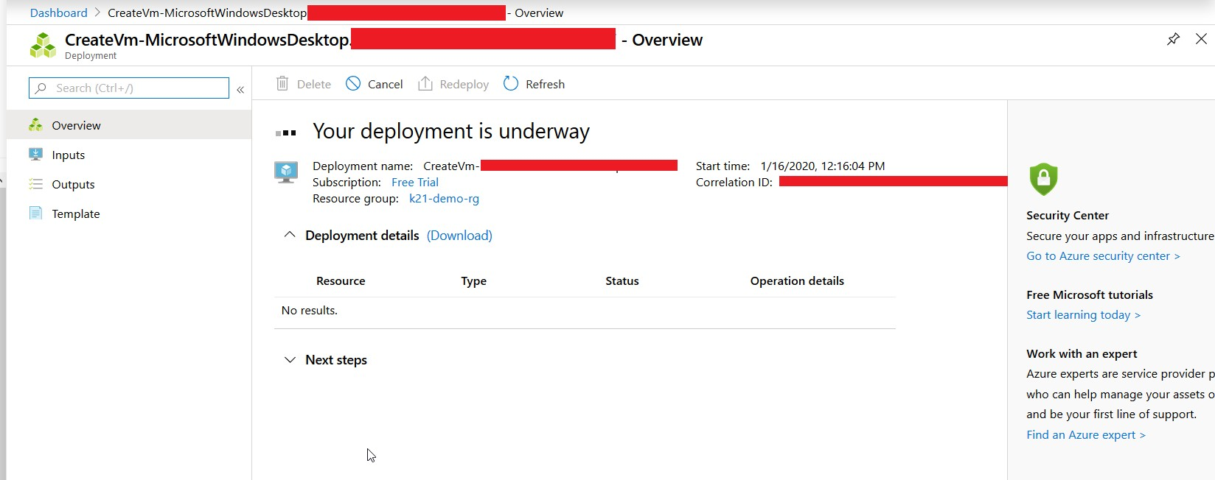

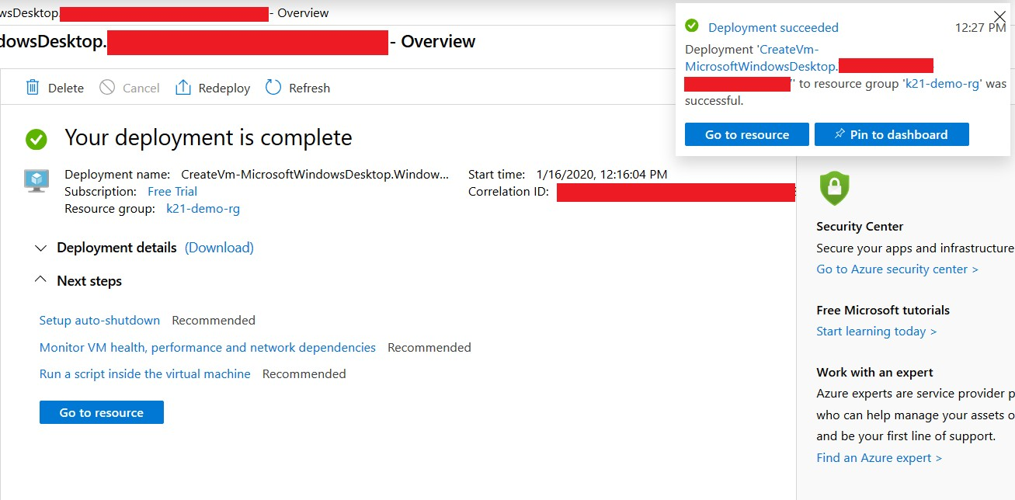

# 3.1 Connect to your Virtual Machine

After you create a Virtual Machine, click on the newly created Virtual Machine. Click on **Connect**.

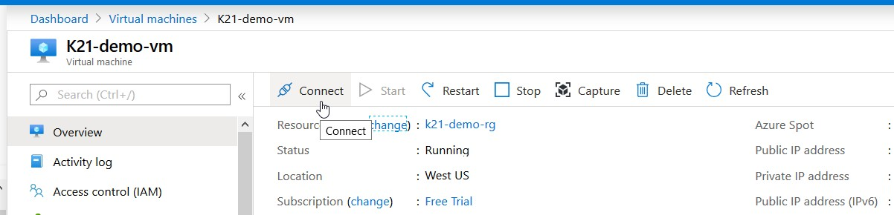

Now a dialogue box will open.

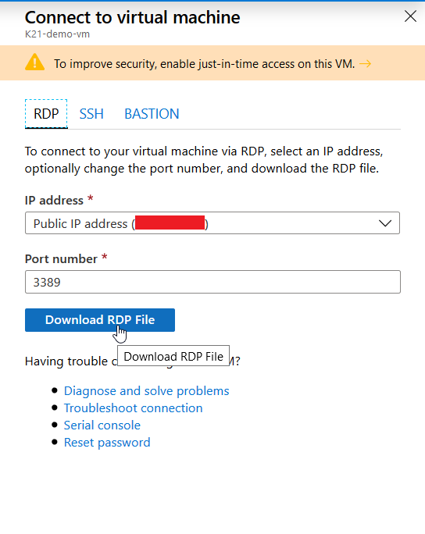

Download the **RDP file** from here and Open the downloaded file. After you open it, a prompt will appear like this:

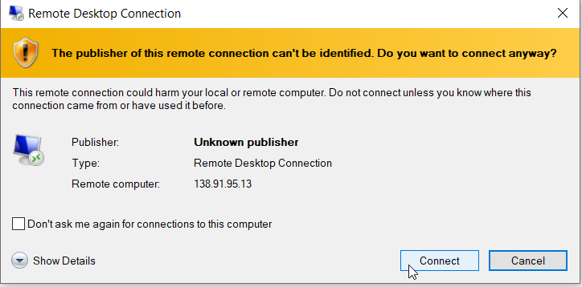

Click on **Connect**.

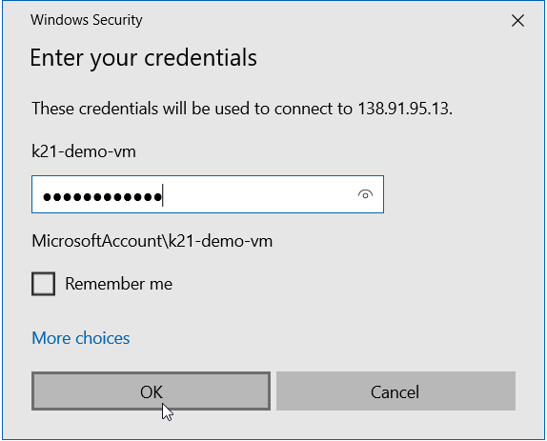

Enter the **username** of your newly created VM and your password.

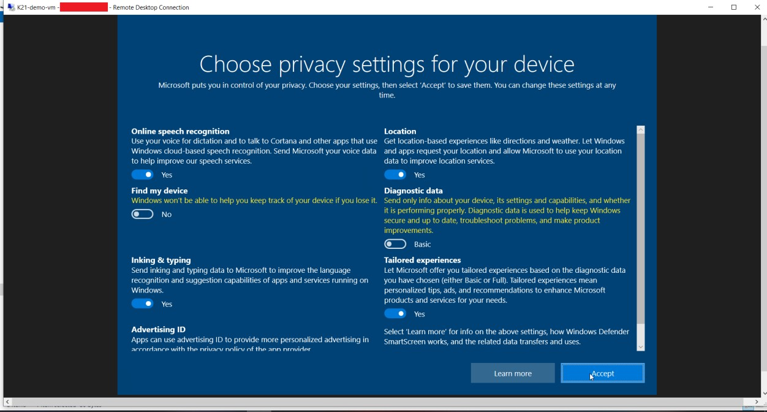

Now your virtual machine will open. You can use it like a normal computer.

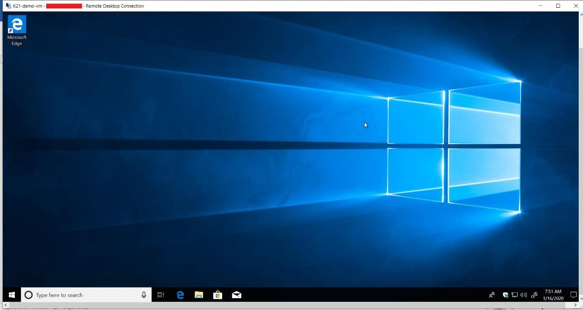

# CREATE VIRTUAL MACHINE USING AZURE CLI

The Azure CLI is used to create and manage Azure resources from the command line or in scripts. This guide shows you how to use the Azure CLI to deploy a virtual machine (VM) in Azure that runs Windows Server 2016.

# Pre-requisite

1. If you don't have an Azure subscription, create a [free account](https://azure.microsoft.com/en-us/free/?WT.mc_id=A261C142F) before you begin.
2. [Install Azure](https://docs.microsoft.com/en-us/cli/azure/install-azure-cli?view=azure-cli-latest) CLI modules in your system.

# Create Virtual Machine

1. Login to Azure Account.

**Run** the login command: ***az login***

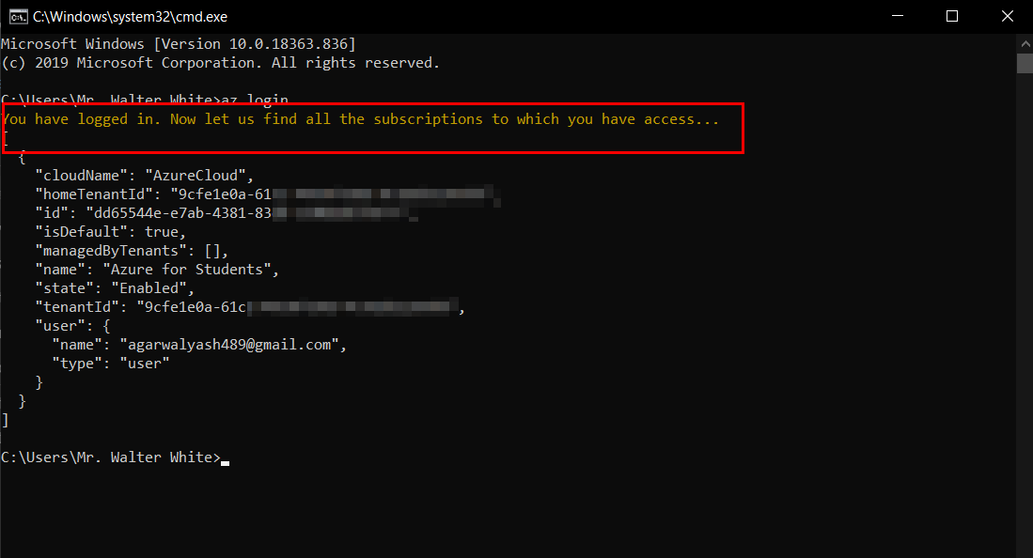

If the CLI can open your default browser, it will do so and load an **Azure sign-in page.**

Otherwise, open a browser page at <https://aka.ms/devicelogin>and enter the authorization code displayed in your terminal.

**Sign in** with your account credentials in the browser.

1. Create a **resource group** with the ***az group create*** command. The following example creates a resource group named **myResourceGroup** in the **eastus** location:

***az group create --name myResourceGroup --location eastus***

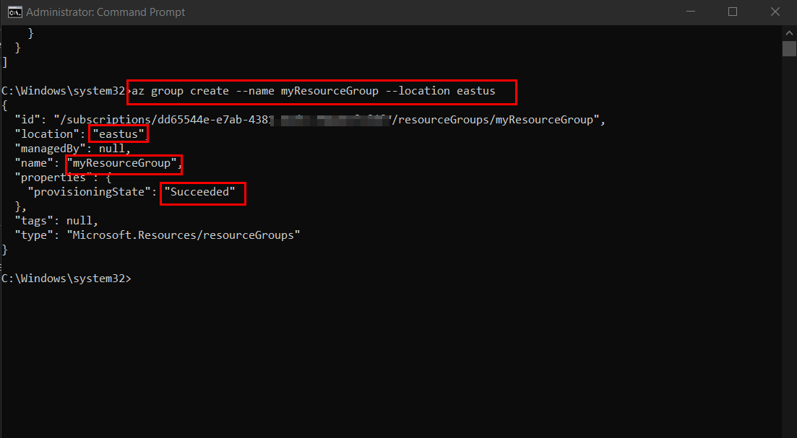

1. Create **virtual machine. Run** command: ***az vm create*** with the following commands:

az vm create --resource-group ***yourResourcename*** --name ***yourVMname*** --image win2016datacenter --admin-username ***yourusername***

The following example creates a VM named **myVM**. This example uses **azureuse**r for an administrative user name. In the image section enter the VM image you want to create in this we

are creating **Windows Server 2016.**

***az vm create --resource-group myResourceGroup --name myVM --image win2016datacenter --admin-username azureuser***

Replace ***myResourceGroup, azureuser*** with your resorce group name and username respectively.

1. Using the example above, you will be prompted to enter a password at the command line. You could also add the the ***--admin-password*** parameter with a value for your password. The user name and password will be used later, when you connect to the VM.

**NOTE:** While creating the password it will not be shown in the cmd screen you just have to type it.

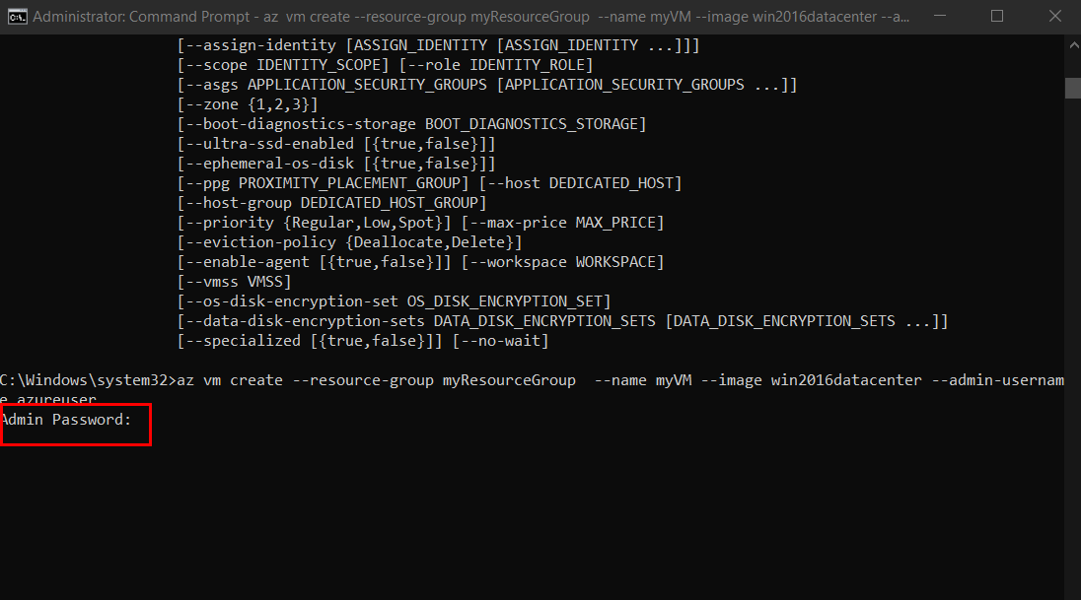

It takes a few minutes to create the VM and supporting resources.

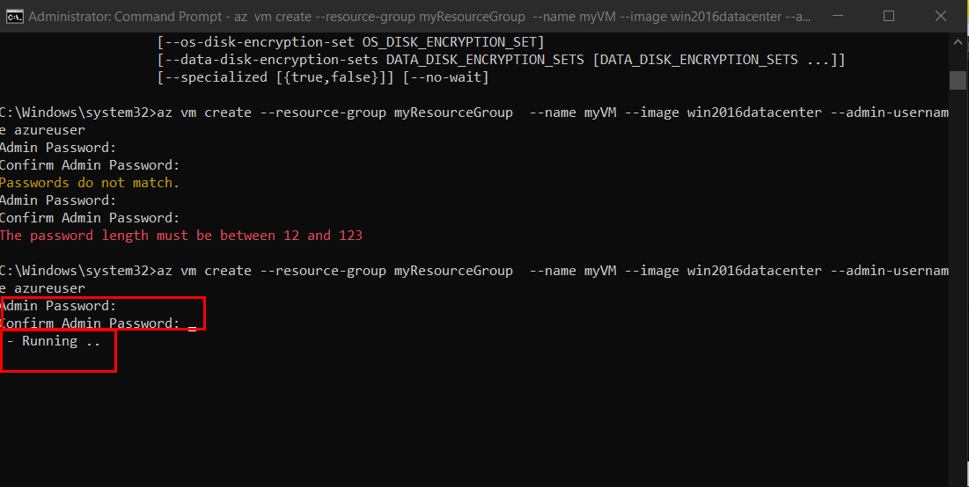

The following example output shows the VM create operation was successful.

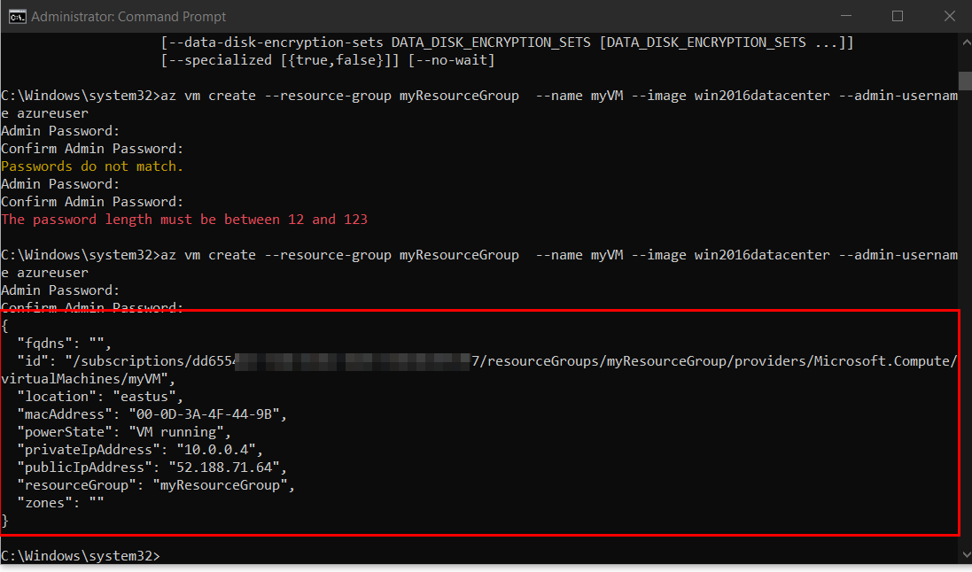

Note your own **publicIpAddress** in the output from your VM. This address is used to access the VM in the **next steps.**

1. Open port 80 for web traffic. By default, only **RDP connections** are opened when you create a Windows VM in Azure. **Run** command:

***az vm open-port --port 80 --resource-group myResourceGroup --name myVM***

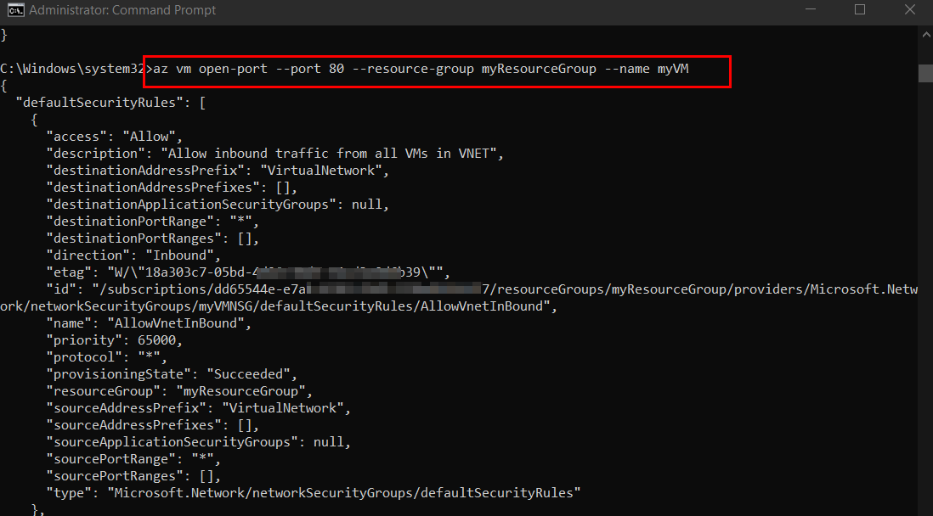

# Connect to virtual machine

1. Use the following command to create a remote desktop session from your local computer. Replace the **IP address** with the **public IP address** of your VM.

***mstsc /v:publicIpAddress***

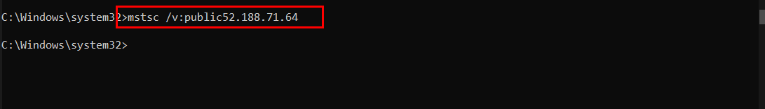

**Troubleshooting:**

* 1. If you are facing this error while connecting through command:

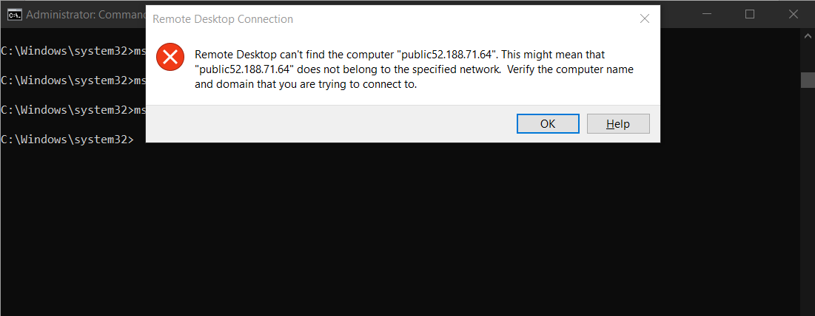

* 1. You can try manually with the **Run** option from the **Start menu** of your Windows OS and type command **mstsc** and click **OK.**

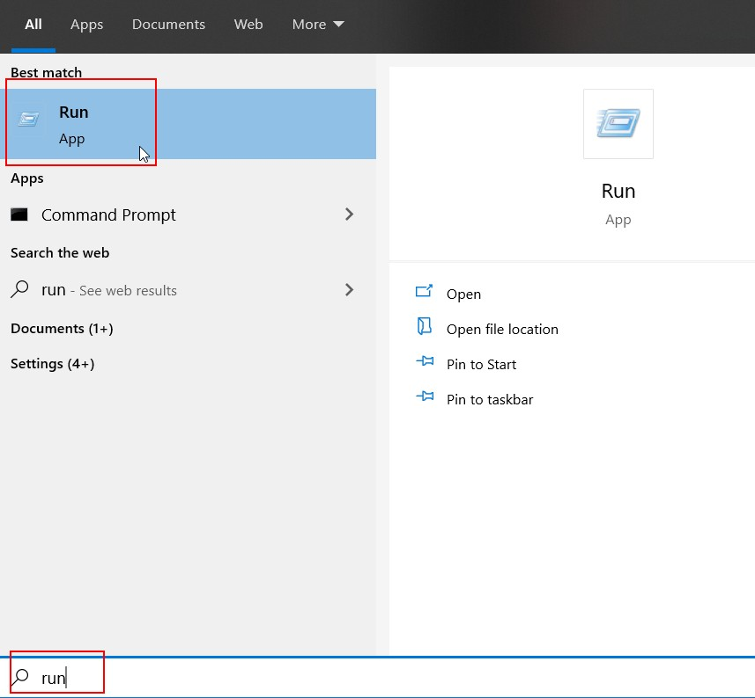

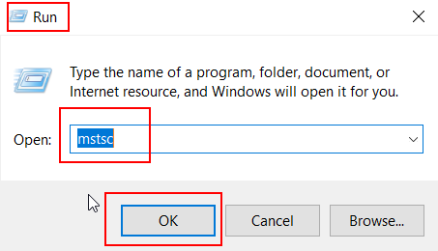

* 1. Now you will be promt to the **RDP Connection** menu: Type your VM **PublicIPAddress**

and then Click **Connect.**

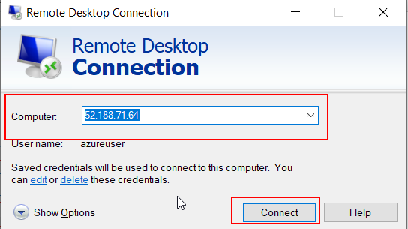

1. When prompted, enter the **credentials** used when the VM was created: Click **OK.**

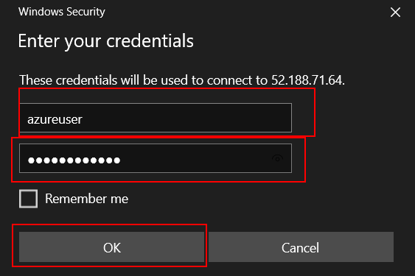

1. You will be successfully logged in into your Windows Server Virtual Machine.

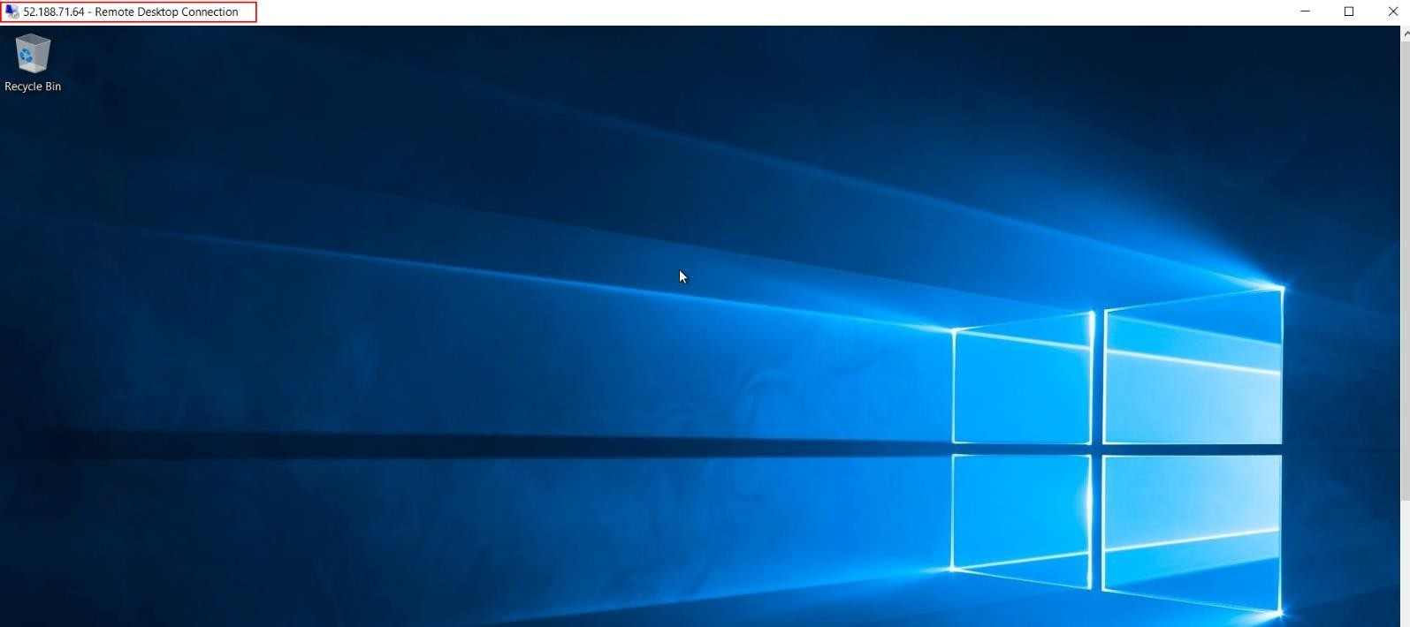

Now you have successfully created and connected to your VM using Azure CLI.

# CREATE VM USING AZURE POWERSHELL CORE

The Azure PowerShell module is used to create and manage Azure resources from the PowerShell command line or in scripts. This quickstart shows you how to use the Azure PowerShell module to deploy a virtual machine (VM) in Azure that runs Windows Server 2016. You will also RDP to the VM, to show the VM in action.

# Pre-requisites

1. If you don't have an Azure subscription, create a [free account](https://azure.microsoft.com/en-us/free/?WT.mc_id=A261C142F) before you begin.
2. [Install Azure PowerShell](https://docs.microsoft.com/en-us/powershell/azure/install-az-ps?view=azps-4.2.0) modules in your system locally.

# Create Windows VM

1. Open PowerShell locally in your system.
2. Sign in to your Azure Account.

*AZ login*

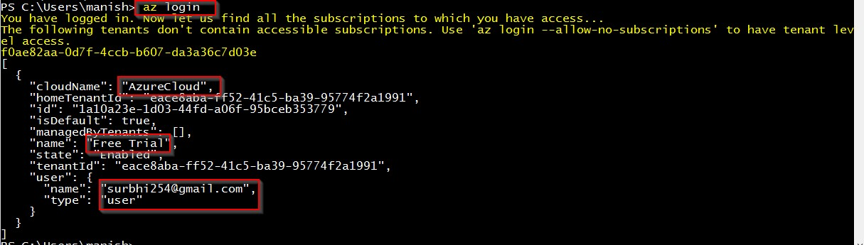

1. To enable Execution Policies to other run command:

*Set-ExecutionPolicy RemoteSigned -Scope process*

1. Create resource group:

*New-AzResourceGroup -Name myResourceGroup -Location EastUS*

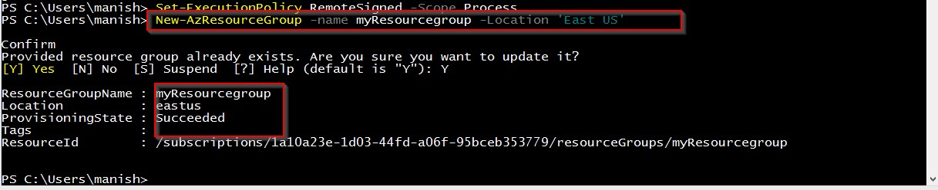

Replace the highlighted sentence according to your requirements.

1. **Create** virtual machine. Provide names for each of the resources and the ***New-AzVM*** cmdlet creates if they don't already exist.

***New-AzVm `***

***-ResourceGroupName "myResourceGroup" `***

***-Name "myVM" `***

***-Location "East US" `***

***-VirtualNetworkName "myVnet" `***

***-SubnetName "mySubnet" `***

***-SecurityGroupName "myNetworkSecurityGroup" `***

***-PublicIpAddressName "myPublicIpAddress" `***

***-OpenPorts 80,3389***

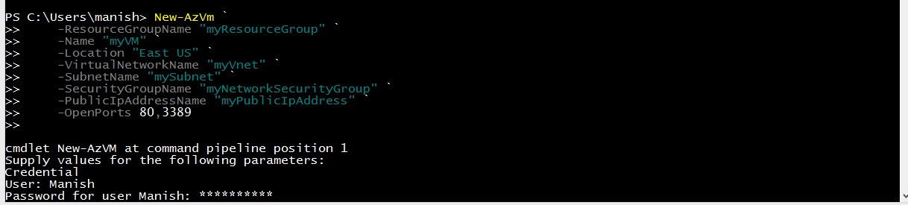

1. When prompted, provide a **username** and **password** to be used as the **sign-in** credentials for the VM:

After enter it starts the deployement

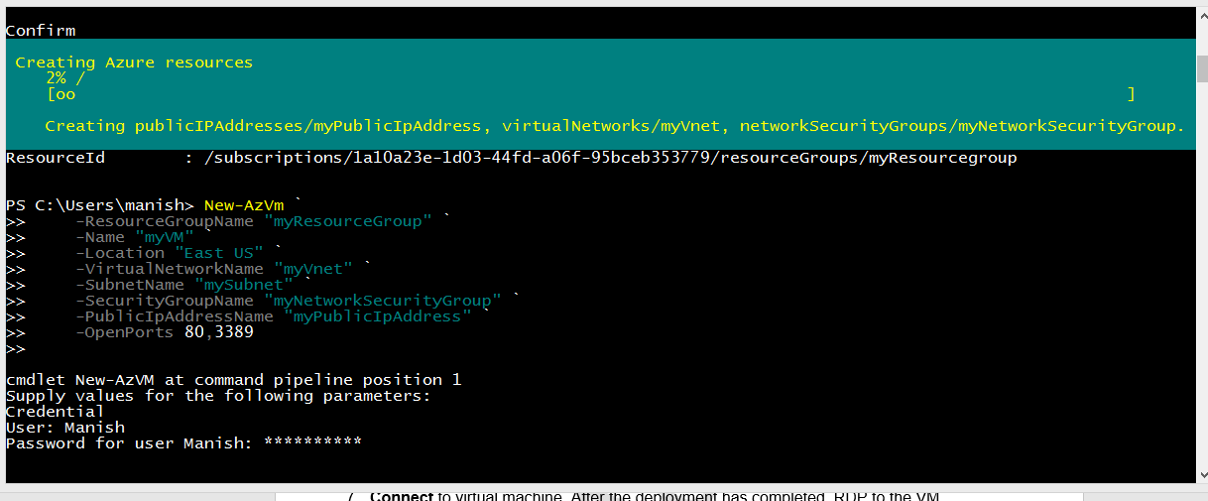

1. Deployment is completed

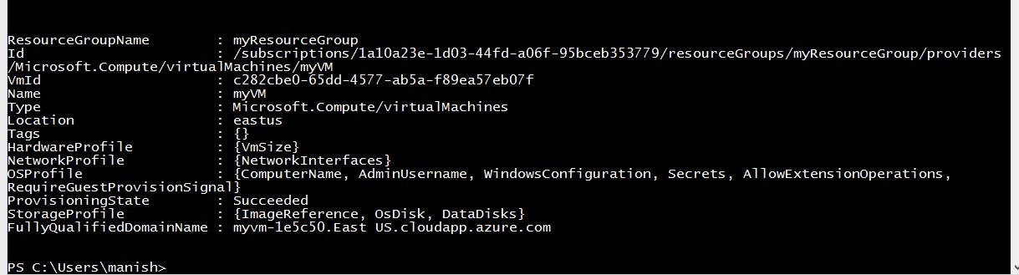

1. **Connect** to virtual machine. After the deployment has completed, RDP to the VM. To see the public IP address of the VM, use:

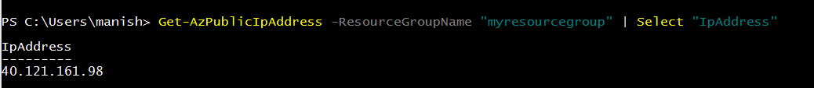

1. Use the following command to create a **remote desktop session** from your local computer.

Replace the IP address with the **public IP address** of your VM.

1. In the Windows Security window, select **More choices**, and then select **Use a different account**. Type the username as **localhost\username**, enter **password** you created for the virtual machine, and then click **OK.**

**Search** for the Remote desktop connection in the search tab of windows operating system (Local machine).

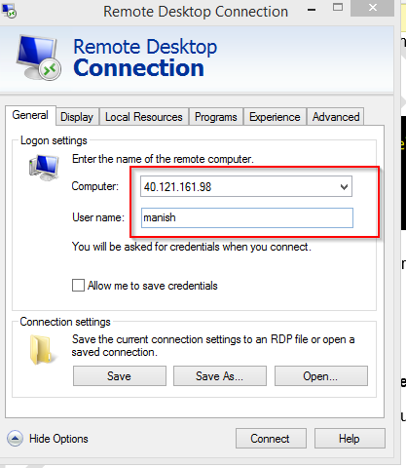

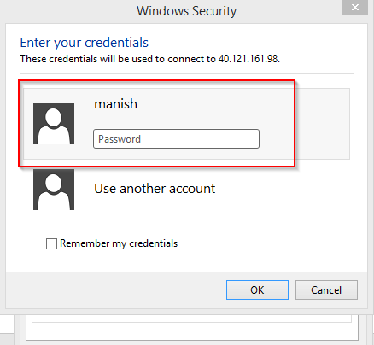You may receive a certificate warning during the sign-in process. Click **Yes** or Continue to create the connection.

1. You have now successfully created and connected to the Windows VM.

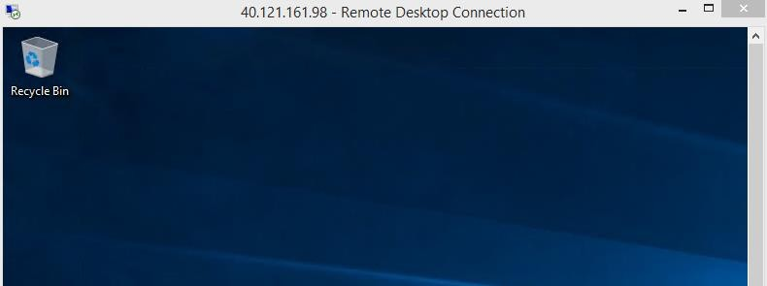

# HOW TO REMOVE RESERVE IP OPTION

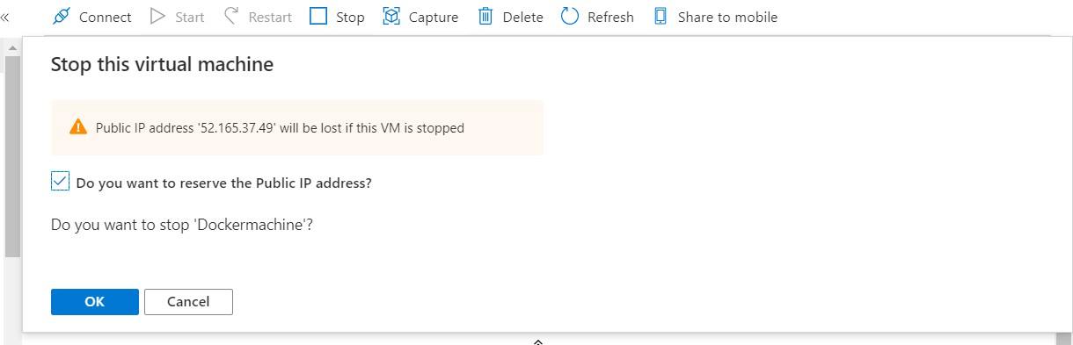If you Accidently Saved IP while Stopping a virtual machine then next time you will not get the option for “**reserve the Public IP**”.

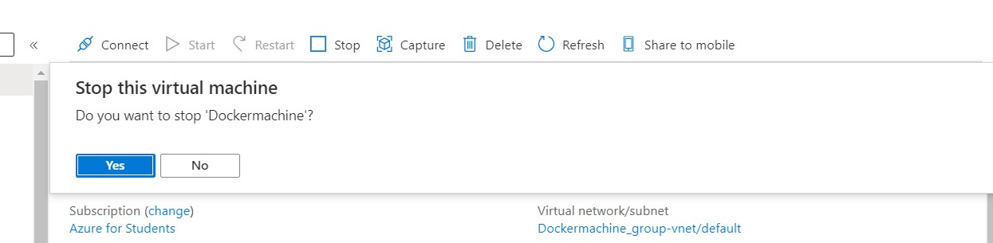Next we will not get the option for “**Reserve public IP address**”

1. Go to Networking in Menu

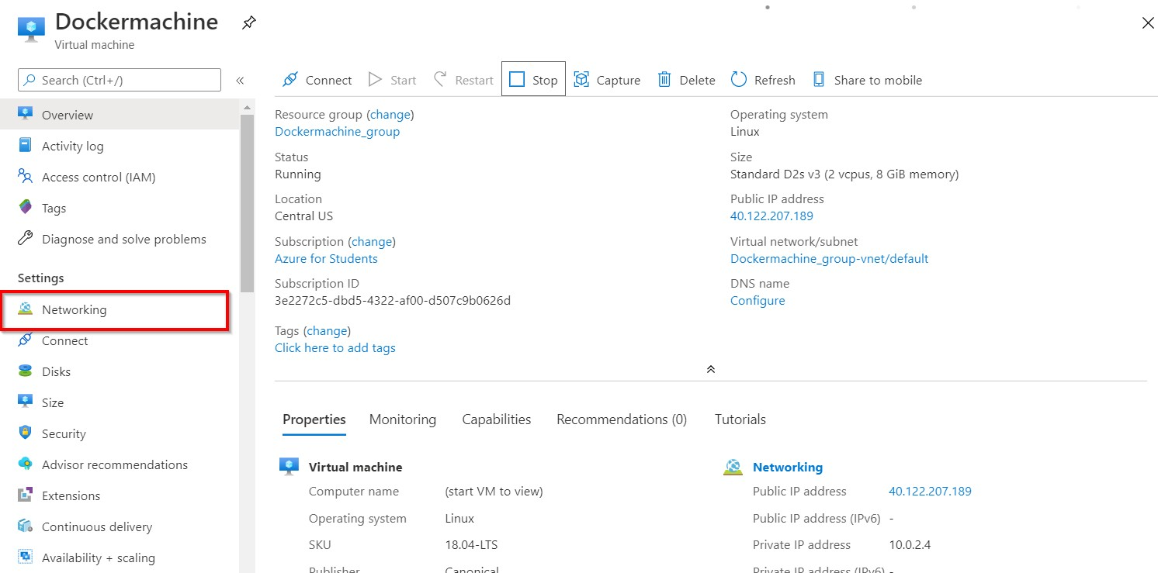

1. 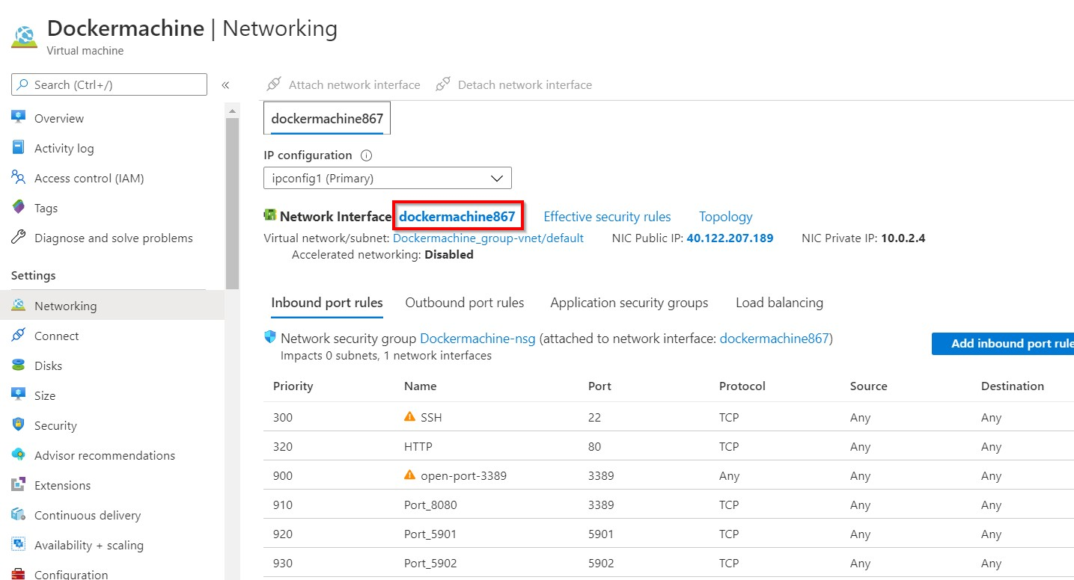Go to the network interface
2. Under Network Inerface click on **IP Configurations**

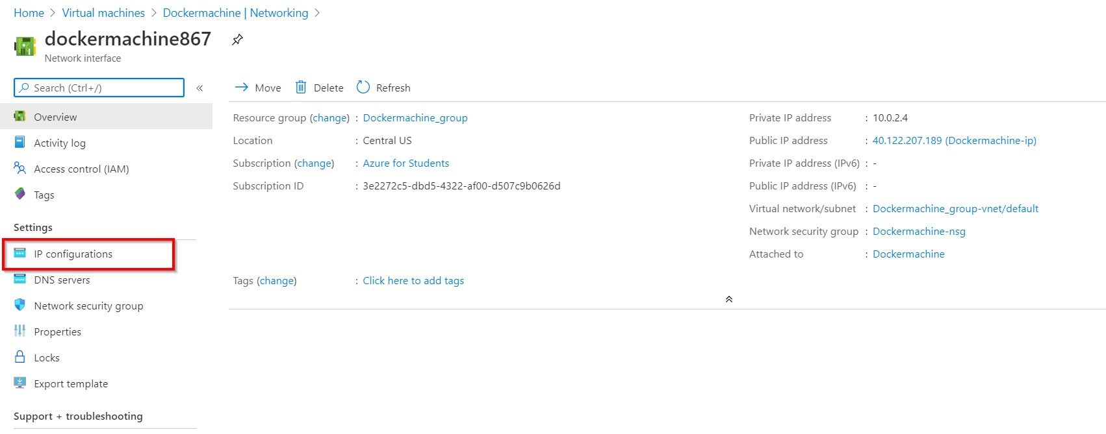

1. 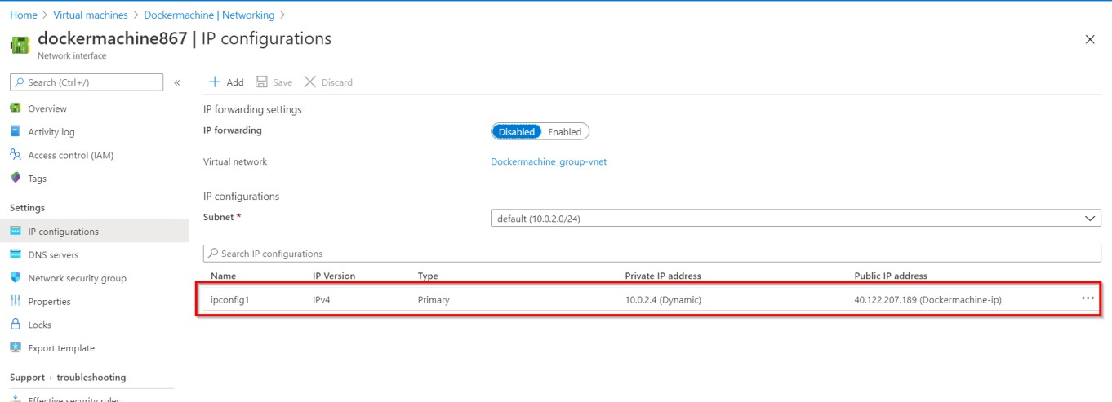Under IP Configuration select Ipconfig
2. Click on IP address

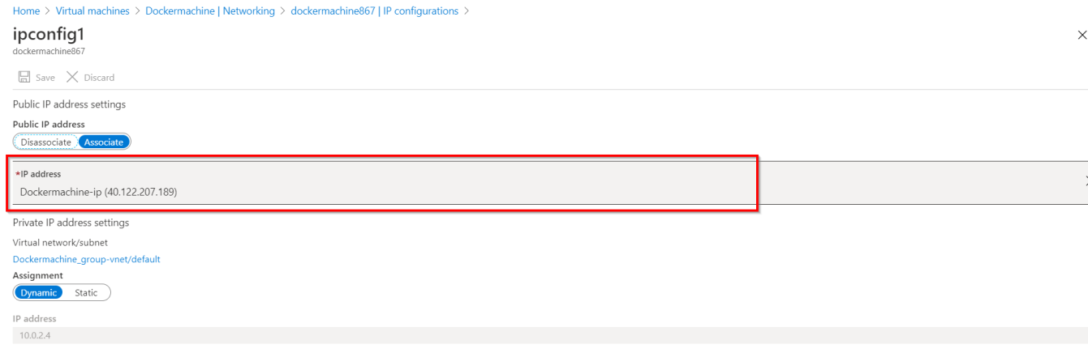

1. Click on Create new

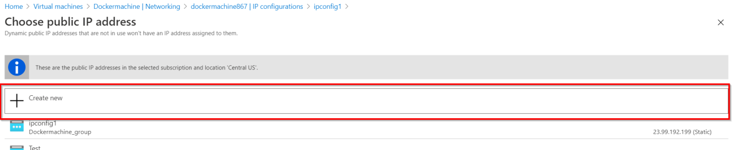

1. Under create IP:
   * **Name:** New_1
   * **SKU:** Select Basic
   * **Assignemt:** Dynamic
   * 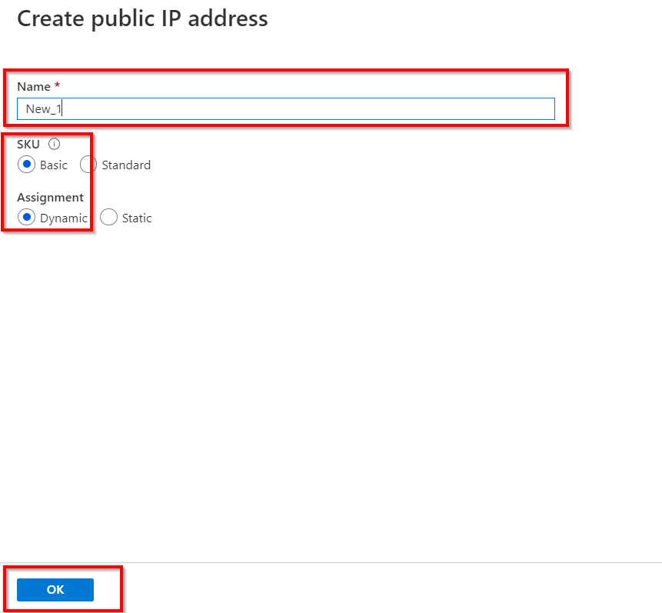Click **Ok**
2. Click on **Save**

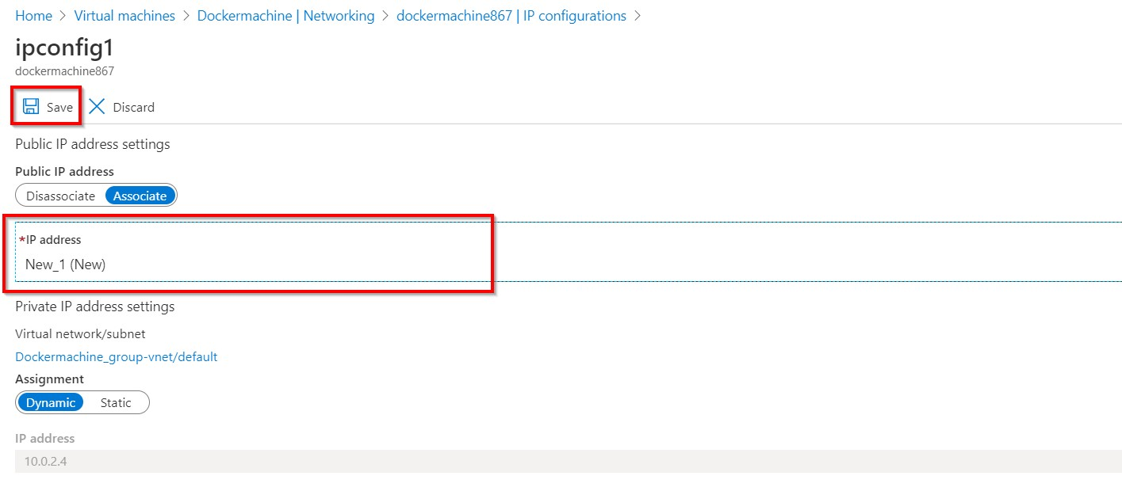

1. 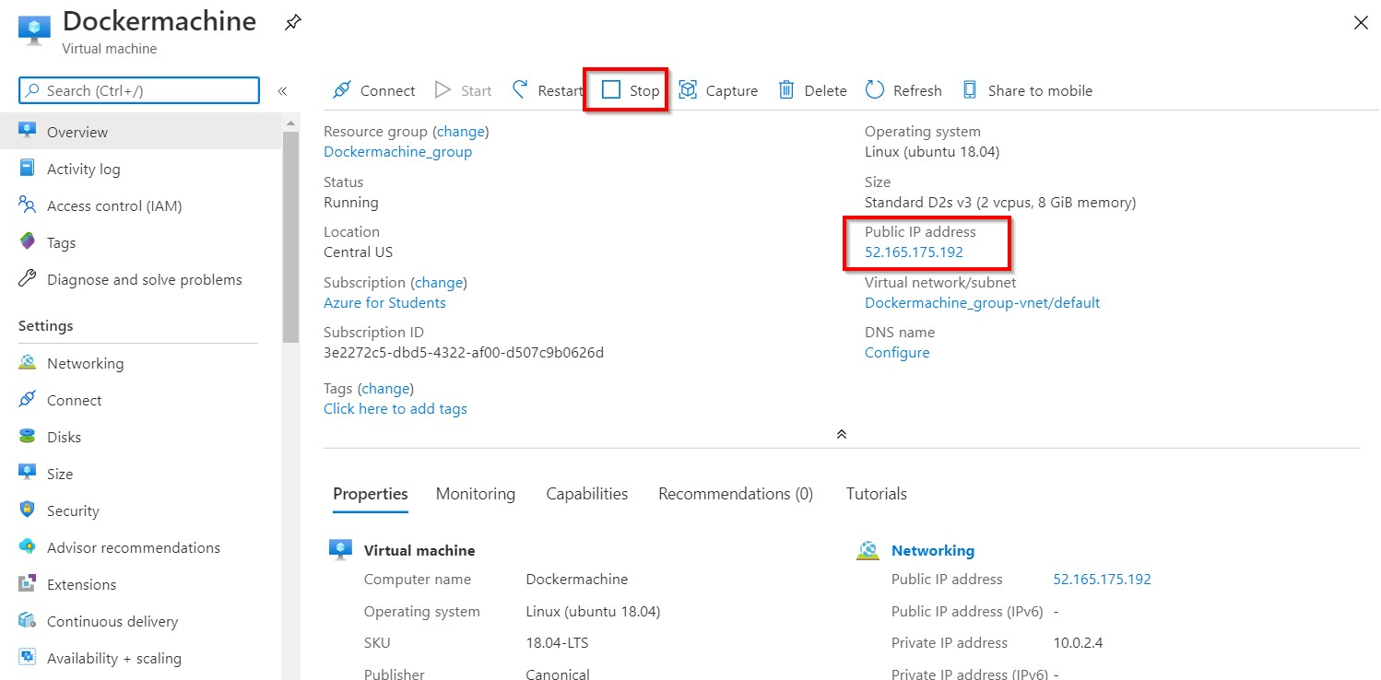Go to the **Overview** page click on **STOP Virtual machine**
2. Now you can stop the VM without Reserve the IP address.

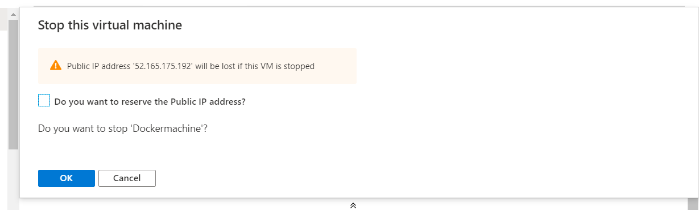

# SUMMARY

In this activity Guide we learned:

* How to create a Virtual Machine on Azure Portal and to connect it.
* How to create a Virtual Machine using Azure CLI and to connect it.
* How to create a Virtual Machine using Azure PowerShell Core and to connect it.
* How to Remove RESERVE IP Option