Create an Azure Bastion host and Connect to a Windows VM

**Contents**

1. Introduction 3
2. Documentation Links 4
3. Create an Azure Bastion host 5
   1. Prerequisites 5
   2. Create a bastion host 5
4. Connect to a Virtual Machine 11
5. Summary

# INTRODUCTION

This activity guide cover steps to

* + Create an Azure Bastion Resource
  + Connect to a Windows virtual machine using Azure Bastion

# DOCUMENTATION LINKS

1. What is Azure Bastion?: [https://docs.microsoft.com/en-us/azure/bastion/bastion-](https://docs.microsoft.com/en-us/azure/bastion/bastion-overview) [overview](https://docs.microsoft.com/en-us/azure/bastion/bastion-overview)

# CREATE AN AZURE BASTION HOST

The Azure Bastion service is a new fully platform-managed PaaS service that you provision inside your virtual network. It provides secure and seamless RDP/SSH connectivity to your virtual machines directly in the Azure portal over TLS. When you connect via Azure Bastion, your virtual machines do not need a public IP address.

# Prerequisites

* + 1. A virtual network.
    2. A Windows virtual machine in the virtual network.
    3. **Ports:** To connect to the Windows VM, you must have the following ports open on your Windows VM:
       - Inbound ports: RDP (3389)

# Create a bastion host

* + 1. Login to your Azure portal and click “**Create a new resource”.**

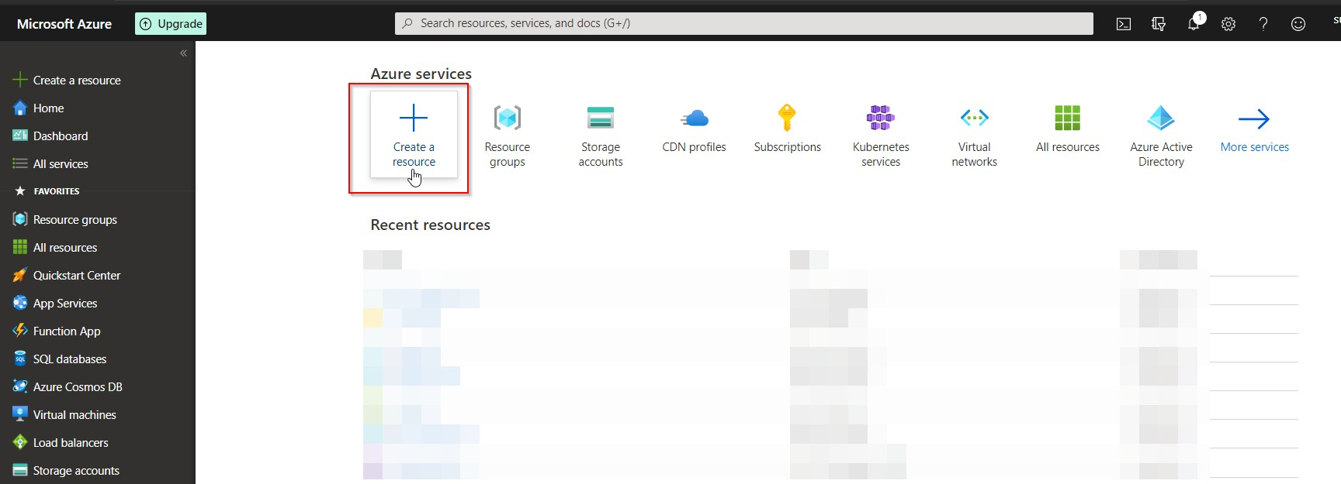

* + 1. On the **New** page, in the Search box, type **Bastion,** then select **Enter** to get to the search results. On the result for **Bastion,** verify that the publisher is Microsoft.

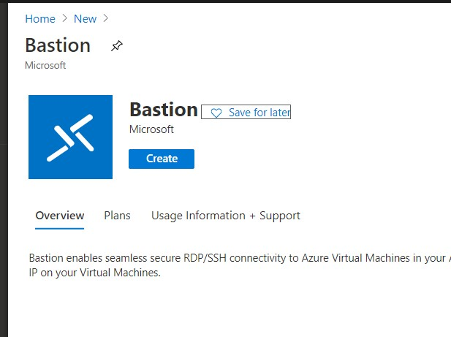

* + 1. Select **Create.**

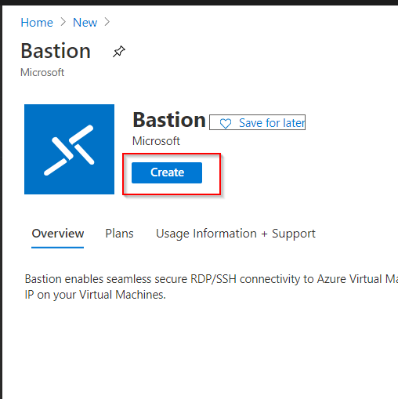

* + 1. On the **Create a Bastion** page, configure a new Bastion resource.

1. **Subscription:** The Azure subscription you want to use to create a new Bastion resource.
2. **Resource Group:** The Azure resource group in which the new Bastion resource will be created. If you don't have an existing resource group, you can create a new one.
3. **Name:** The name of the new Bastion resource.
4. **Region:** The Azure public region that the resource will be created in.
5. **Virtual network:** The virtual network in which the Bastion resource will be created.

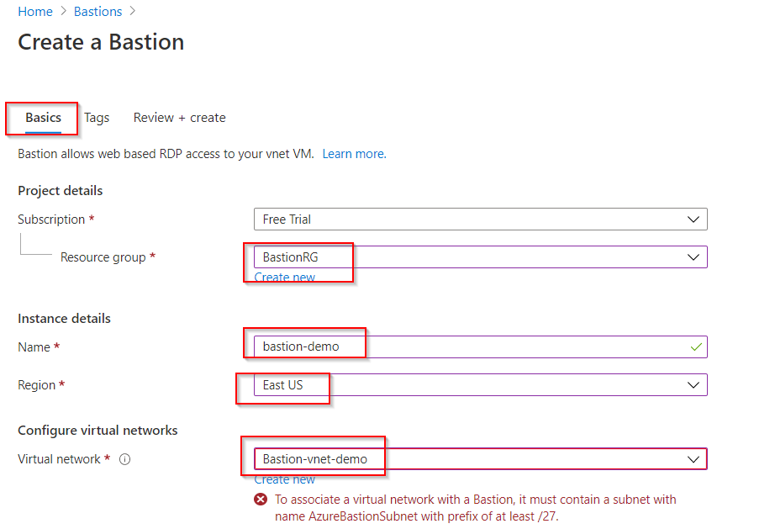You can create a new virtual network in the portal during this process, or use an existing virtual network. If you are using an existing virtual network, make sure the existing virtual network has enough free address space to accommodate the Bastion subnet requirements. If you don't see your virtual network from the dropdown, make sure you have selected the correct Resource Group.

1. **Subnet:** Once you create or select a virtual network, the subnet field will appear. The subnet in your virtual network where the new Bastion host will be deployed. The subnet will be dedicated to the Bastion host. **Select Manage subnet configuration** and create the Azure Bastion subnet.

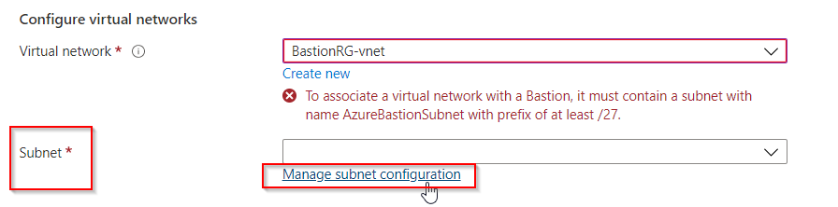

1. Select **+Subnet** and create a subnet using the following guidelines:
   * The subnet must be named **AzureBastionSubnet.**
   * The subnet must be at least /27 or larger.

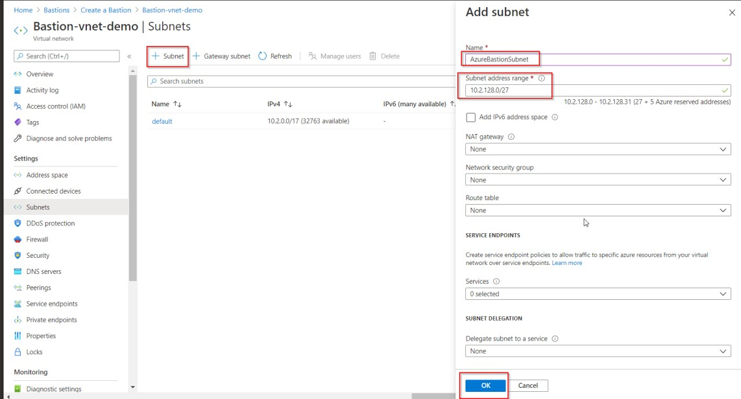You don't need to fill out additional fields. Select **OK** and then, at the top of the page, select **Create a Bastion** to return to the Bastion configuration page.

1. **Public IP address:** The public IP of the Bastion resource on which RDP/SSH will be accessed (over port 443). Create a new public IP. The public IP address must be in the same region as the Bastion resource you are creating. This is IP address does not have anything to do with any of the VMs that you want to connect to. It's the public IP for the Bastion host resource.
2. **Public IP address name:** The name of the public IP address resource. For this tutorial, you can leave the default.
3. **Public IP address SKU:** This setting is prepopulated by default to **Standard.** Azure Bastion uses/supports only the Standard Public IP SKU.
4. **Assignment:** This setting is prepopulated by default to Static.
   * 1. 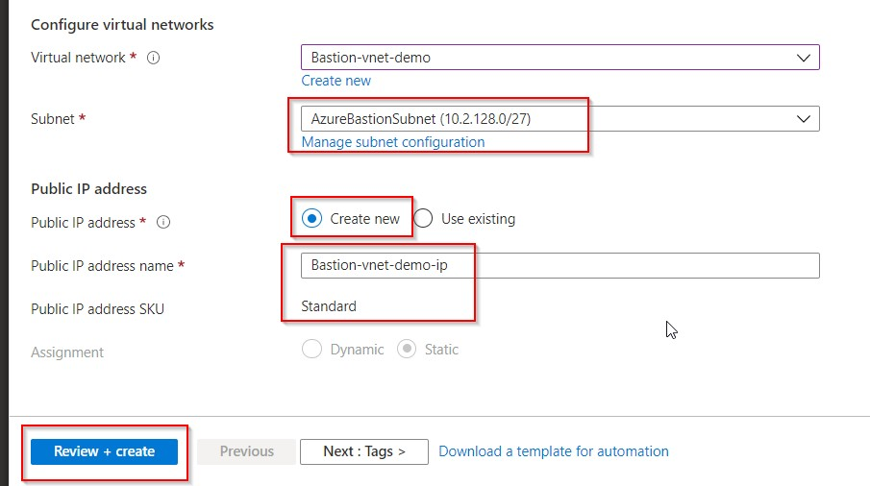When you have finished specifying the settings, select **Review + Create.** This validates the values. Once validation passes, you can create the Bastion resource.
     2. Select **Create.**

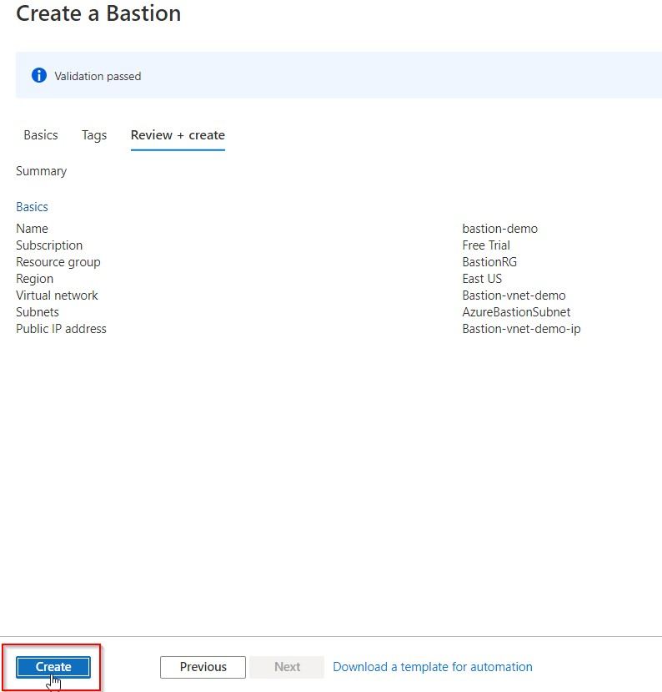

* + 1. You will see a message letting you know that your deployment is underway. Status will display on this page as the resources are created. It takes about 5 minutes for the Bastion resource to be created and deployed.

# CONNECT TO A VIRTUAL MACHINE

1. 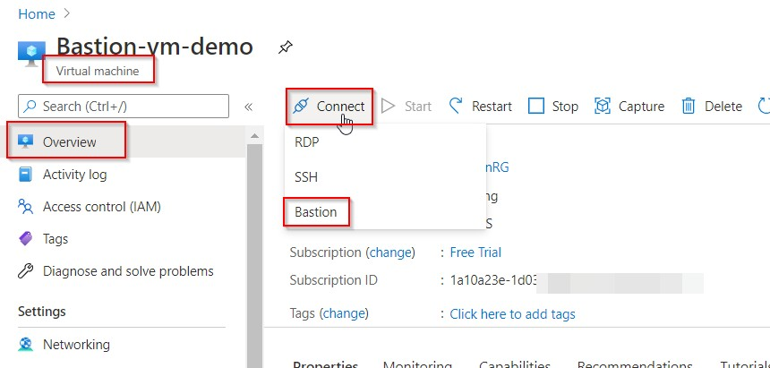Open the Azure portal. Navigate to the virtual machine that you want to connect to, then select **Connect.** Select **Bastion** from the dropdown.
2. 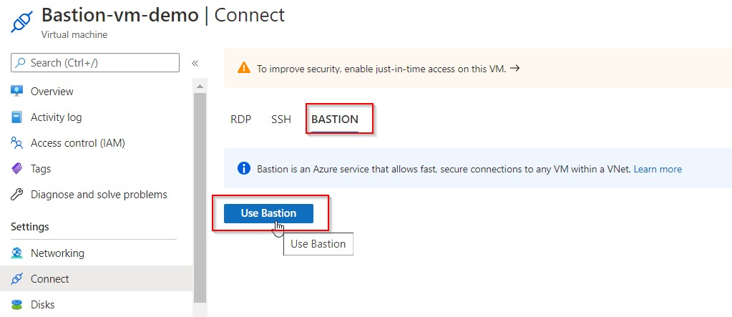After you select Bastion from the dropdown, a side bar appears that has three tabs: RDP, SSH, and Bastion. Because Bastion was provisioned for the virtual network, the Bastion tab is active by default. Select **Use Bastion.**
3. On the **Connect using Azure Bastion** page, enter the **username** and **password** for your virtual machine, then select **Connect.**

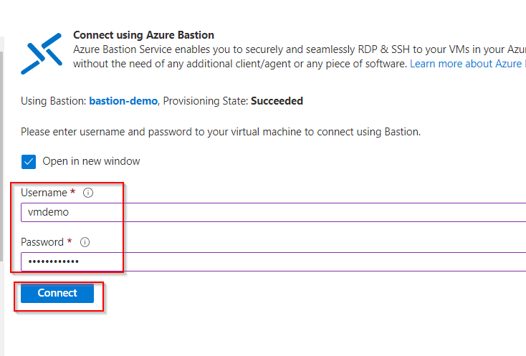

1. 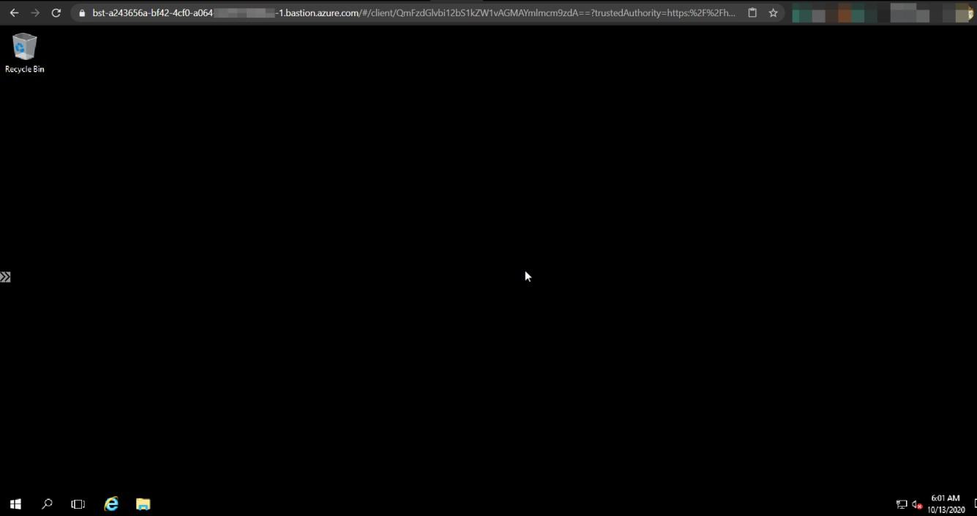The RDP connection to this virtual machine via Bastion will open directly in the new tab of your current web-browser (over HTML5) using port 443 and the Bastion service.

# SUMMARY

This completes step by step guide covering:

* + How to Create an Azure Bastion Resource
  + How to associate it to a virtual network
  + How to Connect to a Windows virtual machine using Azure Bastion