Project Report

On

E-Printing Press Website

Submitted by

G.Gayathri
SK.Reshma
E.Eswar Prasad

Under the guidance of

Mr K.Mahendra

Assistant Professor

Department of Computer Science and Engineering



Rajiv Gandhi University of Knowledge and Technologies R.K.Valley, Kadapa

Andhrapradesh

1 Page of 78

DEPARTMENT OF COMPUTER SCIENCE ENGINEERING

RAJIV GANDHI UNIVERSITY OF KNOWLEDGE TECHNOLOGIES

IIIT RK VALLEY – 516 330

DECLARATION

We hereby declare that the report of the B.Tech Mini Project Work entitled with the “E-Printing Press” which is being submitted to Rajiv Gandhi University of Knowledge Technologies, RK Valley, in partial fulfilment of the requirements for the award of Degree of Bachelor of Technology in Computer Science and Engineering, is a bonafide report of the work carried out by me. The material contained in this report has not been submitted to any university or institution for award of any degree.

G.Gayathri - R170204
SK.Reshma - R170205
E.Eswar Prasad - R170243

2 Page of 78

RAJIV GANDHI UNIVERSITY OF KNOWLEDGE TECHNOLOGIES



RGUKT

(A.P.Government Act 18 of 2008)

RGUKT, RK VALLEY

Department of Computer Science and Engineering

CERTIFICATE FOR PROJECT COMPLETION

This is certify that the project entitled “ E-Printing Press ” submitted by the G.Gayathri (R170204) under our guidance and supervision for the partial fulfilment for the degree Bachelor of Technology in Computer Science and Engineering during the academic year 2021-2022 at RGUKT, RK VALLEY. To the best of my knowledge, the results embodied in this dissertation work have not been submitted to any University or Institute for the award of any degree or diploma.

Project Internal Guide | Head of the Department
Mr K.Mahendra
Project Coordinator, | Mr.P.Harinadha
Assistant Professor, | HOD Of CSE,
RGUKT, RK Valley. | RGUKT, RK Valley.

3 Page of 78

RAJIV GANDHI UNIVERSITY OF KNOWLEDGE TECHNOLOGIES

RGUKT

(A.P.Government Act 18 of 2008)

RGUKT, RK VALLEY

Department of Computer Science and Engineering

CERTIFICATE FOR PROJECT COMPLETION

This is certify that the project entitled “ E-Printing Press ” submitted by the SK.Reshma (R170205) under our guidance and supervision for the partial fulfilment for the degree Bachelor of Technology in Computer Science and Engineering during the academic year 2021-2022 at RGUKT, RK VALLEY. To the best of my knowledge, the results embodied in this dissertation work have not been submitted to any University or Institute for the award of any degree or diploma.

Project Internal Guide | Head of the Department
Mr K.Mahendra
Project Coordinator, | Mr.P.Harinadha
Assistant Professor, | HOD Of CSE,
RGUKT, RK Valley. | RGUKT, RK Valley.

4 Page of 78

RAJIV GANDHI UNIVERSITY OF KNOWLEDGE TECHNOLOGIES

RGUKT

(A.P.Government Act 18 of 2008)

RGUKT, RK VALLEY

Department of Computer Science and Engineering

CERTIFICATE FOR PROJECT COMPLETION

This is certify that the project entitled “ E-Printing Press ” submitted by the E.Eswar Prasad (R170243) under our guidance and supervision for the partial fulfilment for the degree Bachelor of Technology in Computer Science and Engineering during the academic year 2021-2022 at RGUKT, RK VALLEY. To the best of my knowledge, the results embodied in this dissertation work have not been submitted to any University or Institute for the award of any degree or diploma.

Project Internal Guide | Head of the Department
Mr K.Mahendra
Project Coordinator, | Mr.P.Harinadha
Assistant Professor, | HOD Of CSE,
RGUKT, RK Valley. | RGUKT, RK Valley.

5 Page of 78

Acknowledgement

The satisfaction that accompanies the successful completion of any task would be incomplete without the mention of the people who made it possible and whose constant guidance and encouragement crown all the efforts success. I am extremely grateful to our respected Director,Prof. Mrs. K.SANDHYA RANI for fostering an excellent academic climate in our institution. I also express my sincere gratitude to our respected Head of the Department Mr P.HARINADHA for their encouragement, overall guidance in viewing this project a good asset and effort in bringing out this project. I would like to convey thanks to our guide at college Mr. K.MAHENDRA for their guidance, encouragement, co-operation and kindness during the entire duration of the course and academics. My sincere thanks to all the members who helped me directly and indirectly in the completion of project work. I express my profound gratitude to all our friends and family members for their encouragement.

6 page of 78

Index

1. Abstract ……… …………………………………………… 9
2. Introduction……………………………………………… 10
2.1 Purpose…………………………………………………. 11
2.2 Intended Audience…………………………………….. 12
2.3 product Vision ………………………………………… 12
2.4 Existing System & Proposed System…………………. 12-13
2.5 Requirement Specification…………………………….. 14
3. Modules…………………………………………………. 15
3.1 Homepage…………………………………………….... 15
3.2 Admin…………………………………………………. 16
3.3 User…………………………………………………..... 17
3.4 Order………………………………………………….. 17
3.5 History……………………………………………….... 16

7 page of 78

4.Advantages…………………………………………………... 20
5.Technologies used…………………………………………… 21-23
6.Use Case Diagrams………………………………………….. 24-26
7.ER-Diagram…………………………………………………. 27-28
8.Source Code with Outputs…………………………………................ 29-75
9.Conclusion…………………………………………………….. 76
10.Future Enhancement………………………………………..... 77
11.References……………………………………………………. 78

8 Page of 78

Abstract

In the existing Offline Xerox shop System, we go to the nearby shop for taking print outs which is time consuming process and sometimes economically high too.
Online Printing Press system is internet-based Web application where user can create their account by providing valid credentials. User can upload files (Photos or Documents) and provide the number of copies required, based upon the selection, price will be displayed and the discount will be applied based on the order.
Uploaded Documents will be updated in the database and based on the location they had mentioned order will be sent to the nearby publisher along with the details

Printed documents will be sent to the end user to the entered address during order by using Courier Services available.

9 page of 78

INTRODUCTION:

- The main objective of the proposed system is to reduce human intervention in taking offline printing and easier printing by having a Web application for this purpose.

- Our Web application will help the end user to save their time in printing the necessary documents by going physically to the Printing Shop. End user doesn’t need to wait near the shops and getting the printed products directly delivered to the mentioned address.

- This approach takes all the documents uploaded by the user either document or photograph and type of printing whether Color or Black and White copy is needed and price will be displayed accordingly.

- Order details along with the uploaded documents are sent to the respective publisher Gmail Id registered to the website.

- Printed documents are sent to the addresses of the customers by using by courier services such as DTDC, Delhivery, Speed Post etc.

10 page of 78

Purpose:-

The purpose of E-Printing Press Web application will help the end user to save their time in printing the necessary documents by going physically to the Printing Shop. End user doesn’t need to wait near the shops and getting the printed products directly delivered to the mentioned address.

11 page of 78
Intended Audience:-

1)Admin

2)Users

Product Vision:-

The main Vision of this project is to make to change the old style of Printing documents to digitalize using the online web application website for ease of Usage.

Existing System:-

In existing system end user needs to go to the nearby centre for taking hard copies of documents. In this case user have to wait for longer durations and have to travel to avail the services. In some cases, we need to use external drives to share the documents with the Xerox shop vendor. At the end, they can get their documents.

12 page of 78

Proposed System:-

In proposed system end user can create an account and provide soft copies of required documents, then documents will be sent to their respective publisher based on location. This approach can save end users time consumption waiting near the Xerox Shop and services can be availed irrespective of the availability of printing press nearby there.

13 page of 78

Requirement Specification

Hardware Configuration:-

Client side:
Ram : 512 Mb
Hard disk : 10GB
Processor : 1.0 GHz
Server Side:
Ram : 1GB
Hard disk : 20GB
Processor : 2.0 GHz

Software Requirements:-

Front end - HTML, CSS, Bootstrap

Backend - Django

Database Server – SQLite.

Web Browser – Chrome, Mozilla Firefox

OS - Ubuntu, Windows.

Software - Visual Studio Code

14 page of 78

MODULES

- Homepage
- Admin
- User
- Order
- History

Modules Description:-

Homepage :

The Homepage includes the basic UI structure of website. This includes a navigation bar menu which is dynamic based upon user session. Navigation bar contains HOME LOGIN and SIGNUP fields for the anonymous users and HOME LOGOUT HISTORY for the logged in users.

The homepage also includes Prices button which is used to display the printing cost of various types of papers and colours and Order now button is available in the homepage which navigates to the order page.

15 page of 78

Admin:-

Admin is the superuser who has control over the users and the orders received. Admin has access all over the website and holds the sensitive information of a website. Admin can edit the product details and update the users to the website.

USER:-

User module is provided with registration and login options. If user doesn’t have an account, he/she can register by giving necessary credentials like a unique USERNAME, NAME, EMAIL ADDRESS, MOBILE NO. If the user already had an account user can login using those details.

If the user doesn’t remember password, he/she can reset the password using OTP generated and the same changed password will be reflected in the database too.

History:

In the History module previously placed orders of the user will be displayed which are extracted from the database.

16 page of 78

ORDER:-

After logging in user can access the ORDER module. In Order page user needs to provide VALID DETAILS LIKE NAME, EMAIL ADDRESS ,NO OF COPIES and FILE should be uploaded.

If the user enters valid data he will be redirected to confirmation page where the details entered and prices will be shown and asks for confirmation. Then once the user clicks on PLACE ORDER button an EMAIL will be sent to respective publisher based upon the address entered.

17 page of 78

User-Flow Chart:-

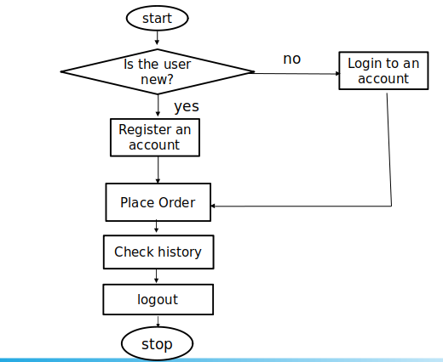

18 Page of 78

Admin-Flow Chart:-

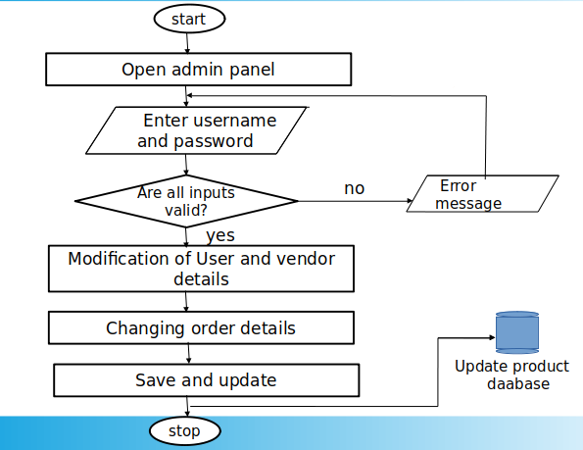

19 Page of 78

Adavntages of Proposed Technology:-

For Organization:-

1.Using E- Printing Press organizations can get more orders which most of them will be bulk orders which inturn will provide them good turnover than offline method.
2) As we are hosting a website online, it is a much efficient way for storing and retrieving information for the printing process. Organizations need to focus on quality users who can provide quantified orders.
3) Users will be sharing the files through Upload page and those can be retrieved easily rather than formal ways where we need to use external drivers for extracting data from users for printing purpose.
4)E-Printing press help organiztions to provide better customer service.
5) E-Printing press website helps publishers to get more orders which are financially high.

For Customers:-

1)It provides 24/7 availability, customer can enquire about a product or service and place order any time,any where from any location.
2)E-Printing press application provides users with more options to select the cheaper and better options than going by man.
3)E-Printing press helps in reducing the cost of products if the user needs bulk copies of documents which may be more costly when done offline.
4) E-Printing press provides better service and users need not to go anywhere else for availing the services.

20 Page of 78

Technologies and Tools Used:-

- FRONTEND : HTML , CSS , BootStrap,

- BACKEND : DJANGO

- DATABASE : SQLite

- ENVIRONMENT: Visual Studio Code.

HTML:-

means Hypertext Markup Language. This language is used in creating web pages. This language also supports other languages such CSS, PHP, JAVASCRIPT, etc. in creating interactive and responsive pages on the pages. HTML5 is just an updated version of the HTML. It supports new features, new attributes, new HTML elements, full CSS3 support, video and audio, 2D/3D graphics that help users and also help web developers to create new features easily on the website

21 page of 68

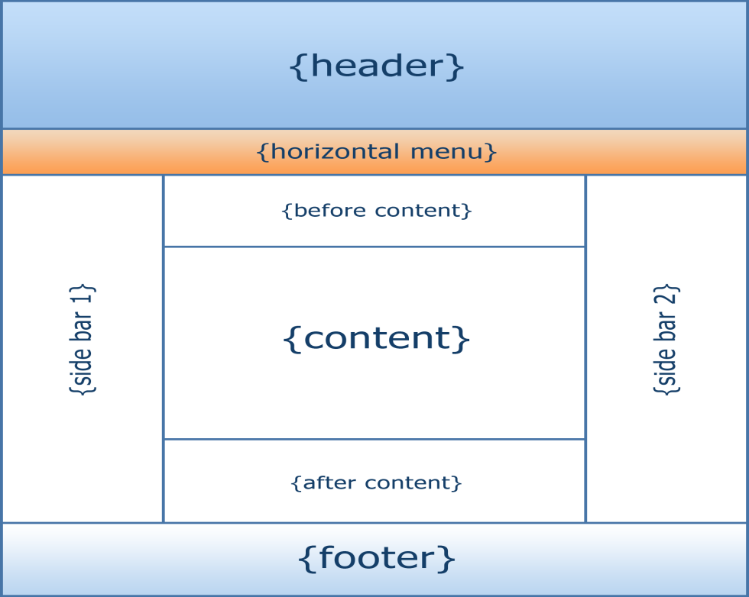

CSS:-

CSS is simply referred to as Cascading Style Sheets.CSS is used to define styles for web pages, including the design, layout, and variations in the display for different devices and screen sizes.

The general structure of CSS Basic syntax:

selector{property: value}

CSS can be used in a separate style sheet or used in the webpage

22 page of 68

JavaScript:-

Javascript is a high-level language which could be used independently or inculcated into the webpage. It can be used to, handle requests and responses and also add dynamic behavior and also store information on a website.

Syntax:
<script =”javascript” type=” text/javascript” >

JavaScript code
</script>

Bootstrap:-

Bootstrap is the most popular HTML, CSS, and JavaScript framework for developing responsive, mobile-first websites.
It includes HTML and CSS based design templates for typography, forms, buttons, tables, navigation, modals, image carousels, etc. It also gives you support for JavaScript plugins.

23 page of 68

Use Case Diagrams:-

Use case diagrams model behavior within a system and helps the developers understand of what the user require. The stick man represents what’s called an actor. Use case diagram can be useful for getting an overall view of the system and clarifying that can do and more importantly what they can’t do. Use case diagram consists of use cases and actors and shows the interaction between the use case and actors.

- The purpose is to show the interactions between the use case and actor.
- To represent the system requirements from user’s perspective.
- An actor could be the end-user of the system or an external system.

24 Page of 78

Use case for E-Printing Press website:-

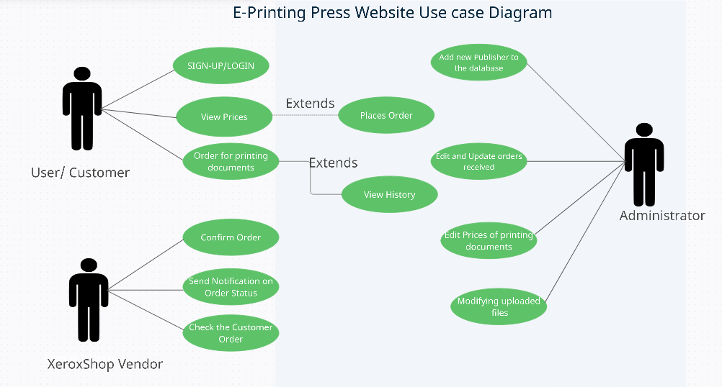

25 Page of 78

Use case Daigram for Top-Level.

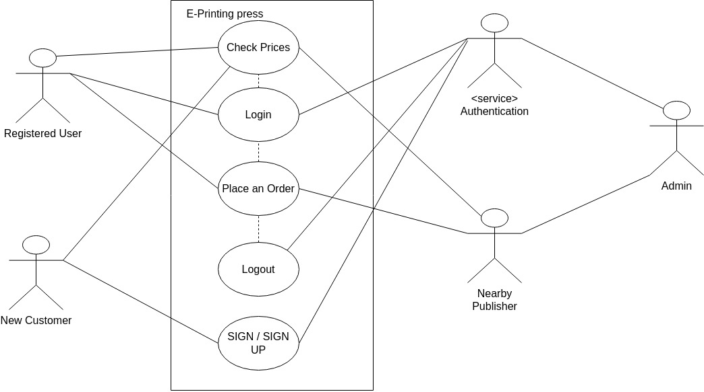

26 Page of 78

ER-Diagrams:-

The Entity-Relationship (ER) model was originally proposed by Peter in 1976 [Chen76] as a way to unify the network and relational database views. Simply stated the ER model is a conceptual data model that views the real world as entities and relationships. A basic component of the model is the Entity-Relationship diagram which is used to visually represent data objects. Since Chen wrote his paper the model has been extended and today it is commonly used for database design for the database designer, the utility of the ER model is:
- It maps well to the relational model. The constructs used in the ER model can easily be transformed into relational tables.
- It is simple and easy to understand with a minimum of training. Therefore, the model can be used by the database designer to communicate the design to the end user.
- In addition, the model can be used as a design plan by the database developer to implement a data model in specific database management software.

27 Page of 78

E-R Diagram:-

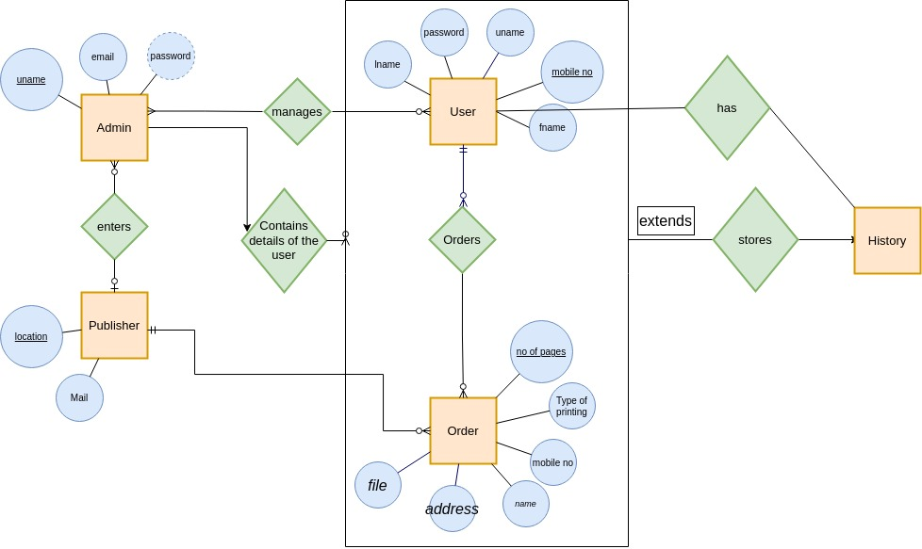

28 Page of 78

Source Code:-

Base.html

<!DOCTYPE html>
{%load static%}
<html lang="en">
<head>
<meta charset="utf-8">
<meta name="viewport" content="width=device-width, initial-scale=1">
<title>{% block title %}{% endblock %}</title>

{% block links %}{% endblock %}
<style>
*{
margin:0px;
padding:0px;
box-sizing: border-box;
font-family: 'Poppins', sans-serif;
}
nav{
width: 100%;
height: 75px;
background-color: #3D0649;
line-height: 75px;
padding:0px 100px;

z-index: 1;
}
nav ul{
float: right;
}
nav ul li{
display: inline-block;
list-style: none;
}

29 Page of 78
nav ul li a{

color:#FFFF;
text-decoration: none;
font-size: 15px;
font-weight: 150;
text-transform: uppercase;
padding:0px 32px;
margin-top: 0px;
}
nav ul li a:hover{
color:#c0d96f;
}
nav ul li .active{
color:#c0d96f;
}
{% block style %}{% endblock %}
</style>

</head>
<body>

<nav>

<ul>

<li>
<li> <a href="/">Home</a></li>
{% if not user.is_authenticated %}
<li> <a href="/login">login</a></li>
<li> <a href="/signup">signup</a></li>
{% else %}
<li> <a href="/logouthand">logout</a></li>
<li> <a href="/history">history</a></li>
{% endif %}
</ul>
</nav>
{% block body %}{% endblock body %}

30 Page of 78
<script src="https://cdn.jsdelivr.net/npm/bootstrap@5.2.1/dist/js/bootstrap.bundle.min.js" integrity="sha384-u1OknCvxWvY5kfmNBILK2hRnQC3Pr17a+RTT6rIHI7NnikvbZlHgTPOOmMi466C8" crossorigin="anonymous"></script>

</body>
</html>

index.html

<!DOCTYPE html>
{% extends 'base.html' %}
{%load static%}

{% block links %}
<link rel="stylesheet" href="https://cdn.jsdelivr.net/npm/bootstrap@4.0.0/dist/css/bootstrap.min.css" integrity="sha384-Gn5384xqQ1aoWXA+058RXPxPg6fy4IWvTNh0E263XmFcJlSAwiGgFAW/dAiS6JXm" crossorigin="anonymous">
<script src="https://code.jquery.com/jquery-3.2.1.slim.min.js" integrity="sha384-KJ3o2DKtIkvYIK3UENzmM7KCkRr/rE9/Qpg6aAZGJwFDMVNA/GpGFF93hXpG5KkN" crossorigin="anonymous"></script>
<script src="https://cdn.jsdelivr.net/npm/popper.js@1.12.9/dist/umd/popper.min.js" integrity="sha384-ApNbgh9B+Y1QKtv3Rn7W3mgPxhU9K/ScQsAP7hUibX39j7fakFPskvXusvfa0b4Q" crossorigin="anonymous"></script>
<script src="https://cdn.jsdelivr.net/npm/bootstrap@4.0.0/dist/js/bootstrap.min.js" integrity="sha384-JZR6Spejh4U02d8jOt6vLEHfe/JQGiRRSQQxSfFWpi1MquVdAyjUar5+76PVCmYl" crossorigin="anonymous"></script>
<link href="https://cdn.jsdelivr.net/npm/bootstrap@5.2.1/dist/css/bootstrap.min.css" rel="stylesheet" integrity="sha384-iYQeCzEYFbKjA/T2uDLTpkwGzCiq6soy8tYaI1GyVh/UjpbCx/TYkiZhlZB6+fzT" crossorigin="anonymous">
{% endblock links %}

31 Page of 78

{% block title %}homepage{% endblock title %}
{% block style %}

body{
background-image: url("{%static 'boxstylewriting.jpg'%}");
background-repeat: no-repeat;
background-size:100%;
height:100%;
}
{% endblock style %}
{% block body %}

<div>
<!-- {{var}}-->
{% if var%}
<div class="alert alert-success alert-dismissible fade show" role="alert">
<strong>Message: </strong>{{var}}
<button type="button" class="close" data-dismiss="alert" aria-label="Close">
<span aria-hidden="true">&times;</span>
</button>
</div>
</div>
{% endif %}
<div>
<br><br><br>
</div>
<a href="/prices" style="text-decoration:none; font-size:14px; text-align:center; margin: 0px auto; display:table;"><button type="submit" class=" btn btn-submitin btn-lg full-width btn btn-primary" id="login-submit" name="login" onClick="check_u_and_p()"><span id="login-text">View Prices</span>
<span id="login-load" style="display:none;"><i class="fa fa-circle-o-notch fa-spin"></i> Loading...</span></button></a>

<div>
<br><br><br>
</div>
{% if not user.is_authenticated %}

32 Page of 78
<button><a href="/login" style="text-decoration:none; font-size:14px; text-align:center; margin: 0px auto; display:table;"><button type="submit" class=" btn btn-submitin btn-lg full-width btn-primary" id="login-submit" name="login" onClick="check_u_and_p()"><span id="login-text">Order Now</span>

{% else %}
<a href="/order" style="text-decoration:none; font-size:14px; text-align:center; margin: 0px auto; display:table;"><button type="submit" class=" btn btn-submitin btn-lg full-width btn-primary" id="login-submit" name="login" onClick="check_u_and_p()"><span id="login-text">Order Now</span>
<span id="login-load" style="display:none;"><i class="fa fa-circle-o-notch fa-spin"></i> Loading...</span></button></a>

{% endif %}

{% endblock body %}

OUTPUT :-
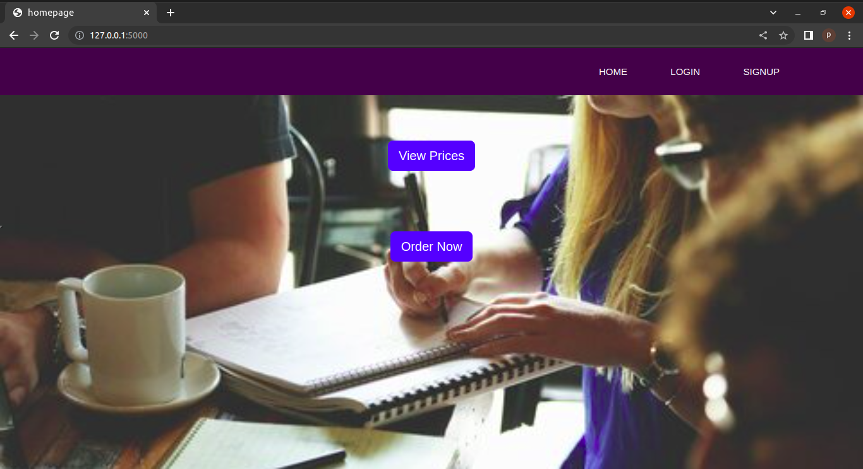

33 Page of 78

Prices.html

<!DOCTYPE html>

{% extends 'base.html' %}
{% block title %}prices{% endblock title %}
{% block style %}
html {
font-family: "helvetica neue", helvetica, arial, sans-serif;
}

thead th,
tfoot th {
font-family: "Rock Salt", cursive;
}

th {
letter-spacing: 2px;
}

td {
letter-spacing: 1px;
}

tbody td {
text-align: center;
}

tfoot th {
text-align: right;
}
table {
table-layout: fixed;
width: 100%;
border-collapse: collapse;
border: 3px solid purple;
}

thead th:nth-child(1) {
width: 30%;

34 Page of 78
}

thead th:nth-child(2) {
width: 20%;
}

thead th:nth-child(3) {
width: 15%;
}

thead th:nth-child(4) {
width: 35%;
}

th,
td {
padding: 20px;
}
{% endblock style %}
{% block links %}{% endblock links %}
{% block body %}

<table>

<thead>
<tr>
<th scope="col">Paper Type</th>
<th scope="col">Colour</th>
<th scope="col">Price</th>
</tr>
</thead>
<tbody>
<tr>
<th scope="row">A4</th>
<td>Black and White</td>
<td>3</td>

</tr>
<tr>
<th scope="row">Book</th>
<td>Black and white</td>
<td>3</td>
</tr>
<tr>

35 Page of 78
<th scope="row">Picture</th>
<td>Black and white</td>
<td>10</td>
</tr>
<tr>
<th scope="row">A4</th>
<td>Colour</td>
<td>10</td>
</tr>
<tr>
<th scope="row">Book</th>
<td>Colour</td>
<td>10</td>
</tr>
<tr>
<th scope="row">Picture</th>
<td>Colour</td>
<td>60</td>
</tr>

</tbody>

</table>
{% endblock body %}

OUTPUT :-
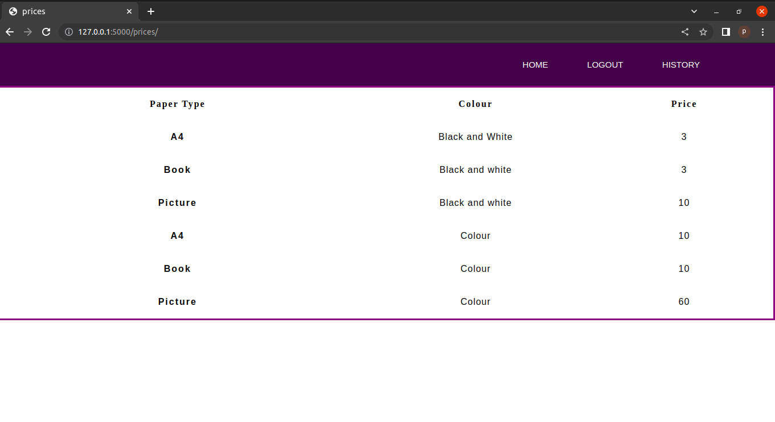
36 Page of 78
Project: urls.py

from django.contrib import admin
from django.urls import path,include
from django.conf import settings
from django.conf.urls.static import static

urlpatterns = [
path('admin/', admin.site.urls),
path('',include("home.urls")),
]+static(settings.MEDIA_URL,document_root=settings.MEDIA_ROOT)

App urls.py

from django.contrib import admin
from django.urls import path
from home import views

urlpatterns = [
path('', views.index,name="index"),
path('PageObjects', views.PageObjects,name="PageObjects"),
path('confirm/',views.confirm,name="confirm"),
path('prices/',views.prices,name="prices"),
path('payment/',views.payment,name="payment"),
path('signup/',views.signup,name="signup"),
path('login/',views.login,name="login"),
path('order',views.order,name="order"),
path('logouthand/',views.logouthand,name="logouthand"),
path('history/',views.history,name="history"),
path('prices/logouthand/',views.logouthand,name="logouthand"),
path('prices/history/',views.history,name="history"),
path('signuphandle',views.signuphandle,name="signuphandle"),

37 Page of 78
path('loginhandle',views.loginhandle,name="loginhandle"),
path('login/loginhandle/',views.loginhandle,name="loginhandle"),
path('forgothandle',views.forgothandle,name="forgothandle"),
path('forgot',views.forgot,name="forgot"),
path('otpval',views.otpval,name="otpval")
]

models.py

from django.db import models
from django.contrib import admin

# Create your models here.

class op(models.Model):
user_name=models.CharField(max_length=20,default="")
order_id=models.AutoField
name=models.CharField(max_length=50)
email=models.EmailField()
mobile=models.PositiveBigIntegerField()
street_no=models.CharField(max_length=50)
colony_choic=[
('idupulapaya','idupulapaya'),
('vempalli','vempalli'),
('kadiri','kadiri'),
('marripaadu','marripaadu'),
('rajampet','rajampet'),
('rajupalem','rajupalem'),
('kamalapuram','kamalapuram'),
('jammalamadugu','jammalamadugu'),
('pendlimarri','pendlimarri'),
('mylavaram','mylavaram'),
('duvuur','duvvur')
]

38 Page of 78
colony=models.CharField(max_length=50,choices=colony_choic)
name_of_pub=models.CharField(max_length=50)
date=models.DateTimeField(null=True)
no_of_pages=models.PositiveIntegerField(default=1)
no_of_copies=models.PositiveIntegerField(default=1)
type_choi=[
('black and white',"balck and white"),
('colur',"colour"),
]
paper_choi=[
('a4','a4'),
('pic','pic'),
('book','book'),
]
sides_choi=[
('one side','one side'),
('two side','two side'),
]
type=models.CharField(max_length=20,choices=type_choi,default="colour")
paper=models.CharField(max_length=10,choices=paper_choi,default="")
sides=models.CharField(max_length=10,choices=sides_choi,default="")
price=models.IntegerField(default=0)
discount=models.IntegerField(default=0)
payment=models.IntegerField(default=0)
file=models.FileField(upload_to="",null=True,blank=True)

def __str__(self):
return self.name

admin.py

from django.contrib import admin
from .models import op
admin.site.register(op)

39 Page of 78
forms.py

from django.forms import ModelForm
from .models import op

class orderform(ModelForm):
class Meta:
model=op
exclude = ['name_of_pub','date','price','discount','payment','user_name']
def __init__(self,*args,**kwargs):
super(orderform,self).__init__(*args,**kwargs)
self.fields['mobile'].widget.attrs.update({'class':'mob'})
self.fields['no_of_copies'].widget.attrs.update({'class':'mob'})
self.fields['no_of_pages'].widget.attrs.update({'class':'mob'})

views.py

from email import message
from .models import op
from django.shortcuts import render,HttpResponse,HttpResponseRedirect,redirect
from django.contrib.auth.models import User
from django.contrib import messages
from django.contrib.auth import authenticate,login as log,logout
from .forms import orderform
import datetime,random
from django.core.mail import send_mail,EmailMessage

# Create your views here.
def index(request):
return render(request,"index.html")
def prices(request):
return render(request,"prices.html")

40 Page of 78
def signup(request):
return render(request,"user/login-sign.html")
def login(request):
return render(request,"user/login.html")
def loginhandle(request):
if request.method=='POST':
login_uname=request.POST['login_uname']
login_password=request.POST['password']
user=authenticate(username=login_uname,password=login_password)

if user is not None:
log(request,user)
form=orderform()
return render(request,"order/order.html",{"form":form})
else:
mydict={"msg":"Invalid credentials"}
return render(request,'user/login.html',context=mydict)

def signuphandle(request):
if request.method=='POST':
name=request.POST['name']
password1=request.POST['password1']
password2=request.POST['password2']
email=request.POST['email']
mobile=request.POST['mobile']
fname=request.POST['fName']
lname=request.POST['lName']
l,u,p,d=0,0,0,0
if(len(password1)>=8):
for i in password1:
if i.islower():
l+=1
if i.isupper():
u+=1
if i.isdigit():
d+=1

41 Page of 78
if i=='@' or i=='$' or i=='_' or i=='-':
p+=1
if User.objects.filter(username=name).exists():
messages.error(request,"Username already exists,Enter unique username ")
return render(request,"user/login-sign.html")
elif(not len(name)>4 ):
messages.error(request,"user name should be of length atleast 4")
elif(not len(fname)>1 or not(fname.isalpha())):
messages.error(request,"Enter valid first name")
return render(request,"user/login-sign.html")
elif(not len(lname)>1 or not(lname.isalpha())):
messages.error(request,"Enter valid last name")
return render(request,"user/login-sign.html")

elif(not len(str(mobile))==10):
messages.error(request,"Enter valid mobile no")
return render(request,"user/login-sign.html")
elif(l<=1 or u<=0 or p<=0 or d<=0):
messages.error(request,"password should be of length 8 and include one capital letter,small letter,special char,digit")
return render(request,"user/login-sign.html")
elif(password1!=password2):
messages.error(request,"passwords didn't match")
return render(request,"user/login-sign.html")
else:
myuser=User.objects.create_user(name,email,password1)
myuser.fname=fname
myuser.lname=lname
myuser.save()
log(request,myuser)
return render(request,'index.html',{"var":"Account Created Successfully"})
else:
return render(request,"user/login-sign.html")

42 Page of 78
def PageObjects(request):
if request.method=='POST':
form=orderform(request.POST,request.FILES)
if form.is_valid():
if(len(form.cleaned_data['name'])<1 or not form.cleaned_data['name'].isalpha() ):
return render(request,'order/order.html',{"form":orderform(),"var":"Enter valid name"})
if(len(str(form.cleaned_data['mobile']))!=10):
return render(request,'order/order.html',{"form":orderform(),"var":"Enter valid mobile"})
if(len(str(form.cleaned_data['street_no']))==0):
return render(request,'order/order.html',{"form":orderform(),"var":"Enter valid street no"})
if(len(request.FILES)==0):
return render(request,'order/order.html',{"form":orderform(),"var":"Upload document"})

new_author = form.save(commit=False)
name=form.cleaned_data['colony']
if(name in ['idupulapaya','vempalli','kadiri','duvvur']):
new_author.name_of_pub="eswar"
elif(name in ['marripaadu','rajampet','rajupalem','kamalapuram']):
new_author.name_of_pub="reshma"
else:
new_author.name_of_pub="gayathri"
col=form.cleaned_data['type']
if col=="balck and white":
col_p=3
else:
col_p=10
pap=form.cleaned_data['paper']
if pap=="a4" or pap=="book":
pap_p=1
else :
pap_p=6
price=col_p * pap_p * form.cleaned_data['no_of_pages'] * form.cleaned_data['no_of_copies']
new_author.price=price
new_author.user_name=request.user.id

43 Page of 78
new_author.discount=price*0.3
new_author.payment=price-price*0.3
new_author.date=datetime.datetime.now()
new_author.save()
order_id=new_author.order_id
nam=form.cleaned_data['name']
email=form.cleaned_data['email']
mobile=form.cleaned_data['mobile']
st_no=form.cleaned_data['street_no']
colony=form.cleaned_data['colony']
name_of_pub=new_author.name_of_pub
date=new_author.date
no_of_pages=new_author.no_of_pages
no_of_copies=new_author.no_of_copies
type=new_author.type
paper=new_author.paper
sides=new_author.sides
pric=new_author.price
discount=new_author.discount
payment=new_author.payment
filename=new_author.file.name
path=new_author.file.path
dict={"order_id":order_id,"name":nam,"email":email,
"mobile":mobile,"address":st_no+" "+colony,"no_of_pages":no_of_pages,
"no_of_copies":no_of_copies,"type":type,"paper":paper,
"sides":sides,"Price":pric,"Discount":discount,"amount":payment,
"file":filename
}
msg="Name\t:\t"+nam+"\nEmail\t:\t"+email+"\nMobile\t:\t"+str(mobile)+"\nAddress\t:\t"+st_no+" "+colony+"\nDate\t:\t"+str(date)+"\nNo of pages\t:\t"+str(no_of_pages)+"\nNo of copies\t:\t"+str(no_of_copies)+"\nType\t:\t"+type+"\nPaper Type\t:\t"+paper+"\nSides\t:\t"+sides+"\nPrice\t:\t"+str(pric)+"\nDiscount\t:\t"+str(discount)+"\nAmount\t:\t"+str(payment)
if(name_of_pub=="eswar"):
to_add="r170243@rguktrkv.ac.in"
elif(name_of_pub=="reshma"):
to_add="r170205@rguktrkv.ac.in"

44 Page of 78
else:
to_add="r170204@rguktrkv.ac.in"
em_msg=EmailMessage("Order Received",msg,"printingpressapp@gmail.com",[to_add])
em_msg.attach_file(path)
em_msg.send()
with open('msg.txt', 'w') as file:
file.write(msg)
return render(request,"order/confirmation.html",dict)

else:
form=orderform()
return render(request,"order/order.html",{"form":form})

def payment(request):
return HttpResponse("HI")

def confirm(request):

return render(request,"index.html",{"var":"Order palced successfully"})

def logouthand(request):
logout(request)
return redirect('/')

def history(request):
u_name=request.user.id
data=op.objects.filter(user_name=u_name).values()
co=op.objects.filter(user_name=u_name).count()
# u_name=request.user.id
return render(request,"user/history.html",{"dict":data,"cou":co})
def forgot(request):
return render(request,'user/forgot.html')
def forgothandle(request):
if User.objects.filter(username=request.POST['user']).exists():

45 Page of 78
usr=User.objects.get(username=request.POST['user'])
otp = random.randint(111111, 999999)
send_mail(
"OTP verification",
"ur otp for the password change is "+str(otp),
"printingpressapp@gmail.com",
[usr.email],

)
with open('secureOtp.txt', 'w') as file:
file.write(str(otp))
with open('uname.txt', 'w') as file:
file.write(request.POST['user'])
return render(request,'user/otpval.html')
else:
return render(request,'user/forgot.html',{"error":"invalid username"})
def otpval(request):
with open('secureOtp.txt', 'r') as file:
actOTP = file.read()
if request.method=='POST':

with open('uname.txt', 'r') as file:
name = file.read()
l,u,p,d=0,0,0,0
if(len(request.POST['pass1'])>=8):
for i in request.POST['pass1']:
if i.islower():
l+=1
if i.isupper():
u+=1
if i.isdigit():
d+=1
if i=='@' or i=='$' or i=='_' or i=='-':
p+=1
if(l<=1 or u<=0 or p<=0 or d<=0):
return render(request,'user/otpval.html',{"error":"Enter valid password"})
if(request.POST['pass1']!=request.POST['pass2']):
return render(request,'user/otpval.html',{"error":"passwords didn't match"})
if request.POST['otp'] == actOTP:

46 Page of 78
return render(request,'user/otpval.html',{"error":"invalid otp"})
usr=User.objects.get(username=name)
usr.set_password(request.POST['pass1'])
usr.save()
return render(request,'user/login.html',{"msg":"password changed successfully"})
else:
return render(request,'user/otpval.html',{"error":"Enter Details"})

def order(request):
form=orderform()
return render(request,"order/order.html",{"form":form})

login.html

<!DOCTYPE html>
{% extends 'base.html' %}
{% block title %}login page{% endblock title %}
{% block links %}
{%load static%}
<link rel="stylesheet" href="{% static 'bootstrap.min.css' %}">
<link href="https://cdn.jsdelivr.net/npm/bootstrap@5.2.1/dist/css/bootstrap.min.css" rel="stylesheet" integrity="sha384-iYQeCzEYFbKjA/T2uDLTpkwGzCiq6soy8tYaI1GyVh/UjpbCx/TYkiZhlZB6+fzT" crossorigin="anonymous">
<link rel="stylesheet" href="{% static 'main/css/custom.css' %}">

{% endblock links %}

{% block style %}

.vh10{
font-size: 30px;
}
.divider:after,

47 Page of 78
.divider:before {
content: "";
flex: 1;
height: 1px;
background: #eee;
}
.h-custom {
height: calc(100% - 73px);
}
@media (max-width: 450px) {
.h-custom {
height: 100%;
}
}
{% endblock style %}
{% block body %}
{%load static%}
<section class="vh-100">
<div class="container-fluid h-custom fs-">
<div class="row d-flex justify-content-center align-items-center h-100 fw-bold " >
<div class="col-md-9 col-lg-6 col-xl-5">
<img src="https://mdbcdn.b-cdn.net/img/Photos/new-templates/bootstrap-login-form/draw2.webp"
class="img-fluid" alt="Sample image">
</div>
<div class="col-md-8 col-lg-6 col-xl-4 offset-xl-1">
<form method="post" action="/loginhandle" class="material-form">
{% csrf_token %}

<div class="d-flex flex-row align-items-center justify-content-center justify-content-lg-start">
<p class="lead mb-0 me-3"><b style="font-size:24px !important">Log in with</b></p>
</div>
<p class="form-label" style="color:red";>{{msg}}</p>
<div class="form-outline mb-4">
<label class="form-label" for="login_uname">Username</label>
<input type="text" id="login_uname" name="login_uname" class="form-control form-control-lg"

48 Page of 78
placeholder="Enter a valid username" />

</div>

<div class="form-outline mb-3">
<label class="form-label" for="fpassword">Password</label>
<input type="password" id="password" name="password" class="form-control form-control-lg"
placeholder="Enter password" />

</div>

<div>
<a href="/forgot" class="text-body">Forgot password?</a>
</div>

<div class="text-center text-lg-start mt-4 pt-2">
<button type="submit" class="btn btn-primary btn-lg"
style="padding-left: 2.5rem; padding-right: 2.5rem;" id="login-submit" name="login" onClick="check_u_and_p()"><span id="login-text">Login</span>
<span id="login-load" style="display:none;"><i class="fa fa-circle-o-notch fa-spin"></i> Loading...</span></button>

<p class="medium fw-bold mt-2 pt-1 mb-0">Don't have an account? <a href="/signup"
class="link-danger">Register</a></p>
</div>

</form>
</div>
</div>
</div>

</section>
{% endblock body %}

49 Page of 78

Output:-

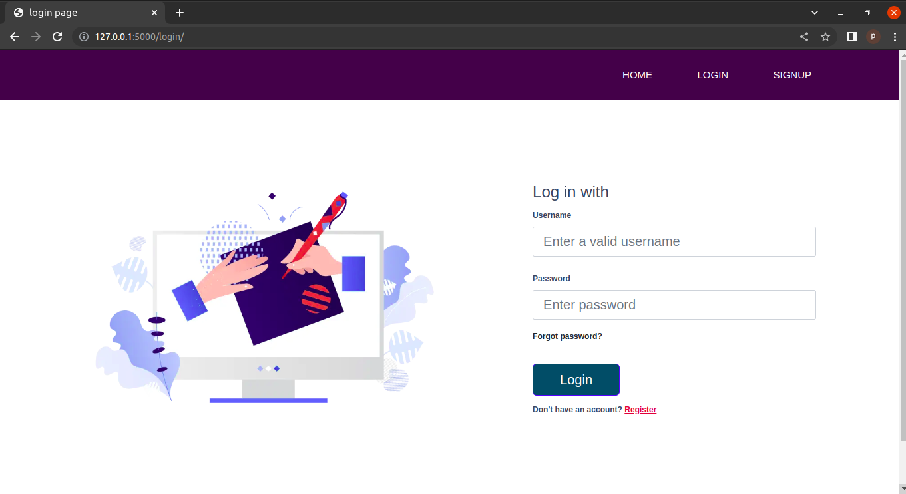

signup.html

<!DOCTYPE html>
{% extends 'base.html' %}
{%load static%}
{% block title %}signup{% endblock %}
{% block links %}
{%load static%}
<link rel="stylesheet" href="https://cdn.jsdelivr.net/npm/bootstrap@4.0.0/dist/css/bootstrap.min.css" integrity="sha384-Gn5384xqQ1aoWXA+058RXPxPg6fy4IWvTNh0E263XmFcJlSAwiGgFAW/dAiS6JXm" crossorigin="anonymous">
<script src="https://code.jquery.com/jquery-3.2.1.slim.min.js" integrity="sha384-KJ3o2DKtIkvYIK3UENzmM7KCkRr/rE9/Qpg6aAZGJwFDMVNA/GpGFF93hXpG5KkN" crossorigin="anonymous"></script>

50 Page of 78
<script
src="https://cdn.jsdelivr.net/npm/popper.js@1.12.9/dist/umd/popper.min.js" integrity="sha384-ApNbgh9B+Y1QKtv3Rn7W3mgPxhU9K/ScQsAP7hUibX39j7fakFPskvXusvfa0b4Q" crossorigin="anonymous"></script>
<script src="https://cdn.jsdelivr.net/npm/bootstrap@4.0.0/dist/js/bootstrap.min.js" integrity="sha384-JZR6Spejh4U02d8jOt6vLEHfe/JQGiRRSQQxSfFWpi1MquVdAyjUar5+76PVCmYl" crossorigin="anonymous"></script>
<link href="https://cdn.jsdelivr.net/npm/bootstrap@5.2.1/dist/css/bootstrap.min.css" rel="stylesheet" integrity="sha384-iYQeCzEYFbKjA/T2uDLTpkwGzCiq6soy8tYaI1GyVh/UjpbCx/TYkiZhlZB6+fzT" crossorigin="anonymous">

<link rel="stylesheet" href="{% static 'main/css/custom.css' %}">

{% endblock links %}
{% block style %}

.vh10{
font-size: 30px;
}
.divider:after,
.divider:before {
content: "";
flex: 1;
height: 1px;
background: #eee;
}
.h-custom {
height: calc(100% - 73px);
}
@media (max-width: 450px) {
.h-custom {
height: 100%;
}

{% endblock style %}

51 Page of 78
{% block body %}
{% for message in messages %}
<div class="alert alert-warning alert-dismissible fade show" role="alert">
<p style="font-size: large; padding:0%"> <strong>Message:</strong>{{message}}</p>
<button type="button" class="close" data-dismiss="alert" aria-label="Close">
<span aria-hidden="true">&times;</span>
</button>
</div>
{% endfor %}
<section class="vh-100">
<div class="container-fluid h-custom ">
<div class="row d-flex justify-content-center align-items-center h-100 " >
<div class="col-md-9 col-lg-6 col-xl-5">
<img src="https://mdbcdn.b-cdn.net/img/Photos/new-templates/bootstrap-login-form/draw2.webp"
class="img-fluid" alt="Sample image">
</div>
<div class="col-md-8 col-lg-6 col-xl-4 offset-xl-1">
<form method="post" action="/signuphandle" class="material-form">
{% csrf_token %}

<div class="d-flex flex-row align-items-center justify-content-center justify-content-lg-start">
<p class="lead mb-0 me-3"><b style="font-size:24px !important">Sign Up</b></p>
</div>
<p class="form-label" style="color:red";>{{var}}</p>
<div class="form-outline mb-4">
<label class="form-label" for="name">User name</label>
<input type="text" id="name" name="name" class="form-control form-control-lg"
placeholder="Enter unique username" />

</div>

52 Page of 78
<div class="form-outline mb-4">
<label class="form-label" for="fName">First name</label>
<input type="text" id="fName" name="fName" class="form-control form-control-lg"
placeholder="Enter first username" />

</div>
<div class="form-outline mb-4">
<label class="form-label" for="lName">Last name</label>
<input type="text" id="lName" name="lName" class="form-control form-control-lg"
placeholder="Enter Last username" />

</div>
<div class="form-outline mb-4">
<label class="form-label" for="email">Email Address</label>
<input type="email" id="email" name="email" class="form-control form-control-lg"
placeholder="Enter email address" />

</div>
<div class="form-outline mb-4">
<label class="form-label" for="mobile">Phone no</label>
<input type="tel" id="mobile" name="mobile" class="form-control form-control-lg"
placeholder="Enter mobile no" />

</div>

<div class="form-outline mb-4">
<label class="form-label" for="password1">Enter Password</label>
<input type="password" id="password1" name="password1" class="form-control form-control-lg"
placeholder="Enter Password" />

</div>
<div class="form-outline mb-3">
<label class="form-label"

53 Page of 78
for="password2">ConfirmPassword</label>
<input type="password" id="password2" name="password2" class="form-control form-control-lg"
placeholder="Confirm password" />

</div>

<button type="submit" class=" btn btn-primary btn-lg full-width btn-primary" id="login-submit" name="login" onClick="check_u_and_p()"><span id="login-text">Submit</span>
<span id="login-load" style="display:none;"><i class="fa fa-circle-o-notch fa-spin"></i> Loading...</span></button>
</div>
</form>
</div>
</div>
</div>
</section>

{% endblock body %}

Output:-

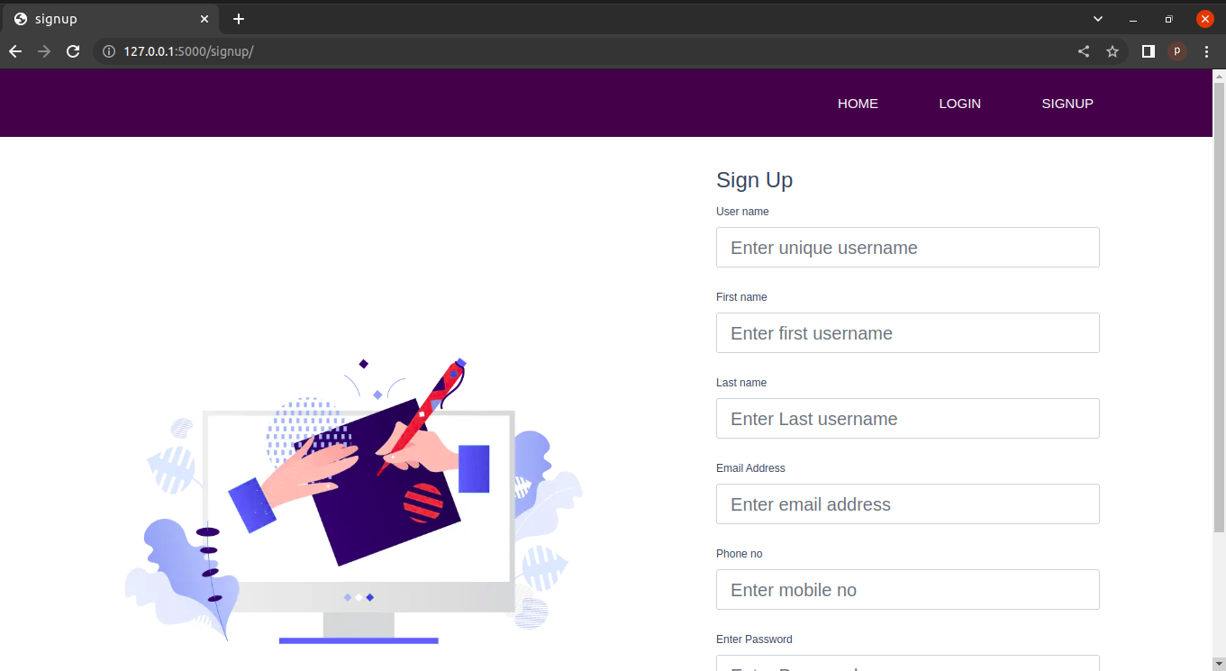

54 Page of 78

forgot.html:-

<!DOCTYPE html>
{% extends 'base.html' %}
{% block title %}login page{% endblock title %}
{% block links %}
{%load static%}
<link rel="stylesheet" href="{% static 'bootstrap.min.css' %}">
<link href="https://cdn.jsdelivr.net/npm/bootstrap@5.2.1/dist/css/bootstrap.min.css" rel="stylesheet" integrity="sha384-iYQeCzEYFbKjA/T2uDLTpkwGzCiq6soy8tYaI1GyVh/UjpbCx/TYkiZhlZB6+fzT" crossorigin="anonymous">
<link rel="stylesheet" href="{% static 'main/css/custom.css' %}">

{% endblock links %}

{% block style %}

.vh10{
font-size: 30px;
}
.divider:after,
.divider:before {
content: "";
flex: 1;
height: 1px;
background: #eee;
}
.h-custom {
height: calc(100% - 73px);
}
@media (max-width: 450px) {
.h-custom {
height: 100%;
}
}

{% endblock style %}

55 Page of 78

{% block body %}
{%load static%}
<section class="vh-100">
<div class="container-fluid h-custom fs-">
<div class="row d-flex justify-content-center align-items-center h-100 fw-bold " >
<div class="col-md-9 col-lg-6 col-xl-5">
<img src="https://mdbcdn.b-cdn.net/img/Photos/new-templates/bootstrap-login-form/draw2.webp"
class="img-fluid" alt="Sample image">
</div>
<div class="col-md-8 col-lg-6 col-xl-4 offset-xl-1">
<form method="post" action="/forgothandle" class="material-form">
{% csrf_token %}

<div class="d-flex flex-row align-items-center justify-content-center justify-content-lg-start">
<p class="lead mb-0 me-3"><b style="font-size:24px !important">Forgot Password</b></p>
</div>
<p class="form-label" style="color:red";>{{error}}</p>
<div class="form-outline mb-4">
<label class="form-label" for="user">Username</label>
<input type="text" id="user" name="user" class="form-control form-control-lg"
placeholder="Enter username" />

</div>

<div class="text-center text-lg-start mt-4 pt-2">
<button type="submit" class=" btn btn-primary btn-lg full-width btn-primary" id="login-submit" name="login" onClick="check_u_and_p()"><span id="login-text">Send OTP</span>
<span id="login-load" style="display:none;"><i class="fa fa-circle-o-notch fa-spin"></i> Loading...</span></button>
</div>
</div>
</form>

56 Page of 78
</div>
</div>
</div>

</section>
{% endblock body %}
<!--<!DOCTYPE html>
{%load static%}
<html lang="en">
<head>
<meta charset="utf-8">
<meta name="viewport" content="width=device-width, initial-scale=1">
<title>PrintingPress</title>
<link rel="stylesheet" href="{% static 'bootstrap.min.css' %}">
<link rel="stylesheet" href="{% static 'main/css/custom.css' %}">
<link href="https://cdn.jsdelivr.net/npm/bootstrap@5.2.1/dist/css/bootstrap.min.css" rel="stylesheet" integrity="sha384-iYQeCzEYFbKjA/T2uDLTpkwGzCiq6soy8tYaI1GyVh/UjpbCx/TYkiZhlZB6+fzT" crossorigin="anonymous">
<style>
*{
margin:0px;
padding:0px;
box-sizing: border-box;
font-family: 'Poppins', sans-serif;
}
nav{
width: 100%;
height: 75px;
background-color: #3D0649;
line-height: 75px;
padding:0px 100px;
position:fixed;
z-index: 1;
}
nav ul{
float: right;
}
nav ul li{
display: inline-block;
list-style: none;
}
57 Page of 78
nav ul li a{
color:#FFFF;
text-decoration: none;
font-size: 15px;
font-weight: 150;
text-transform: uppercase;
padding:0px 32px;
margin-top: 0px;
}
nav ul li a:hover{
color:#c0d96f;
}
nav ul li .active{
color:#c0d96f;
}
</style>
</head>
<body>

<nav>
<ul>
<li>
<li> <a href="/">Home</a></li>
{% if not user.is_authenticated %}
<li> <a href="/login">login</a></li>
<li> <a href="/signup">signup</a></li>
{% else %}
<li> <a href="logouthand/">logout</a></li>
<li> <a href="history/">history</a></li>
{% endif %}
</ul>
</nav>
<h1>Hello, world!</h1>
{{name}}
<div class="container">
<br/>
<br/>
<div class="well well1 " style="background:#FFFFFF; box-shadow: 0px 2px 4px 3px rgba(38, 51, 64, 0.4) !important; margin-bottom: 30px; height:100% !important">

<p style="font-size:14px "><b style="font-size:24px !important">Forgot password</b><br />

to continue to Xeroxshop.com</p>
58 Page of 78
<center><span id="user-availability-status" class="text-center"></span>
<span class='alert alert-danger center-block' id="empty-error" style="display:none;"> <i class='fa fa-times'></i> Please Enter Username and Password</span>
</center>
<form method="post" action="/forgothandle" class="material-form">
{% csrf_token %}
<p>{{error}}</p>
<div class="form-group ">
<input type="text" class="form-control na" placeholder="username" name="user" id="user" autofocus>

<span class="input-border"></span>
</span>

<br/>
<button type="submit" class=" btn btn-submitin btn-lg full-width btn-primary" id="login-submit" name="login" onClick="check_u_and_p()"><span id="login-text">Send OTP</span>
<span id="login-load" style="display:none;"><i class="fa fa-circle-o-notch fa-spin"></i> Loading...</span></button>

<br/>
</form>
</div>

</div>
<script src="https://cdn.jsdelivr.net/npm/bootstrap@5.2.1/dist/js/bootstrap.bundle.min.js" integrity="sha384-u1OknCvxWvY5kfmNBILK2hRnQC3Pr17a+RTT6rIHI7NnikvbZlHgTPOOmMi466C8" crossorigin="anonymous"></script>

</body>
</html>

59 Page of 78
Output:-

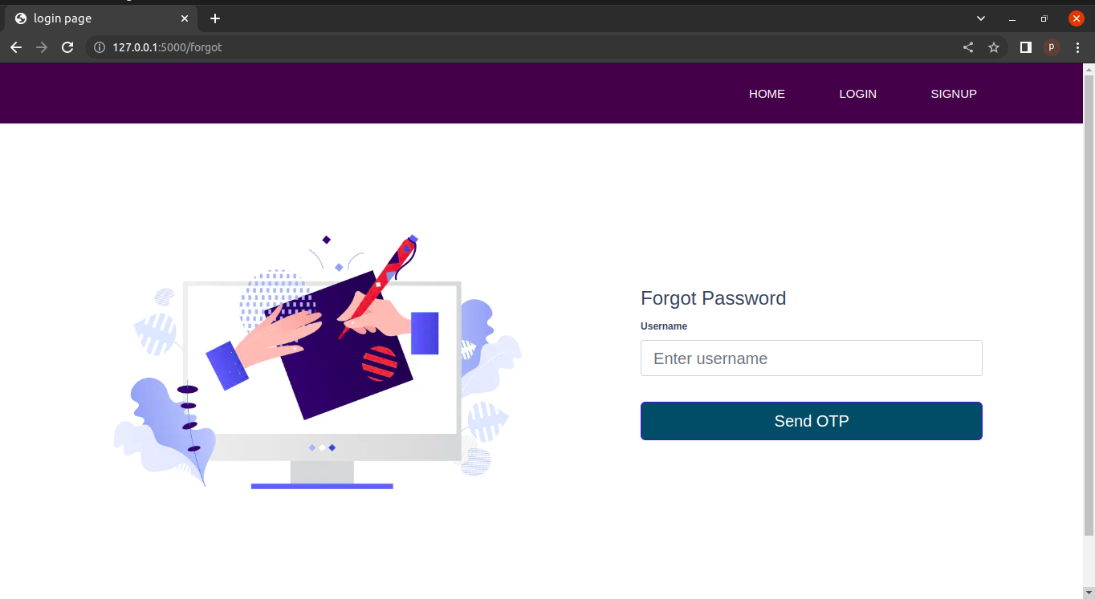

otpval.html

<!DOCTYPE html>
{% extends 'base.html' %}
{%load static%}
{% block title %}signup{% endblock %}
{% block links %}
{%load static%}
<link rel="stylesheet" href="https://cdn.jsdelivr.net/npm/bootstrap@4.0.0/dist/css/bootstrap.min.css" integrity="sha384-Gn5384xqQ1aoWXA+058RXPxPg6fy4IWvTNh0E263XmFcJlSAwiGgFAW/dAiS6JXm" crossorigin="anonymous">
<script src="https://code.jquery.com/jquery-3.2.1.slim.min.js" integrity="sha384-KJ3o2DKtIkvYIK3UENzmM7KCkRr/rE9/Qpg6aAZGJwFDMVNA/GpGFF93hXpG5KkN" crossorigin="anonymous"></script>
<script src="https://cdn.jsdelivr.net/npm/popper.js@1.12.9/dist/umd/popper.min.js" integrity="sha384-ApNbgh9B+Y1QKtv3Rn7W3mgPxhU9K/ScQsAP7hUibX39j7fakFPskvXusv
60 Page of 78
fa0b4Q" crossorigin="anonymous"></script>
<script src="https://cdn.jsdelivr.net/npm/bootstrap@4.0.0/dist/js/bootstrap.min.js" integrity="sha384-JZR6Spejh4U02d8jOt6vLEHfe/JQGiRRSQQxSfFWpi1MquVdAyjUar5+76PVCmYl" crossorigin="anonymous"></script>
<link href="https://cdn.jsdelivr.net/npm/bootstrap@5.2.1/dist/css/bootstrap.min.css" rel="stylesheet" integrity="sha384-iYQeCzEYFbKjA/T2uDLTpkwGzCiq6soy8tYaI1GyVh/UjpbCx/TYkiZhlZB6+fzT" crossorigin="anonymous">

<link rel="stylesheet" href="{% static 'main/css/custom.css' %}">

{% endblock links %}
{% block style %}

.vh10{
font-size: 30px;
}
.divider:after,
.divider:before {
content: "";
flex: 1;
height: 1px;
background: #eee;
}
.h-custom {
height: calc(100% - 73px);
}
@media (max-width: 450px) {
.h-custom {
height: 100%;
}

{% endblock style %}

{% block body %}
<section class="vh-100">
<div class="container-fluid h-custom ">
<div class="row d-flex justify-content-center align-items-center h-100 " >
<div class="col-md-9 col-lg-6 col-xl-5">
61 Page of 78
<img src="https://mdbcdn.b-cdn.net/img/Photos/new-templates/bootstrap-login-form/draw2.webp"
class="img-fluid" alt="Sample image">
</div>

<div class="col-md-8 col-lg-6 col-xl-4 offset-xl-1">
<form method="post" action="/otpval" class="material-form">
{% csrf_token %}
<div class="d-flex flex-row align-items-center justify-content-center justify-content-lg-start">
<p class="lead mb-0 me-3"><b style="font-size:24px !important">OTP validation</b></p>
</div>
<p class="form-label" style="color:red";>{{error}}</p>
<div class="form-outline mb-4">
<label class="form-label" for="password1">Enter Password</label>
<input type="password" id="pass1" name="pass1" class="form-control form-control-lg"
placeholder="Enter Password" />

</div>
<div class="form-outline mb-3">
<label class="form-label" for="password2">ConfirmPassword</label>
<input type="password" id="pass2" name="pass2" class="form-control form-control-lg"
placeholder="Confirm password" />

</div>
<div class="form-outline mb-3">
<label class="form-label" for="otp">Enter OTP</label>
<input type="number" id="otp" name="otp" class="form-control form-control-lg"
placeholder="OTP" />

</div>
<button type="submit" class=" btn btn-primary btn-lg full-width btn-primary" id="login-submit" name="login" onClick="check_u_and_p()"><span id="login-

62 Page of 78
text">Submit</span>
<span id="login-load" style="display:none;"><i class="fa fa-circle-o-notch fa-spin"></i> Loading...</span></button>
</div>

</form>
</div>
</div>
</div>

</section>

{% endblock body %}

Output :-

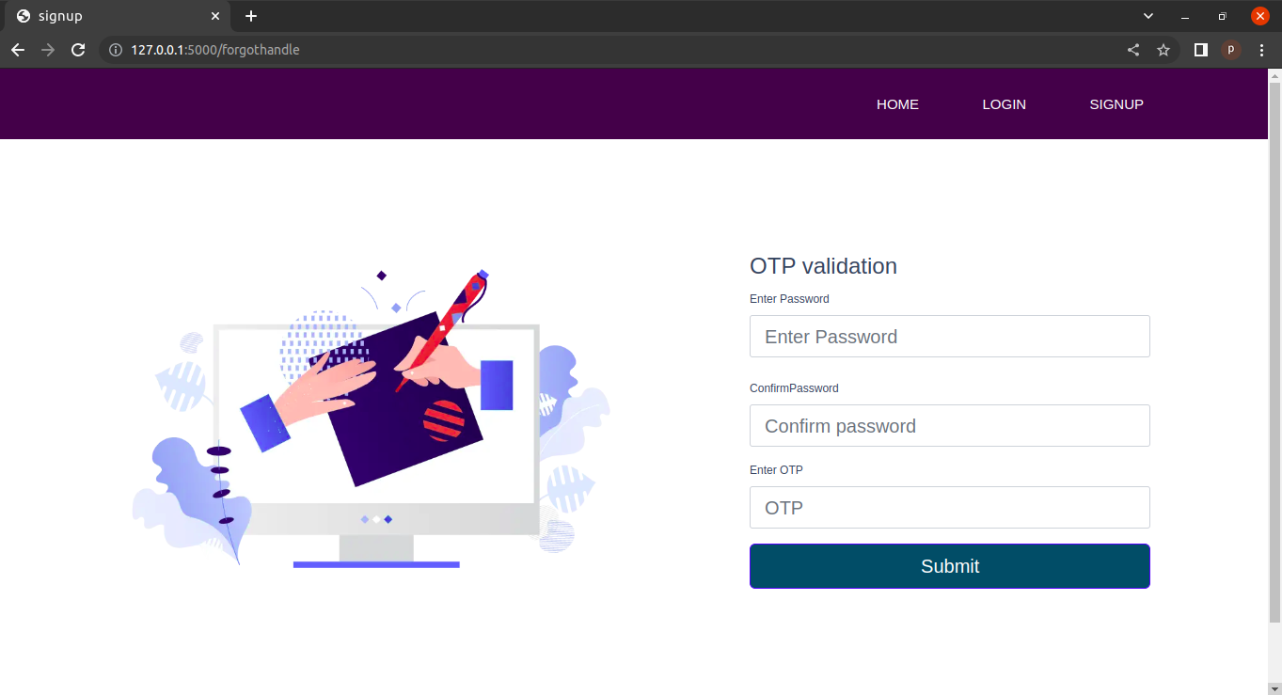

63 Page of 78
order.html:-

<!DOCTYPE html>
<html lang="en">
<head>
<meta charset="utf-8">
<meta name="viewport" content="width=device-width, initial-scale=1">
<title>PrintingPress</title>
<link href="https://cdn.jsdelivr.net/npm/bootstrap@5.2.1/dist/css/bootstrap.min.css" rel="stylesheet" integrity="sha384-iYQeCzEYFbKjA/T2uDLTpkwGzCiq6soy8tYaI1GyVh/UjpbCx/TYkiZhlZB6+fzT" crossorigin="anonymous">
<style>
*{
margin:0px;
padding:0px;
box-sizing: border-box;
font-family: 'Poppins', sans-serif;
}
nav{
width: 100%;
height: 75px;
background-color: #3D0649;
line-height: 75px;
padding:0px 100px;
position:fixed;
z-index: 1;
}
nav ul{
float: right;
}
nav ul li{
display: inline-block;
list-style: none;
}
nav ul li a{
color:#FFFF;
text-decoration: none;
font-size: 15px;
font-weight: 150;
text-transform: uppercase;
padding:0px 32px;
64 Page of 78

margin-top: 0px;
}
nav ul li a:hover{
color:#c0d96f;
}
nav ul li .active{
color:#c0d96f;
}
body {
font-family: Arial, Helvetica, sans-serif;
background-color: aliceblue;
margin: 0;
padding:0 0;
display: flex;
justify-content: center;
}

.page{
padding:5% 5%;
text-align: left;
background-color:white;
font-weight: bold;
word-spacing: 0%;
height:100%;
width:40%;

}
input[type=tel]{
width: 515px;
padding: 12px 20px;
margin: 8px 0;
display: inline-block;
border: 1px solid #ccc;
box-sizing: border-box;
}

.mob,select,input[type=file],input[type=text],input[type=tel],input[type=email],input[type=password] {
width: 100%;
padding: 12px 20px;
margin: 8px 0;
display: inline-block;
border: 1px solid #ccc;
box-sizing: border-box;
}
65 Page of 78
.mob,select:focus,input[type=text]:focus,input[type=text]:focus,input[type=tel]:focus,input[type=email]:focus,input[type=password]:focus{
outline: none;
}
button {
background-color: #164e10;
color: white;
padding: 14px 20px;
margin-bottom: 20px;
margin: 8px 0;

border: none;
cursor: pointer;
width: 100%;
font-weight: bold;
}

button:hover {
opacity: 0.8;
}

.imgcontainer {
text-align: center;
margin: 24px 0 12px 0;
}
.container {
padding: 16px;
}
.in{
float:left;
}

</style>
</head>
<body>
<nav>
<ul>
<li>
<li> <a href="/">Home</a></li>
{% if not user.is_authenticated %}
<li> <a href="/login">login</a></li>
<li> <a href="/signup">signup</a></li>
{% else %}
66 Page of 78
<li> <a href="logouthand/">logout</a></li>
<li> <a href="history/">history</a></li>
{% endif %}
</ul>
</nav>
<div class="page">
<form action="/PageObjects" method="post" enctype="multipart/form-data">
{% csrf_token %}
<div class="imgcontainer">
<h2><b>Order</b></h2>
<p>{{var}}</p>
</div>
<div class="container text-center">
{% for entry in form %}
<div class="in">

{{entry.label_tag}}
<br>
</div>
<div class="le">
{{entry}}
</div>
{% endfor %}
<button type="submit" >Order now</button>
</script>
</div>

</form>
</div>

<script src="https://cdn.jsdelivr.net/npm/bootstrap@5.2.1/dist/js/bootstrap.bundle.min.js" integrity="sha384-u1OknCvxWvY5kfmNBILK2hRnQC3Pr17a+RTT6rIHI7NnikvbZlHgTPOOmMi466C8" crossorigin="anonymous"></script>

</body>
</html>

67 Page of 78
Output:-

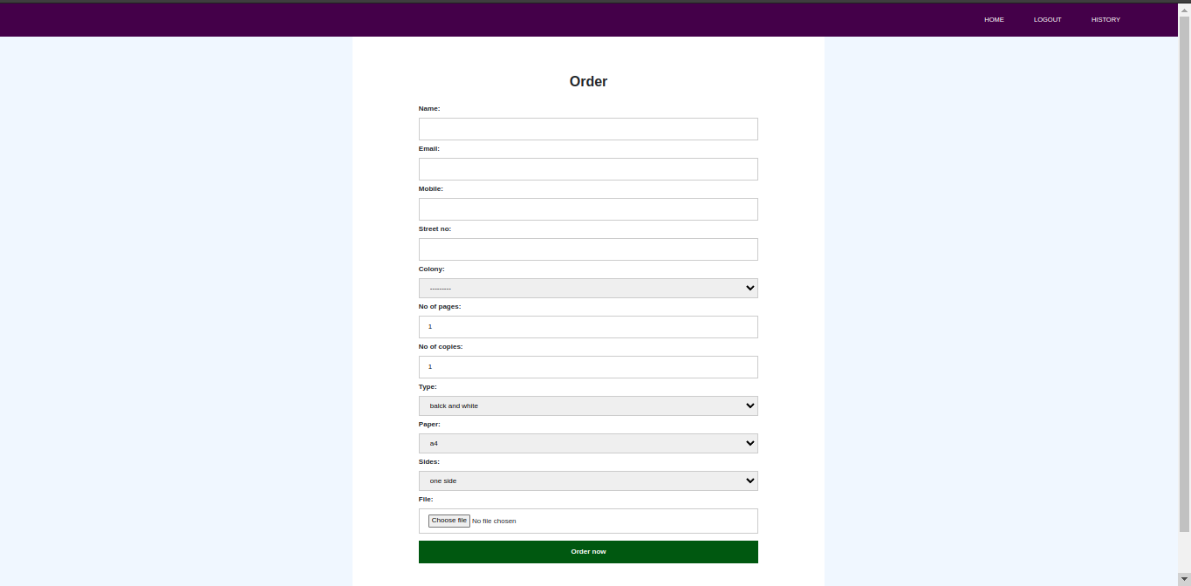

confirmorder.html:-

<!DOCTYPE html>
<html lang="en">
<head>
<meta charset="utf-8">
<meta name="viewport" content="width=device-width, initial-scale=1">
<title>PrintingPress</title>
<link

68 Page of 78
href="https://cdn.jsdelivr.net/npm/bootstrap@5.2.1/dist/css/bootstrap.min.css" rel="stylesheet" integrity="sha384-iYQeCzEYFbKjA/T2uDLTpkwGzCiq6soy8tYaI1GyVh/UjpbCx/TYkiZhlZB6+fzT" crossorigin="anonymous">
<style>

<style>
*{
margin:0px;
padding:0px;
box-sizing: border-box;
font-family: 'Poppins', sans-serif;
}
nav{
width: 100%;
height: 75px;
background-color: #3D0649;
line-height: 75px;
padding:0px 100px;
position:fixed;
z-index: 1;
}
nav ul{
float: right;
}
nav ul li{
display: inline-block;
list-style: none;
}
nav ul li a{
color:#FFFF;
text-decoration: none;
font-size: 15px;
font-weight: 150;
text-transform: uppercase;
padding:0px 32px;
margin-top: 0px;
}
nav ul li a:hover{
color:#c0d96f;
}
nav ul li .active{
color:#c0d96f;
}

69 Page of 78
</style>

<style>

html {
font-family: "helvetica neue", helvetica, arial, sans-serif;
}

thead th,
tfoot th {
font-family: "Rock Salt", cursive;
}

th {
letter-spacing: 2px;
}

td {
letter-spacing: 1px;
}

tbody td {
text-align: center;
}

tfoot th {
text-align: right;
}
</style>
<style>
table {
table-layout: fixed;
width: 100%;
border-collapse: collapse;
border: 3px solid purple;
}

thead th:nth-child(1) {
width: 30%;
}

thead th:nth-child(2) {
width: 20%;

70 Page of 78
}

thead th:nth-child(3) {
width: 15%;
}

thead th:nth-child(4) {
width: 35%;
}

th,
td {
padding: 20px;
}
</style>
</head>
<body>

<nav>
<ul>
<li>
<li> <a href="/">Home</a></li>
{% if not user.is_authenticated %}
<li> <a href="/login">login</a></li>
<li> <a href="/signup">signup</a></li>
{% else %}
<li> <a href="logouthand/">logout</a></li>
<li> <a href="history/">history</a></li>
{% endif %}
</ul>
</nav>

<div>
<table>
<tr>
<th colspan="2">Confirm Details
</th>
</tr>
<tr>
<td>name</td>
<td>{{name}}</td>
</tr>
<tr>
<td>email adress</td>
<td>{{email}}</td>
71 Page of 78
</tr>
<tr>
<td>mobile</td>
<td>{{mobile}}</td>
</tr>
<tr>
<td>address</td>
<td>{{address}}</td>
</tr>
<tr>
<td>no of pages</td>
<td>{{no_of_pages}}</td>
</tr>
<tr>
<td>no of copies</td>
<td>{{no_of_copies}}</td>
</tr>
<tr>
<td>type</td>
<td>{{type}}</td>
</tr>
<tr>
<td>paper</td>
<td>{{paper}}</td>
</tr>
<tr>
<td>sides</td>
<td>{{sides}}</td>
</tr>
<tr>
<td>Total amount</td>
<td>{{Price}}</td>
</tr>
<tr>
<td>Discount</td>
<td>{{Discount}}</td>
</tr>
<tr>
<td>amount</td>
<td>{{amount}}</td>
</tr>
<tr>
<td>file</td>
<td>{{file}}</td>
</tr>

72 Page of 78
</table>
<div class="text-center">
<a href="confirm/"><button class="btn btn-submitin btn-lg full-width btn-primary">place order</button></a>
</div>
</div>
<script src="https://cdn.jsdelivr.net/npm/bootstrap@5.2.1/dist/js/bootstrap.bundle.min.js" integrity="sha384-u1OknCvxWvY5kfmNBILK2hRnQC3Pr17a+RTT6rIHI7NnikvbZlHgTPOOmMi466C8" crossorigin="anonymous"></script>

</body>
</html>

Output:-

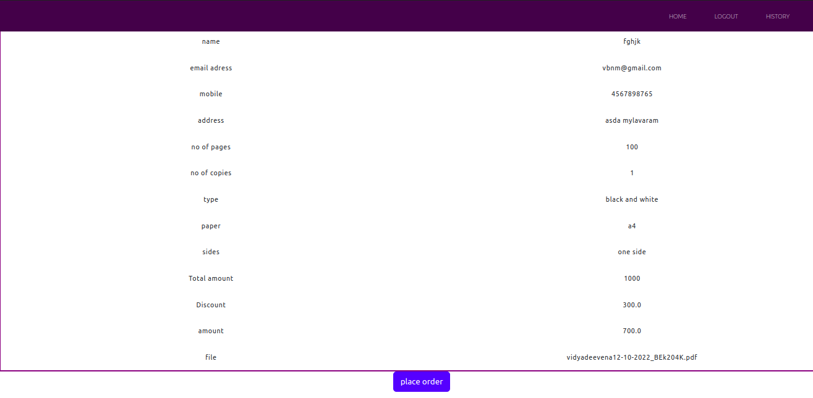

history.html:-

<!doctype html>
{% extends 'base.html' %}
{% block title %}history{% endblock title %}

{% block links %}
<link rel="stylesheet" href="https://cdn.jsdelivr.net/npm/bootstrap@4.0.0/dist/css/bootstrap.min.css" integrity="sha384- 73 Page of 78 Gn5384xqQ1aoWXA+058RXPxPg6fy4IWvTNh0E263XmFcJlSAwiGgFAW/dAiS6JXm" crossorigin="anonymous">
<script src="https://code.jquery.com/jquery-3.2.1.slim.min.js" integrity="sha384-KJ3o2DKtIkvYIK3UENzmM7KCkRr/rE9/Qpg6aAZGJwFDMVNA/GpGFF93hXpG5KkN" crossorigin="anonymous"></script>
<script src="https://cdn.jsdelivr.net/npm/popper.js@1.12.9/dist/umd/popper.min.js" integrity="sha384-ApNbgh9B+Y1QKtv3Rn7W3mgPxhU9K/ScQsAP7hUibX39j7fakFPskvXusvfa0b4Q" crossorigin="anonymous"></script>
<script src="https://cdn.jsdelivr.net/npm/bootstrap@4.0.0/dist/js/bootstrap.min.js" integrity="sha384-JZR6Spejh4U02d8jOt6vLEHfe/JQGiRRSQQxSfFWpi1MquVdAyjUar5+76PVCmYl" crossorigin="anonymous"></script>
<link href="https://cdn.jsdelivr.net/npm/bootstrap@5.2.1/dist/css/bootstrap.min.css" rel="stylesheet" integrity="sha384-iYQeCzEYFbKjA/T2uDLTpkwGzCiq6soy8tYaI1GyVh/UjpbCx/TYkiZhlZB6+fzT" crossorigin="anonymous">
{% endblock links %}
{% block body %}
<table style="border:3px solid purple" class="table table-hover">
<thead>
<tr style="background-color: aqua;">
<th scope="col">File</th>
<th scope="col">No of Copies</th>
<th scope="col">Type</th>
<th scope="col">Paper</th>
<th scope="col">Sides</th>
<th scope="col">Amount</th>
<th scope="col">Vendor</th>
</tr>
</thead>
<tbody>
<!--{{dict}} -->
{% for i in dict %}
<tr>
<td scope="row">{{i.file}}</td>
<td scope="row">{{i.no_of_copies}}</td>
<td scope="row">{{i.type}}</td>
<td scope="row">{{i.paper}}</td>
<td scope="row">{{i.sides}}</td>
74 Page of 78
<td scope="row">{{i.payment}}</td>
<td scope="row">{{i.name_of_pub}}</td>
</tr>
{% endfor %}

</tbody>
</table>

{% endblock body %}

Output:-

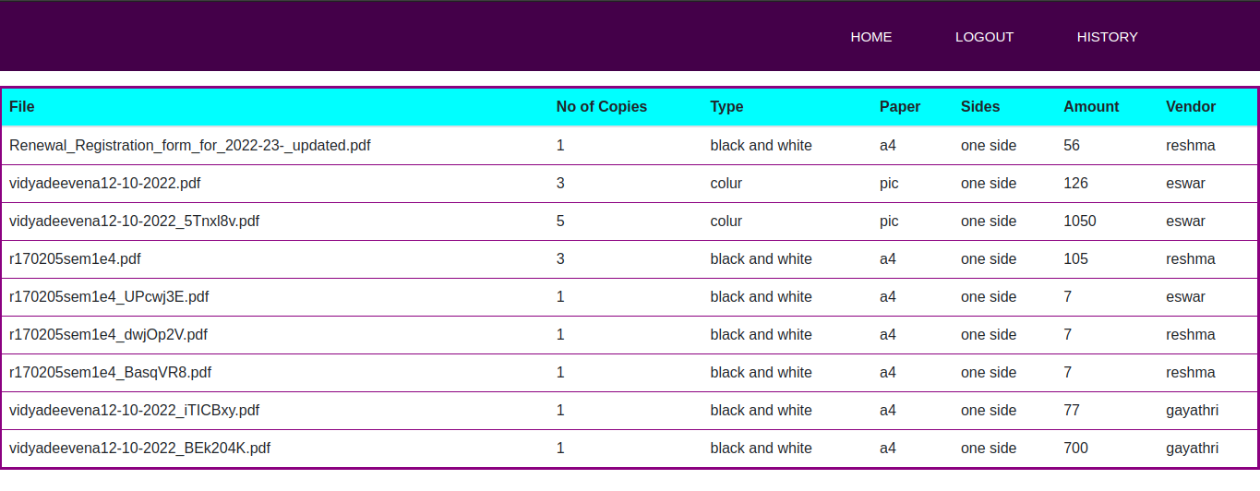
Admin Panel :-

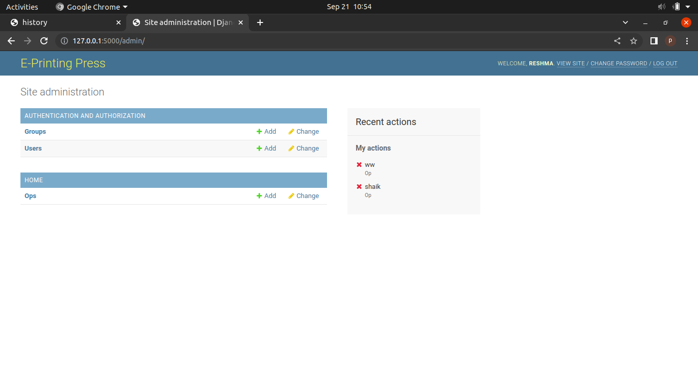

Conclusion:-

After careful observation, it has come to my conclusion that everything is becoming digital and has undeniably become an important part of our society. The world wide web is and will have a large part in our daily lives.
This web application provides user to take printed copies of the documents without manual interference and receiving Hard copies at doorstep. Online Printing press being web based needs to be thoroughly tested before implementation to find any security gaps.

76 Page of 78
Future Enhancement:-

- In the future we can add the Retailers modules for best quality purpose.
- We can add the machine Learning Algorithms for automated shopping in the store.
- We can add the return orders after the orders are delivered to the customer and the customer is not satisfied about their products.
- Maintaining retailers and Designers data are helpful in the improving the marketing tactics.

77 Page of 78

References:-

HTML & CSS
- HTML- W3schools
- CSS - W3Schools

BOOTSTRAP
- Bootstrap - W3schools

- https://getbootstrap.com/

DJANGO
- Django Documentaion

- https://www.youtube.com/playlist?list=PLu0W_9lII9ah7DDtYtflgwMwpT3xmjXY9

78 Page of 78

