1. What is DEVOPS ?

Ans:

DevOps integrates developers and operations teams in order to improve collaboration and productivity by automation infrastructure, automating workflows and continuously measuring application performance.

**Automation**

Automate code testing

Automate workflows

Automate infrastructure

Automate everything

**Benefits of DevOps:**

Faster time to market

More focus on improving the business

Innovate (new product develops) faster

More responsive to business needs

Better collaboration

Better quality

More frequent releases

1. What is Continuous Integration (CI) ?

Ans:

CI is the process of automating the build and testing of code every time, a team member commits changes to version control system(VSC). CI encourages developers to share their code and unit tests by merging their changes into a shared version control repository after every small task completion. Commiting code triggers an automated build system to grab the latest code from the shared repository and to build, test, and validate the full master branch (also known as the trunk or main).

**Continuous integration tools:**

1. Jenking
2. Circle CI
3. Hudson
4. Buildbot
5. Travis CI
6. Bamboo
7. Teamcity
8. What is Jenkins ?

Ans:

Jenkins is a continuous integration server which can fetch the latest code from VCS, build it, test it and modify it to the developers. Jenkins can do many more things apart from just being a CI server. It was orginally know a Hudson, Oracle inc owns Hudson now. Jenkins is an open source project writing by Kohsuke kawaguchi.

Jenkins is a java based wed application server.

1. What is Version Control System?

Ans:

Version Control system is a system that allows you to manage multiple revisions of the same unit of information. For example of documents, of source files or any other items of that sort. And as the graphical depiction(picture) shows, a VCS allows a multiple actor. Here we have all, to cooperate and share files.

**Why is VCS useful?**

1. Enforce discipline
2. Archive versions
3. Maintain historical information
4. Enable collaboration
5. Record from accidental deletions and edits
6. Conserve disk space

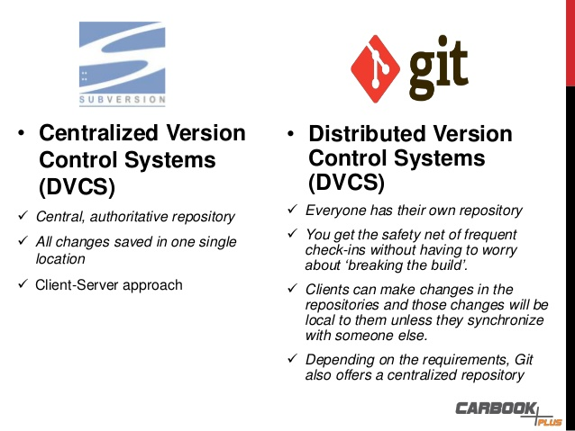

|  |  |
| --- | --- |
| SVN (Sub Version) | GIT |
| Server-Client based | Every project independent |
| You always need net connection | No need of continues net connection |
| Eat more disk space more burden | Less disk space and less burden |
| Centralised version control system | Distributed version control system |

1. What is Version Configuration Management (CM)?

Ans:

Configuration Management is basically a process, then help to manage change in your infrastructure in a most systematic and structure way, if we are updating a software you keep a record of what are thinks your updated and what are changes you are making in your infrastructure all those thinks.

To achieve configuration management with the help of “Infrastructure as code” (IAC)

Configuration Management (CM) tools are used to deploy the code on multiple servers parallelly.

Here we can deploy the same code on multiple servers. So, that we can access the application quickly based on the load

https://www.lynda.com/Chef-tutorials/Manage-multiple-nodes/585256/620740-4.html

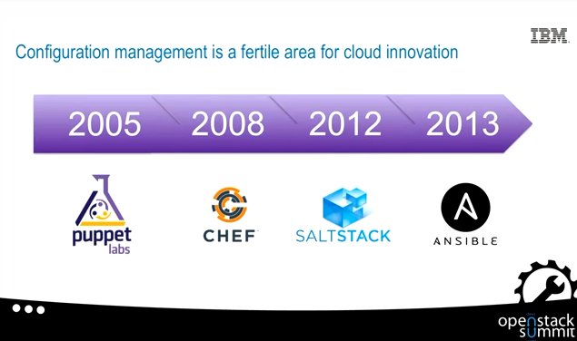

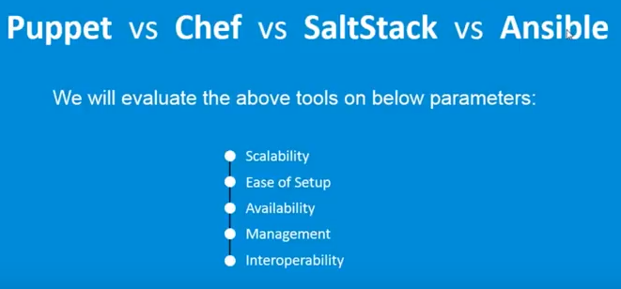

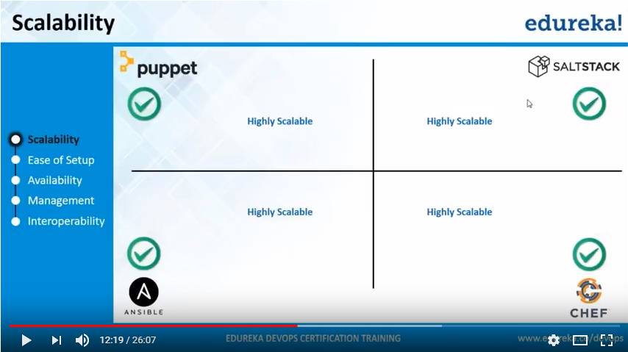

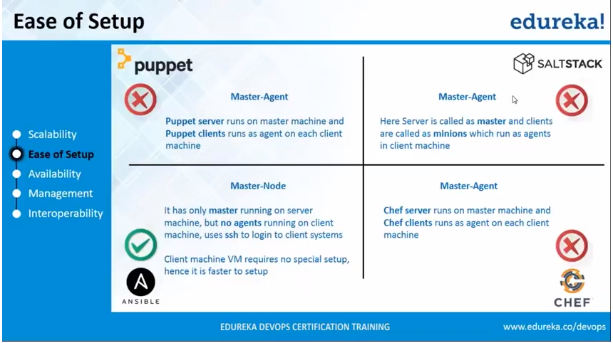

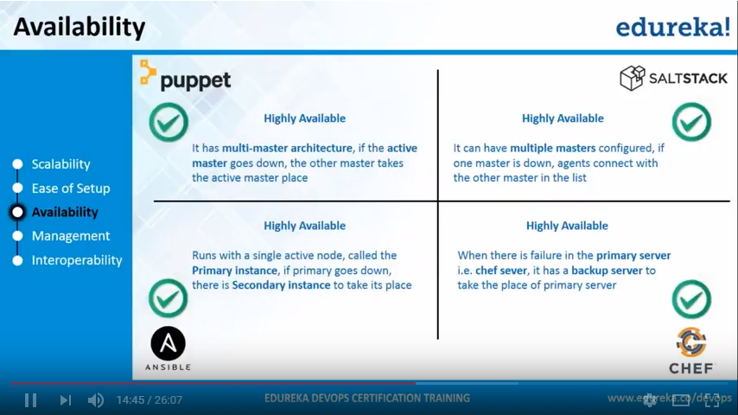

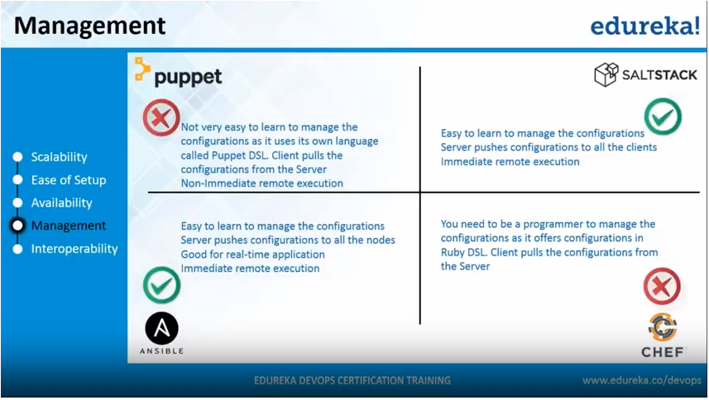

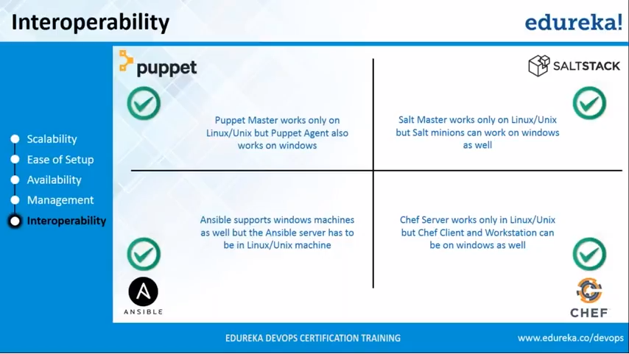

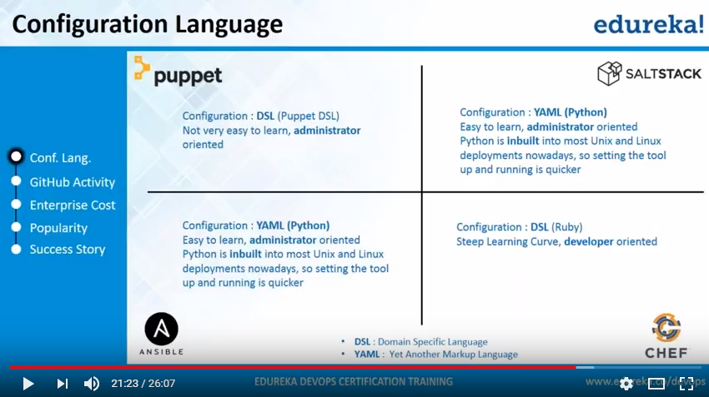

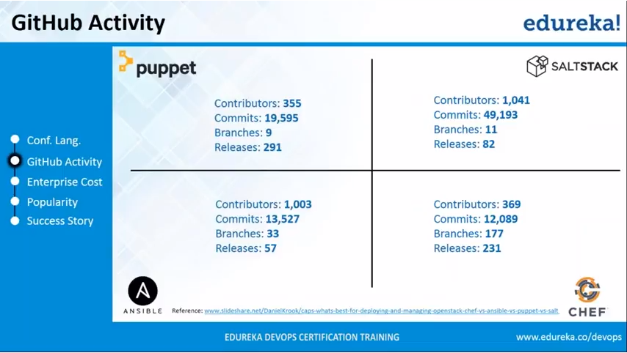

1. What is Microservice?

Ans:

Essentially, **Microservice** architecture is a method of developing software applications as a suite of independently deployable, small, modular services in which each service runs a unique process and communicates through a well-defined, lightweight mechanism to serve a business goal.

1. What is Virtual machine?

Ans:

A virtual machine is a software computer that, like a physical computer, run an operating system and application. An operating system installed on a virtual machine is called a guest operating system.

Because every virtual machine is an isolated computing environment. You can use virtual machine as desktop or workstation environments, as testing environments, or to consolidate server application.

Virtual machine run on hosts. The same host can run many virtual machines.

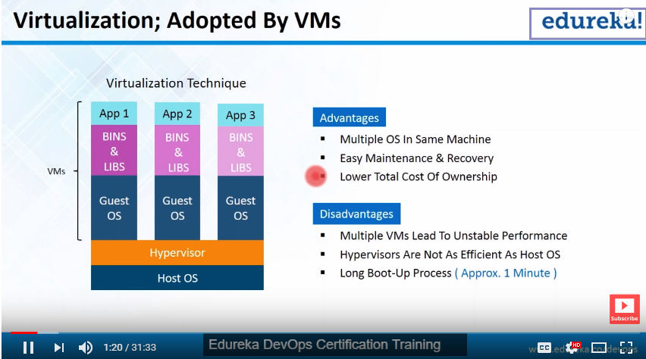

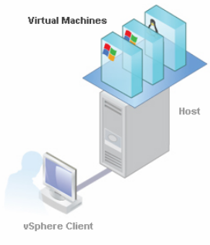

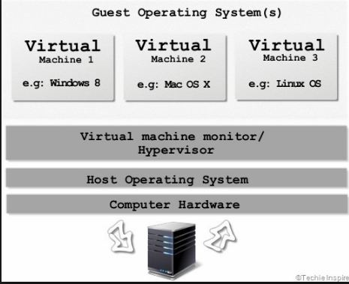

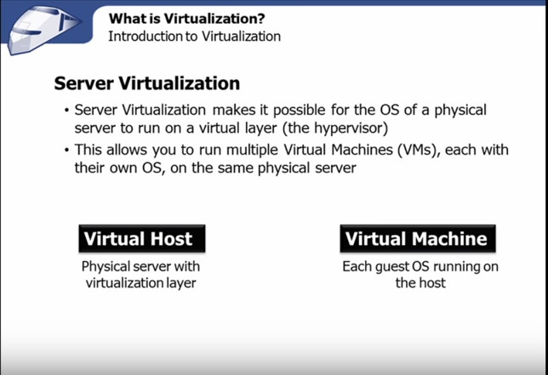

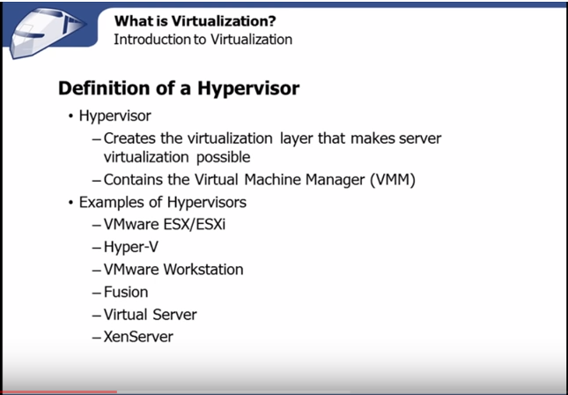

1. What is Docker?

Ans:

A

