**S3**

# S3 ACCESS PERMISSIONS

$ aws configure

AWS Access Key ID [None]: AKIAI44QH8DHBEXAMPLE

AWS Secret Access Key [None]: je7MtGbClwBF/2Zp9Utk/h3

Default region name [None]: us-east-1

Default output format [None]: text

Assign S3 Access roles to EC2 Instance

# HOW TO COPY LOCAL FILES TO S3 WITH AWS CLI

Aws s3 cp <source> <destination>

Aws s3 cp <Local Path> <S3 URL>

**SNS**

SNS (Simple notification service)

Amazon SNS enable you to set up, operate, and send notification to subscribing service other applications. Message published to topic. Topic subscribers receive message

Subscriber types:

1. Email (plain or JSON)
2. HTTP/HTTPS
3. Short message service (SMS) Cellular text messages
4. Amazon SQS queues
5. Mobile push messaging
6. S3 bucket Event Notification
7. AWS Lambda function

Publisher:

* Human
* S3 Event
* Cloud watch Alarm

**SQS**

Queues help to you to streamline things,

think of queues as simple pipe from one side continuously writing messages and another end of pipe is continuously reading.

it read a message and understands that what is the content of message it will go ahead and the process that message. And once it can process the message it will go ahead and delete it from that queue or pipe.

Unless until a message is processed there is no chance that it will get deleted.

SQS Parameters.

1. Give SQS Name
2. Pass parameters
3. Every Message size = Max 256 KB
4. Max retention period in Queue= 14 Days

While Pipe both end continuous to write and continues to read at same time by this process using AWS Simple API.

Setup the IAM user or role you give the permissions only that particular guy would be read and write from the queue.

Wherever a synchronous processing is okay where it is fine to smaller amount of delay in process it’s okay any batch processing this is good bill processing, batch processing.

Example:

Go to Amazon or Flipkart and done shopping and process to payment, once done the successful payment there is no failure nothing the request back and you see a red colour text which says payment happened still not placed order is not conformed and then within a period of probably two minutes or five minutes you get second email which says your order is conformed.

This scenario once payment completed, backed run lot of process, check the payment details, stock availability and conform to order this all are running in backend.

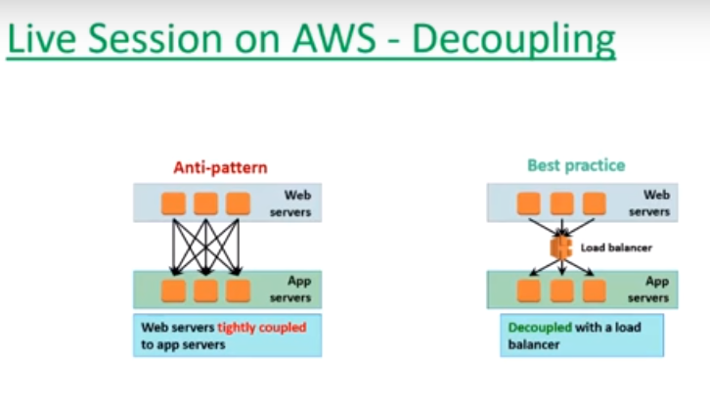

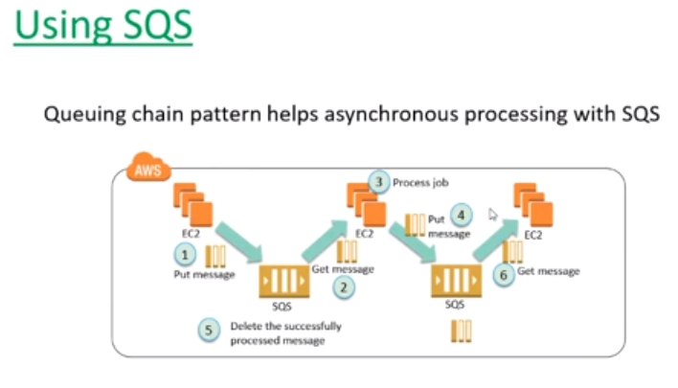

**Network Access Control List (N - ACL)**

|  |  |
| --- | --- |
| **Security Group** | **NACL** |
| Attached to EC2 Instances | Attached to Subnets |
| Only allow option is available | Allow & Denay both options available |
| Max 50 Rules can assign  1 EC2 Instance Max 5 Security Groups can assign | Max 20 Rules can assign |

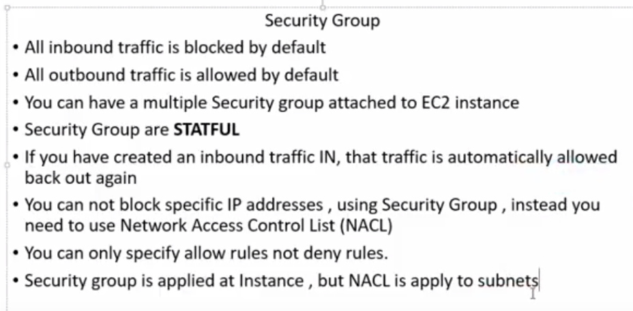

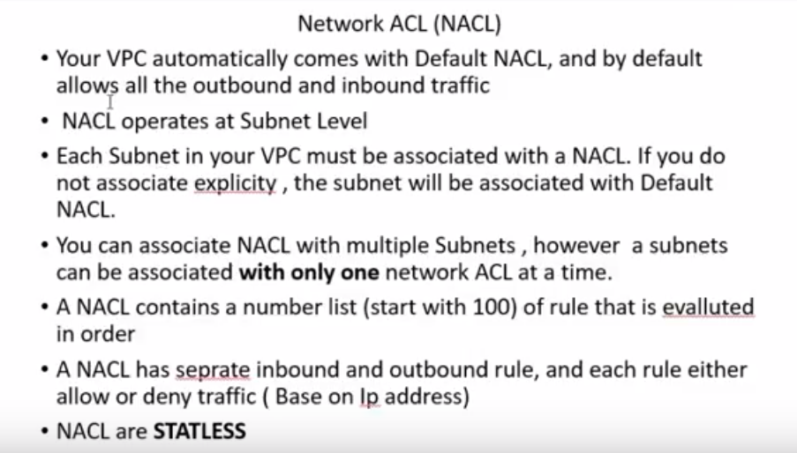

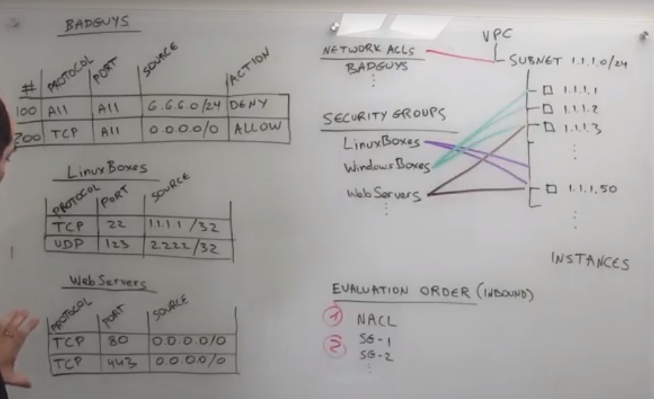

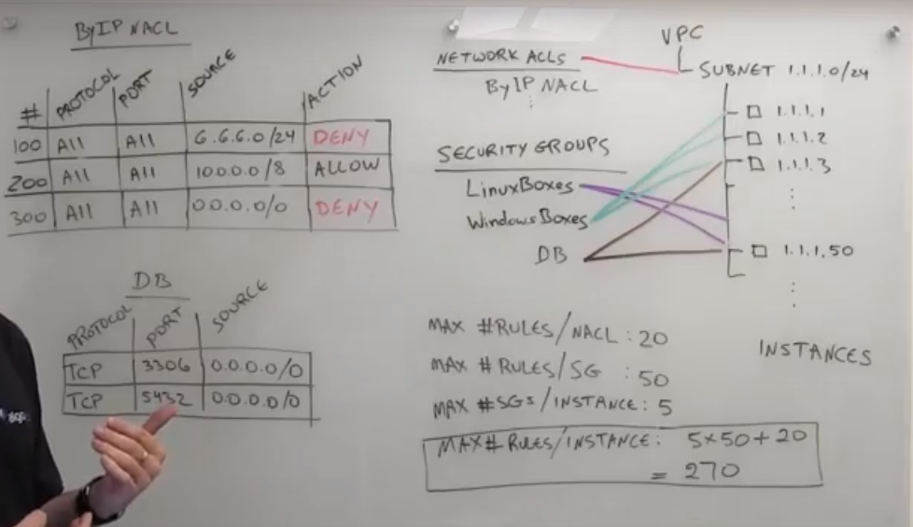

**Cloud-formation**

**Types**

1. Stack
2. Stack-set
3. Template
4. Cloud-Former

**Cloud formation parameters**

AWSTemplateFormatVersion: "*version date*"

Description:

*String*

Metadata:

*template metadata*

Parameters:

*set of parameters*

Mappings:

*set of mappings*

Conditions:

*set of conditions*

Transform:

*set of transforms*

Resources:

*set of resources*

Outputs:

*set of outputs*