**Sonar-Qube**

#Go to Sonarqube.ogr

wget <https://sonarsource.bintray.com/Distribution/sonarqube/sonarqube-6.7.3.zip>

unzip sonarqube-6.7.3.zip

/root/sonarqube-6.7.3/bin/linux-x86-64/ sonar.sh start

/root/sonarqube-6.7.3/bin/linux-x86-64/ sonar.sh stop

/root/sonarqube-6.7.3/bin/linux-x86-64/ sonar.sh restart

**#Setting Up Sonar-qube As A Service**

1. Create a file /etc/init.d/sonar and copy the following content on to the file.

Vi /etc/init.d/sonar

|  |  |
| --- | --- |
| 1  2  3  4  5  6  7  8  9  10  11  12  13  14  15  16  17  18 | #!/bin/sh  #  # rc file for SonarQube  #  # chkconfig: 345 96 10  # description: SonarQube system (www.sonarsource.org)  #  ### BEGIN INIT INFO  # Provides: sonar  # Required-Start: $network  # Required-Stop: $network  # Default-Start: 3 4 5  # Default-Stop: 0 1 2 6  # Short-Description: SonarQube system (www.sonarsource.org)  # Description: SonarQube system (www.sonarsource.org)  ### END INIT INFO    /usr/bin/sonar $* |

2. Now, create a symbolic link for /usr/bin/sonar with out sonarqube start scripts in the source file directory. i.e /opt/sonarqube/bin/linux-x86-64

sudo ln -s /opt/sonarqube/bin/linux-x86-64/sonar.sh /usr/bin/sonar

3. Change the file permissions and add sonar to the boot.

sudo chmod 755 /etc/init.d/sonar

sudo chkconfig --add sonar

4. Once you are done with all the above configurations, you can manage sonar using the following commands.

sudo service sonar start

sudo service sonar stop

sudo service sonar restart

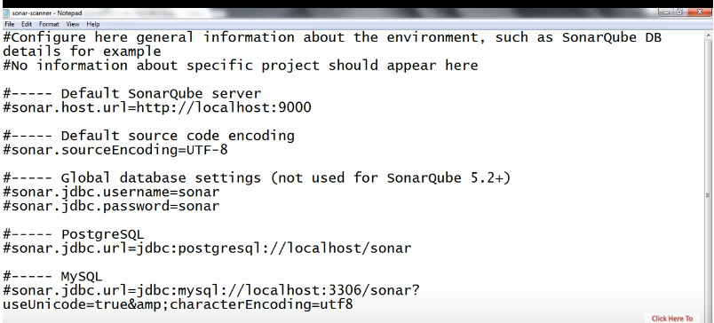

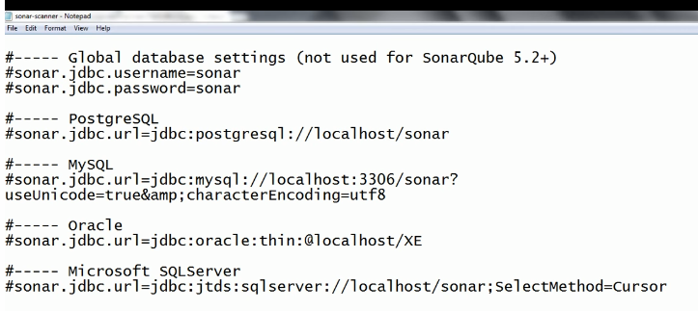

**#Setting Up Sonar-qube in Jenkins**

# Install Plugin

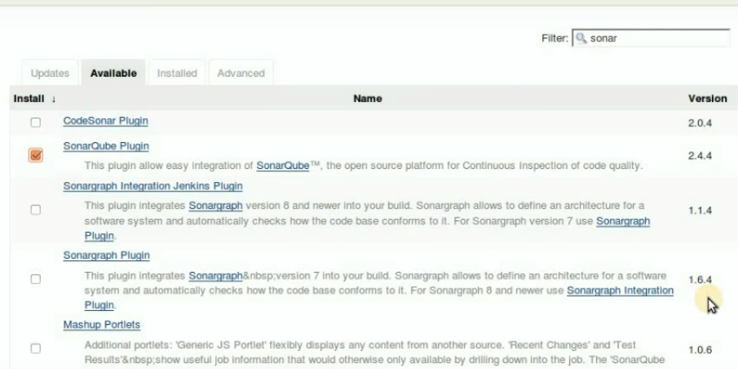

# Configuration

Go to manage Jenkins + configuration

Set the “NAME” “URL” “VERSION” “TOKEN”

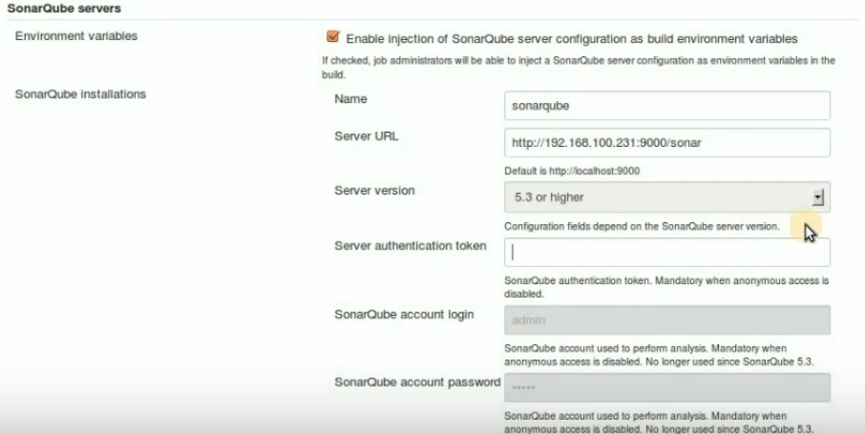

Sonar-qube version above 5.3 required authentication token

Sonar-qube version above 5.3 required Login name & pass word.

Go to manage Jenkins + Global tool configuration

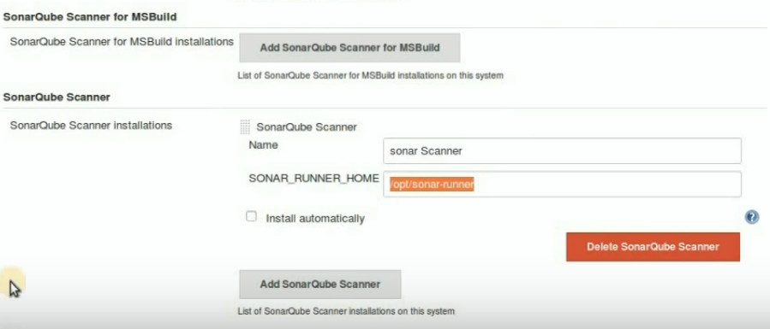

Above Home path is default.

#Job creation setup

Select Build environment

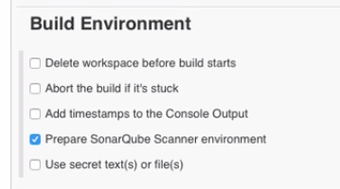

#Sonar Dash Board

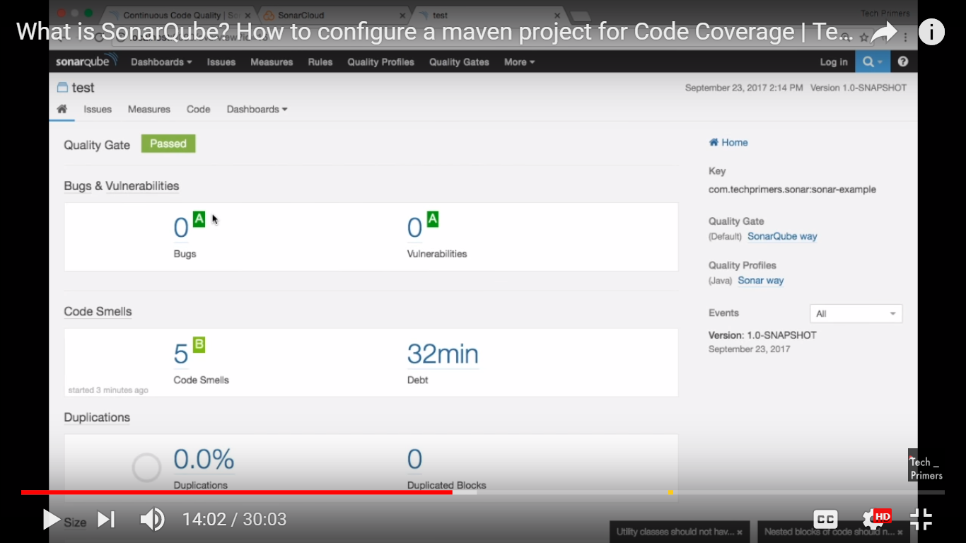

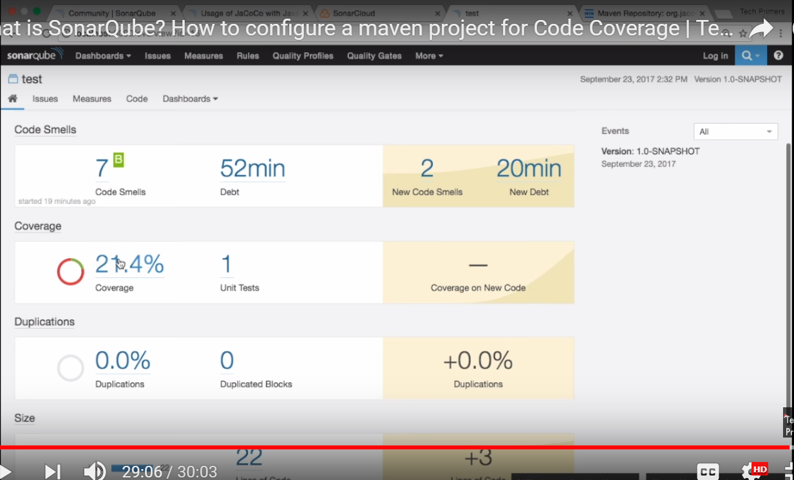

# Rules

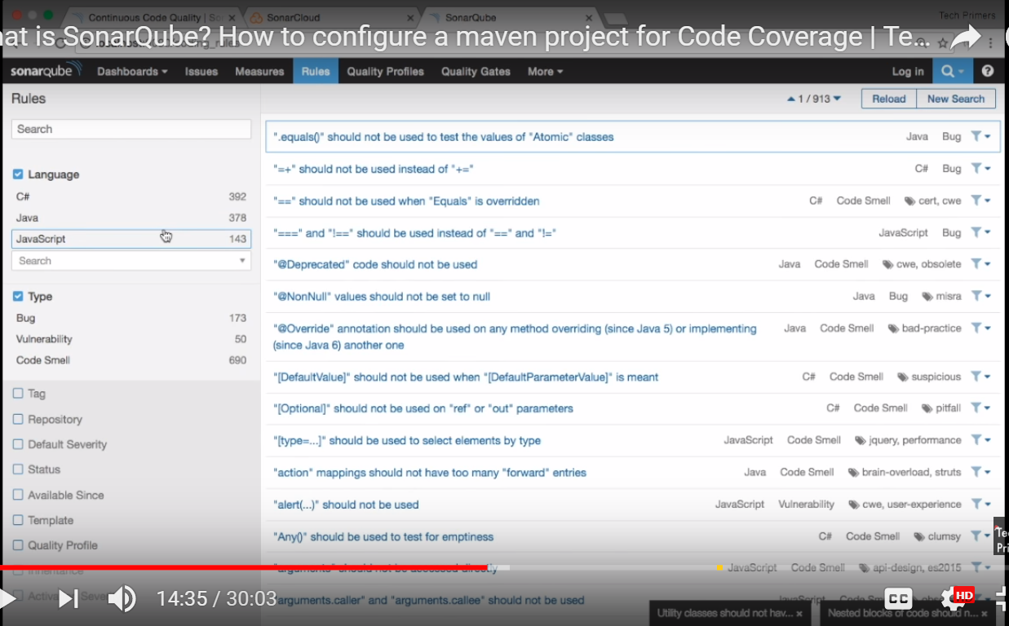

# JAVA Rules

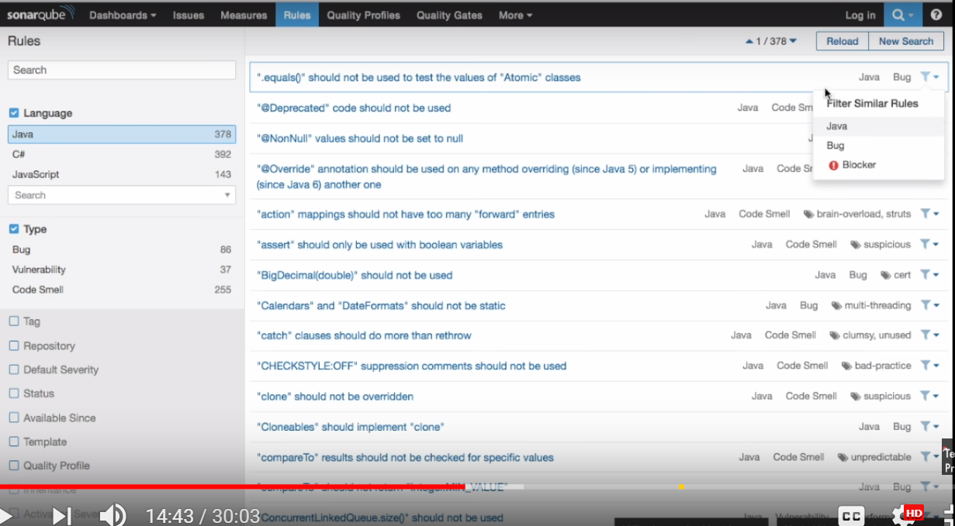

# Quality Policy

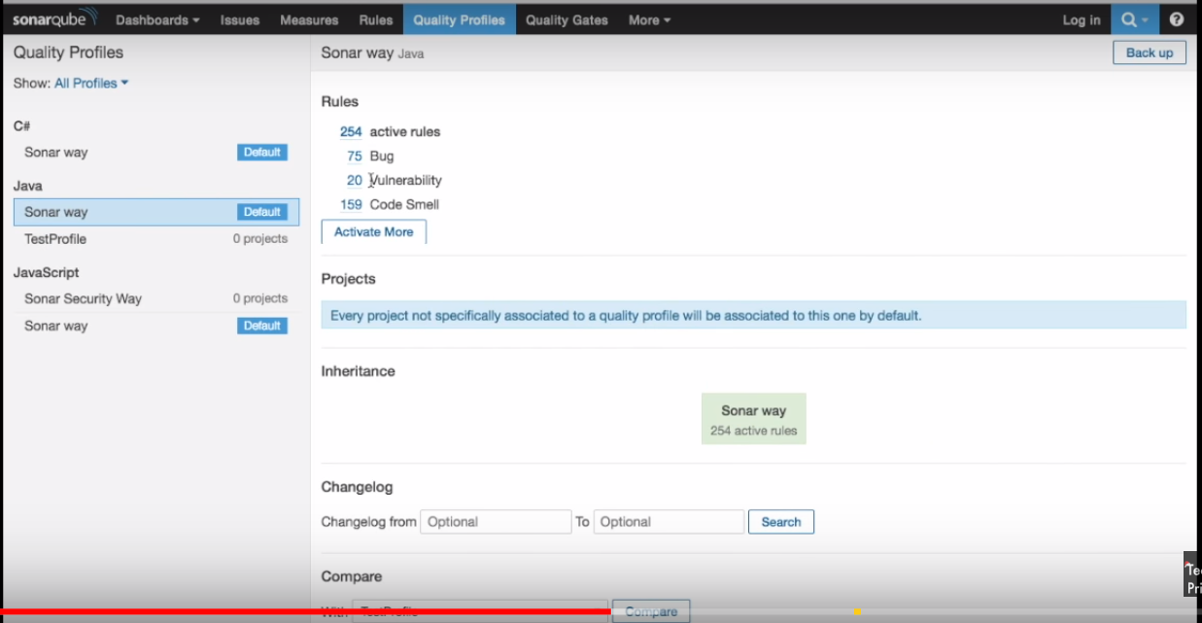

# Quality Gates

