**Report**

**(Day 5)**

Reported by: P. PRUDVI REDDY (BU21EECE0100361)

Mail Id: [ppoli@gitam.in](mailto:ppoli@gitam.in)

**Objective:**

* To design and simulate a system using the AT89C51 microcontroller, AC0808 and resistance variable to measure voltage by the LED’s as output

Inputs:

* where the clock act as clock input in ADC0808 , where the variable resistor acting as input and connected to the port 26 ,power supply at port 12 of ADC0808 , port 22,23,24,25 of ADC0808 to port 25,23,22,21 of AT89C51 and from P3.0 to P3.7 of AT89C51 act as input to the leds

Outputs:

* where the leds work as the ouput when the variable resistor we changes in the workplace

**Logic:**• Pin declarations are made for control signals (ALE, OE, SC, EOC) and address lines (ADDR_A, ADDR_B, ADDR_C).

• A delay function (MSDelay) is defined for introducing delays.

• In the main function, ADC_Value is initialized and port configurations are set.

• Control signals (ALE, OE, SC) are set low initially.

• The program enters an infinite loop for continuous ADC operation.

• The input channel is selected using ADDR_A, ADDR_B, and ADDR_C pins.

• Delays are introduced for stabilization and timing.

• ALE is enabled to initiate conversion, followed by a delay.

• SC signal is set high to start conversion.

• EOC is monitored for conversion completion.

• Once conversion is done, the digital value is read from Port 1 (P1) and stored.

• OE is cleared to allow data transmission from the ADC.

Results:

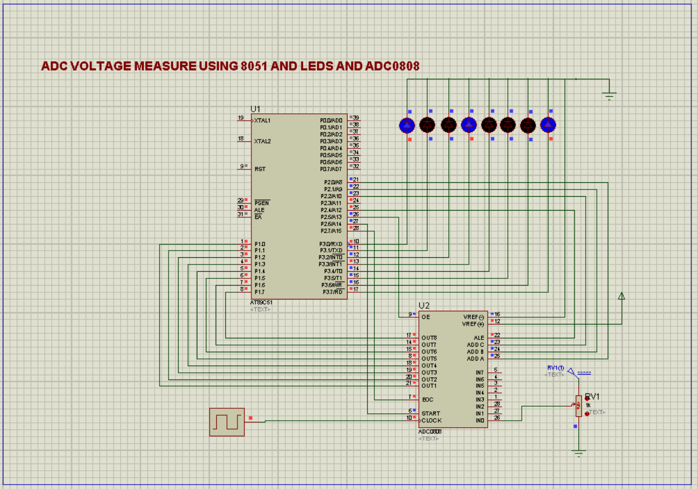

Code:

#include <reg51.h>

sbit ALE = P2^4;

sbit OE = P2^5;

sbit SC = P2^6;

sbit EOC = P2^7;

//Declaring the input selection pin

sbit ADDR_A = P2^0;

sbit ADDR_B = P2^1;

sbit ADDR_C = P2^2;

//void MSDelay(unsigned int);

void MSDelay(unsigned int delay)

{

unsigned int i,j;

for(i=0;i<delay;i++)

for(j=0;j<1275;j++);

}

void main()

{

unsigned char ADC_Value = 0;

P1 = 0xFF;

EOC = 1;

ALE = 0;

OE = 0;

SC = 0;

while(1)

{

ADDR_C = 0;

ADDR_B = 0;

ADDR_A = 0;

MSDelay(10);

ALE = 1;

MSDelay(10);

SC = 1;

MSDelay(10);

ALE = 0;

SC = 0;

while(EOC==1);

//while(EOC==0);

OE=1;

MSDelay(10);

ADC_Value= P1;

P3 = ADC_Value;

OE = 0 ;

}

}

Common mistakes How do I overcome:

* the common mistakes I made during this design that is where the connection mismatch happened and taken the other components different components comparing the circuit design workplace
* the solution that I overcome of this problem is exploring the more time on the circuit design and the components and taken more time practicing which connections should made between the components