**Report**

**(Day 4)**

Reported by: P. PRUDVI REDDY (BU21EECE0100361)

Mail Id: [ppoli@gitam.in](mailto:ppoli@gitam.in)

**Objective:**

* Develop a Proteus simulation showcasing the seamless interaction between an AT89C51 microcontroller and an LCD display, emphasizing the establishment of a reliable communication interface between the two components.

Inputs:

* The inputs for this project include signals from the AT89C51 microcontroller, specifically the data signals transmitted through pins such as P1.0 to P1.7, along with a stable power supply and resistor variable

outputs:

* LCD display displaying the output as the  
    
  ES TRAINING  
  GITAM UNIVERSITY , BANGLORE  
    
  CLASS STRENGTH  
  20 STUDENTS

**Logic:**• **LCD Initialization:** Configuration commands set up the LCD, including the number of display lines, format, and cursor settings.

• **Data Transmission:** Predefined and custom strings are sent to the LCD using specific functions.

• **Dynamic Content Update:** The LCD continuously updates with dynamic content, like the number of students in a class.

• **Delay Function:** A delay function ensures proper timing between LCD commands and data transmission.

• **LCD Communication Functions:** Functions manage the transmission of commands and data to the LCD, setting control signals and writing data to the LCD interface.

• **String Transmission:** Strings are sent character by character to the LCD, ensuring accurate display of textual information.

Results:

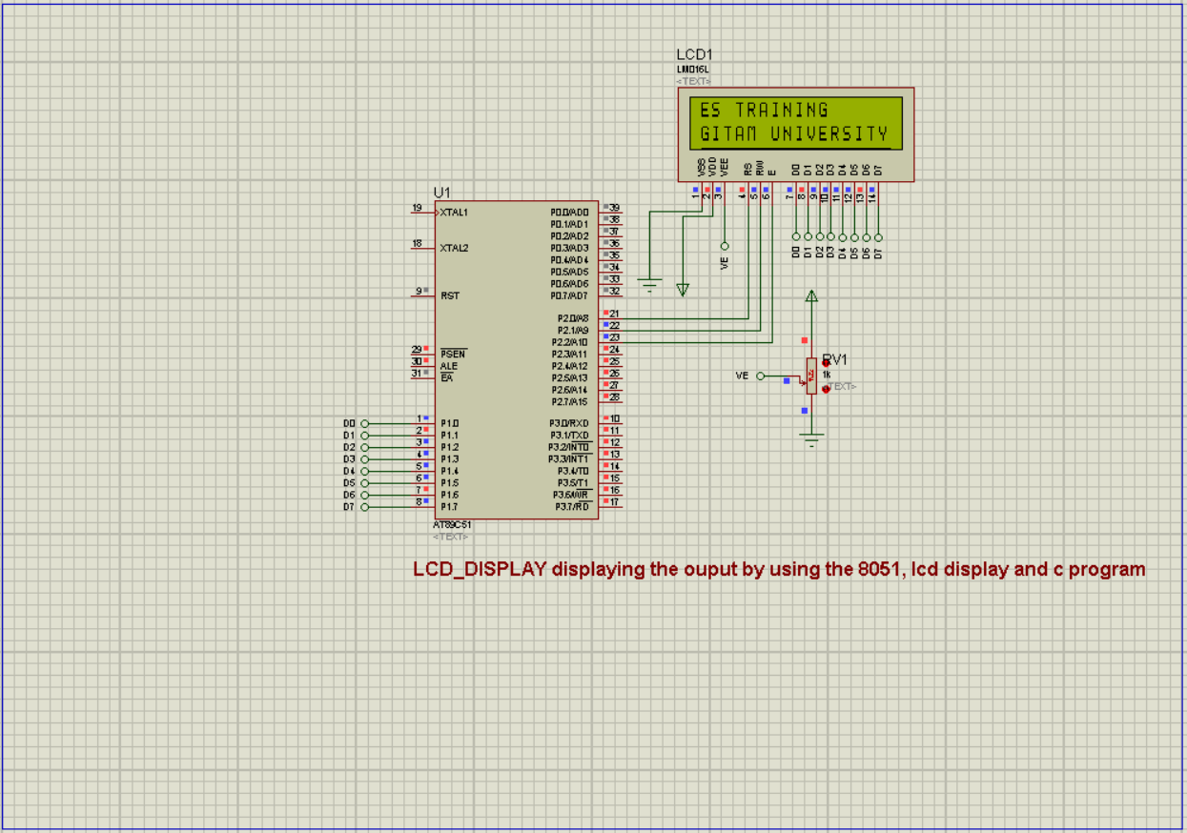

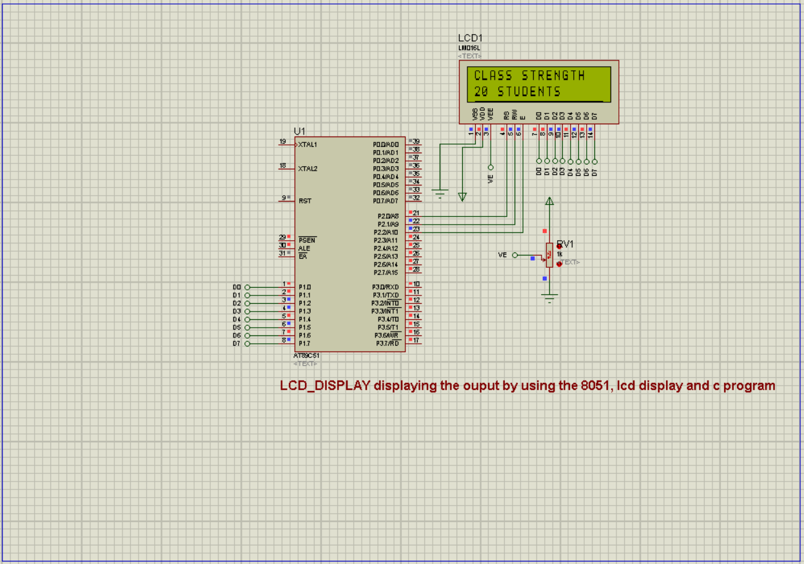

Code:

#include <reg51.h>

sbit rs=P2^0;

sbit rw=P2^1;

sbit e=P2^2;

void delay(unsigned int);

void WriteCommandToLCD(unsigned char ch);

void WriteDataToLCD(unsigned char ch);

void WriteStringToLCD(unsigned char ch[]);

void main(void)

{

// unsigned char ch[]="ES TRAINING";

unsigned char ch1[]="GITAM UNIVERSITY, BANGLORE";

unsigned int j,k;

unsigned int MyData = 20;

// LCD Initialization

WriteCommandToLCD(0x38); // 2 lines and 5x7 matrix

WriteCommandToLCD(0x01); // Clear display screen

WriteCommandToLCD(0x0c); // Display ON, Cursor OFF

WriteCommandToLCD(0x80); // Force cursor to begining (1st line)

WriteCommandToLCD(0x06); // Increment cursor (shift cursor to right)

// Sending Data to LCD

WriteStringToLCD("ES TRAINING"); // Sending String to the LCD

WriteCommandToLCD(0xc0); // Force cursor to the beginning (2nd line)

for(j=0;ch1[j]!='\0';j++)

{

WriteDataToLCD(ch1[j]); // Sending one character to LCD

}

for(k=0;k<30;k++)

{

WriteCommandToLCD(0x1c); // Shift entire display right

}

while(1)

{

WriteCommandToLCD(0x01); // Clear display screen

WriteCommandToLCD(0x80); // Force cursor to the beginning (1st line)

WriteStringToLCD("CLASS STRENGTH"); // Sending string to LCD

WriteCommandToLCD(0xc0); // Force cursor to the beginning (2nd line)

WriteDataToLCD((MyData / 10) + 48); // Separating the first digit of Mydata

WriteDataToLCD((MyData % 10) + 48); // Separating the second digit of Mydata

WriteStringToLCD(" STUDENTS");

}

}

void delay(unsigned int t) // Function for setting 1ms delay

{

unsigned int i,j;

for(i=0;i<t;i++)

for(j=0;j<1275;j++);

}

void WriteCommandToLCD(unsigned char ch) // Function for sending command

{

e=1;

rs=0;

rw=0;

P1=ch;

e=0;

delay(20);

}

void WriteDataToLCD(unsigned char ch) // Function for sending Data

{

e=1;

rs=1;

rw=0;

P1=ch;

e=0;

delay(20);

}

void WriteStringToLCD(unsigned char ch[]) // Function for sending string

{

int i;

for(i=0;ch[i]!='\0';i++)

{

WriteDataToLCD(ch[i]);

}

}

Common mistakes How do I overcome:

* the common mistakes I made during this design that is connecting the wires from the AT89C51 from P1.0 to P1.7 to LCD D0 to D7 where it causes the mess in the workplace of the design and also unable to find the potentiometer
* the solution that I overcome of this problem where I use the default pins labeled as from DO to D7 and connected to ATC89C51 from P1.0 to P1.7 and also did for the LCD from DO to D7 and where in place of the potentiometer I used the resistance variable component in the proteus